NDIS Planning Meeting Tip Sheet – Over 18

This tip sheet is for young people over 18.

Once you have joined the National Disability Insurance Scheme (NDIS) you will have a planning meeting with someone called a planner or Local Area Coordinator (LAC).

They will contact you to organise a planning meeting.

Tips for your planning meeting

- You can choose to have your planning meeting at a time and place that works for you.

- You can bring whoever you want with you to your planning meeting. This may be family, friends or an advocate.

- Since you are over 18 you don’t need to bring a parent or guardian to your planning meeting, but you can if you want to.

- Speaking up at your planning meeting will help your planner understand what supports you need. If you don’t feel comfortable to speak up you can write down notes, take photos or make a video to bring into your meeting.

- You have a say in what supports you receive through the NDIS. You don’t have to join the NDIS.

- You can ask to change planners if you want to.

- If you are unhappy with your NDIS plan you can ask for it to be changed.

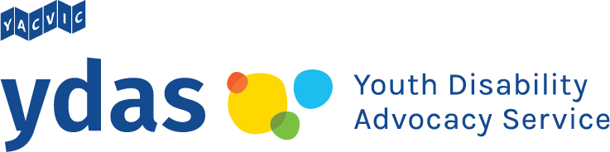
YDAS acknowledges the support of the Victorian Government.

