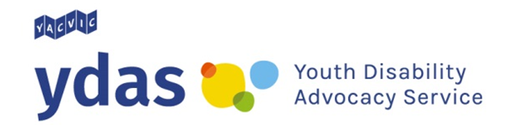
Map Your Future

Are you 15 – 25 years old?
Do you live in Victoria?
Do you have a disability?

Would you like to practice speaking up for what YOU want?
If so, you should think about joining Map Your Future!

Map Your Future is a trial program from the Youth Disability Advocacy Service (YDAS). YDAS is a state wide advocacy service for young people with disability in Victoria.
Map Your Future will help you plan for the NDIS and plan for the future. Thinking about what you want will help you to work out what kind of support you need and where you want to go in life.

What happens if you join?
- A chat with someone to work out what’s happening for you now.
- One group workshop with up to four other people. This will run for five hours and include different activities, lunch and a workbook to take home.
- Three one-to-one coaching calls (via Skype, phone or in person). Each call could take up to one hour long.

You will get a Certificate of Completion for finishing the program.
Because Map Your Future is new, we will also want to know what you think afterwards.

The program ran for the first time in the July school holidays and we received some great feedback! It will run for the second time starting in the September school holidays.

It is free to take part in the Map Your Future program.

We will make sure you get the support you need for your disability during the program.

You need to be:
- Keen to learn more about speaking up
- Interested in working out what you want to happen in your life
- Ready to put in the time to make it happen!

For our groups, we are looking for people who:
- Already know a little bit about the NDIS
- Can tell us what they think about the program

To sign up, just fill out an Expression of Interest form.

For further information or for an Expression of Interest form please contact:
Luke David
Map your Future Project Advisor
E ydasmyfadvisor@yacvic.org.au
P (03) 9267 3703

YDAS acknowledges the support of the Victorian Government

