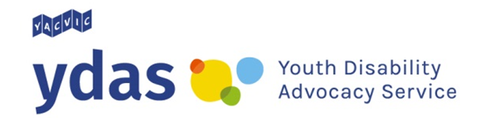

NDIS 101: Self-management

Self-managing your NDIS plan means that you organise your own disability supports. There are some skills you need to have so that you can look after your NDIS plan. Think about whether you have some of these skills or whether you need to learn them.

Steps you need to take to find disability supports

Research to find people and companies that provide the disability supports you want.

Decide who you want to support you.

Contact people and companies to find out how they can support you.

Make agreements with the people and companies supporting you.

Steps you need to take to use your disability supports

Contact your planner or Local Area Coordinator (LAC).

Check and pay your bills if you get supports from a person or company that is not registered with the NDIS.

Keep your bills and receipts.

Check and pay your bills if you get supports from a person or company that is not registered with the NDIS.

Access the NDIS portal. The NDIS portal is a website to keep track of your NDIS plan.

Problem solve if something goes wrong.

Talk to people about how things are going – both when things are going well and when they need to change.

YDAS acknowledges the support of the Victorian Government.

