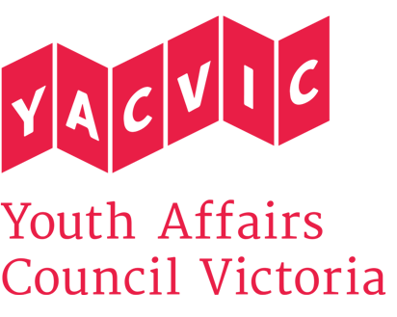
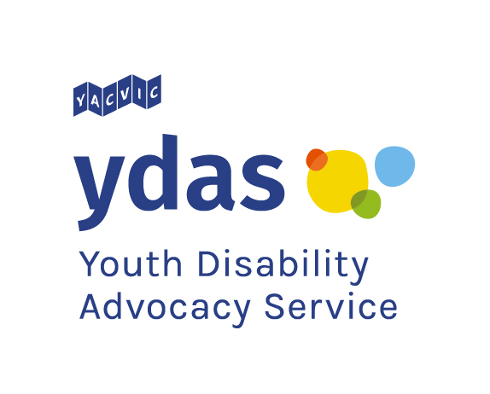
Title: | YDAS Manager
Reporting to: | Chief Executive Officer
Hours: | 1.0 EFT – 38 hours a week
Remuneration: | Classified at SCHCADS Award Level 6.1, $83,229.00  (YACVic pays above award rates, with generous T&C.)
Status: | Full Time – Ongoing Contract
Location: | Melbourne CBD

About Youth Affairs Council Victoria (YACVic)
Youth Affairs Council Victoria (YACVic) is the state’s peak body and leading policy advocate for young people aged 12 – 25 and the sector that supports them. YACVic’s vision is that young Victorians have their rights upheld and are valued as active participants in their communities. YACVic is an independent, for-purpose, member driven organisation.

About the Youth Disability Advocacy Service (YDAS)
YDAS is a core YACVic agency, funded by the Victorian Government, and the only service of its kind in Australia. YDAS has a service model which places the human rights and interests of young people with disability at the centre of its work. YDAS undertakes individual and policy advocacy to support young people with disability to have a stronger voice, reduce the barriers that they experience and improve their quality of life. YDAS also designs and delivers projects and programs that align with its service model and which contributes to the strategic vision of YDAS and YACVic. At times YDAS works in partnership or on a fee-for-service basis to bring its expertise to other organisations’ projects.

About the role
The YDAS Manager oversees YDAS’ high quality individual casework advocacy service for young people with disability, including supervision of the Advocate and backup support.
Further, the YDAS Manager works closely with the YACVic Policy Manager to further YDAS’s and YACVic's systemic advocacy in the interests of young people with a disability in Victoria, including providing policy advice to governments. The YDAS Manager also oversees several projects and programs focused on empowering and improving outcomes for young people with disability.

In addition, the YDAS Manager:
- Convenes and facilitates relevant working groups and/or reference groups to assist with the systemic advocacy work of YDAS and YACVic.
- Meets all relevant reporting and quality compliance obligations.
- Oversees all relevant budgeting, grant proposals, reporting and acquittals.

Reporting
The YDAS Manager reports to the YACVic CEO, and oversees a team of seven (7) staff and several casual staff, including young people with disability who co-design and co-deliver workshops. Roles that report directly to the YDAS Manager are:
- Youth Disability Advocate
- TSP Project Coordinator
- ILC Project Officer x 2
- Digital and Content Officer

Key Responsibilities
- Ensure high quality individual advocacy is provided to young people with disability in line with contractual obligations.
- Work together with the YACVic Policy Manager to provide specialist high-level policy advice to government and other relevant agencies to advance the interests of young people with disability.
- Oversee other YDAS projects and programs, focused on building inclusive practice and empowering young people with disability.
- Manage the recruitment (working with the YACVic HR Manager) and performance of YDAS staff.
- Lead YDAS Quality Management System (QMS) processes and maintain compliance; ensure the service meets relevant targets, reporting and regulatory requirements.
- Develop and sustain links with relevant youth, disability, advocacy, community and government agencies/groups to promote YDAS and YACVic; present and represent YDAS and YACVic at relevant meetings, committees or events.
- Direct and oversee YDAS communication channels, including media enquiries and releases, in consultation with YACVic Media Manager.
- Work with the YACVic CEO and Finance Officer to develop and monitor YDAS budgets, secure funding, and manage reporting and acquittals.
- Promote and support the work of YACVic and its core and partner agencies, and participate in YACVic meetings, activities and events as required.
- Carry out any other duties assigned to you by the CEO, having regard to your skills, training and experience.

Key Selection criteria:
- Demonstrated commitment to the rights and interests of young people with disability, and proven ability to work effectively with people with disability, their families and carers.
- Demonstrated experience in supervising staff, ideally in a complex casework environment.
- Demonstrated experience in successfully managing complex programs, services and projects, including setting and managing budgets.
- Demonstrated ability to build and maintain productive relationships with a wide variety of stakeholders.
- Undergraduate or postgraduate qualifications relevant to the role (e.g. disability studies, community development, social work, youth work, project management).
- Knowledge and/or experience of the National Disability Insurance Scheme (NDIS), the Victorian disability sector, and the disability advocacy sector.
- Demonstrated understanding of appropriate behaviours when engaging with children and young people, including those with diverse needs and/or backgrounds, and commitment to the Code of Ethical Practice for the Victorian Youth Sector.
- Highly developed written and verbal communication skills.
- Highly developed organisational skills with ability to balance multiple tasks efficiently.
- Willingness to travel throughout Victoria and work occasional evenings or weekends when required.

Employment Conditions:
YACVic is an Equal Opportunity Employer. People with disability are strongly encouraged to apply for this position.

YACVic promotes the safety, wellbeing and inclusion of all children and young people, including those with a disability, those who are Aboriginal or those from refugee or migrant backgrounds. We take child protection very seriously and all employees are subject to screening and assessment against child safety standards, including rigorous background, identity and reference checks.

Successful appointment to a position will be subject to a National (and International if applicable) Police Check, Victorian Employee Working with Children Check, Right to Work in Australia, and current driver’s license or other relevant photo ID. All employees must also agree to adhere to our child safe policy and code of conduct.

To be eligible to apply for this position you must be an Australian or New Zealand citizen, permanent resident or hold a valid work permit or visa.

Application Process
Email your application to Stephanie Brenkovich – HR Office Manager at sbrenkovich@yacvic.org.au with ‘YDAS Manager’ in the subject line and include:
- A brief cover letter including what attracted you to the role;
- Your resume, including contact details for a minimum of two referees, one of which being your most recent line manager (we will not contact referees without your permission).
- A separate document detailing your response to each selection criteria, as stated in the position description.
Only applications that follow the above process will be accepted and considered for interview.

Applications close 5pm Wednesday 4 September with interviews to be held from Monday 9 September in the Melbourne CBD.

If you have any questions about the role, please contact Stephanie Brenkovich (HR Office Manager) on 9267 3700.

