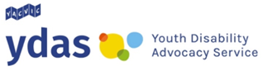

Help to get your COVID-19 Vaccinations

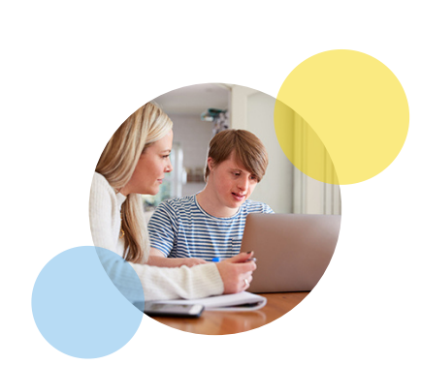

This is an Easy English book
It uses pictures to explain ideas

This book was made by YDAS.
When you see “we” or “our” it means YDAS.
Some words in this book are bold.
They are hard words. We will tell you what they mean.
This book will tell you
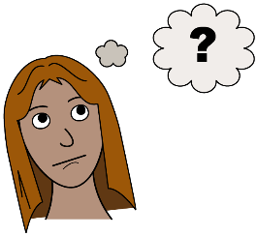
- About YDAS
- How we can help you get your COVID-19 vaccinations.
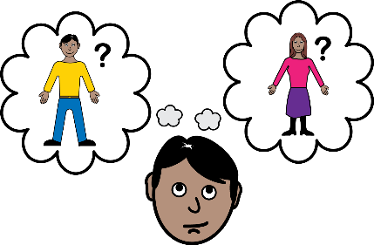
- Who you can talk to for help getting your COVID-19 vaccinations.

About YDAS
YDAS helps disabled young people.
We can help you get your COVID-19 vaccination if you are
- Disabled
- Between 12 and 25 years old
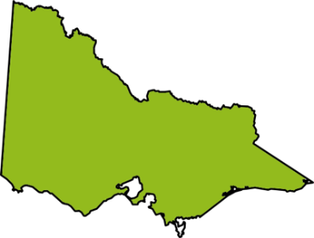
And
- Live in Victoria
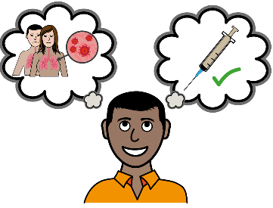
Vaccinations are medicines that can keep you safe from sickness.
You get vaccinations as a needle in your arm.
How we can help you get COVID-19 vaccinations
YDAS can tell you about
- COVID-19 vaccinations
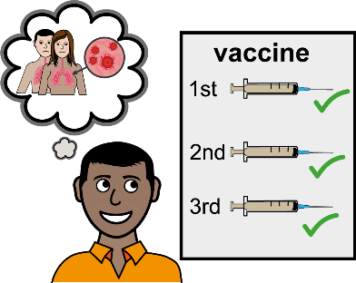
- COVID-19 boosters
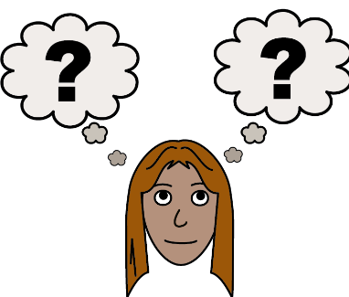
A booster is a vaccination you get after you have already had one or two vaccinations.
- Where you can get your vaccinations
- What happens when you get your COVID-19 vaccinations.
How we can help you get COVID-19 vaccinations
YDAS can
- Help you find a vaccination centre.
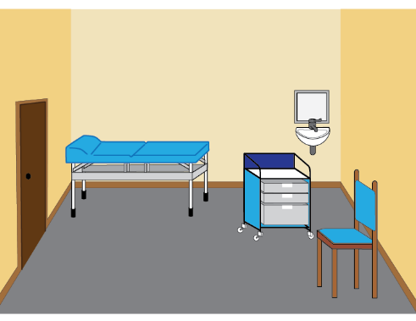
A vaccination centre is a place you go to get your COVID-19 vaccination.
- Answer your questions about COVID-19 vaccinations.
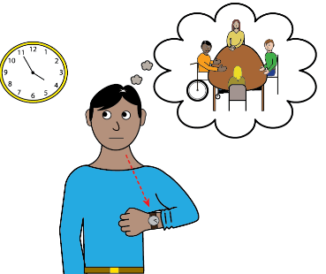
- Find information about COVID-19 vaccines that is easy to understand.
- Help you make an appointment for your COVID-19 vaccination.
How we can help you get COVID-19 vaccinations
YDAS can
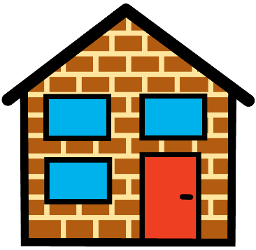
- Help you understand how to get to your vaccination appointment
- Help you understand how to get home from your vaccination appointment
If we do not know the answer to a question when you speak with us we will find the answer for you.
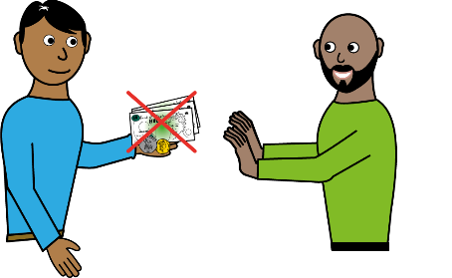
It is free for YDAS to help you get your COVID-19 vaccinations.
Free means you do not have to pay.

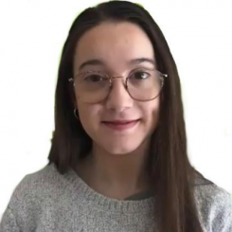
Who you can talk to for help getting your COVID-19 vaccinations
This is Elyse.
Elyse works at YDAS.
Elyse can help you get your COVID-19 vaccinations.
You can contact Elyse by
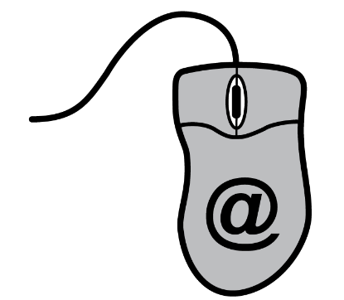
- Email
Elyse’s email address is ewestwood@ydas.org.au

- Text
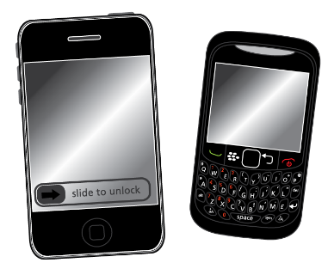
- Phone call
Elyse’s phone number is 0447 186 888
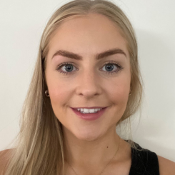
Who you can talk to for help getting your COVID-19 vaccinations
This is Meg.
Meg works at YDAS.
Meg can help you get your COVID-19 vaccinations.
You can contact Meg by
- Email
Meg’s email address is mlangmaid@ydas.org.au
- Text
- Phone call
Meg’s phone number is 0447 679 121
The End
This is the end of the book about help to get your COVID-19 vaccinations.
Thank you for reading it.
You can learn more about YDAS at our website.
www.yacvic.org.au/ydas
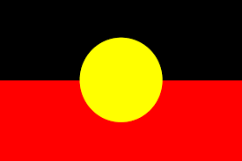
This book was made on Aboriginal land.
Aboriginal people have been taking care of the land for many years.

