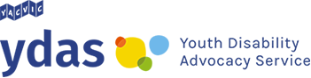
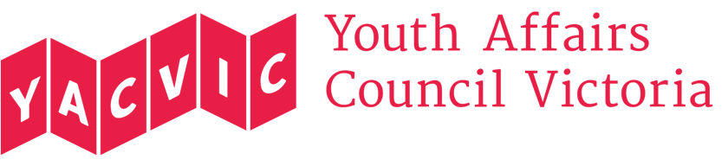

Feedback Form
Youth Disability Advocacy Service

The Youth Disability Advocacy Service (YDAS) provides individual advocacy for young people with disability between the ages of 12-25 to pursue their rights and have a stronger voice. YDAS supports clients with advocacy needs in areas including education, housing, employment and support services.

YDAS supports the young person with disability by working with them to identify what they want to achieve and assisting them to develop and implement a plan for how to achieve it. YDAS may support the client with letter writing and telephone calls, as well as arranging and attending meetings that are all aimed at achieving the outcome that the client wants. YDAS also assist clients to advocate for themselves.

How would you describe the service that you received from YDAS?
-- please circle --

poor average good very good excellent

What did you like most about the service you received?

What could have been done to improve the service you received?

Any further comments?

Thank you for taking the time to complete and return this form.

