Disability in the time of COVID-19
The experiences of young people with disability during the 2020 pandemic and their recommendations for recovery.

YDAS COVID-19 Working Group

Acknowledgements
Authors
YDAS COVID-19 Working Group - Cindy Liu (she/her), Timothy Chan (he/him), William Henry McIntosh (he/him), Lee Tsourvakas (she/her), Catherine Dunn (she/her).
Report compiled by Is Hay (they/them).

With support from
Is Hay (they/them), Sarah Whinnen (she/her), Eliza Wills (they/them), Mija Gwyn (she/her) and the YDAS team.

Acknowledgement of Country
We would like to respectfully acknowledge the true custodians of the lands on which we work, create and meet, the Wurundjeri Woiwurrung people of the Kulin nation. We would like to pay our respects to Elders, past and present. We would like to affirm that this land was violently stolen, that sovereignty was never ceded and that this always was and always will be Aboriginal land.

Thanks
We are thankful to those who supported this project with funding and mentorship. Including but not limited to: Helen Dickinson, Catherine Smith, and UNSW. The ongoing support of the YDAS team to continue to help us meet our vision and do the work we feel is important has been incredible. We also acknowledge the support and guidance of the COVID-19 Working Group convenor Is Hay (they/them) whose facilitation of the Working Group meetings and actions made the group work, including this report, possible.

The Context 5
Who is YDAS? 5
What is the YDAS COVID-19 Working Group? 5
Who are the members of the YDAS COVID-19 Working Group? 6
What did the YDAS COVID-19 Working Group do? 9
What language will we be using? 9
What are the focuses of the YDAS COVID-19 Working Group? 10
What is this research project? 11
Research methodology 11
The Themes 12
Introduction to themes 12
What was the impact on support services? 13
What was the impact on mental health? 14
What was the impact on education? 16
What was the impact on employment? 18
What was the impact on social inclusion and community? 20
What was the impact made by the government and decision makers? 21
What does it all mean? 23
The Recommendations 25
Introduction to recommendations 25
Recommendation 1 27
Recommendation 2 27
Recommendation 3 28
Recommendation 4 28
Recommendation 5 29
Recommendation 6 29
Recommendation 7 30
Recommendation 8 30
Recommendation 9 31
Recommendation 10 32
Recommendation 11 32
Recommendation 12 33
Reflections on recommendations 34
The Reflections 35
The Conclusion 37

The Context

Who is YDAS?
The Youth Disability Advocacy Service (YDAS) is an advocacy organisation that works with disabled young people aged between 12 and 25. We work directly with disabled young people in Victoria to ensure their human rights are being met and they can speak up and are being treated fairly.
YDAS is a core agency of the Youth Affairs Council Victoria (YACVic). YDAS was established in 2006 and is funded by the Victorian Government.

What is the YDAS COVID-19 Working Group?
In May 2020 YACVic and YDAS identified that disabled young people were impacted disproportionately by the COVID-19 pandemic (YACVic, 2020). However, opportunities for disabled young people to share their experiences with decision makers were limited.
The impacts of the COVID-19 pandemic were unprecedented. Disabled young people experienced difficulties with the following:
- Lack of access to essential goods and services including these required for their disability
- Disruption to support required for their daily lives and activities
- Closure of education, employment and other systems
- Exacerbation of physical and mental health issues
The lack of understanding within the community and the government of the challenges for disabled people also created barriers to support and engagement (Dickinson & Yates, 2020).
YDAS created the COVID-19 Working Group in response to these issues. The group consisted of 5 outstanding young people with disability who came together to identify themes and issues that they wanted to act on. The group spoke with stakeholders and decision makers about the challenges experienced by young people with disability and presented solutions.
The group's work is underpinned by the phrase ‘Nothing about us without us.’ Its vision is that young people with disability will become pivotal influencers in the Government’s pandemic response.

The COVID-19 Working Group began meeting in June 2020 using the online platform Zoom. The Working Group members are paid for their time.

More information about the Working Group can be found here.

Who are the members of the YDAS COVID-19 Working Group?
There were 5 excellent members of the COVID-19 working group in 2020: Cindy, Lee, William, Tim and Catherine. They have each put a bio below so you can get to know them better!

Catherine
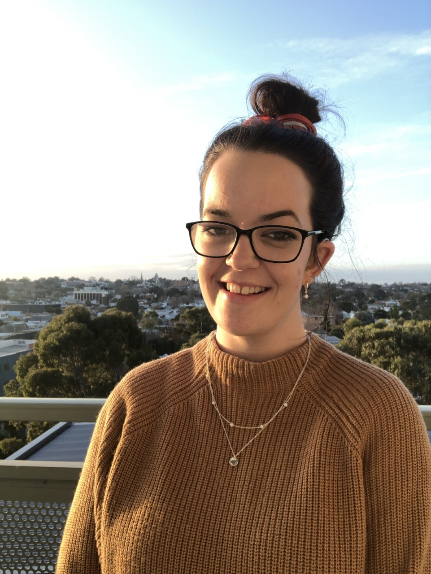
Hey hey! I’m Catherine (she/her) and I work at Deaf Victoria as an advocate. I am currently studying my Bachelor of Arts majoring in sociology, and I love watching the footy. I am super excited to be part of YDAS’ COVID-19 Working Group as it aligns with my passions of authentic representation, equity and youth voice. With all the changes occurring in 2020, it’s amazing to be part of this working group to make a change for the better!

Cindy
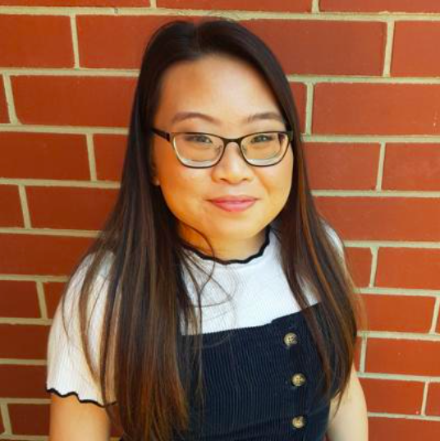
Hi everyone! I’m Cindy, I’m currently a full-time uni student and a part of YDAS’ COVID-19 Working Group. I am involved in, and passionate about, disability and mental health advocacy, which is one of the reasons I have joined this wonderful working group. The COVID-19 pandemic is a cornerstone for change, as the struggles and inequities experienced as young people with a disability have bubbled up to the surface. And this boiling point is the best time for change by and for young people with disabilities.

Lee
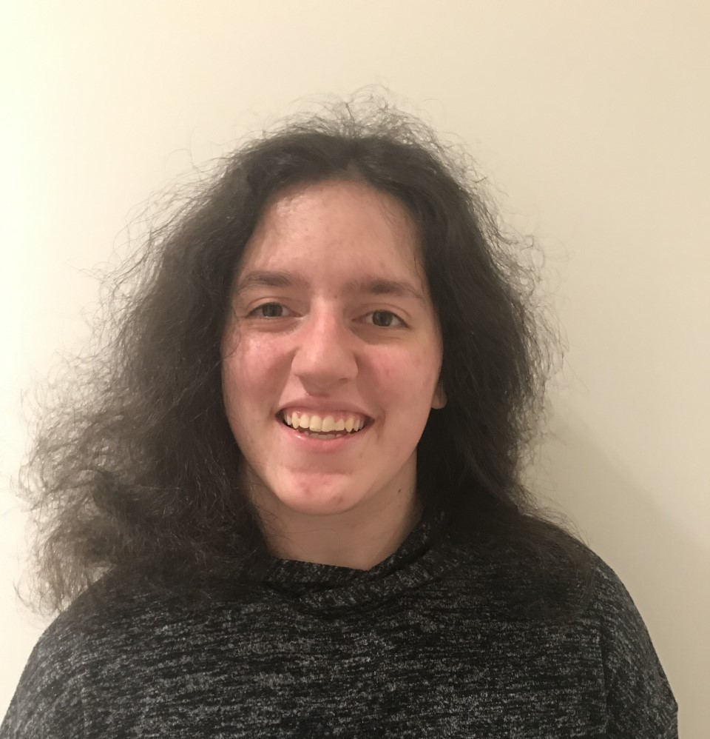
Hey there! My name is Lee, I’m a high school student, a girl guide, and proud member of this working group! I joined this working group because I wanted to share my own experiences, hear other disabled young people’s experiences, and combine our voices to advocate about what is needed for our community. What I would like to communicate, to people outside our community, is that all of our needs to do with COVID-19 are different. COVID-19 has only highlighted the lack of knowledge of some non-disabled people within our society about people with a disability.

Tim
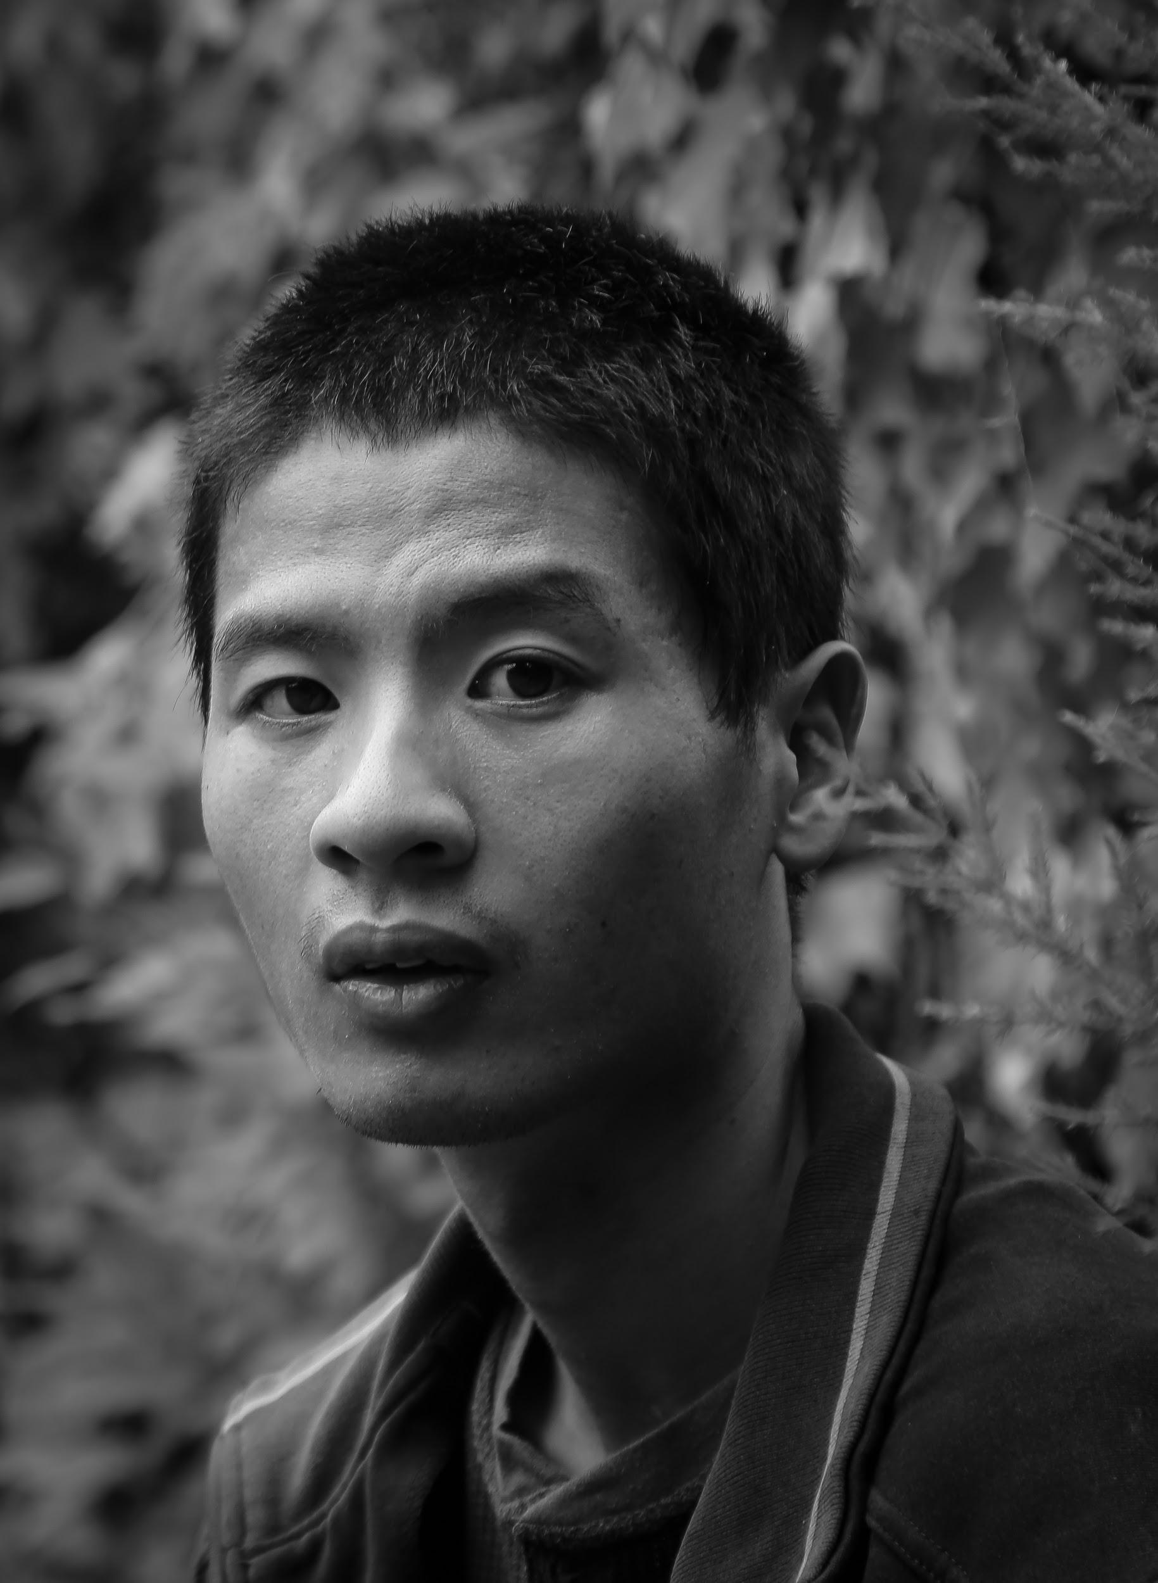
Hi everyone. My name is Tim. I’m an autistic non-speaker and use assisted typing to communicate. I am studying full time in an Arts degree majoring in sociology. I am a proud member of the COVID-19 Working Group. Getting together as a group with a common purpose in working towards how we can navigate the pandemic in better ways has been fantastic. Advocating for disabled young people, for access and inclusion, to have a say and live satisfying lives, has been my passion since being discriminated against at high school for my differences. The working group has provided opportunities to be connected to others in the same boat and putting our heads together in helping all disabled young people has been wonderfully rewarding.

William
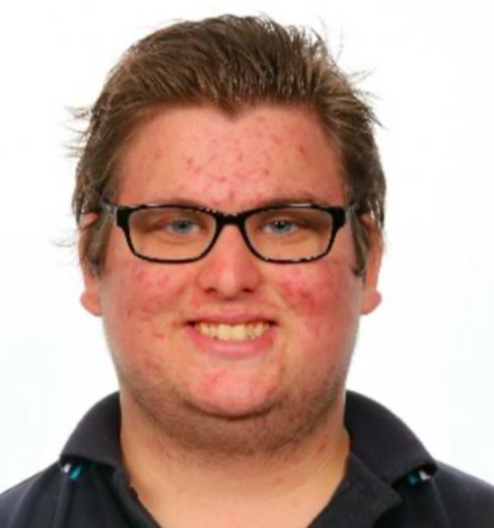
I’m William, I joined the COVID-19 Working Group because I wanted to meet new people and make a change. I enjoy all aspects of the working group. We are all in this together!

You can also meet the members of the Working Group here.

What did the YDAS COVID-19 Working Group do?
Starting in June 2020 the Working Group met every week to discuss the important things happening in the world because of COVID-19.
The Working Group met with a range of stakeholders. They were lucky enough to have met with:
- People from Department of Health and Human Services (DHHS)
- Staff from the University of Melbourne and the University of New South Wales and
- Representatives from Children and Young People with Disability Australia (CYDA), and the National Disability Insurance Agency (NDIA).

The Working Group hosted focus groups with young people with disability to understand their experience during the COVID-19 pandemic. The data from the focus groups has informed the findings and recommendations in this report.

What language will we be using?
In the disability community there are lots of different perspectives on the language people want to use to refer to themselves and the community overall.

Person first language is “person with a disability” or “young person with a disability” or “person with cerebral palsy.” Identity first language is “disabled person” or “disabled young person” or “autistic person.” Both sets of language are valid and each person will have a different preference on which language is used to describe them. The most important thing to do is to ask each person what language they want to be used for themselves.

Person first language suggests that disability doesn’t have to be a defining part of a person. It can be very affirming to have personhood emphasised. Identity first language is used when disability is an aspect of a person that they embrace as an important and unwavering part of who they are. This can be very empowering for people who use identity first language.

In a non-unanimous decision (not everyone agreed), the YDAS COVID-19 Working Group decided to use person first language. This is because it highlights the importance of this conversation and checking with people about which language they prefer to use. YDAS uses ‘disabled young people’ as per the guidance of the YDAS Steering Committee. Accordingly, we have used ‘disabled young people’ in the introduction to this report. For the remainder of the report, we will use ‘young people with disability’. We recognise and respect people’s autonomy in choosing how they identify themselves.

What are the focuses of the YDAS COVID-19 Working Group?
The Working Group identified 3 key focus areas for this report. They also identified the target audiences for their findings.

The outcomes of the YDAS COVID-19 Working Group are:
- Highlighting that underlying problems were made worse by the COVID-19 pandemic.
- Sharing young people with disability’s experiences of the COVID-19 pandemic.
- Communicating the changes that need to be made to properly support young people with disability recovering from the pandemic.

The audiences the YDAS COVID-19 Working Group wants to communicate this to are:
- Representatives in government
  - Examples: Victorian State Minister for Disability - Luke Donellan, Victorian Minister for Youth - Ros Spence, Parliamentary Secretary for Youth - Josh Bull, Senator - Jordon Steele-John, etc.
- Youth services, representatives and organisations
  - Examples: local councils, social enterprises, NFP services, peak bodies, YSAS, CYM, Victorian Youth Congress, etc.

What is this research project?
Inspired by researchers Helen Dickinson and Catherine Smith, the YDAS COVID-19 Working Group decided to address the lack of research about the impact of the COVID-19 pandemic on young people with disability.

The Working Group noted that existing research was not always co-designed or created by young people with disability. Notably, the research methods used were often not accessible or inclusive for young people with disability. There was a strong tendency for researchers to engage with parents and carers of young people with disability, as opposed to engaging directly with young people with disability. This meant the direct experiences of young people were not being heard.

Addressing this gap and prioritising the lived experience of young people with disability became the Working Group’s focus.

Research methodology
The Working Group identified a research methodology that was inclusive, accessible and engaging. Their goal was to obtain qualitative data.

The Working Group developed and facilitated a series of focus groups for young people with disability with guidance from researchers. They crafted engaging and fun activities to encourage conversations about COVID-19 in a way that was by, with and for young people with disability.

Fifteen young people with disability attended the focus groups, which took place in November 2020. The participants were paid for their time.

The Themes

Introduction to themes
The Working Group used the following themes to frame the focus group discussions:
- Support services
- Mental health
- Education
- Employment
- Government and
- Social inclusion and community.

Through meetings and focus groups, the larger picture of the impact of COVID-19 emerged. This showed how the pandemic disproportionately impacted young people with disability, notably along the six themes listed above.

These themes are intricately connected. For example, if a young person with disability was not getting the support they needed from support services, it may have negatively impacted their mental health. This in turn may have limited their ability to engage in education or employment.

The themes reflected areas in which decisions had been made about young people with disability without their input. This led to young people with disability feeling that they had been ignored.

What was the impact on support services?
Young people with disability engage with a number of different support services in daily life, in order to:
- Maintain their health,
- Get the support they need and
- Continue the routines that best help them live their lives.

The changes to support services during the pandemic had a major impact on their lives. Access to services was limited for everyone, but young people with disability were particularly impacted.

Young people with disability spoke with desperation about being forgotten and left behind when services were altered in ways which affected them. Young people with disability felt excluded from the opportunity to be consulted on the changes to services, which meant services were delivered in a way that wasn't suitable for them.

The Working Group and the participants in the focus groups identified the following issues:
- In 2020 many support services became unavailable, or only available by telehealth. The experiences of young people with disability using telehealth services were varied. Some people appreciated the greater flexibility, however others reported that the quality of services delivered by telehealth was significantly lower.
- The impact of the pandemic on specific support services, namely medical services and the NDIS were particularly notable. Changes to these services were not communicated to young people with disability in accessible, timely, clear or inclusive ways. This made it even harder for them to get what they needed.
- Services were deemed ‘non-essential’ based on abled people’s access to services. This meant that young people with disability were denied services that were essential for them, including treatment and support. For example, physio appointments may be helpful for able-bodied people after an injury. For some young people with disability, regular physio is essential to their ability to function every day.

The quotes below are directly taken from conversations in focus groups with young people with disability.

“I felt like the responsibility for identifying issues became my responsibility and issues took longer to get fixed because they weren’t identified early enough because I wasn’t equipped with the knowledge to do so.”

“There was the feeling as though you couldn’t seek support for certain things that were physical/emotional because it was hard to… self identify.”

“Waiting lists [have been] definitely way too long.”

“Going for any assessments… has been really hard and a lot of them have had to be put on hold and then will [still] be on hold when [they] go back because it will be so busy.”

“Medical support [has] been put [to] the side. I couldn’t go in person for 6 months to see [one of my doctors] in person as it wasn’t ‘essential’. This meant I had multiple medical emergencies and had to go to the emergency room. [This] wouldn’t have happened if COVID-19 wasn’t a thing.”

[We struggled] “because [doing online appointments] wasn’t interesting, because there was no face to face contact. It didn’t actually benefit us, even though we were still doing it.”

“Accessing medical support appointments has been easier for me because it’s been more flexible, which works for my busy schedule. And I felt like appointments were more available and I could get in quicker for medical appointments. But the quality of the medical services provided over TeleHealth was much worse.”

What was the impact on mental health?
The experience of mental health during the pandemic was a topic of regular conversation. Young people with disability consistently indicated that mental health was a greater concern for them during COVID-19, which was exacerbated by the lack of access to mental health support.

The Working Group and other young people with disability communicated how hard this year had been for them and their mental health, and how that had impacted their ability to engage in other systems such as employment or education. It also impacted on their ability to socialise and maintain self-care.

The following issues were identified by the Working Group and the participants in the focus groups.
- Young people with disability who had pre-existing mental health conditions spoke about having a harder time accessing services, including long delays to see doctors and psychologists, or the transition to telehealth services being detrimental to their care.
- For a lot of young people with disability, there was anxiety about the way the general public spoke about vulnerable cohorts during 2020. There was also concern when abled people put these cohorts at risk by not following restrictions.
- Some young people with disability struggled with their mental health for the first time and found there were not adequate resources to support them. There was also a lack of understanding of intersectionality amongst services, meaning young people with disability did not receive the support they needed.

The quotes below are directly taken from conversations in focus groups with young people with disability.

“It [has] been weird, like simultaneously I had time to do a lot of things I wanted to do to take better care of my mental health (e.g. journaling, moving my body the way it feels it needs), but also found myself doing a lot of catchup [because] it is hard to tell what feelings are when I don’t have anyone to bounce feelings off of (like see other people feel feelings or talk about it).”

“The public waiting list for mental health services has grown, Headspace waiting lists are over 6 months to see a psychologist.”

“I went through the bushfires with my family and my community. We were kind of recovering from that emotionally and quite physically and then COVID hit and all the promises that were made around accessibility to not just health services, but support services, government initiatives and mental health - was kind of thrown out the window when everything was really streamlined into the COVID pandemic.”

“[It is this] bureaucratic thing that’s always been there, but I think this pandemic has really highlighted the inequalities and the holes in our mental health system.”

“I felt more comfortable in my home talking to [my psychologist] in a comfortable environment.”
“I would say my community has been let down. Even if you weren’t already getting access to mental health support before the pandemic, there is no way in hell that you’re getting it now because it’s just so overrun.”

What was the impact on education?
The attempts made to engage with young people with disability about the impact of the pandemic on their education were a novel experience for many young people. There was a focus on measures to support specialist schools. This did not consider the many young people with disability who were in mainstream education. Young people with disability had varied feelings about remote learning. Some students expressed the desire to continue remote learning beyond lockdown, due to the choice and control it gave them. However, some young people with disability spoke passionately about the isolation of remote education. They also spoke about the detrimental impact of the shifts between styles of education. This was characterised by inconsistency between schools, education systems and teachers in supports, messaging and services.

The following issues were identified by the Working Group and the participants in the focus groups.
- Specific education supports such as IEP (Individual Education Plans) or LAP (Learning Access Plans) were often ignored or unaltered during the pandemic. They should have been re-assessed and adapted for new learning situations.
- Every young person with disability had a different experience of education, with some feeling supported, while others ‘fell through the cracks’ and disengaged.
- Special considerations and adjustments in education became more accessible. There was frustration that it took a global pandemic for these changes to be implemented, and that they were often reversed once it was safe for students to return to classrooms.

The quotes below are directly taken from conversations in focus groups with young people with disability.

“There was special consideration where you can get extra points for, you know, kind of missed opportunities. And I feel like, in that way, the system is very backwards, where they’re kind of putting a band-aid over the sore that’s already happened.”

“I think accessibility needs is something that the education system is not very good at identifying.”

“I’m now getting really nervous about going back into that classroom environment and not having that time to rest and rethink because I end up getting really quickly overwhelmed.”

“I was able to get some adjustments to assessments when I got some supporting letters from professionals like psych and speech and communication advocates which I think is an important point during COVID, when it's often harder to access those people to get those letters of support.”

“I just personally enjoyed online school.”

“I definitely really struggled with that weird ‘oh are we gonna go back? Or are we just like staying in limbo for, you know, six months’.”

“Changes that I want to see in education after COVID-19 would be no more home learning.”

“I wasn’t the person that was stressed. It was my 64 year old teacher that was stressed, because she didn’t even know how to do any technology.”

What was the impact on employment?
Young people with disability had difficulty maintaining, gaining or changing meaningful employment during 2020. The lack of additional support from the government made this an even greater challenge. The same issues that all young people faced during COVID-19 (such as not receiving government supplements due to casual employment, being in higher COVID-19 risk industries, etc.) were exacerbated for young people with disability.

The following issues were identified by the Working Group and the participants in the focus group.
- Young people with disability are far more likely to be unemployed and underemployed than their abled peers. They were more harshly impacted by the instability of workplaces and job seeking during the COVID-19 pandemic.
- Many people shared their personal experiences of losing their jobs, being viewed as ‘not essential’ by their workplaces and being the victim of unethical practices intended to exclude them from employment. This topic was distressing for many young people with disability. They emphasised the negative impact of this on other areas of their lives.
- Measures that were denied prior to the pandemic were made compulsory and best practice almost overnight. This included reasonable adjustments such as working from home, having online meetings and blended working. This indicated that many requests made by young people with disability prior to the pandemic were indeed reasonable and necessary.

The quotes below are directly taken from conversations in focus groups with young people with disability.

“So many people have lost their jobs so the job market is so much more competitive. There is also so little support for people with disabilities who have lost their jobs. I wish there was more time, energy and money spent by the government to take this into consideration.”

“Employment plays such a big part in mental health, social inclusion and support services.”

“Unfortunately, during COVID I lost my job. But coming out of lockdown, I actually went back to work, and it was a lot of stuff to catch up on.”

[We need] “employment opportunities that are sustainable into the future, not just driving down unemployment.”

“I haven’t worked since March. We closed down quite early in the crisis. I have been out of work, which is hard, because it was such a kind of integral part of my life.”

“It’s been really, really hard not having any of that. And also employment, that’s been another huge thing weighing on my mental health - being unemployed.”

What was the impact on social inclusion and community?
Young people with disability communicated frequently that some of the most difficult impacts of the COVID-19 pandemic were on their socialisation and communities. Young people with disability were often completely isolated, especially when social events, education and employment were previously crucial parts of community engagement for them.
They identified that this was an area that could be easily improved, though decision makers made little effort to do so. The Working Group and focus group participants shared that having a safe space for to share their experiences was validating and was something they missed during the pandemic.
Young people with disability appreciated the opportunity to spend more time with their families and connect at home. They reflected on how important their use of social media throughout the pandemic had been in connecting with peers, services and community.

The following issues were identified by the Working Group and the participants in the focus group.
- Limited efforts were made to promote community and social engagement, especially for young people with disability. Any efforts made were often not accessible or understanding of the specific needs of young people with disability.
- The reality of ‘Zoom fatigue’ and the difficulty of being able to engage in a number of different ways all from the same screen in the same day became apparent. This meant young people with disability did not have enough social battery to engage online and felt left behind.

The quotes below are directly taken from conversations in focus groups with young people with disability.

“It's actually super nice to know I'm not alone in that because I previously felt incredibly isolated in the effects of my social exhaustion.”

“COVID-19 has really highlighted personal social battery and social exhaustion, especially for myself. I know how isolating social exhaustion is but, it's completely normal to take breaks in social situations.”

“I miss playing with friends, like in sports.”

“Because of changing support services, I wanted to get more support because of my disability. Like I want to get into more sports, like for a club.”

What was the impact made by the government and decision makers?
Young people with disability felt frustrated that they were not consulted about the decisions being made by the government. Those decisions often had a large impact on young people with disability. As such, the COVID-19 Working had many meetings with government staff who appreciated the opportunity to directly engage with young people with disability.

There was also frustration around support that was promised but not delivered, and the lack of understanding about the needs of young people with disability. Many young people with disability expressed they lost a lot of trust in decision makers and the government because of how the pandemic was handled.

The following issues were identified by the Working Group and the participants in the focus group.
- A lack of accessible communication about what was happening with COVID-19 and restrictions. Young people with disability often were only given important information about the pandemic through other people, such as parents or teachers, because the government routinely failed to communicate directly with young people with disability.
- Many young people with disability felt the consequences of the decisions made by the government would have a significant impact for a long time to come, including during recovery.
- Young people were portrayed negatively at times by the State government in communications that characterised them as having greater responsibility for spreading COVID-19 compared to other demographics. This invalidated the experience of COVID-19 for young people with disability who were often forced into more intense lockdowns due to personal safety and health requirements. This was the only time the government targeted their communications directly at young people. Young people with disability felt that there was no attempt made to support or understand their experiences.

The quotes below are directly taken from conversations in focus groups with young people with disability.

“It’s like you didn’t realise how bad it actually was, but then when COVID hit, it’s like you just realise that there’s so much crap that the state and stuff promised us, but they never actually fulfil.”

“I want the government to listen to disabled young people and also just the young people in general. Definitely fulfilling promises - I think that is a really big one that you learn when you’ve gone through a pandemic and a natural disaster.”

“Fulfilling promises to young people that they’ve made, that they will support us in - not just at the moment, but into the future. We are going to be feeling the effects, mentally, physically, economically, socially, for years to come.”

“Centrelink has never been the best, especially for us young people with disabilities, but now it is just an overwhelming experience.”

As the COVID-19 Working Group identified the government as being one of the key audiences they wanted to communicate their experiences to in this report, it was important to them that they were honest about how they felt the government had treated them. This report is an opportunity for the government to listen to young people with disability and to engage with and support young people with disability during the pandemic recovery. Many of the recommendations made later in this report speak directly to the government about how they can support young people with disability during recovery from the pandemic.

What does it all mean?
Synthesising six months of conversations and focus groups into a summary of what 2020 looked like for young people with disability is not an easy task. The process of preparing this report fulfilled the goals of the Working Group, in showing the changes that need to be made to support young people with disability during the recovery period. The Working Group also identified that it was underlying (not new) problems that were worsened by the pandemic.

While this report is a success for the Working Group, the members emphasised the importance of ensuring meaningful and sustainable change takes place following its publication.

The government, decision makers and other people who work with young people with disability must commit to:
- Demonstrating that they understand how failed young people with disability felt during the pandemic, and how they can be better supported in the future.
- Ensuring these experiences aren’t repeated.
- Ensuring that the abled world doesn’t go back to ‘normal’ because it is convenient to them, but instead learns what can be done better to include young people with disability.

Young people with disability have a lot to say and deserve to be heard. They have creative and specific ideas about how they should best be supported by people whose jobs it is to support them. Young people with disability are waiting for the opportunity to be listened to, because they know what can be done better. However, they are rarely given the legitimacy and platform they deserve. They deserve better.

The quotes below are directly taken from conversations in focus groups with young people with disability.

“It highlighted the faults in the system.”

“I think that people need to really listen to us.”

“COVID-19 just forced me to take a step back.”

“We don’t want to get a third wave.”

“It just didn’t work very well.”

“I think that listening to young people’s voices, and especially people with disabilities themselves [is important]. I think it’s important to have these discussions regularly, like, it is so good that we are having this discussion [in a focus group], but it should not take a global pandemic for us to have the opportunity. I think that needs to be regular, and ongoing, and accessible to all.”

The Recommendations

Introduction to recommendations
A lot of the Working Group’s conversations have been rightfully focussed on concerns about the issues which disproportionately affect young people with disability. However, they had many discussions about how to improve the situation for young people with disability. The recommendations in this report come directly from young people with disability and are meant to target people with decision-making power and influence, as well as all those working with young people with disability.

The Working Group recognises that it is not as simple as proposing an idea and then seeing the results. But we hope audiences recognise the ambition and clarity of these proposed solutions.

To better support young people with disability, the YDAS COVID-19 Working Group made the following recommendations.

The Recommendations

Recommendation 1
Invest in accessible community events and activities during the COVID-19 pandemic and the recovery.
- This investment needs to be led by and co-designed with young people with disability, with direct input from them about what activities and events are missing and how to improve these that already exist.
- Recognise where there are already successful networks of young people, especially those with disability and other intersectional identities, and provide them with additional scope, funding, resources and support to continue the programs and projects they are running.
- Reach out to organisations who have meaningful relationships with young people with disability to ask them to deliver these projects.
- The events should prioritise building the capacity of young people with disability.
- Ensure that these projects are developed with the understanding of disaster management and flexible arrangements to be able to engage young people with disability who may experience other disasters or have unique access needs.
- Centre lived experience as expertise and prioritise connection over profit.

Recommendation 2
Create, maintain and promote a specialised hotline with information and resources for young people with disability to call in non-emergency situations.
- This hotline should include information and resources for topics such as mental health services and other support services.
- Existing support services should also set up their own hotlines or specialised places with information that are relevant and accessible to young people with disability. This could include mental health services, youth services or government services and programs.

Recommendation 3
Ensure that access needs are always met online, no matter what the current COVID-19 restrictions are.
- Online software and platforms have been fundamental in allowing young people with disability to access education, employment and support during the pandemic. The regular use of these services should be maintained beyond recovery.
- Services, supports and meetings, whether in employment, social, education or support contexts should offer clients and attendees the option for online meetings if that is more accessible to them.
- This can include things being offered in blended models where some people engage in-person, and some people engage online.
- Actively ask all people but especially young people with disability what worked well for them with online delivery during the pandemic and continue to implement that.
- Offer resources and information in online formats as well as in person in the recovery period and beyond.

Recommendation 4
Commit to researching the impacts of the pandemic and recovery on young people with disability.
- Pay young people with disability to lead, run and participate in research about their lived experience.
- Get direct feedback on short- and long-term implications of decisions made during the COVID-19 era and how young people with disability are navigating recovery. Commit to doing this periodically.
- Ensure this research is done in ways that are accessible, engaging and rewarding for young people with disability. Hint: unpaid surveys and data collection is not good enough, engage us in actual conversations.
- Ask young people with disability which ways they would like to engage with research and be open to qualitative and creative methods for data collection.
- Be responsive to this feedback, be willing to change directions and actions as needed.
- Be accountable to the communities you are having conversations with, tell them what you have learned, why you are researching and what you will do better.

Recommendation 5
Ensure considerations and adjustments that were made during COVID-19 are continued into recovery and beyond.
- Maintain academic adjustments – such as special considerations, individual assessments, more flexibility, online learning and others – beyond the pandemic. Just because they were only seen as necessary because of COVID-19 does not mean they are no longer necessary once the pandemic has ended.
- Maintain employment and life accommodations – such as working from home, blended working, remote learning and socialising, the use of online tools, asking for access needs, engaging from home environments, limited commutes and others – beyond the pandemic. Just because they only were seen as necessary because of COVID-19 does not mean they are no longer necessary once the pandemic has ended.
- Ask people, especially young people with disability what considerations worked for them and be willing to maintain them post-COVID-19.
- Do not return to ‘normal’. Normal before COVID-19 was un-inclusive and inaccessible for young people with disability. It is not something to which we should return. Ensure the “COVID-19 normal” is accessible. If it isn’t, change it.

Recommendation 6
More effectively communicate about and expand upon the supports that already exist for young people, especially for mental health.
- Widely communicate, in formats that are accessible and engaging for young people with disability about mental health supports, (for instance the 20 government subsidised sessions on a mental health care plan), as access to this information was limited during the pandemic.
- Ensure the supports that are available to young people in employment and education are promoted widely so that people who need them can access them.
- More effectively communicating what already exists will mean that additional investments and programs are used more efficiently.

Recommendation 7
Provide support for employees, clients and students who prefer to work or attend appointments from home, and incentivise their employers, services and schools to provide this.
- Ensure that services and institutions do not make it mandatory to return to on-site practice, especially in the coming months and years. Openly state that clients who want to stay online can and ensure services do the same.
- Consider providing incentives (whether monetary, subsidies or other) for institutions that offer their clients, staff and students the opportunity to continue remotely, to ensure that for those whom it works best for are prioritised and valued. This will also aid in prevention of COVID-19 cases.
- Support the services that were previously offering online or remote services to share their insights, skills and resources with other services that are considering trialling longer term attempts at online service delivery.
- Provide services with resources around online access needs for students, staff and customers.

Recommendation 8
Ensure better access to support, resources, training and information regarding self-advocacy for young people with disability to prepare for future disasters.
- Empathise with young people with disability who have been failed by institutions during the pandemic and recognise that considerable work needs to be done to improve relationships and trust with them.
- Provide self-advocacy training and resources specifically made for and accessible to young people with disability, which will equip them better to navigate and challenge the failings that occurred during 2020.
- Create these resources in paid consultation and co-design with young people with disability and widely share them. Incentivise people to use and share those resources.
- Ensure there is content specifically about disaster management and disability so that young people with disability understand that they are valid and worthy of being treated fairly, even in instances of disaster.
- Use social media and current networks of young people with disability to distribute these resources.

Recommendation 9
Implement clear mechanisms and structures to find meaningful employment and training opportunities for young people with disability in the wake of the pandemic and in recovery.
- Recognise that the pandemic disproportionately impacted young people with disability and implement strategies in line with that disproportionate impact.
- Recognise the financial and health barriers to employment and training that were exacerbated by the pandemic and put in additional efforts to support young people with disability to access these opportunities, such as remotely, in person, and for free or reduced costs.
- Ask young people with disability what opportunities they are looking for and listen to what they say. Fund and support services that provide individual support for young people with disability.
- Create accessible and engaging resources about work and education skills that can be used by young people with disability.
- Have easy to access and step by step guides published online and shared in community around how to access the opportunities and resources available.

Recommendation 10
Create a pool and resource of support workers specifically for young people with disability to access during disasters.
- Develop a platform where support workers for young people with disability can register their skills, availability and capacity. Make this platform accessible to young people with disability and the services they use to organise support workers.
- Ensure there is an extensive and accessible online location of these support workers and how to contact and engage them, especially in times of disaster, so that they can easily be engaged when need be.
- Provide incentives to support workers to register onto this database with their information, such as subsidies, financial benefits or other levels of support, to encourage them to be available and accessible.
- Consider providing training or micro-credentials to the people who register on this platform to be able to guarantee that they have desire and skills to support specifically young people with disability during disaster periods.
- Provide free and accessible training for workers who work with young people with disability about things to know to support them during disasters.

Recommendation 11
Acknowledge that services (ie. Centrelink and NDIS, etc.) have been inaccessible in COVID-19 times and implement steps to engage with young people with disability to address these issues.
- Be willing to admit to faults that have occurred during COVID-19 and offer sincere and meaningful apologies to the people who have been impacted.
- Reflect on the poor experience that services provided during COVID-19 for young people with disability and use it as a learning opportunity to ensure they are appropriately improved and developed for ordinary times in recovery, as well as for future disasters.
- Meaningfully consult with young people with disability to hear from them about what needs to change and how to implement it. Pay them for their time and report back to them about the success of their input.
- Be open to conversations with young people with disability in the format that is most safe and comfortable for them. Ensure the space is open for them to provide any insights without judgement. Make these spaces and conversations accessible and engaging.
- Consult in formats that are not only accessible but specifically fun, interactive, engaging and tailored for young people with disability.

Recommendation 12
Introduce designated quiet places in public spaces to support young people with disability in the return to these places during recovery.
- Recognise the overstimulation and overcrowding of spaces following the easing of restrictions, especially the juxtaposition with how people experienced these spaces during COVID-19 restrictions.
- Make active efforts to create new quiet and safe spaces or convert spaces that already exist into this purpose. This will provide opportunities for people who have sensory or other needs to engage in these environments in ways that are most comfortable for them.
- Publish access keys around the general accessibility and information about public spaces, and widely publicise which spaces have quiet areas, and which don’t. Ensure this includes instructions on how young people with disability can access them.

Reflections on recommendations
While this is a long list of recommendations, and it may not be feasible for all of them to be immediately implemented, the overall message that young people with disability want to communicate is that there are things that can be done better, but that people just need to decide to do them.

A common theme of these recommendations is around taking the learnings from the COVID-19 pandemic and being creative in implementing them in recovery and beyond. Another consistent theme is the commitment to providing space for young people with disability to help consult, codesign and participate (and be paid appropriately for) opportunities to improve programs, projects and resources beyond the pandemic. This recognises the importance of this during the COVID-19 pandemic and the value of lived experience.

This is by no means a complete list of solutions for the errors of 2020, but it is the first step of a commitment to support and listen to young people with disability in recovering from the most intense time in many of their lives.

The collection of ambitious and creative ideas in this report is a testament to the strength and power that young people with disability have and deserve to be recognised for.

Young people with disability have told you what you could do to make the world better, this is your chance to do it.

The Reflections
“I am so incredibly grateful to the COVID-19 Working Group for their passion, drive and commitment to supporting our community. As someone who has seen them share their ideas without any hesitation, and continue to work to make them happen, I couldn’t be prouder to be the staff member who has supported them in this project. The work of the COVID-19 Working Group is not done until they are done fighting, and I can promise you, that disabled young people will continue fighting until the world is better, and even when that happens, won’t get complacent. You would be wise to listen to what they have to say, as they know what they are talking about and are willing to make their ideas happen. Prove you have listened to what they have said and commit to supporting them in the future. Snaps to the COVID-19 Working Group.” - Is Hay (a very proud YDAS worker).
“It has been an unprecedented year of crisis and upheaval, with the COVID-19 pandemic ravaging most of the world and Australia. Although I had felt uncertain and lost, it has been exceedingly fortunate to be part of the COVID-19 Working Group which has given me a sense of purpose and commitment in working with other YPD towards understanding more about the impact of the pandemic on people especially us, coming to terms with the health guidelines for combatting and containing its spread as well as in brainstorming ways to navigate this crisis. It’s very empowering to think that as Young People with Disability, who have been side-lined in many respects, we will be able to have a voice and be the change we want to see. A sincere and much appreciated shout-out to Issy, our convenor, to other YDAS staff, researchers, government and NGO personnel who supported us in the process and to fellow WG members who have made the WG such a wonderful learning experience and rewarding platform for participation and change.” - Tim Chan (Working Group member).

“This working group has pushed many of us out of our comfort zones- from it being online to facilitating our first ever focus group. We have learnt a lot about each-other and ourselves. We could not have done this without everyone who supported us. As the youngest member of the working group, I have been able to learn from my amazing elders within the disability community- the other working group members, the focus group members and YDAS staff. To even have been in the same Working Group as them/ be supported by them, is a privilege- let alone to have the honour to say that they are my friends and mentors. They have amazed me with how willing they are to take leadership and guide us young ones into becoming the best advocates that we can be. The focus group members trusted us to come up with this report and recommendations- this is not something that we have taken lightly. And to this- I can assure you that we as YPD will not stop until they are implemented, whether this be in 1 years time or 10 years time. YPD are amazing and determined people and are most certainly people that you do not want to disregard.” - Lee Tsourvakas (Working Group member).

The Conclusion
Since the first meeting of the YDAS COVID-19 Working Group in June of 2020, the young people with disability who have been involved in the project have had many heavy and frustrating conversations about the state of the world. They have had the opportunity to meet with important decision makers, organisations and researchers, and have developed their own skills and thinking. They have met the challenge of creating a plan to support their community in recovery from the pandemic.

This research report has been months in the making and took a team of creative and committed young people with disability to bring together and develop. Their work is not over just because this report is done. With the incredible insights and ground-breaking lived experience led research provided by this report, the Working Group will be able to influence decision makers, youth organisations, and the wider world, as long as those groups are up to the challenge. There had been no research led by the people it was about, regarding young people with disability’s experiences of COVID-19, which makes this work and report all the more important.

The YDAS COVID-19 Working Group is continuing in 2021. This is to ensure that the experience of young people with disability throughout the pandemic and into recovery will continue to be heard and prioritised. Just because COVID-19 cases are very low doesn’t reduce the impact of the pandemic and doesn’t mean the world can return to ‘normal’, which as this report has explored was highly inaccessible to young people with disability.

The Working Group is also open to upskilling, capacity building and consulting opportunities. Throughout the last 12 months, they have developed skills in all sorts of areas such as facilitation, event development, codesign, research, writing and many others that they would be more than willing to share with other people. They have a great deal of knowledge about the impact of the pandemic on young people with disability and they are filled with passion and the desire to change the world.

