Annual Report 2019-2020

Youth Affairs Council Victoria (YACVic) 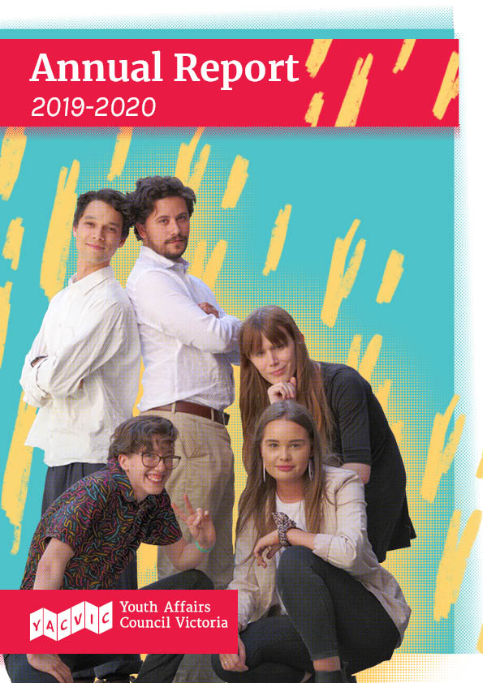
YACVic works across the entire state of Victoria. YACVic’s head office is based on the lands of the Kulin Nation in Naarm (Melbourne). We also have offices based on the lands of the Gunditjmara Nation in Warrnambool, and on the lands of the Wemba Wemba, Wadi Wadi and Weki Weki Nations in Swan Hill.
YACVic gives our deepest respect to Aboriginal and Torres Strait Islander Elders past, present and emerging for their wisdom, strength, support and leadership.
We acknowledge all Aboriginal and Torres Strait Islander people in Victoria, and stand in solidarity to pay respect to the ongoing culture and continued history of all Aboriginal and Torres Strait Islander Nations.
YACVic is the leading advocate for young people aged 12–25 in Victoria. As a peak body, we work closely with young Victorians and the sector that supports them to deliver effective advocacy, events, training, resources and support—so that young people can live their best lives. We’re driven by our valued members and their vision for a positive future for young Victorians. YACVic is an independent, for purpose organisation with core funding from the Victorian Government’s Office for Equality and Youth. We pursue social justice by maintaining a focus on those young people in our community who face disadvantage or marginalisation.
We provide additional targeted advocacy through our key services, YACVic Rural and the Youth Disability Advocacy Service, and proudly auspice and support our partner agency, the Koorie Youth Council.
Level 2, 235 Queen Street Melbourne, Victoria, 3000
www.yacvic.org.au
info@yacvic.org.au

Chairperson’s Report

Youth advocacy in a year like no other

It goes without saying that this has been a year like no other, and the board and I could not be prouder of how YACVic has supported young people and the sector during this strange and challenging time.

In a year where our members have faced bushfires and COVID-19, YACVic has played a central role in keeping young people’s needs and experiences on the public and political agenda, and supported the youth sector to address them in these unprecedented times. We have also helped interpret all the policy changes and restrictions for young people.
We have strengthened our role and reputation as a connector, coordinator, and collaborator, and we have not only stabilised, but grown despite the pandemic.
In the wake of such upheaval, it is easy to forget that we launched our strategic plan late in 2019. I am pleased that the plan has remained extremely relevant as we have pivoted to face these new challenges. Since then, we have supported young people from across the state: from bushfire affected communities in Eastern Victoria to young people experiencing homelessness in Warrnambool. We have tackled important issues like mental health, income support, and lowering the voting age—to name just a few.
Of course, we have also faced a significant change of our very own as we bid a bittersweet farewell to VicSRC. We are proud to have supported VicSRC for 17 years. Our partnership has been a strong and fruitful one, and we are proud of the way they have grown considerably with us, always keeping the ideas and experiences of students at the centre of their efforts. We look forward to continuing to work in partnership; sharing skills and knowledge, supporting each other to amplify young voices and enable young people to lead and shape their communities.
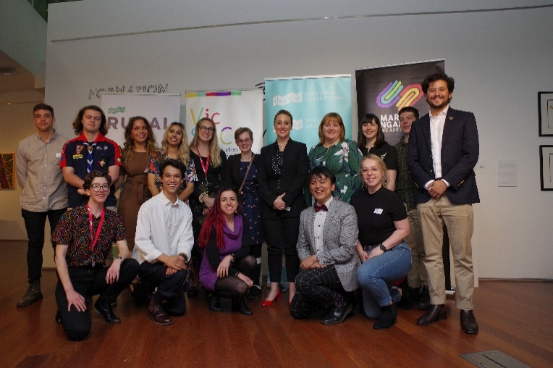

Image caption: Chairperson Kerrie Loveless, CEO Katherine Ellis, and The Hon Gabrielle Williams MP with young people at the 2019 AGM

Summarising the achievements of this year, once again, gives me pause to recognise and appreciate the passion, skill, and commitment of our team. This has not been an easy year. Like so many people, they have managed the stressors of COVID-19: Juggling work, parenting and teaching; working from bedrooms, lounge rooms, and laundries; overcoming technical difficulties; and all the while working tirelessly for you, our members and young people across Victoria.
On behalf of the board, I want to offer my sincere gratitude to YACVic for their efforts, and to Katherine for her expert leadership of such a wonderful team. I am confident that YACVic will continue to play a crucial role as we support young people and youth workers across Victoria move towards a post-COVID-19 world.

—Kerrie Loveless, Chairperson

Board of Governance
- Kerrie Loveless, Chairperson
- Natasha Ritchie, Deputy Chairperson
- Peter Glynn, Treasurer
- Becc Brooker
- Katerina Dandanis
- Kareem El-Ansary
- Tessa Jenkins
- Jill McCabe
- Alexandra Neill
- Georgina Oxley
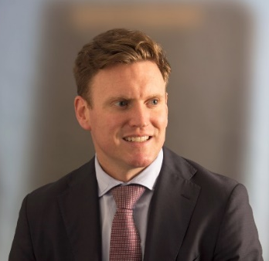
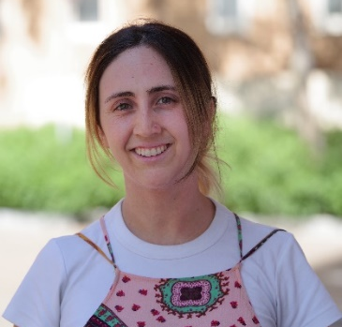
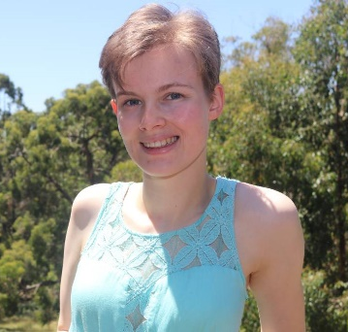
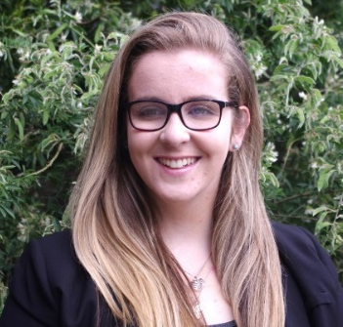

CEO’S Report

Creating hope, stability, and opportunity

We could never have foreseen a year like 2019-20 for the young people of Victoria, or for YACVic.

It was really a year of two parts. The first six months were a period of rejuvenation and renewal, with a new strategic plan launched at the AGM in November, and many new staff on board and really starting to kick goals. Then came January and the bushfires, which slammed the lives and communities of so many young people in the east of the state, only to be quickly followed in March by the COVID-19 pandemic, a generation-defining crisis which continues to evolve as I write.
The demands on YACVic as a peak body, and the work of our key partners and agencies KYC, VicSRC, YDAS and YACVic Rural, have been significant. But I am very pleased to report that we have met the challenges, and supported and advocated for young people and the sector, to the best of our ability and resources. This has included a sharp increase in communications, ‘Huddle’ connection events and information webinars; moving programs and events online, especially KYC’s successful Online Koorie Youth Summit; analysing and advocating about the impact of COVID-19 on young people, including VicSRC’s important Learning from Remote Learning Report; and establishing a major partnership with Bushfire Recovery Victoria to ensure youth participation in bushfire recovery.
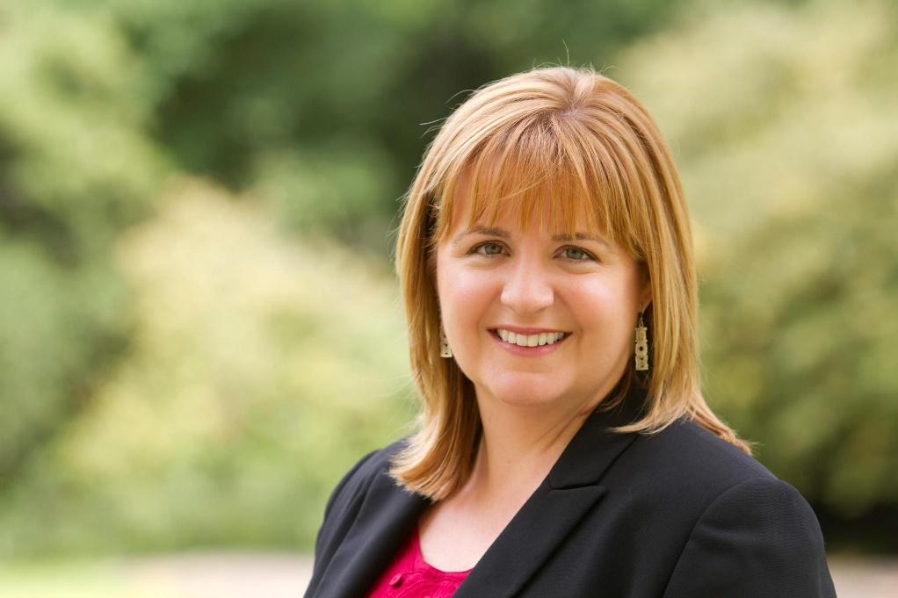

Image caption: CEO Katherine Ellis

We have also continued with ‘business as usual’ in many ways, with substantial policy advocacy and sector collaboration on mental health, youth justice and housing security, including a significant report on Youth Homelessness; a three-year extension of YDAS’s Emerging Young Leaders program; expanding our Youth Participation Network to over 300 members; strengthening the HEY partnership and grants program; and broadening our work on youth participation beyond the immediate youth sector. We also increased our advocacy and media on issues like lowering the voting age, raising the rate of Youth Allowance, and raising the age of criminal responsibility.
A milestone event of 2019/20 saw our partner agency VicSRC graduate from its YACVic auspice to become an independent incorporated entity, continuing to fight for student voices to be heard at the centre of education decision making. Huge congratulations to VicSRC—we wish you all the best, and look forward to a continued strong collaborative relationship.
I want to pay tribute to the Youth Sector and YACVic’s own workforce, who have done outstanding work this past year under extremely difficult circumstances to support and advocate for young people right across Victoria. Your efforts have been so important to sustaining hope, and creating stability and opportunities vital to young people now and in the coming years. Thanks also to the Victorian Government and other funding partners for your great support and collaboration this past year.
Finally, and most importantly, I want to acknowledge the resilience and courage of the many young Victorians who have been disproportionately impacted by the bushfires and the COVID-19 pandemic, with job losses, education disruption, social isolation, mental health issues, and so many other challenges. It has been tough, and it is not over yet. We are here for you, and will continue to do our best to make sure that, as Victoria moves through and beyond this very difficult time, your needs, your perspectives and your ideas are respected and embraced in the recovery and re-imagining of Victoria.

—Katherine Ellis, CEO

Bla(c)k Lives Matter

YACVIC Board Statement on Racial Inequality and Injustice

We, the YACVic Board, collectively and passionately support the ongoing efforts made to, yet again, highlight and address issues around racial inequality and black deaths in custody in Australia. We unequivocally understand that Bla(c)k Lives Matter.

We believe in a fair and just society and will continue to strive towards it, amplifying the voices and stories of all young people, including those who face marginalisation. To be actively anti-racist is our work, and it is the work of our members.
Since the 1991 Royal Commission into Aboriginal Deaths in Custody, at least 434 further deaths in custody have been reported, with no convictions. This is despite evidence that in many cases procedures were not followed, and the required care not provided. The Royal Commission recommendations sought to reduce the incarceration rates of Aboriginal and Torres Strait Islander people, yet nearly 30 years on disproportionate representation remains.
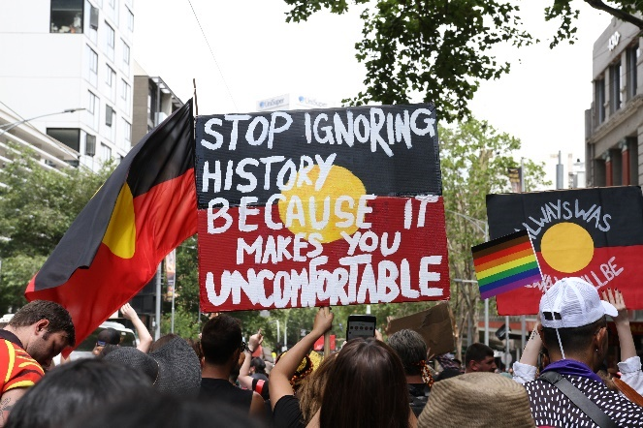

Image captions: Melbourne Parliament House, January 26, 2020

We stand in solidarity with all Aboriginal and Torres Strait Islander people, and all people of color who seek to tackle the systemic racism in our country. We applaud those working tirelessly to change minds, change laws, change systems. We call on all governments to work collectively with communities to address inequalities and to enable true self-determination.
The conversations happening in homes, in the streets and in public are difficult, and they can be uncomfortable, but they are vital. We share a vision of our state and our country as safe, fair, and equal.
This statement demonstrates our support, but we commit to more than just words. Racial justice is an endurance sport, and YACVic is committed to the long game; beyond the trending hashtags, we commit to continue to do the work, to support and elevate Aboriginal and Torres Strait Islander people and people of colour in our organisation and networks, and proactively encourage the allies in our organisation and networks to continue to unlearn, show up and be active.

—YACVic Board

"Change is possible when you tell the truth, or when you listen deeply and enable truth to be brought to the surface. The more truth is told, the more support for truth grows in this nation. Truth-telling can shift expectations and perspectives.

“Truth-telling is hard work. But the power of truth-telling is in its process, where grief makes way for healing, and healing unites people who once were divided. It is my experience that behaviours and actions change when people come to know another reality."

- June Oscar, AO

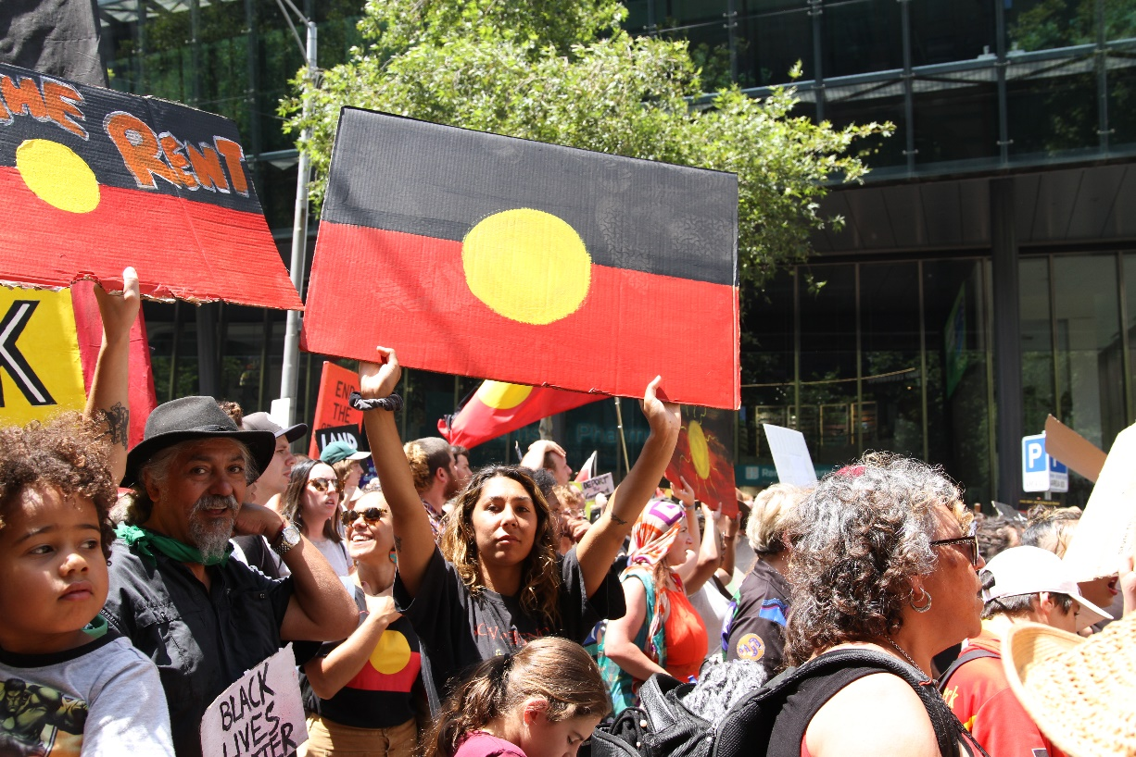

Young Thinker In Residence

The Young Thinker in Residence program provides a platform for a young person to express views on issues they care about.

The 2019 YACVic Young Thinker in Residence, Levi McKenzie-Kirkbright, was sponsored by KYC. Levi is a proud young Aboriginal man with ancestry from Gadigal, Yuin, Worimi, Biripi, and Gamilaraay, and he belongs to the La Perouse Aboriginal community in Botany Bay, Sydney. Levi produced an essay titled ‘Sovereignty: A Way Forward’.
Levi said, "I decided to publish one essay (out of many) that I wrote during my time as Young Thinker that I think will challenge and elevate the thinking of other young Aboriginal people the most.
"The question at the core of this essay is ‘What does sovereignty mean to us as young people?’...I want my essay to allow people to give themselves permission to really critically analyse the important concepts which are crucial to our future as Aboriginal and Torres Strait Islander people."
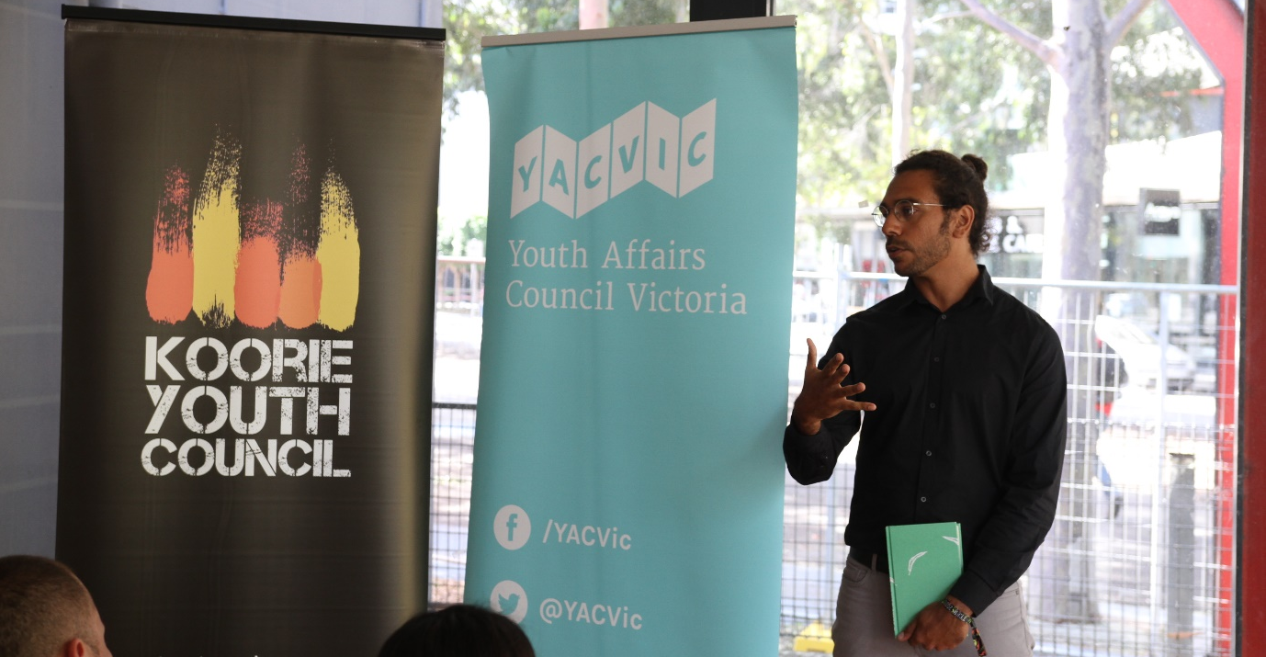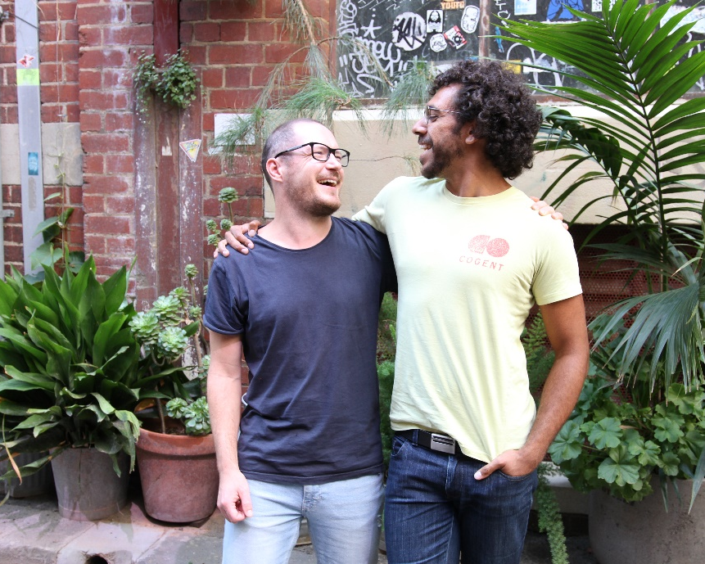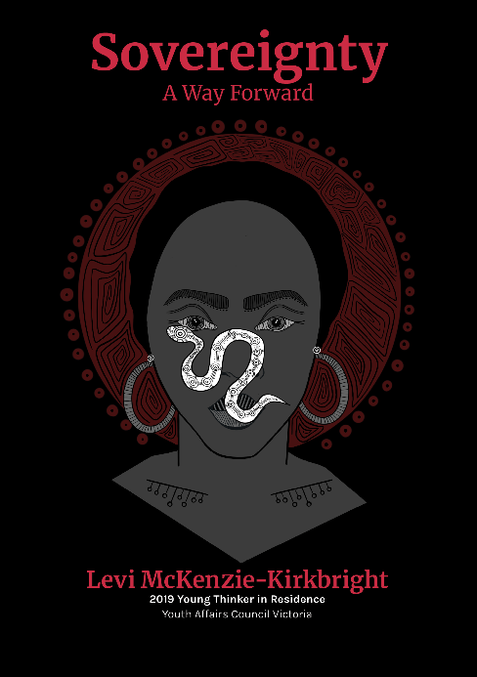
Read Levi’s powerful essay on Sovereignty here.

Image caption: TOP: Levi McKenzie-Kirkbright speaking at the launch of his essay. LEFT: Levi and Sam Champion, YACVic’s Participation and Development Manager. RIGHT: the cover of ‘Sovereignty: A Way Forward’ with art by Cheyenne Rain Travis, a Yorta Yorta and Wemba Wemba woman from the Day-Walker family who also recognises and respects her mother’s connections to England.

Where we’ve been

Where we’ve been in 2019-2020

YACVic
- Bright
- Brunswick
- Carlton
- Coburg
- Collingwood
- Dandenong
- Footscray
- Frankston
- Heywood
- Kingston City
- Kyneton
- Macedon Ranges
- Maribyrnong
- Marysville
- Melbourne CBD
- Myrtleford
- Parkville
- Portland
- Robinvale
- Shepparton
- South Melbourne
- Towong
- Wangaratta
- Wodonga
- Woodend

YACVic Rural
- Ararat
- Avoca
- Bairnsdale
- Ballarat
- Bendigo
- Boort
- Boundary Bend
- Camperdown
- Charlton
- Cohuna
- Echuca
- Hamilton
- Kerang
- Lake Boga
- Leitchville
- Mallacoota
- Manangatang
- Mildura
- Orbost
- Robinvale
- Sale
- Swan Hill
- Terang
- Warrnambool
- Woorinen
- Wycheproof

YDAS
- Ballarat
- Bulleen
- Cranbourne East
- Darebin
- Frankston
- Geelong
- Knox
- Macleod
- Maribyrnong
- Melbourne CBD
- Melton
- Mildura
- Mooney Valley
- Scoresby
- Werribee
- Williamstown
- Yarra

KYC
- Bairnsdale
- Camp Jungai
- Gippsland
- Geelong
- Healesville
- Heywood
- Newborough
- Shepparton
- Swan Hill
- Warrnambool
- Wyndham Vale

VicSRC
- Bulleen
- Castlemaine
- Dandenong
- Diamond Creek
- Dromana
- Eaglehawk
- Hoppers Crossing
- Kilmore
- Lara
- Melbourne
- Torquay

2019-2020 Organisational Members
- Anglicare Victoria
- Ardoch Youth Foundation
- Association for Children with a Disability
- Australian Catholic University - Youth Work
- Bass Coast Shire Council
- Bayside City Council Youth Services
- Benalla Rural City Council
- BGT
- Blue Light Victoria
- Boroondara City Council
- Brophy Family & Youth Services Inc
- Campaspe Shire Council
- Catholic Care Melbourne
- Centacare Ballarat
- Centre for Excellence in Child and Family Welfare
- Centre for Excellence in Rural Sexual Health
- City of Ballarat
- City of Casey
- City of Darebin
- City of Greater Dandenong
- City of Kingston
- City of Monash Youth Services
- City of Port Phillip
- City of Whittlesea
- Colac Area Health
- Corangamite Shire Council
- East Gippsland Shire Council
- Family Access Network Inc.
- Fusion Australia
- Girl Guides Victoria
- Glenelg and Southern Grampians LLEN
- Glenelg Shire Council
- Golden Plains Shire Council
- Hepburn Shire Council
- Hume City Council Youth Services
- Innovation Youth Centre
- Job Watch Inc.
- Knox City Council Youth Services
- Les Twentyman Foundation
- Macedon Ranges Shire Council
- Mansfield Shire Council
- Maribyrnong City Council
- Melbourne City Mission
- Mental Health Victoria
- Mildura Rural City Council
- MOIRA
- Moira Shire Council
- Moonee Valley City Council
- Moorabool Shire Council
- Moreland City Council
- Mount Alexander Shire Council
- Murrindindi Shire Council
- Save the Children
- South East LLEN
- South Gippsland Shire Council
- Squash & Racquetball Victoria
- State Library Victoria
- Stonnington Youth Services
- Strathbogie Shire Council
- SYN Media
- The Bridge Youth Service
- The Drum Youth service
- UN Youth Victoria Inc
- UnitingCare
- VCOSS
- Victoria University - Youth Studies
- Victorian Local Governance Association (VLGA)
- Volunteering Victoria
- WAYSS
- Wellington Shire Council
- Whereto Research
- Whitehorse City Council
- Whitelion Youth Agency
- Yarra Ranges Council
- Youth Action
- Youth Affairs Council of Western Australia (YACWA)
- Youth Affairs Network of Queensland (YANQ)
- Youth Coalition of the ACT
- Youth Live4Life Inc
- Youth Network of Tasmania (YNOT)
- Youth Research Centre
- Youthlaw
- YSAS Pty Ltd

A tribute to VicSRC

VicSRC has become a fierce, relentless and outstanding advocate for students. Huge congratulations to VicSRC on becoming an independent organisation, taking flight from the YACVic nest to continue their vision for education that is flexible, relevant, and includes

all students in the decisions that affect them.

"VicSRC is the only student led education based advocacy organisation in Australia and has continued to amplify and empower students to actively participate in decisions made about their education since it began."

— Nina Laitala, VicSRC Executive Officer since 2017

"After decades of students calling for representation, the VicSRC has worked tirelessly and successfully for over 15 years to enable students in Victoria to sit alongside teachers, parents, school leaders and community members in decision-making at school and state levels. Because of the VicSRC, student voices can to be heard; student agency enacted; student participation in decision-making a growing reality."

—Roger Holdsworth, VicSRC critical friend

"VicSRC has developed a strong reputation in the education sector for promoting and including the voices of students in education, and building the capacity of educators to do likewise."

—Katherine Ellis, YACVic CEO.

VicSRC Timeline:
- 1980s: Victorian students attempt to establish a state organisation to represent students.
- 2001: 300 students meet at Paving the Way Conference to establish the Victorian Secondary Students Network and elect the first Student Executive.
- 2002: Victorian Government withdraws support and funding.
- 2003: Students regroup as VicSRC and create VicSRC’s statement of aims for students. YACVic offers office space and support for VicSRC.
- 2005: VicRC hosts its first annual Congress, a single day event involving over 100 students from across Victoria.
- 2007: VicSRC hires its first Co-ordinator James Tonson. 2007 Congress elects a new Student Executive.
- 2008: Victorian Government Department of Education provides funding agreement to support VicSRC that also retains student independence.
- 2009: Kate Walsh is appointed as the new Co-ordinator for four years.
- 2013: Krista Seddon becomes the new Co-ordinator. Teach the Teacher program is developed.
- 2016: VicSRC, YACVic and YDAS push for changes to school expulsions and more accessible and inclusive education.
- 2017: Nina Laitala joins as the new Co-ordinator. VicSRC Strategic Plan 2017-2020 is launched, DET announces students on all government school councils
- 2018: VicSRC staff grows to eight
- 2019: VicSRC moves into independent office space, VicSRC Student Executive Committee elections move online, and VicSRC appoints inaugural board
- 2020: VicSRC officially incorporates and becomes an independent organisation.

YACVic Core Report

Youth participation and sector development

Like everyone else, we have had to adapt our work for exclusively online delivery, which has come with huge challenges and successes.

Moving to online delivery of our training and sector development work has been a huge piece of work for YACVic. In the space of a few weeks in April we adapted our training workshops in order to run them exclusively online. This came at a time when Victorian youth services were responding to new restrictions, being put on hold, or shutting down entirely. We found that our workshops were a way teams could come together and realign around important topics such as ethical practice or youth participation in a positive way that took them out of conversations that were revolving exclusively around coronavirus.
This year has seen us developing three new training modules for young people, which are an exciting new addition to our workshop offerings. We now offer training on Advocacy 101, Workshop Facilitation Skills as well as Media and Interview Skills. These training sessions have received great feedback and can all be delivered online whilst restrictions continue.
The move to online convening of workers prompted us to look at the support we were offering the sector and we noticed gaps to be filled. Using our experience in running community of practices such as the Youth Participation Practice Network (YPPN) and the Healthy Equal Youth (HEY) Partners, we looked to create online spaces to bring the sector together. These spaces were for sharing challenges and solutions as well as providing opportunities for YACVic to hear directly from the sector. We called them ‘Huddles,’ as we wanted to create the feeling of coming together despite the physical distancing rules that were keeping us all apart.
Youth Participation is a key focus across the organisation and we are proud of the varied ways young people are threaded throughout our organisation, including supporting us to employ the best staff as part of our HR Team, working groups such as our working group on mental health that led our work on the Royal Commission into Victoria’s Mental Health System, blog posts, media appearances and mentions, focus groups, consultations and co-design, workshop design and facilitation and lots more besides. A real stand-out in our youth participation work this year has been Levi, our incredible Young Thinker in Residence, sponsored by the Koorie Youth Council. Levi researched and consulted with young people and across the Aboriginal Community sector, and as a result of his thinking wrote a passionate and provocative essay on Sovereignty and what it means to him and other young Aboriginal and Torres Strait Islander People.

Key Stats
- 13 Youth Participation 101 & Code Training sessions for workers with 246 participants
- 94% of participants were satisfied or extremely satisfied with the training
- 9 Advocacy 101, Workshop Facilitation Skills & Media and Interview Training sessions for young people with 94 participants
- 8 Youth Participation Practice Network events with 318 participants (249 online during COVID-19 restrictions)
- 190 Youth Participation Opportunities
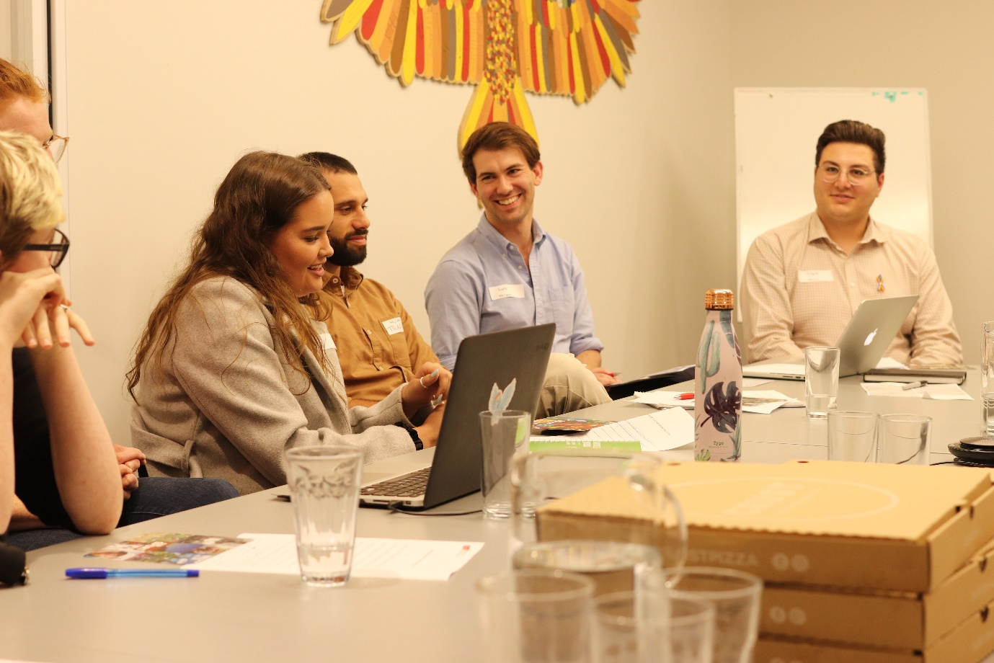

Rural Projects

Marram Nganyin

Marram Nganyin, meaning ‘we are strong’ in the Woiwurrung language of the Wurundjeri people, is an Aboriginal youth mentoring program supported by a partnership between YACVic, Koorie Youth Council (KYC)and the Victorian Government. YACVic and KYC assist five Aboriginal community organisations in different parts of the state to design and deliver local mentoring opportunities for Aboriginal young people (12–25 years old).
This year, Marram Nganyin supported organisations to further improve and develop their mentor programs with 56 separate and tailored support sessions and 12 field visits. Following the devastating bushfires which severely impacted East Gippsland, we supported our mentor and partner organisation GEGAC to hold two community healing events focused on recovery. After COVID-19 restricted our movements this year, we hosted two partner forums and initiated a new online yarning huddle to provide support for on-the-ground mentors.
Marram Nganyin has this year, commenced an in-depth, strength-based mentor program review with all the partners to further build on the outcomes of the 2019 program evaluation.
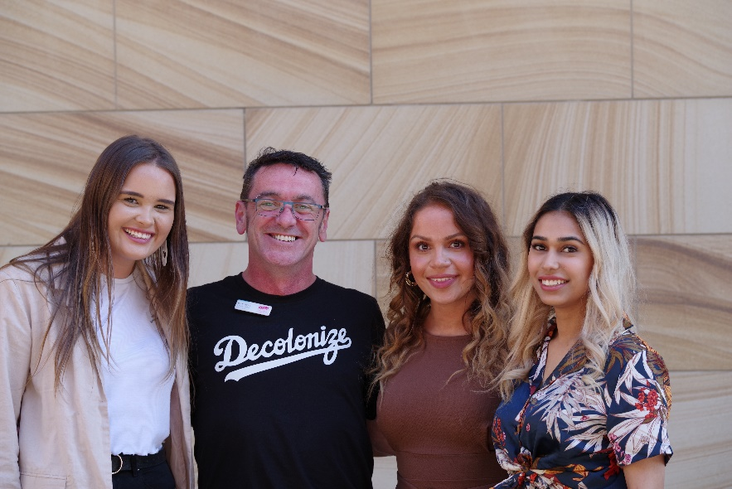

Healthy Equal Youth

YACVic continued to deliver the highly successful HEY (Healthy Equal Youth) program on behalf of the Victorian Government.
We coordinate the HEY Partners, a Community of Practice of 16 community and health organisations that support LGBTIQA+ young people in place-based settings across Victoria. In addition to regular quarterly meetings and professional development training, this year we supported the group via fortnightly, one-hour, online meetings known as ‘HEY: Breaking the Isolation.’ The HEY Partners collaborated with YACVic to produce policy submissions on the proposed Religious Freedom Bill, and on the development of the Victorian Government’s LGBTIQ Strategy.
YACVic hosted the Victorian Commissioner for Gender and Sexuality, Ro Allen, at our annual HEY Day which included presentations and four topic-based workshops for youth workers and LGBTIQA+ young people. In June 2020, YACVic hosted Talking It Up, an LGBTIQA+ sexual health research forum. This online forum was well received and updated participants on new research for young gay and bisexual men, and also data from the Australian Trans and Gender Diverse Sexual Health Survey produced by UNSW.
YACVic also administers the HEY Small Community Grants Program, which support community organisations to undertake wellbeing promotion and community engagement activities to support LGBTIQA+ young people. There were 31 applications to Round 9 of the grants (2019-20). Of these, 15 applications were metropolitan, 10 were regional, 5 were state-wide services, and one was national. The applications totalled $372,633 vying for a grant pool of $100,000. Applications were assessed by a committee which included four young people. Eleven applications were selected for funding totalling $106,000 – three metropolitan, six rural and two state-wide.
The HEY Partners want to thank the VicSRC for continuing to prioritise LGBTIQA+ student voice over many years. VicSRC’s advocacy has improved the quality of life of many LGBTIQA+ young people who felt disenfranchised or were discriminated against in the education system. VicSRC’s dedication and empowerment of student rights has greatly improved the educational experiences for many, many young people and they have been proud supporters of all of us at HEY. We wish them well and we look forward to continuing the strong links we forged whilst they were part of YACVic.
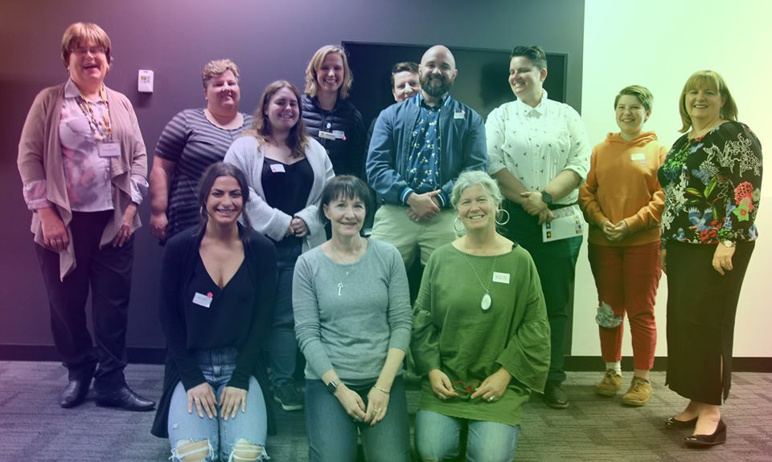

YACVic Core Report

Policy and advocacy

We worked with young people and the youth sector during an incredibly difficult year to ensure that young people are at the centre of decision making in Victoria.

We continued our focus on mental health and supported young people to directly share their ideas and solutions with the Royal Commission into Victoria’s Mental Health System. We also launched the Youth Mental Health Community of Practice in partnership with Orygen and provided opportunities for young people and the youth sector to connect, share expertise and speak directly with decision makers.
We worked with young people to end youth homelessness in Victoria. Our report, Ending Youth Homelessness: The Solutions from Young People centres the voices, experiences and solutions of young people with lived experience of homelessness. Through this work we were able to connect young people to the Victorian Parliament to directly share their experiences and solutions.
We also supported young people to meet with decision makers and developed new research to highlight the importance of young people’s involvement in government. We continued our work to lower the voting age to ensure that young people are heard and valued in Victoria. To do this we supported young people to meet with their local representative and make their case for a more representative democracy. We also completed the first major analysis of youth research, policy and reports in Victoria. This work identified that all government departments and portfolios are relevant to young people and must include young people in decision making.
The COVID-19 pandemic dramatically changed the lives of young people in Victoria. We worked rapidly to connect with young people to provide support and advocate for a better future. We published a widely cited series of surveys that identified the immediate impact for young people and the youth sector. We also hosted online events and published resources to support young people to navigate the pandemic and recovery.
We would also like to thank the students and volunteers who generously worked with us to make Victoria a better place for young people: Albert Giglia, Hannah Ewing, Isabelle Mountford, Mia Frederiksen, Miranda Watson, Lawrence Rogers, Sabrina Choo and Zachary Campbell.

Key Stats
- 647 young people and workers involved in developing policy
- 15 submissions, reports and research publications
- 23 unique opportunities for young people to get involved with decision making
- 22 meetings with parliamentarians
- 2 state government hearings
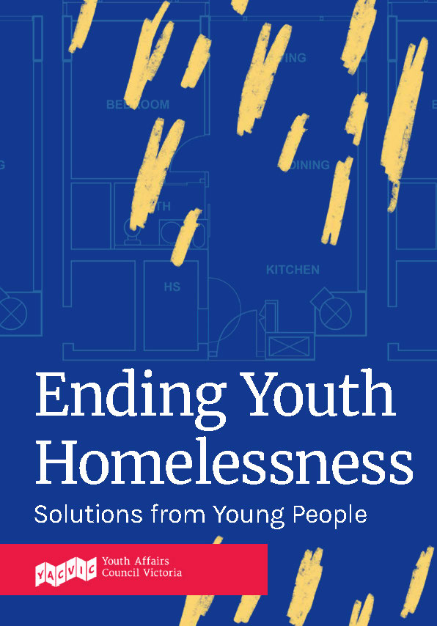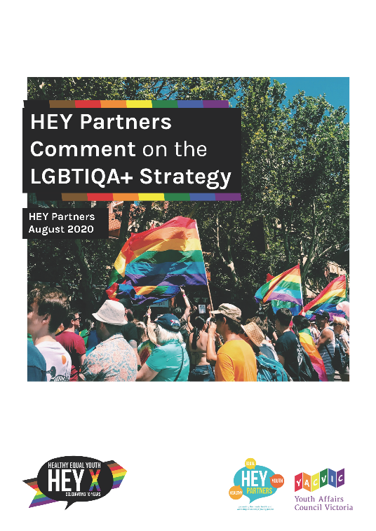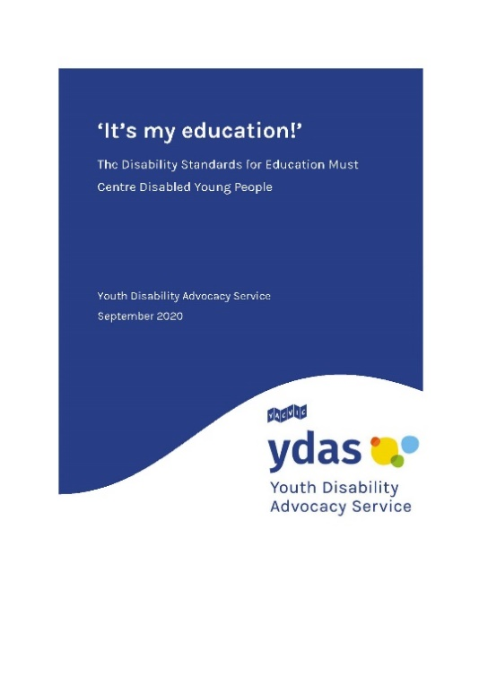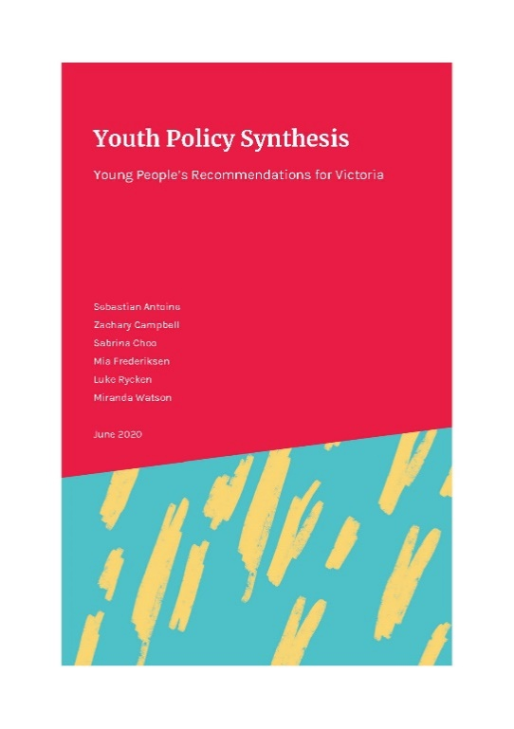

Ending Youth Homelessness in Victoria

Several of YACVic’s organisational members raised the issue of youth homelessness, especially how it plays out in regional and rural Victoria.

The policy team heard their concerns and jumped into action. At the same time, the Victorian Parliamentary inquiry into Homelessness was underway so we seized the opportunity to relay the concerns of our members and the voices of young people to that process to effect change.
In partnership with YACVic Rural, the Policy team designed and delivered two in-depth focus groups with young people with lived experience of homelessness in Warrnambool and Mildura. We also delivered a focus group in Melbourne that attracted participants from across metropolitan Melbourne and several who travelled in from regional locations. In these sessions we heard stories of struggle and resilience. The young people we spoke with demonstrated astounding maturity and a firm commitment to improving the housing system, so no other young person had to experience what they went through. The young people clearly identified key solutions that needed to be implemented to effectively address the youth homelessness crisis.
Our report to the Parliamentary Inquiry centres on the lived experiences and solutions of young people who have experienced homelessness. The report is a powerful and incisive call to action and clearly lays out the next steps for the Victorian Government. We launched the report on the steps of Parliament House, where the policy team and several of the young participants formally handed the report over to the Chair of the Legal and Social Issues Committee, Ms Fiona Patten, and the Deputy Chair, Dr Tien Kieu.
After handing over the report, the Inquiry invited YACVic to attend a Hearing to provide more evidence about youth homelessness and to discuss our solutions. We invited Cass who had been in one of the focus group sessions to join us at the Hearing. Cass delivered a powerful statement to the Committee about the lack of funding for homelessness services, pointed out the systemic issues in the Victorian private housing market and relished the chance to redirect the focus of the Inquiry onto the solutions identified by young people.
You can read the report on the YACVic website here.
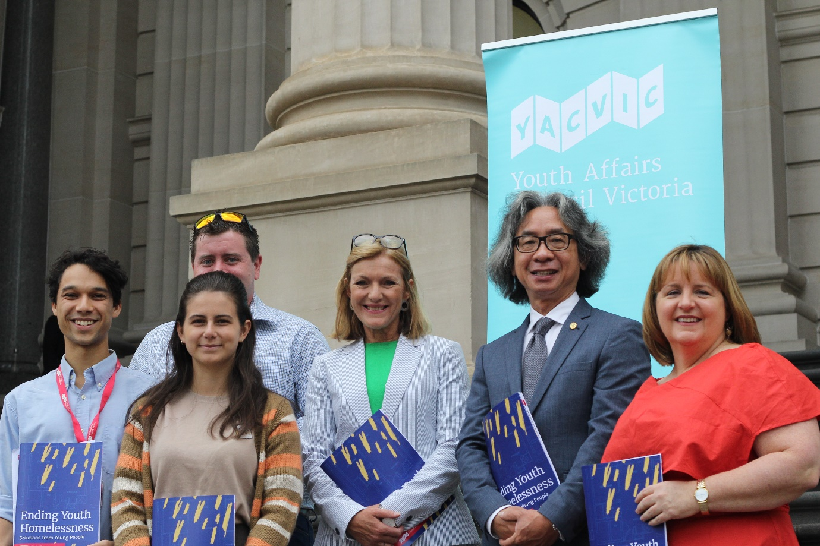

YACVic Rural Report

YACVic Rural

YACVic Rural has continued to strengthen and grow our support for place-based youth work over the last year.
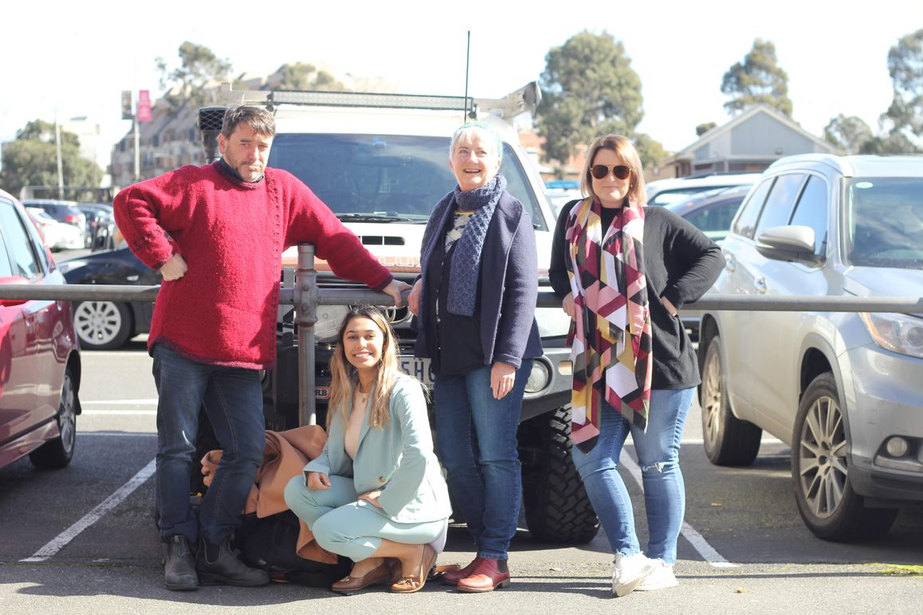
Following the devastating fires of early 2020, we developed a Youth-Focused Disaster Recovery Protocol to inform several agencies on best practice engagement with young people. Additionally, we repurposed our Activators project to focus on animal welfare related projects in bushfire affected communities, with sponsorship and support from RSPCA Victoria. We have also partnered with the Victorian Department of Education and Bushfire Recovery Victoria to develop a comprehensive program of consultations, skills building and support workshops and resource production in partnership with local communities and young people across eastern Victoria. This program will continue throughout 2020-2021.
Our advocacy related to homelessness across the Great South Coast saw a young person supported to give evidence to the Victorian Government Homelessness Inquiry, following our state-wide consultation on the issue. A regional young person also led and facilitated our ongoing work on the Royal Commission into Victoria’s Mental Health System, including a roundtable between young people and two of the Commissioners and a webinar update to the sector.
The Great South Coast piloted a new comprehensive Advocacy Workshop, codesigned and facilitated by two young people, which informed and upskilled locals across six LGAs and scored 100% participant satisfaction in the evaluation. We also continued to support multiple youth-focused initiatives in the region, including Beyond the Bell’s Youth Conversations.
The Southern Mallee continued to build on the outcomes of the Sexy and Safe Report by developing and delivering sexual health peer education and information sessions across the region. Two young people are currently being mentored to develop localised Sexual and Reproductive Health webinar resources for the Mallee. We developed a new partnership collaboration with the National Centre for Farmer Health to bring the Digital Story Telling Workshops: Thriving & Surviving to the Mallee. Funded by the Foundation for Rural and Regional Renewal, our Deadly Yarning and Learning Aboriginal Youth Mental Health workshops were stymied by COVID-19, but fortunately we were able to pivot to develop a series of yarning sessions for Aboriginal young people in Swan Hill, using peer support approaches to target mental health.
After having our wings clipped by COVID-19 lockdowns and travel restrictions, we initiated the Rural Huddles. The Huddles are online gatherings which use case studies and presentations to connect and support rural and regional workers across Victoria, with a diverse range of topics on youth participation and emerging issues impacting their practice.
We continued to increase our media and communications presence with 10 editions of Signposts produced this year, 10 articles in regional newspapers, a growing social media presence, and a variety of blogs on the YACVic website.

Key Stats
- 1 Youth Focused disaster recovery protocol tool developed
- 1 new online advocacy skills workshop developed and piloted with young people across 6 LGAs
- 480 young people engaged in workshops, advocacy, events, policy submissions and consultations.
- 4 online Rural Huddles attended by over 270 workers and young people post COVID-19 lockdowns
- 10 editions of Signposts produced with 331 new subscribers

How YACVic Rural empowers young people

Cassandra Prigg
From transitioning from high school into university, moving from a regional area to Melbourne, and trying to figure out what my place in the world might be, it’s now seven years later and I’m still proud to be a YACVic member and involved with their work in the Warrnambool region.
I have learned so much about advocacy, activism, governance, and community building through YACVic including practical skills like how to structure an agenda and take minutes, how to work in a team, and how to be an effective leader. A highlight this year has been working with the Policy team on a YACVic report on homelessness amongst young people in Victoria. As part of that work I was able to testify to the Victorian parliamentary inquiry into homelessness which was a great opportunity. Having the confidence to speak openly about my experiences to MPs (and even tell them when they got things wrong) was not something I would have been able to do if it weren’t for my involvement with YACVic.
My involvement with YACVic has reinforced my passion for social justice and building communities that are safe for and inclusive of young people. I am now planning on doing a master’s degree of Social Work partly because of my positive experiences of the youth sector as facilitated by YACVic.

Mia Rovere
Rhiannon reached out to me to be involved with the Sexy and Safe: Let’s Talk About It Youth Consultations on sexual and reproductive health. At the time I had 2 kids under 5 while juggling study and work, and the last 12 months had been a struggle after the birth of my second child.
Being involved with YACVic was very exciting and gave me something to look forward to that was ‘separate’ from work, study, or my family. It was amazing being able to use my lived experience to instigate positive outcomes for others and I could feel myself becoming more confident in myself as time went on.
We spoke with 130 young people and ran a series of consultations which has transformed into work in the region being done on a sexual and reproductive health strategy. It also had a positive impact on my mental wellbeing and allowed me to push myself past boundaries I didn’t know possible.

Jennifer Rowan
With the world turned upside down by COVID-19, I personally was facing much uncertainty, particularly in my financial situation. But thankfully after facilitating consultations across the Great South Coast for YACVic’s submission to the Royal Commission into the Mental Health System, YACVic Rural supported me to design and facilitate the first ever advocacy workshops ‘UCAN’ for the region. I am certainly much more confident in myself as a facilitator, which has seen me become a trained Mental Health First Aid Instructor.

YDAS Report

Youth Disability Advocacy

It has been another busy year for YDAS, with our individual advocacy service, systemic advocacy, and many projects.

Demand for our individual advocacy service rose significantly. YDAS provided advocacy for 26 disabled young people and had a full waitlist.
We have continued to provide systemic advocacy for disabled young people, ensuring that disabled young people can contribute to policy making and decision making that impact on their lives and futures.
Two noteworthy systemic advocacy projects include the YDAS response to the Royal Commission into Violence, Abuse, Neglect and Exploitation of People With Disability and the COVID-19 pandemic. Both saw the implementation of working groups consisting of disabled young people. These working groups have been working with YDAS and YACVic staff to determine the themes and issues that we will be prioritising in our systemic advocacy work and submissions.
Our projects continued to grow, with YDAS and Children and Young People Australia (CYDA) partnering to successfully receive three years of NDIS ILC funding to continue the highly successful Emerging Young Leaders Program. You can read more about the Emerging Young Leaders Program on Page 19.
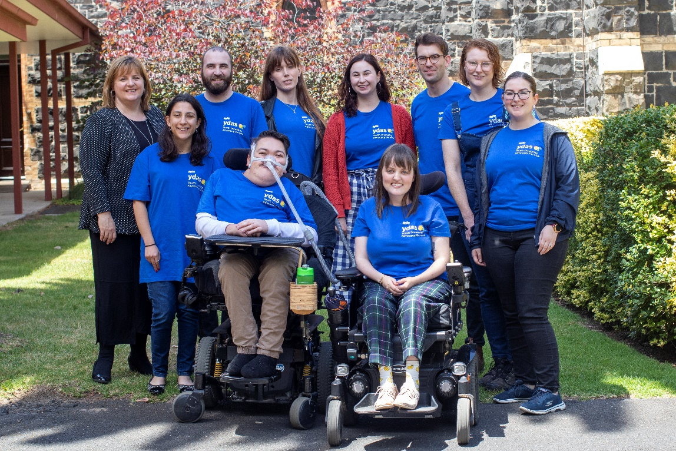

We began the ambitious project of adapting our popular Map Your Future workshops into a digital resource available online. The workshop was co-designed with disabled young people and will be available to all disabled young people in Victoria so they can access valuable information and resources to help guide their goal-setting and planning for their future.
Co-design and authentic representation continues to be central to YDAS, with all our projects and resources being developed by, with and for disabled young people. We are especially proud that of the 19 staff who worked with YDAS in 2019–2020, 15 identify as having a disability, and 11 were young people.

Key Stats
- 6,293 followers on Facebook
- 1,243 followers on Instagram
- 2,209 followers on Twitter
- 41 resources were developed by, with and for disabled young people
- 557 people participated in workshops and training delivered by YDAS
- 26 disabled young people received individual advocacy support

Emerging Young Leaders Program

Too many Victorians don’t see disabled young people as leaders. Our Emerging Young Leaders Program aims to change that.

As the first leadership program designed by and for disabled young Victorians, we’re paving the way for a new generation of disabled leaders.
This year marked a new milestone for the program, with 24 young leaders graduating.
They discovered their own leadership styles, developed their communication and teamwork skills, and set their own leadership goals.
Hearing from well-known leaders in the disability community, including author Carly Findlay and autism advocate Chloe Hayden, was a highlight.
Part of the success of our leadership program is that the team continues to support graduates and connect them with leadership opportunities after the workshops end.
Graduates have secured paid employment, won a film contest, participated in working groups and consultations, and contributed to state and federal strategies.
One graduate was mentioned in State Parliament for their efforts during the bushfires in Victoria. Others were on the co-design committee for the National Youth Disability Summit.
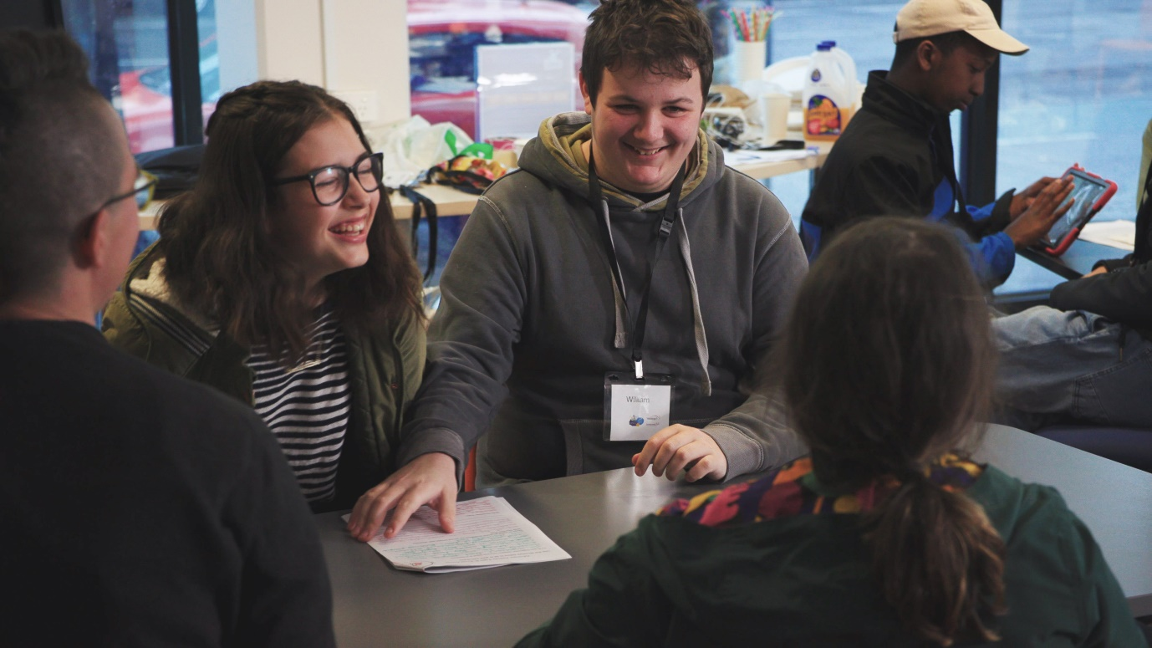
Graduates also play an important role in our organisation, as members of our Disability Royal Commission and COVID-19 working groups.
Government ministers, employers, influencers, and the wider community are seeing and hearing from these young leaders.
Every time our graduates speak up, influence, and lead, they are impacting who is seen as a leader.
Only 6% of Victorians have ever had contact with a boss with disability. Our leadership program is changing that statistic, one disabled young leader at a time.
"I was able to meet people who wouldn’t judge me, and I was able to become more confident." — Graduate
"The program is creating a network of impassioned, dedicated, thoughtful, and now more trained disabled young leaders." —Simon Green, EYL Co-ordinator

YDAS’ Bushfire Resources
Many disabled people were impacted by the bushfires in Victoria earlier this year. The disability community can be particularly vulnerable during emergencies due to a lack of accessible information, emergency housing, and vital equipment.
When we saw that disabled young people were missing out on important bushfire information, we decided to collate the accessible resources and information we found into one easy-to-read resource.
We created a blog post with resources specifically for disabled Victorians impacted by the bushfires. The blog post received over 800 views and almost 200 shares on social media, which shows the need for resources specifically for the disability community during emergencies.

KYC Report

Koorie Youth Council

Koorie Youth Council (KYC) would like to pay our deepest respect to people of the Kulin Nation and to all Elders past, present and emerging for their knowledge, wisdom and legacies that continue to drive us and for the continued support of all KYC projects.

Thank you to all the incredible young people and communities we work with for trusting us, as we collectively create our future where all of our people are able to thrive.
Despite the impacts of COVID-19, KYC experienced another incredible year of growth, as we continue to create culturally safe spaces and platforms for Aboriginal and Torres Strait Islander young people to connect, be proud, and discuss what is important. KYC continued to be a strong, active and influential voice in the Aboriginal and youth affairs policy space, amplifying our voices and aspirations for social change.
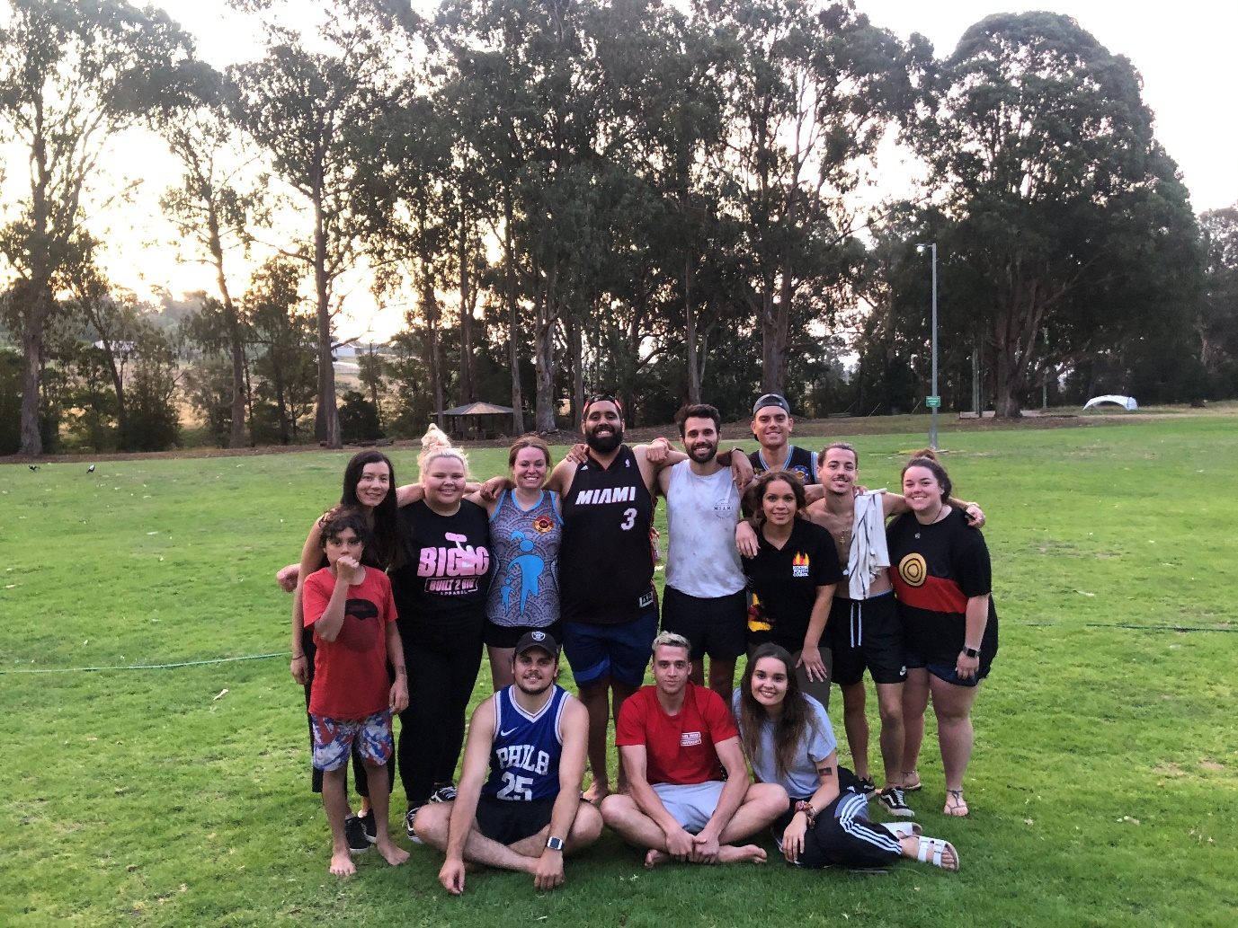
KYC’s Executive of Aboriginal and Torres Strait Islander young people aged 16-28 years living in Victoria, have been strong and engaged. The Executive and the staff meet regularly discussing what is important, guiding KYC’s work, embedded in youth participation. Throughout COVID-19 restrictions in Melbourne and Regional Victoria, the Executive and staff have held weekly catch-ups to connect virtually and support one another through these challenging times. Earlier in the year the Executive’s yearly regional camp was held at Camp Jungai, where Executive members gathered to connect with each other, as well as plan and discuss KYC’s major events, projects and programs for the coming year.
KYC and the Marram Nganyin Aboriginal youth mentoring program continue to support five Aboriginal organisations to deliver youth mentoring programs across the state. KYC’s youth participation network meetings and training sessions have provided opportunities for youth workers to share, learn, discuss and explore culturally safe ways to work with Aboriginal and Torres Strait Islander young people in Victoria.

Key Stats
- 8 Yarning circles connecting with young people
- 1 Healing Together event
- 2 Koorie Youth Participation Network meetings
- 4 Koorie Youth Participation Training sessions
- First ever online Koorie Youth Summit (4 weekly yarns with special guests, 4 yarning circles & 5 live performances)
- 6,411 Facebook followers
- 3,474 Twitter followers

The Online 2020 Koorie Youth Summit

Koorie Youth Council (KYC) hosted the 7th annual Koorie Youth Summit for the very first time online.

Since 2014, KYC has hosted the Summit to create a culturally safe space for Aboriginal and Torres Strait Islander young people to gather from across the state, to connect with each other, discuss what is important, be proud, learn, share and celebrate culture. The Summit is the largest gathering in Victoria created for and by Aboriginal and Torres Strait Islander young people aged 18-28 years.
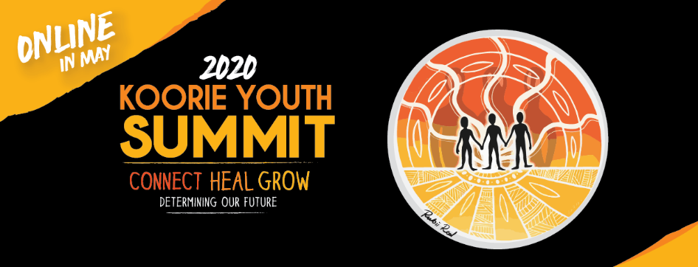
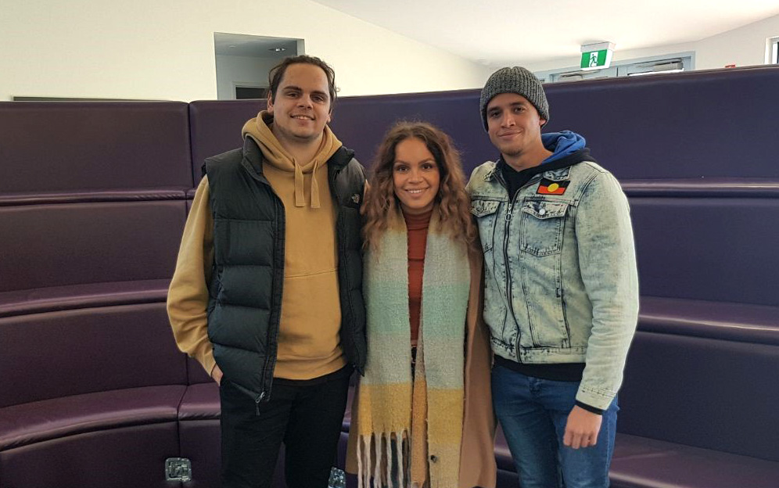
This year KYC adapted a selection of the Summit program for online over four weeks due to the impact of COVID-19. The theme for the Summit, ‘Connect, Heal, Grow: Determining our future,’ was selected by our Executive and is symbolic of our culture, our people and our history, as Aboriginal and Torres Strait Islander young people. The theme illustrated the collective wisdom of our past and present, as it supports us in determining our future.
Speakers and yarning circles featured an incredible line-up of inspiring Aboriginal and Torres Strait Islander community members. Highlights included Steven Oliver (Kukuyalanji, Waanyi, Gangalidda, Woppaburra, Bundjalung and Biripi, well known writer and actor) and international guest, Tunchai Redvers (Deninu K’ue First Nation, from the We Matter Campaign in Canada).
Yarning circles included a Treaty panel featuring the young members of the First People’s Assembly of Victoria, and yarning circles focused on themes such as wellness, and staying strong and connected during these uncertain times. First Nations owned and operated arts booking and program service, Still Here presented Medicine Songs featuring Aboriginal and Torres Strait Islander musicians and performers live via social media.
Thank you to all the speakers, musicians and young people who attended while staying at home keeping our mob safe and healthy.
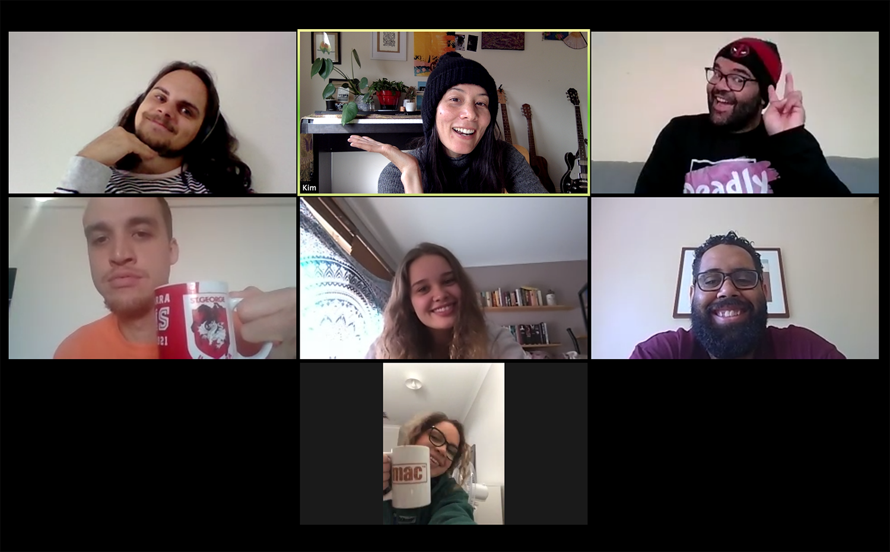

VicSRC Report

Victorian Student Representative Council

VicSRC kicked off the 2019-2020 year with a bang.

VicSRC started by hosting Congress 2019 and bringing together students from around the state to propose solutions to the issues they see in education. This year’s proposals were particularly well received, with the Politics 101 idea picked up first by media, then by the Minister for Education, and funded as a Civics & Citizenship project to help students better understand politics. This project is ongoing and will come to fruition at the end of 2020.
For the first time in the organisation’s history, elections for our Student Executive Advisory Committee were not held at Congress and instead moved online. This year an unprecedented number of Victorian students voted to elect their 2019-2020 Executive Committee, who immediately went to work meeting with stakeholders and advocating for reform in the education system.
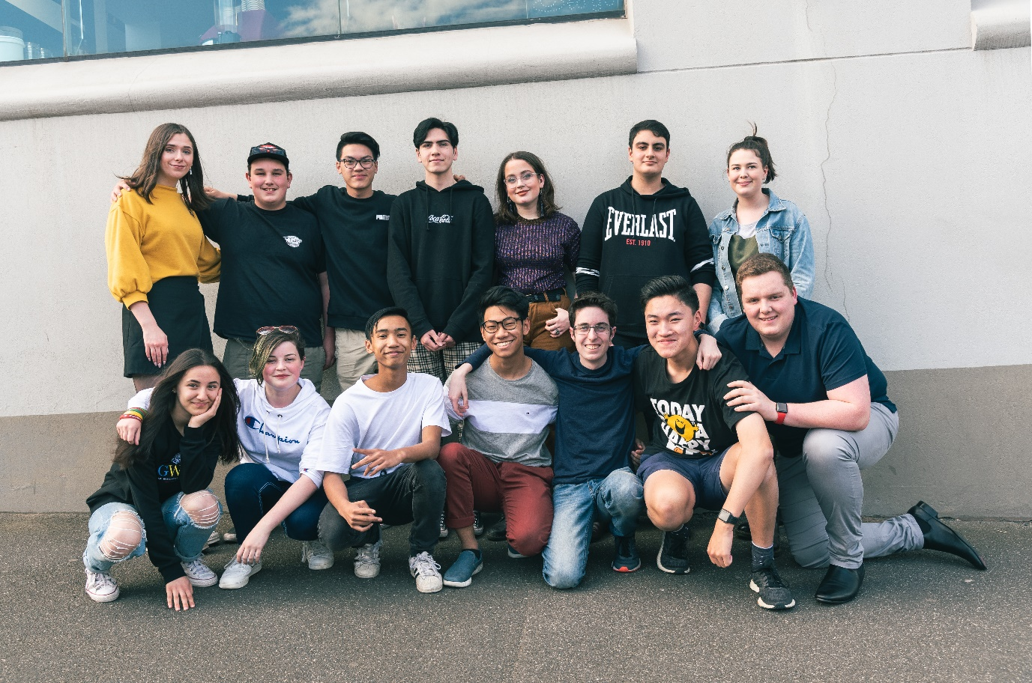
Despite the disrupted nature of early 2020—including rampant bushfires and pandemic—our staff, students, inaugural Board of Trustees and Strategic Plan working group were able to finalise the VicSRC 2020–2024 Strategic Plan. While working from home and in lockdown the Executive Committee and staff have continued to attend stakeholders meetings, appear on panels, bring student voices to traditional media, and advocate to the Department for Education and Training. A particular achievement is the Learning From Remote Learning report, which surveyed over five hundred Victorian students on their experience of remote learning. From the survey, six recommendations were made. Significant interest has been expressed by both policy makers and education stakeholders.
Our other key project for 2019-2020—supported by the appointment of a Board of Trustees and development of the strategic plan—was to incorporate as an independent entity. After fifteen wonderful years of support, VicSRC Ltd has spread its wings and left the YACVic nest to create its own path.

Key Stats
- 500+ reflecting on remote learning
- 24 media mentions and appearances by VicSRC students
- 497 visits to the Student Voice Hub in a single day, and over 8500 visits in the year
- 612 Student Community members
- 82 Stakeholder meetings and engagements attended by VicSRC Student Executive Advisory Committee members

VicSRC Translation Project

The COVID-19 pandemic has created one of the most disrupted years of education for students across Victoria.

Moving between remote and face to face learning has provided new challenges and opportunities for individuals and communities. Early on in the pandemic, VicSRC realised that while updated information on restrictions was shared regularly with schools, very little of this was communicated directly to students, and then rarely in language that was accessible.
VicSRC began translating the constantly changing information that affected students into Plain English, accompanied by graphics and formatted accessibly. This information was shared on the Student Voice Hub but was also widely accessed and shared by students, educators and parents all across Victoria through social media platforms.
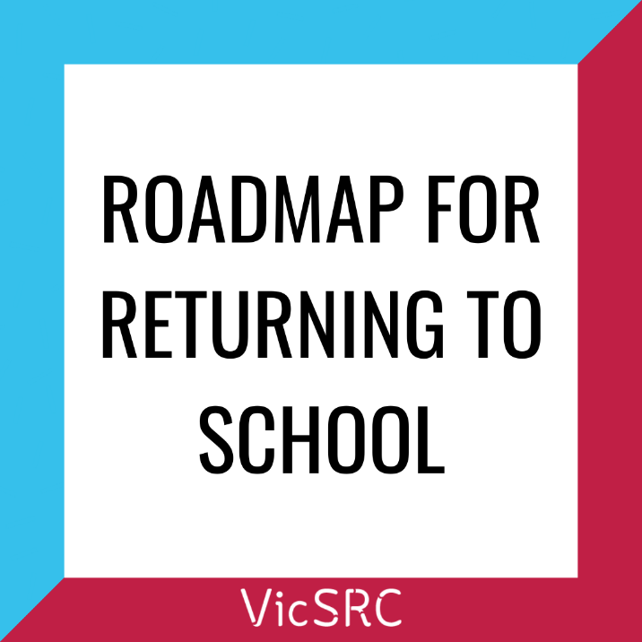
Not only did VicSRC focus on sharing important information at key junctures like the start of Term Two, the return to remote learning, and the start of Term Three, the Student Voice Hub blog also shared perspectives and advice for and from students. This ranged from tips for online learning, interviews with DET Directors, and students’ perspectives on returning to school. All of these posts were extremely successful, with more than half of the most visited posts for the 2019-2020 year featuring COVID-19 information. There was also a jump of 700% in average daily visits to the Student Voice Hub after the start of the translation initiative.
From the beginning of the crisis, VicSRC was also consistently advocating for specific communication from the Department of Education and Training (DET) to students about the pandemic. As a direct result of this advocacy, DET created a new, student-focussed page to support the mental health of students throughout remote learning, lockdown, and other challenges of the pandemic.
Students, schools and community organisations in Victoria have reported being particularly pleased with our translation project and communications. The project has been widely acknowledged as a regular source of clear information that was easy to read and simple to share with young people.
"VicSRC has worked to empower students across Victoria in a way that allows us to take ownership over our education, regardless of school." —Bri Hines, three time VicSRC Student Executive Advisory Committee member, 2020 Congress Coordinator.

Media and Communications

In a generation-defining pandemic, YACVic has empowered young people and the sector to use their voices and stories to advocate for change, and kept them engaged and informed.
YACVic’s media and communications has evolved, shifted and grown in its focus on storytelling and promoting the lived experiences of young people and the youth sector.
Our brand recognition has grown significantly both in traditional and new media. We were in the media 98 times this past year, including our first ever appearances on Triple J Hack, TODAY Show, and SBS World News, as well as prominent outlets such as The Age and the Herald Sun.
We reached an astonishing 1,109,703 people across our Facebook, Instagram and Twitter this year, and we made our first forays into TikTok to make sure we’re still with the times! Our first TikTok did incredibly well, reaching just under 50,000 views!
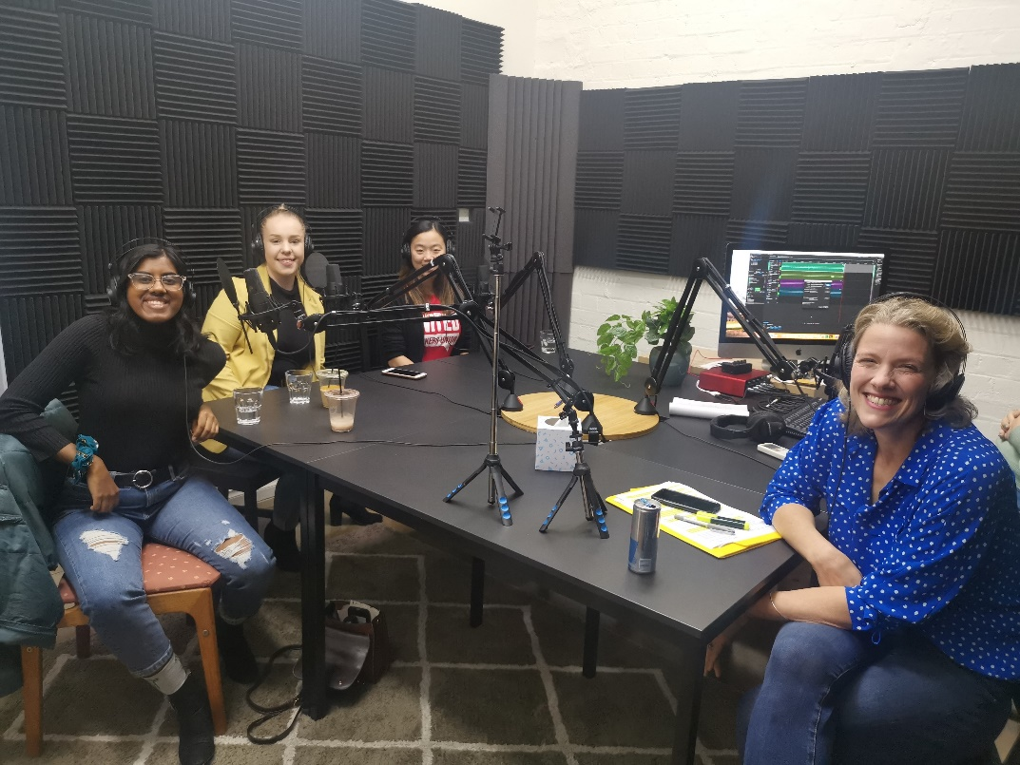

Image caption: Young members Nuriyah Haque and Tiana Sixsmith talk to Labor MP Clare O’Neill, Federal Shadow Minister for Innovation, Technology and the Future of Work, on her podcast "The Long View" about young people’s future

YACVic’s blog has continued to grow, with 26,955 views over the past year, a 100% increase on last year, showing the appetite and relevance for young people’s stories and the resources we create. We covered topics ranging from the need for change in the residential care system, co-designed youth mental health projects like Keep In Touch (KIT), and how young people could take action (and care) during the bushfires.
We also piloted and began delivering dedicated media training to support young people to advocate themselves on the issues they care about.
With the onset of COVID-19, YACVic’s communications kicked into full gear and focused on ensuring young people and the youth sector had the most up-to-date information when they needed it. Our resources on family violence during COVID-19 and rental support helped young people easily find services that were designed for them.
We look forward to continuously improving and showcasing how to ethically and impactfully engage and empower young people in our work.

Key Stats
- 156,712 total page views on the YACVic website.
- 6 national media appearances
- 98 mentions in the media across YACVic Core, YACVic Rural and YDAS
- 34 blog posts
- 1,109,703 people reached through our social media channels
- 3 media training sessions with 41 participants

Operations, People and Culture

Over the 2019-20 year we have built a strong, collegial, committed team.

We have settled into our new office space, and are finalising a few things to ensure it is as inclusive and accessible as possible, including technology to connect with staff and stakeholders who cannot be in the office, and natural light lamps for those who have sensitivities. To further make it a safe space, large Pride and Trans flags have been placed on our walls, along with other posters that encourage the use of pronouns and inclusiveness.
Fortunately, we upgraded our IT systems to MS Office 365 and cloud storage just before the onset of COVID-19, for more effective collaboration, confidentiality and data security. This allowed us to transition the whole organisation seamlessly to remote access when we had to close the office and have everyone work from home.
We have successfully brought young people into our own workforce. We have recruited several young staff, who are adding great value in their individual roles. In collaboration with VCOSS and Youth Projects, we also successfully hosted our first trainee, Ardu, who worked as our Office Assistant while undertaking a Certificate IV in Community Services, and now supports our Rural team. In addition, we trained five young people on YACVic’s interviewing processes, in collaboration with HAYS, who advised on applying for the position and the use of agency for young people. These young people now sit as active participants on interview panels for all our recruitment, to provide feedback on candidates from a young person’s perspective.
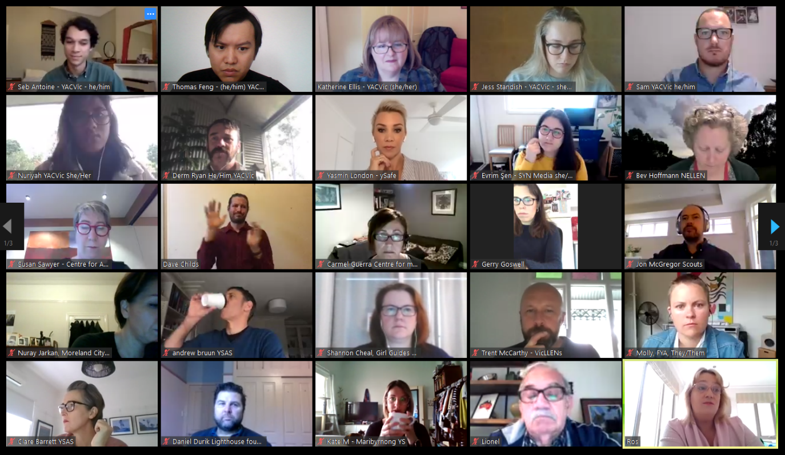

Image caption: YACVic meetings in 2020

We put in place a new Enterprise Agreement, which includes a requirement for professional development and health and wellbeing. A Health and Wellbeing Committee plans activities and shares information to promote staff’s wellbeing and self-care. Activities so far have included a Wayapa session run by Indi Clarke, an end of year celebration, creation of a YACVic Dodgeball team (appropriately named The Yaks) who won their first three games, and information about wellness and an e-voucher treat during the lockdown.
Despite everyone working from home for months, we have managed to stay well-connected and support each other by catching up regularly online, including for important events such as a Reconciliation Day Lunch where we had a deep conversation about what reconciliation means and the path forward. We are also still having our weekly quiz, minus the bagels!
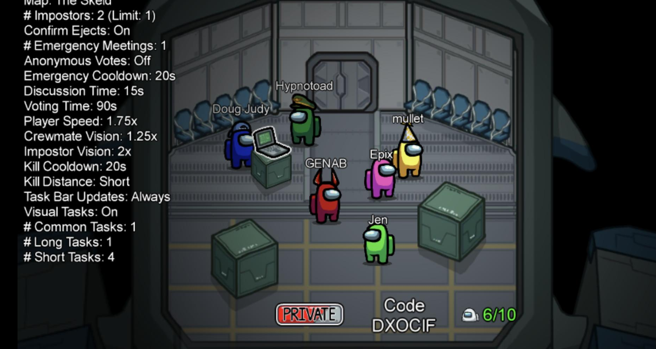

Image caption: YACVic, YDAS, and KYC honing their team building skills

2019-2020 Staff

Thank You

Thank you to the young people of Victoria for speaking up on issues that matter, getting involved, and making a difference in your communities.
Thank you to our members for sharing our vision of a positive future for young people, and for the work you do every day.
Thank you to our funders, partners and dedicated supporters for making this important work possible, and to our board and staff for your commitment, passion and expert guidance.
- Alyssa Jeffrey
- Banok Rind
- Benita Bruce
- Briar Rolfe
- Bridget Jolly
- Bree O’Dwyer
- Bryce Taylor
- Charli Ellis
- Cienan Muir
- David Trevorrow
- Derm Ryan
- Douglas Briggs
- Evrim Sen
- Fiona Campbell
- Hayley Allen
- Haley Zilberberg
- Hella Ibrahim
- Ian Johnson
- Indi Clarke
- Issy Orosz
- Jade Maiolo
- Jess De Mercurio
- Jess Standish
- Karen Walsh
- Katherine Ellis
- Kim Evans
- Kirsty Fromholtz
- Laura Pettenuzzo
- Levi Mckenzie-Kirkbright
- Leyla Quartermaine
- Luke David
- Luke Rycken
- Miia Tolvanen
- Mija Gwyn
- Nell MacColl
- Nikayla Bamblett
- Nina Laitala
- Nuriyah Haque
- Rhiannon Jennings
- Sam Champion
- Sebastian Antoine
- Shahnaz Rind
- Shaye Chalmers
- Simon Green
- Stacey Christie
- Steph Brenkovich
- Thomas Feng
- Tom Nice

Financial Report 2019-2020

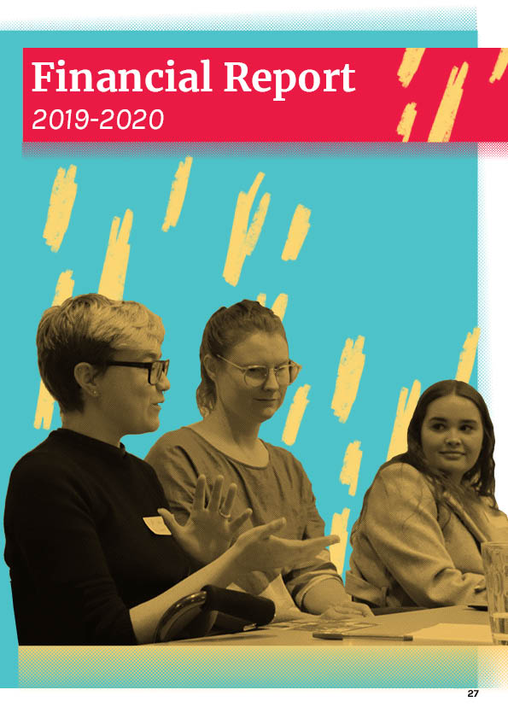

Treasurer’s Report

The 2020 financial year (FY20) has been a challenge in so many different ways.

Following the dreadful impact to our communities caused by the summer bushfires, the COVID-19 pandemic in Australia commenced and required your Board to display prudent financial management given the unknown territory that YACVic, its people, members and communities were entering. We entered the pandemic strong, financially speaking, which allowed us to make the right decisions that were consistent with our strategic objective of supporting and advocating for young people.
The FY20 surplus increased to $309,889 from $123,389 in the prior year. This result was generated by increased revenues of $236,420 to $4,229,390 principally due to an increase in government funding to address COVID-19-related capacity requirements, although this increase was partially offset by a reduction in conference income following the decision to regrettably postpone the planned 2020 Youth Forum and Youth Sector Conference as a result of the COVID-19 restrictions. For the same period, our expenses increased by $49,900 to $3,919,491 principally due to increased employee costs incurred to support the additional government funded work. This amount was offset by a reduction in other expenses such as travel, conference and other general operating expenses following the onset of COVID-19.
Our financial position remains strong with net assets at 30 June 2020 of $1,489,697 which included a healthy cash position of $2,814,485. One notable change to the Statement of Financial Position in the current year was due to YACVic being required to adopt a new accounting standard, AASB 16 Leases. Whereas in the prior years, lease payments were expensed as incurred, the new lease accounting standard required YACVic to recognise a Right-to-use asset of $497,013 and associated lease liabilities of $514,407. Lease expenses in the annual surplus are replaced with the Right-to-use amortisation expenses and lease liability interest charges. Whilst our cash position remains strong it includes $1,186,205 which was collected in advance for 2021 funding programs, in addition to $256,133 being transferred to VicSRC following their legal separation in July 2020.
I am proud of the way YACVic’s management team and Board continue to lead the organisation. Whilst the FY21 will undoubtedly be another challenging period, we do this importantly from a position of financial strength.

—Peter Glynn, Treasurer

Statement of Financial Performance

for the year ended 30 June 2020

Income | 2020 $ | 2019 $
Conferences | 137,565 | 248,717
Member subscriptions | 26,659 | 35,303
Government grants | 3,794,351 | 3,424,397
Other grants | 30,000 | 66,835
Interest received | 25,328 | 37,693
Admin and management fee | 6,500 | 6,500
Other income | 208,987 | 173,535
Total | 4,229,390 | 3,992,980

Expenditure | 2020 $ | 2019 $
Depreciation and amortisation expense | 243,880 | 40,512
Finance costs | 20,035 | -
Employee costs | 2,857,674 | 2,561,947
Sector development and consultation | 77,451 | 152,921
Accommodation expenses | 103,663 | 212,884
Administration expenses | 173,517 | 228,557
Communication expenses | 127,085 | 121,297
Publication and printing | 5,696 | 4,211
Project costs | 310,490 | 547,262
Total | 3,919,491 | 3,869,591

 | 2020 $ | 2019 $
Surplus for the year | 309,899 | 23,389

Statement of Financial Position

As at 20 June 2020

Assets | 2020 $ | 2019 $
Current Assets
Cash and cash equivalents | 2,814,485 | 2,503,517
Trade and other receivables | 170,674 | 75,070
Prepayments | 13,111 | 25,150
Total Current Assets | 2,998,270 | 2,603,737

Non-Current Assets | 2020 $ | 2019 $
Plant and equipment | 261,908 | 343,768
Right-of-use assets | 497,013 | -
Total Non-Current Assets | 758,921 | 343,768

 | 2020 $ | 2019 $
Total Assets | 3,757,191 | 2,947,505

Liabilities | 2020 $ | 2019 $
Current Liabilities
Trade and other payables | 341,374 | 333,144
Employee benefits | 192,672 | 100,519
Other liabilities | 1,192,154 | 1,302,402
Lease liabilities | 137,510 | -
Total Current Liabilities | 1,863,710 | 1,736,065

Non-Current Liabilities | 2020 $ | 2019 $
Lease liabilities | 376,897 | -
Employee benefits | 26,887 | 31,642
Total Non-Current Liabilities | 403,784 | 31,642

 | 2020 $ | 2019 $
Total Liabilities | 2,267,494 | 1,767,707
Net Assets | 1,489,697 | 1,179,798

Members’ Funds | 2020 $ | 2019 $
VicSRC retained surplus | 256,133 | 187,842
Retained surplus | 1,233,564 | 991,956
Total Members’ Funds | 1,489,697 | 1,179,798

Statement of Changes in Equity

For the Year Ended 30 June 2020

2020 | Retained Surplus $ | VicSRC Retained Surplus $ | Total $
Balance at 1 July 2019 | 991,956 | 187,842 | 1,179,798
Surplus for the year | 241,608 | 68,291 | 309,899
Balance at 30 June 2020 | 1,233,564 | 256,133 | 1,489,697

2019 | Retained Surplus $ | VicSRC Retained Surplus $ | Total $
Balance at 1 July 2018 | 932,053 | 124,356 | 1,056,409
Surplus for the year | 59,903 | 63,486 | 123,389
Balance at 30 June 2019 | 991,956 | 187,842 | 1,179,798

Statement of Cash Flows

For the Year Ended 30 June 2020

Cash Flows From Operating Activities: | 2020 $ | 2019 $
Receipts from government and members | 4,399,027 | 4,636,689
Payments to suppliers and employees | (3,948,726) | (4,249,118)
Interest received | 25,328 | 37,693
Interest paid on lease liabilities | (20,035) | -
Net cash provided by/(used in) operating activities | 455,594 | 425,264

Cash Flows From Investing Activities: | 2020 $ | 2019 $
Purchase of property, plant and equipment | (16,553) | (317,559)
Net cash provided by/(used in) investing activities | (16,553) | (317,559)

Cash Flows From Financing Activities: | 2020 $ | 2019 $
Payment of lease liabilities | (128,073) | -
Net cash provided by/(used in) financing activities | (128,073) | -
Net increase/(decrease) in cash and cash equivalents held | 310,968 | 107,705
Cash and cash equivalents at beginning of year | 2,503,517 | 2,395,812
Cash and cash equivalents at end of financial year | 2,814,485 | 2,503,517

Notes to the Financial Statements

For the Year Ended 30 June 2020

The financial statements cover Youth Affairs Council of Victoria as an individual entity. Youth Affairs Council of Victoria is a not-for-profit Association incorporated in Victoria under the Associations Incorporation Reform Act 2012 (‘the Act’).

Basis of Preparation
In the opinion of the Committee of Management, the Association is not a reporting entity since there are unlikely to exist users of the financial statements who are not able to command the preparation of reports tailored so as to satisfy specifically all of their information needs. These special purpose financial statements have been prepared to meet the reporting requirements of the Act.
Youth Affairs Council of Victoria special purpose financial statements comply with all the recognition and measurement requirements in Australian Accounting Standards.
The following significant accounting policies, which are consistent with the previous period unless stated otherwise, have been adopted in the preparation of these financial statements.

1) Summary of Significant Accounting Policies

(a) Revenue
Revenue is recognised on the following basis:
- Revenue from the rendering of a service is recognised upon the delivery of the service to the clients.
- Interest revenue is recognised on a proportional basis taking into account the interest rates applicable to the financial assets.
- Membership revenue is recognised progressively over the period to which the membership relates. Any portion of membership fees received relating to the following financial year is brought to account at balance date as membership in advance.
- When the Association receives government grants, it performs an assessment to determine if the contract is ‘enforceable and contains’ sufficiently specific performance obligations. In cases where there is an ‘enforceable contract with a customer with’ sufficiently specific performance obligations, the transaction is accounted for under AASB 15 where income is recognised when (or as) the performance obligations are satisfied. In all other cases the transaction is accounted for under AASB 1058 where the income is recognised upon receipt.
All revenue is stated net of the amount of goods and services tax (GST).
The core principle of AASB 15 is that revenue is recognised on a basis that reflects the transfer of promised goods or services to customers at an amount that reflects the consideration the Association expects to receive in exchange for those goods or services. Revenue is recognised by applying a five-step model as follows:

- Identify the contract with the client
- Identify the performance obligations
- Determine the transaction price
- Allocate the transaction price to the performance obligations
- Recognise revenue as and when control of the performance obligations is transferred

(b) Income Tax
The Association is exempt from income tax under Division 50 of the Income Tax Assessment Act 1997.

(c) Goods and services tax (GST)
Revenue, expenses and assets are recognised net of the amount of goods and services tax (GST), except where the amount of GST incurred is not recoverable from the Australian Taxation Office (ATO).
Receivables and payable are stated inclusive of GST.
Cash flows in the statement of cash flows are included on a gross basis and the GST component of cash flows arising from investing and financing activities which is recoverable from, or payable to, the taxation authority is classified as operating cash flows.

For the complete financial report, please find the full 2019-20 Auditor’s Report on the YACVic website here.

Independent Audit Report

to the members of Youth Affairs Council of Victoria

Report on the Audit of the Financial Report

Opinion
We have audited the accompanying financial report, being a special purpose financial report of Youth Affairs Council of Victoria (the Association), which comprises the statement of financial position as at 30 June 2020, the statement of financial performance, the statement of changes in equity and the statement of cash flows for the year then ended, and notes to the financial statements, including a summary of significant accounting policies, and the responsible persons’ declaration.
In our opinion, the accompanying financial report of the Association is in accordance with the Australian Charities and Not- for-profits Commission Act 2012, including:
(i) giving a true and fair view of the Association’s financial position as at 30 June 2020 and of its financial performance for the year then ended; and
(ii) complying with Australian Accounting Standards to the extent described in Note 1 and the Australian Charites and Not- for-profits Commission Regulation 2013.

Basis for Opinion
We conducted our audit in accordance with Australian Auditing Standards. Our responsibilities under those standards are further described in the Auditor’s Responsibilities for the Audit of the Financial Report section of our report. We are independent of the Association in accordance with the auditor independence requirements of the ethical requirements of the Accounting Professional and Ethical Standards Board’s APES 110 Code of Ethics for Professional Accountants (the Code) that are relevant to our audit of the financial report in Australia. We have also fulfilled our other ethical responsibilities in accordance with the Code.
We believe that the audit evidence we have obtained is sufficient and appropriate to provide a basis for our opinion.

Emphasis of Matter - Basis of Accounting
We draw attention to Note 1 of the financial report, which describes the basis of accounting. The financial report is prepared to assist the Association in meeting its financial reporting requirements under the Australian Charities and Not-for-profits Commission Act 2012. As a result, the financial report may not be suitable for another purpose. Our report is intended solely for the Association and should not be distributed to or used by parties other than the Association. Our opinion is not modified in respect of this matter.

Responsibilities of Committee and Those Charged with Governance
The committee is responsible for the preparation and fair presentation of the financial report in accordance with the Australian Charities and Not-for-profits Cimmission Act 2012, and for such internal control as the committee determines is necessary to enable the preparation of the financial report is free from material misstatement, whether due to fraud or error.
In preparing the financial report, the committee is responsible for assessing the Association’s ability to continue as a going concern, disclosing, as applicable, matters related to going concern and using the going concern basis of accounting unless the committee either intends to liquidate the Association or to cease operations, or has no realistic alternative but to do so.
Those charged with governance are responsible for overseeing the Association’s financial reporting process.

Auditor’s Responsibilities for the Audit of the Financial Report
Our objectives are to obtain reasonable assurance about whether the financial report as a whole is free from material misstatement, whether due to fraud or error, and to issue an auditor’s report that includes our opinion. Reasonable assurance is a high level of assurance, but is not a guarantee that an audit conducted in accordance with the Australian Auditing Standards will always detect a material misstatement when it exists. Misstatements can arise from fraud or error and are considered material if, individually or in the aggregate, they could reasonably be expected to influence the economic decisions of users taken on the basis of this financial report.
- As part of an audit in accordance with the Australian Auditing Standards, we exercise professional judgement and maintain professional scepticism throughout the audit. We also:
- Identify and assess the risks of material misstatement of the financial report, whether due to fraud or error, design and perform audit procedures responsive to those risks, and obtain audit evidence that is sufficient and appropriate to provide a basis for our opinion. The risk of not detecting a material misstatement resulting from fraud is higher than for one resulting from error, as fraud may involve collusion, forgery, intentional omissions, misrepresentations, or the override of internal control.
- Obtain an understanding of internal control relevant to the audit in order to design audit procedures that are appropriate in the circumstances, but not for the purpose of expressing an opinion on the effectiveness of the Association’s internal control.
- Evaluate the appropriateness of accounting policies used and the reasonableness of accounting estimates and related disclosures made by the committee.
Conclude on the appropriateness of the committee’s use of the going concern basis of accounting and, based on the audit evidence obtained, whether a material uncertainty exists related to events or conditions that may cast significant doubt on the Association’s ability to continue as a going concern. If we conclude that a material uncertainty exists, we are required to draw attention in our auditor’s report to the related disclosures in the financial reporter, if such disclosures are inadequate, to modify our opinion. Our conclusions are based on the audit evidence obtained up to the date of our auditor’s report. However, future events or conditions may cause the Association to cease to continue as a going concern.
Evaluate the overall presentation, structure and content of the financial report, including the disclosures, and whether the financial report represents the underlying transactions and events in a manner that achieves fair presentation.
We communicate with the committee regarding, among other matters, the planned scope and timing of the audit and significant audit findings, including any significant deficiencies in internal control that we identify during our audit.

Accru Melbourne (Audit) Pty Ltd

G D Winnett, Director

