Reshape Our Future
Warrnambool
at Brother Fox

Getting here
Bus route 3 runs between the Lava St interchange in the CBD and Deakin Campus in Warrnambool. The bus stop is located close to Brother Fox. There is a path with a slight downhill incline going from the bus stop to the H building where Brother Fox, the conference venue, is located. Buses within Warrnambool are fitted with wheelchair ramps.
The V/Line train from Southern Cross Station Melbourne stops at the Sherwood Park stop which is closest to the venue. The V/Line service is fitted with wheelchair access ramps but you will need to let a conductor know you require this and what stop you are getting off at.
https://www.transitsw.com.au/
https://www.vline.com.au/Plan-trip-buy-tickets
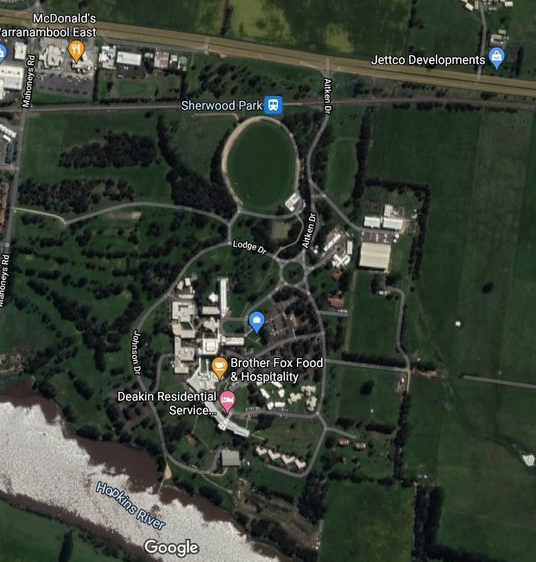
Image description: a map of Brother Fox Food & Hospitality.
Campus Access is via the Princess Hwy approximately eight km east of the centre of Warrnambool. Enter campus on Aitken Drive. Take the fourth exit, first right at the large roundabout onto Johnson Drive. Stay on Johnson Drive until you reach car park 7 (CP7), the assigned parking for the conference. There is a paved path approximately 200 metre concrete uphill approximately 25-degree slope from CP7 to Brother Fox, the venue. There will be an A-frame sandwich board style sign saying “Brother Fox” at the beginning of the path, see image below.
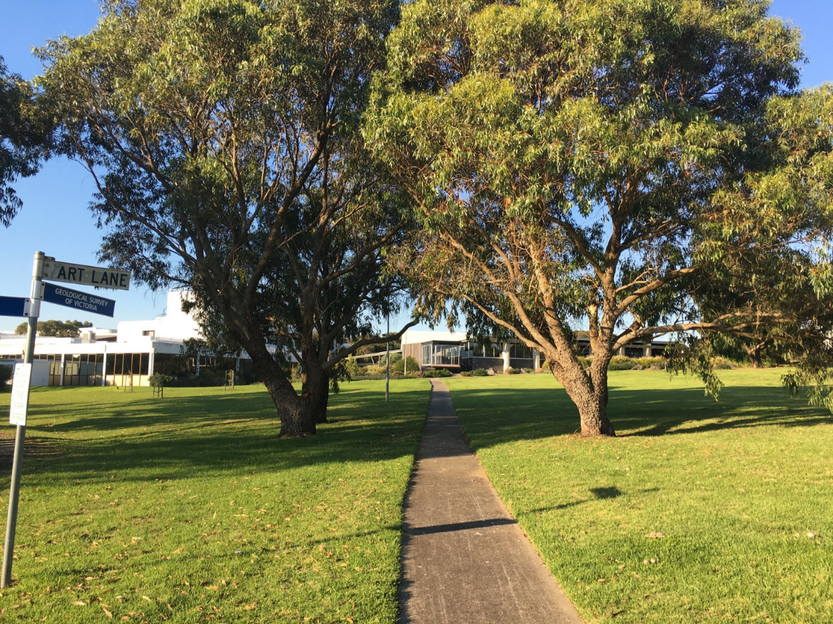
Image description: a photo of a smooth concrete path to the venue from CP7.
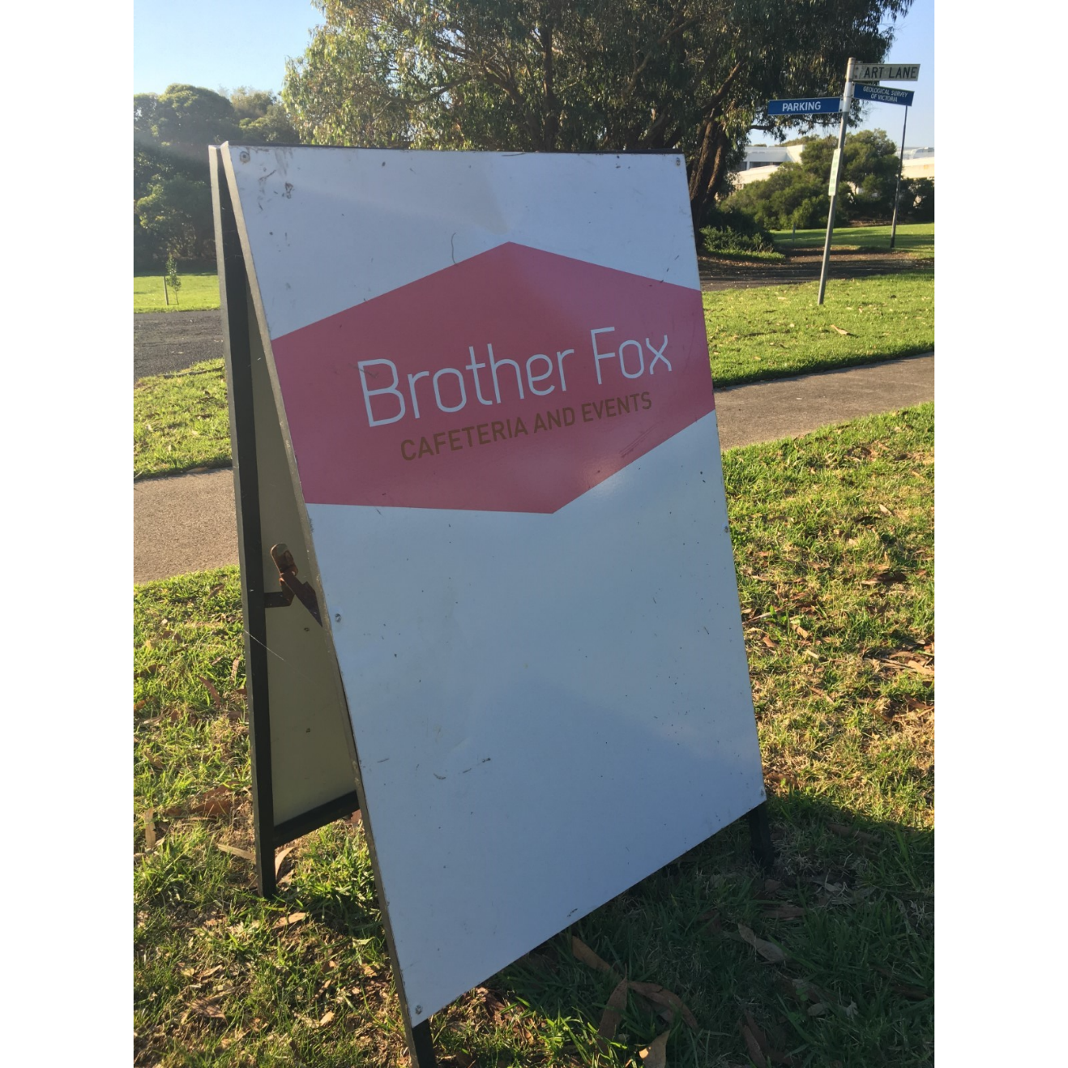
Image description: an A-frame construction sandwich board that reads ”Brother Fox Cafeteria and Events”.
If you require an accessible parking space, you will follow a different route. Refer to the following section on accessible parking spaces. Additionally, if you cannot walk up steps, we recommend you follow the route to the accessible parking spaces.

Car parking

Enter campus on Aitken Drive from the Princes Highway. Take the second exit at the roundabout onto Lodge Drive and then turn right onto Cafeteria Lane. Stay on Cafeteria Lane past the small roundabout and the accessible car parks will be to your right. To enter the conference venue from these car parks, walk along the path to the automatic double doors to enter H building.

Getting In
Directions:
Entering the venue from CP7
There are four steps leading up to the deck outside Brother Fox where there will be a registration table set up. If you cannot use steps to access the conference space we suggest you use the disabled parking spaces adjacent to H building (see above for how to access). To go inside to the conference space there are double automatic opening doors as well as heavy glass inward opening double doors, both with an entryway width of approximately 100cm.
Entering the venue from accessible parking
Enter H building through the automatic double doors. Immediately inside the building is smooth linoleum flooring leading into the cafeteria and food service area. The conference spaces themselves are carpeted with the exception of the bar, which also has linoleum flooring. There is a small lip between the carpeted areas and linoleum flooring areas that is not considered a trip hazard.

Quiet Space
There will be a designated quiet space in a separate room to the main conference proceedings to allow participants to take a break as needed.

Bathrooms
Inside H building there are women’s toilets with four separate stalls, men’s toilets with stalls and urinals, a unisex disabled toilet with handrails, and an accessible changing space with an automatic sliding door entry, hoist, hand rails, adult change table, toilet and shower.

The Venue:

The venue is single story. Deakin University and Brother Fox do not have a scent policy in place and there will not be one enforced for this particular event. You can expect there to be some fragrance. Floors in the event space are carpeted with the exception of toilets and change spaces.
There is a mix of natural lighting from windows and glass doors as well as fluorescent overhead lighting. Smoking is prohibited on all Deakin campuses.
During the conference there will be a mix of auditory inputs including music, conversations, a PA system, and sounds from the café including food preparation and the coffee machine.
Inside the conference area round tables will be set up that seat approximately ten people. The tables will be spaced to allow plenty of room for people who use mobility aids. Presentations will be Auslan interpreted on screens, and there will be a closed captioning option available on request as well as a hearing aid loop set up.
Epilepsy Trigger Warning
We will be using an online polling and presentation program called Mentimeter.
In presentation mode, the screen may flicker with incoming information.
MCs and presenters will provide warnings prior to using presentation mode.

