Reshape Our Future
Wangaratta
at the Wangaratta Performing Arts Centre (WPAC)
Getting here
Wangaratta Performing Arts Centre (WPAC) is located at 33-37 Ford Street Wangaratta on the Corner of Ford and Ovens Street. It’s a 7-minute walk from the railway station.
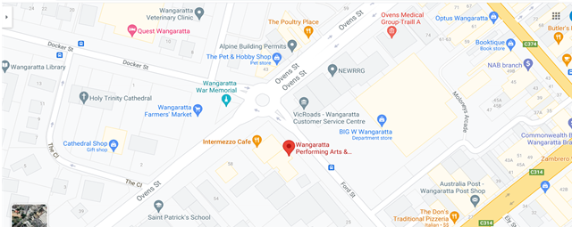
Image description: map of the WPAC area.
If you are arriving by train, there is a service between Melbourne and Albury.
The station is a is 600 metres from the venue and takes about seven minutes to walk.
When you exit the station, walk out on to Norton Street. Turn left and head towards the large colourful water tower. Walk 270 meters along Norman Street which turns to the right at the water tower and becomes Docker Street. Walk 330 meters up Docker Street passing the TAFE, library, cathedral on the tight and the Quest Wangaratta on the left. The next intersection has a roundabout. You will see the WPAC on the far side (Southeast corner) on the corner of Ovens and Ford Street.
There is a pedestrian crossing (unmarked) across Oven Street and another (marked with tactile paving) 100 meters to cross Ford Street.
Bus
There is a local bus stop (buses 401/402/403/404) on Ford Street. The bus stop is 40 meters from the entrance to WPAC. The bus stop is located on the same side of the street.

Car parking
There are two accessible parking spaces on Ford Street about 20 meters from the front of the building. They are on the same side and there is accessible paving to the footpath. There are also another five accessible parking spaces outside the Big W, across the road from the WPAC about 50 meters from the building. Alternatively, there is a disabled parking space located in the on-site parking at the Wangaratta Arts Centre (next door to the WPAC located on Ovens Street.) the WPAC can be accessed by a path leading to the back door (café entrance).

Getting In

Directions:
You can enter from the front of the building or the back of the building via a café.
Front access
As you approach the venue there is a ramp (pictured) on the left side (Ford Steet) at the entrance to the WPAC. It is 145cm wide approximately 9 meters long and has rails on both sides. There are four steps to enter the building from outside with rails on both sides.
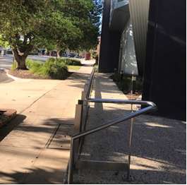
Image description: the ramp outside the venue.
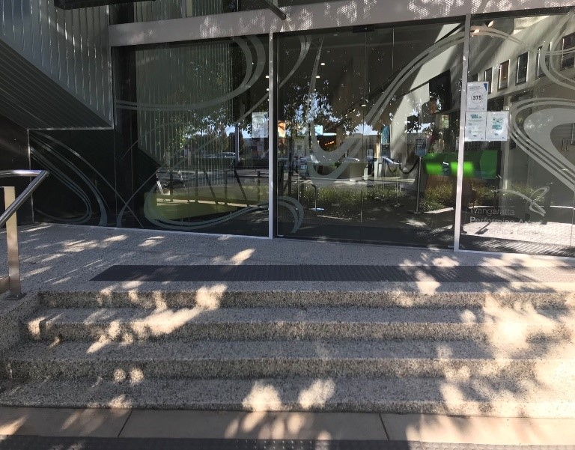
Image description: the automatic glass sliding doors at the entrance to the building.
When you get to the end, there café located on the right-hand side at the back of the building, and it also has a bright green coloured counter 147 cm high (pictured above).
There are six steps that lead up to a landing/foyer on the mezzanine level which is the entrance to the main conference room. There are tactile dots at both the top and bottom of the stairs.
The ramp access to the main conference room is on the left. It is 125 centimetres wide and there are two rails. The ramp is 13 meters long and has tactile dots at both ends. There is a twist to the right at the end of the ramp going up.
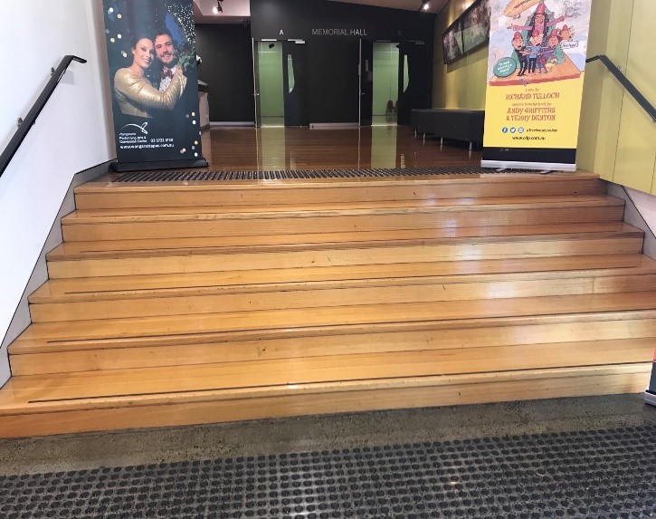
Image description: steps leading to the foyer.
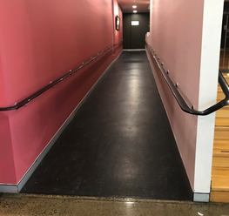
Image description: ramp access to the main conference room.
All areas are well lit with down lighting throughout. In the common areas there is a lot of natural light. The entrance is white and grey and ground floor moving into dusty pink and grey further into the venue.
The mezzanine and conference rooms have light-coloured polished floors. The mezzanine has seating (couches with no arms) on the right-hand side. It has a yellow wall on the right, with artwork and pink on the left with a service desk. The doors to the entrance of the memorial hall (main conference space) are dark black.
Rear access
There is a paved path leading to a café and rear access to the WPAC. The door is 87cm wide. It is heavy and glass and it pulls open from the outside.

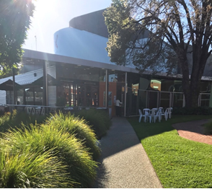
Image description: path leading to the event through rear access.
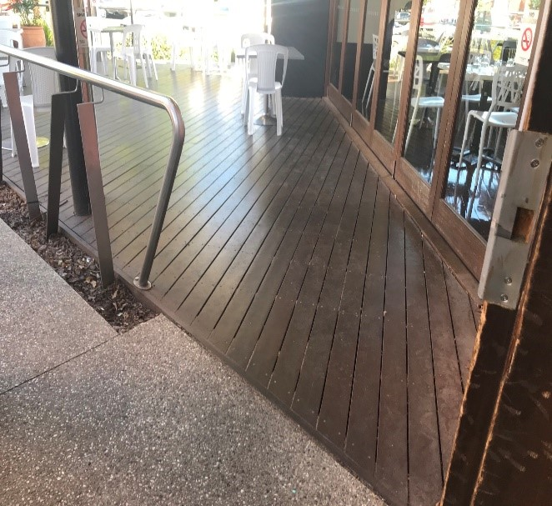
Image description: the back entry to the event through a café.

Bathrooms

The bathrooms and toilets are located on the ground entrance level past the café. It is on the left as you are going towards the conference room or on the right as you are leaving the conference room. There are three bathroom/toilets. One is male, one is female and one is an all-gender accessible toilet. The entrance to the accessible toilet is on the left and the entrance to the male and female toilets are on the right.

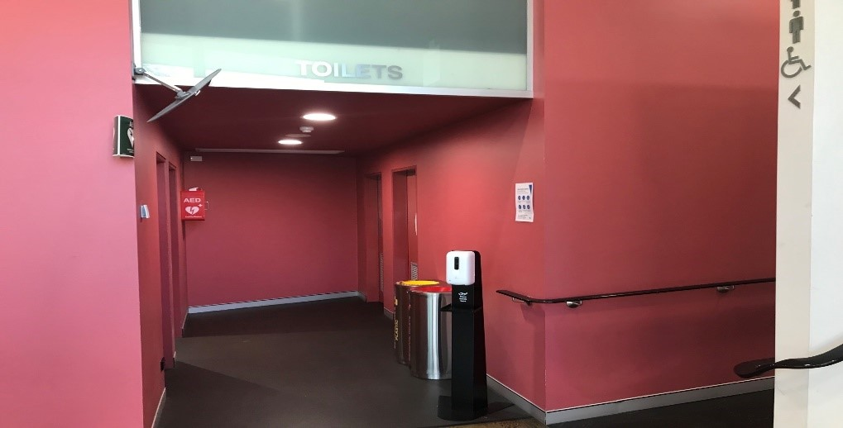
Image description: the entry to toilets.
The entrance to the accessible bathroom/toilet is via a door with a handle and it is 83.cm wide and you push to open. Inside is a toilet with a rail and a wash basin. This bathroom also has a sanitary waste bin inside. The door has a lock. The floor is nonslip lino.
The entrance to the male bathroom/toilet is via a door you push to open, and it is 83.cm wide inside. There are two stalls (door 56cm wide) and six urinals. There are 4 wash basins. The floor is nonslip linoleum.
The entrance to the female bathroom/toilet is via a door you push to open, and it is 83.cm wide. Inside there are six stalls and four wash basins. There are sanitary waste bins inside.
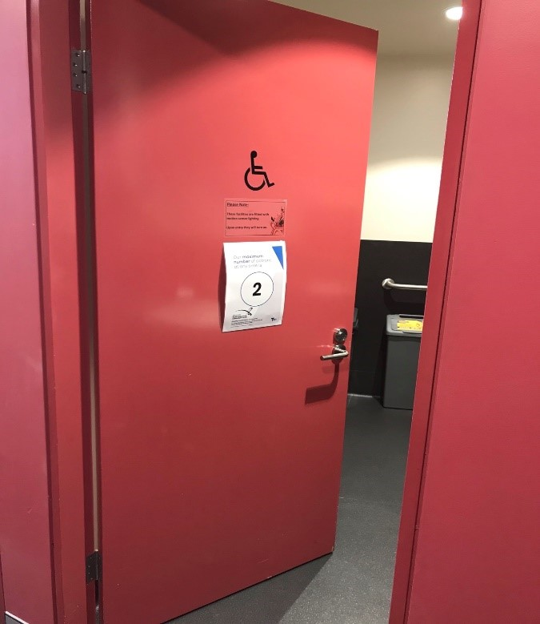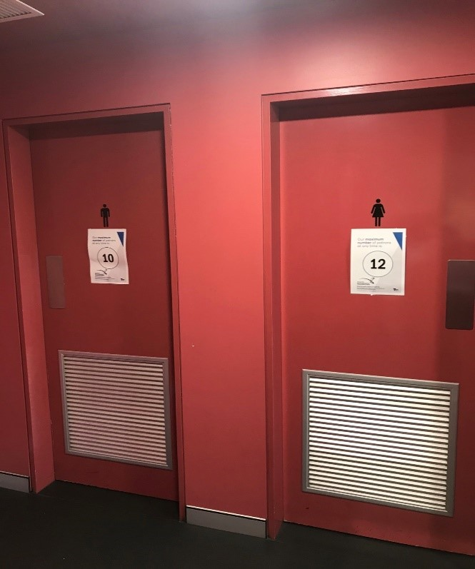
Image description: entry to the accessible toilet, male toilet, and female toilet.

Quiet Space
There are quiet spaces outside the Memorial Hall on the mezzanine or at the café, in the hallways, or outside in the garden. The green room (conference HQ) can also be used as a quiet space if needed.
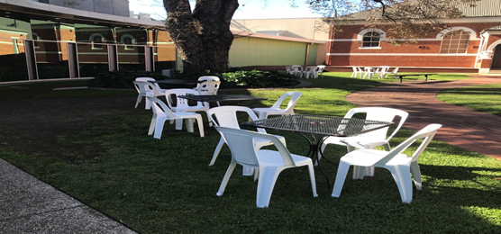
Image description: outdoor area that can be used as a quiet space.

The Venue:
The majority of the conference event will take place in the memorial hall. To enter you through a large double door. There is a small metal step as you cross into the room. It is about two milimetres thick. The doors have a single metal handle and pull towards you to enter. As you enter the staging area will be on the right. This will be referred to as the front.
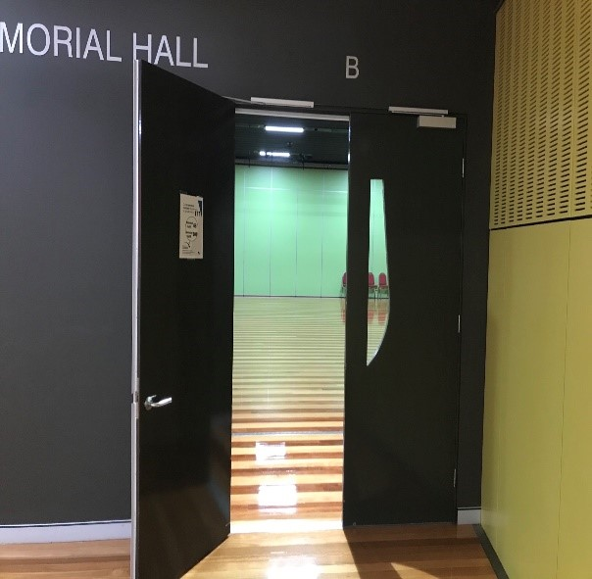
Image description: the entry leading to Memorial Hall.
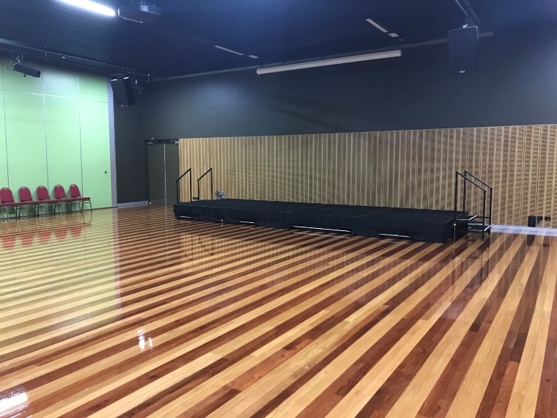
Image description: a photo of the inside of Memorial Hall.
There are no lifts in the building. There are four steps to enter the building with a ramp and six steps to get to the mezzanine level and a ramp. All areas have tactile dots on the flooring and handrails.
The green room, which is on the mezzanine level, is on is the staff HQ. It is located behind the Memorial Hall. The entrance is on the right.
The building has a hearing loop.
Epilepsy Trigger Warning
We will be using an online polling and presentation program called Mentimeter.
In presentation mode, the screen may flicker with incoming information.
MCs and presenters will provide warnings prior to using presentation mode.

