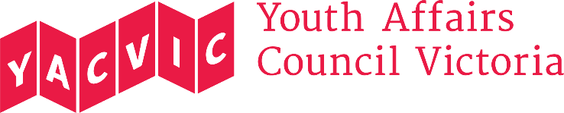

Title: | Policy Officer
Reporting to: | Policy Manager
Hours: | 1.0 FTE, 38.0 hours a week (5 days a week)
Remuneration: | $70,404 p.a. classified under the SCHADS Award at Employment Level 4.1.  (YACVic pays above award rates, with generous T&C.)
Status: | This is a fixed term 6-month contract.
Location: | Melbourne CBD, with working from home arrangements during COVID-19

About Youth Affairs Council Victoria (YACVic)
Youth Affairs Council Victoria (YACVic) is the peak body and leading policy advocate on young people’s issues in Victoria. YACVic’s vision is that the rights of young people in Victoria are respected, and they are active, visible and valued in their communities. YACVic is an independent, for-purpose, member-driven organisation that represents young people (aged 12–25 years) and the sector that works with them.
YACVic provides additional targeted advocacy and services through our key services, YACVic Rural and the Youth Disability Advocacy Service, and our auspice partners, the Koorie Youth Council.
Working for Victoria Fund
The Working for Victoria (WfV) Fund is part of the Victorian Government's $1.7 billion Economic Survival Package to address the impact of the COVID-19 crisis. The Fund supports the creation of new short-term roles, and has partnered with Sidekicker to support job seekers to find work. Under this initiative, a coalition of eight youth-focused organisations, led by YACVic, has received funding to employ a variety of roles to strengthen youth outreach and the youth sector in Victoria in light of the COVID-19 crisis. This is one of those roles.
About the role
The Policy Officer will work as a member of YACVic’s small but dynamic Policy Team. They will support YACVic’s policy and advocacy work by conducting research, planning advocacy activities, designing and facilitating consultations, and drafting policy submissions. This includes policy work related to the impact of COVID-19 on young people in Victoria.

Major Duties
- Conduct research and complete literature reviews to inform policy submissions and advocacy.
- Assist in the production of policy and advocacy materials, including summarising research, preparing briefing papers and drafting policy submissions.
- Convene, facilitate and analyse data from consultations and roundtables, and ensure that events are accessible, inclusive and focused on capturing the voice of young people.
- Prepare and plan advocacy activities, including campaigns
- Attend meetings and maintain records of engagement with relevant YACVic stakeholders.
- Attend regular staff meetings and participate as a member of the YACVic staff team.

You will be required to perform these duties, and any other duties the Policy Manager or CEO may assign to you, having regard to your skills, training and experience.

Reporting
This role reports to the YACVic Policy Manager. This role has no direct reports.

Employment conditions
YACVic is an Equal Opportunity Employer. People with disability, people from culturally and/or linguistically diverse backgrounds, and Aboriginal and Torres Strait Islander people are encouraged to apply for this position.

YACVic promotes the safety, wellbeing and inclusion of all children and young people, and takes child protection very seriously. All employees are subject to screening and assessment against child safety standards, including rigorous background, identity and reference checks. The successful applicant will require a current Working with Children Check and Police Check (costs reimbursed) and must agree to adhere to our child safe policy and code of conduct.

To be eligible to apply for this position you must be an Australian or New Zealand citizen, a permanent resident or hold a valid work permit or visa.

If you have any questions about the role, please contact Steph Brenkovich, at recruitment@yacvic.org.au

