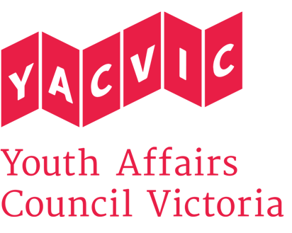
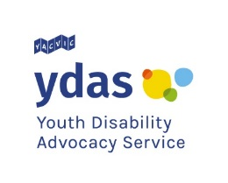

Title: | YDAS TSP Resources Development Officer
Reporting to: | TSP Project Coordinator
Hours: | 3 – 4 days (22.8 – 30.4 hours) per week, negotiable. Flexibility will be needed, with occasional evening and weekend work
Remuneration: | $58,825.00 p.a. pro-rated, classified under the SCHADS Award at Employment Level 3.1  (YACVic pays above award rates, with generous T&C.)
Status: | 6 month fixed term contract
Location: | Based in Melbourne CBD with some state-wide travel.

About Youth Affairs Council of Victoria (YACVic)
YACVic is the peak body and leading policy advocate on young people’s issues in Victoria. YACVic’s vision is that young Victorians have their rights upheld and are valued as active participants in their communities. YACVic is an independent, not-for-profit, member-driven organisation that represents young people (aged 12-25 years) and the sector that works with them.

Youth Disability Advocacy Service (YDAS)
YDAS is a core YACVic agency, funded by the Victorian Government. YDAS has a service model which places the human rights and interests of young people with disabilities at the centre of its work. YDAS undertakes individual and policy advocacy to support young people with disabilities to have a stronger voice, reduce the barriers that they experience and improve their quality of life.

About the role
Are you good at researching and presenting complex information in a way that can be easily understood? Are you passionate about social justice and empowering young people with disability to take control of their lives? Read on!

YDAS has funding from the Victorian Government to support the transition of young people with a disability to the National Disability Insurance Scheme (NDIS). We refer to this funding as TSP (Transition Support Package). The NDIS and TSP offers the chance to enable young people with a disability to make informed choices about their future and to exercise choice and control when accessing support.

The Resources Development Officer will work closely with the YDAS team to develop resources about NDIS targeted at young people with disability. The Resources Development Officer will review existing resources and identify gaps. They will work with key stakeholders to develop resources that are accessible and relevant for young people with disability and professionals who work with young people with disability.

Some of the resources developed by the Resources Development Officer will include:
- A guide for professionals about how they can prepare documentation for Access Requests so young people can apply to join the NDIS
- A planning handbook to help young people prepare for their NDIS planning meeting
- Learning materials for Map Your Future workshops

This role will lead the provision of engaging, exciting and youth relevant information for young people with disabilities to transition into the NDIS with the greatest sense of choice, control and confidence.

POSITION DESCRIPTION

Key Responsibilities

- Work to the goals and timelines of the YDAS TSP project as part of a small and dynamic team.
- Research existing resources and guides that relate to NDIS, including the application process to become a NDIS participant, planning meetings, plan management and plan implementation.
- In line with the TSP project strategy work with the TSP staff develop accessible resources targeted at young people with disability, their parents, carers, guardians and professionals who work with young people.
- Coordinate feedback from young people with disability throughout the resources development to ensure that the resources are effective and relevant for young people.
- Work with the NDIS Digital and Content Officer to promote and distribute resources to young people with disability, their families, support organisations and professionals who work with young people.
- Participate in regular supervision, staff meetings, forums, professional development and organisational development activities as directed by managers.
- Attend regular YACVic and YDAS staff meetings and participate as a member of the wider YACVic staff team.
- Carry out any other duties your manager may assign to you, having regard to your skills, training and experience.

ESSENTIAL CRITERIA:

- Demonstrated commitment to the rights and interests of young people with disability.
- Proven skills in locating and analysing information and resources.
- Demonstrated ability to produce resources that explain complex information in a manner that is easy to understand, accessible and inclusive.
- Ability to work alongside young people with disability and create pathways for young people to provide feedback and input into the resources that are being developed.
- High level organisational skills with the ability to meet tight deadlines.
- Demonstrated ability to communicate effectively and maintain productive relationships with a variety of stakeholders.
- Demonstrated ability to work effectively as part of a team and with staff and volunteers.
- A willingness and capacity to travel throughout Victoria and work occasional evenings or weekends when required

DESIRABLE CRITERIA:

- Understanding of the National Disability Insurance Scheme and of education and employment pathways for young people.
- Experience in producing Easy English materials.
- Experience in graphic design.
- Qualifications and/or practical experience related to community development, policy or youth work.
REPORTING
The Resources Development Officer will report to the TSP Project Coordinator.

EMPLOYMENT CONDITIONS
YACVic is an Equal Opportunity Employer. People with a disability are strongly encouraged to apply for this position.
YACVic promotes the safety, wellbeing and inclusion of all children and young people, including those with a disability, those who are Aboriginal or those from refugee or migrant backgrounds. We take child protection very seriously. All employees are subject to screening and assessment against child safety standards, including rigorous background, identity and reference checks. The successful applicant will require a current Working with Children Check and Police Check (costs reimbursed) and must agree to adhere to our child safe policy and code of conduct.
As relevant to the role, the Resources Development Officer will adhere to and uphold YACVic’s service quality objectives:
- Implement the quality management system (QMS) and comply with ISO 9001
- Enhance client satisfaction by implementing systems that record, analyse and use participant feedback to improve services
- Develop employee competence by undertaking system awareness training.

APPLICATION PROCESS
Applications should be emailed to recruitment@yacvic.org.au with ‘Resources Development Officer application’ in the subject line and must include:
- A brief cover letter
- Your resume
- Your answers to the key selection criteria, as listed in the position description
- Contact details for a minimum of two referees, including your most recent line manager (we will not contact referees without your permission).

Only applications that follow the above process will be accepted and considered for interview.

Applications close at 5pm 10 October 2019. Interviews are likely to be the week starting 14 October 2019 in Melbourne CBD.

If you have any questions about the role, please contact Mija Gwyn by emailing mgwyn@yacvic.org.au or by calling Stephanie Brenkovich at 03 9267 3700.

