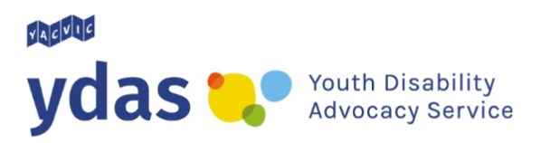
Useful resources about the
NDIS (National Disability Insurance Scheme)

NDIS (National Disability Insurance Scheme)
Website: ndis.gov.au/

YDAS (Youth Disability Advocacy Service)
YDAS is a state wide advocacy service for young people with disability in Victoria.
We offer a free individual advocacy service to young people, aged 12-25, with disability.
Website: www.ydas.org.au/
Facebook: www.facebook.com/ydasvic
Twitter: twitter.com/ydasvic
Instagram: www.instagram.com/ydas_vic/

YDAS NDIS Resources
Joining the NDIS as a young person with disability
https://www.yacvic.org.au/blog/joining-the-ndis-as-a-young-person-with-disability/

Handy hints for your NDIS planning meeting
https://www.yacvic.org.au/blog/handy-hints-for-your-ndis-planning-meeting/

NDIS 101: Managing your NDIS plan
https://www.yacvic.org.au/blog/ndis-101-managing-your-ndis-plan/

VMIAC (Victorian Mental Illness Awareness Council)
Fact sheets, Plain English worksheets, videos and advocacy support.
Website: https://www.vmiac.org.au/services/ndis/

ECCV (Ethnic Communities Council of Victoria)
Information and resources.
Website: http://eccv.org.au/

ACD (Association for Children with a Disability)
Resources, support, education & policy development for families, carers and professionals.
Website: https://acd.org.au/
Disability Loop
Fact sheets, Plain English worksheets and videos
Website: www.disabilityloop.org.au/resources.html

NDIS Grassroots Facebook group
A Facebook group for people to ask questions, share resources and read about other people’s NDIS experiences.
Facebook group: www.facebook.com/groups/239631286154106/

Advocacy organisations funded through the Disability Advocacy Program (DHHS)
Website: https://providers.dhhs.vic.gov.au/disability-advocacy-organisations

Find an Advocate (Disability Advocacy Resources Unit)
Website: http://www.daru.org.au/find-an-advocate

Your LAC (Local Area Coordinator)

The Brotherhood of St Laurence
North East Melbourne, Hume Moreland, Bayside Peninsula, Brimbank Melton, and Western Melbourne
Website: ndis.bsl.org.au/

Latrobe Community Health Service
Central Highlands, Ovens Murray, Wimmera South West, Barwon, Inner East Melbourne, Inner Gippsland, Outer Gippsland, Outer East Melbourne, and Southern Melbourne
Website: lchs.com.au/aged-disability-carers/national-disability-insurance-scheme-ndis

Intereach
Loddon, Mallee, and Goulburn
Website: www.intereach.com.au/support/disability/

