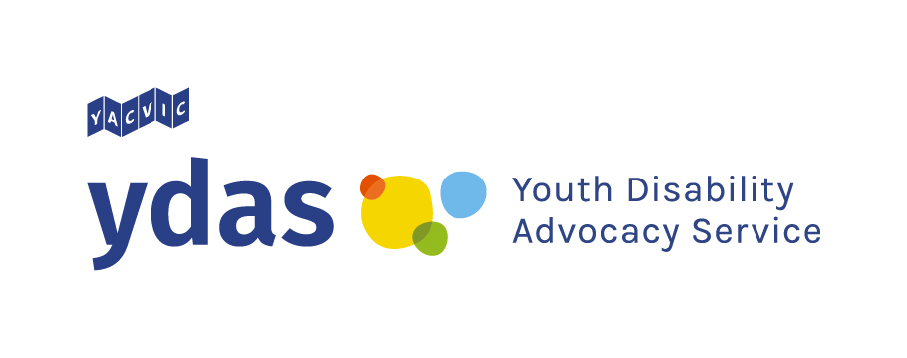
Sharing your experiences with Youth Disability Advocacy Service
About this survey
This survey is about disabled young people's bad experiences. The survey will help stop those bad experiences from happening. In this survey we will ask questions about your experiences and what you think should change.
The survey is run by Youth Disability Advocacy Service. We will use the information you share with us to tell the Australian Government how to make life better for disabled young people.
Only answer the questions you feel comfortable answering.
Before starting this survey, you might want to look at some information on the Youth Disability Advocacy Service website that explains some of the words we use.
This survey might make you feel sad. Please make sure that you are feeling okay before starting the survey. At the end, take some time to look after yourself. If you want to talk to someone about your feelings, please use the numbers below:
Kids Helpline: 1800 55 1800
QLife Australia: 1800 184 527
1800RESPECT: 1800 737 732
Lifeline: 13 11 14
This survey is not part of Youth Disability Advocacy Service's individual advocacy service. To find out more about that, go to www.ydas.org.au

- This survey is for disabled young people (aged 12-25) living in Victoria. Is this you?
Yes
No
- Are you completing this survey on behalf of or with a young disabled person?
Yes
No

About You
We will ask some questions about you. You only need to answer the questions you want to answer. You can leave a question blank if you do not know the answer or you do not want to tell us
- How old are you?

- What is your gender? (pick one – you can highlight, make it bold, or delete the other ones)

- Where do you live?
Rural/regional Victoria
A regional city (Ballarat, Bendigo, Geelong, Horsham, Latrobe, Mildura, Shepparton, Wangaratta, Warrnambool or Wodonga)
Melbourne and suburbs
- What is your postcode?

- Are you currently studying? If yes, what are you studying? (pick one – you can highlight, make it bold, or delete the other ones)
Mainstream school
Specialist school
Alternative school (e.g. Steiner, Montessori) Home Schooling or Distance Education TAFE
Undergraduate degree
Post-graduate degree Apprenticeship/Traineeship
I'm not studying
- Is your school or university private or public? (pick one – you can highlight, make it bold, or delete the other ones)
Private
Public
Not sure
- Are you currently working? If yes, what is the main kind of work you are doing? (pick one – you can highlight, make it bold, or delete the other ones)
Working full time
Working part time
Working casually
Contract- or task-based work (e.g. short-term contract or delivery riding)
Supported employment or sheltered workplace
Self-employed
Looking for work
Doing unpaid work (internship, caring, unpaid domestic labour)
Not currently working
- Do you belong to any of the following groups? (you can pick more than one– you can highlight, make it bold, or delete the other ones)

Aboriginal and/or Torres Strait Islander
Culturally and/or Linguistically Diverse (CALD) and/or refugee and/or migrant and/or Person of Colour
LBGTIQA+
Have an experience of mental ill-health
International student
In out-of-home care
Experienced justice system
Experienced homelessness
- What kind of disability/disabilities do you have?( At YDAS we define disability very broadly. We include things like physical disability, intellectual disability, neurodiversity, mental illness, chronic illness)

Your Experiences
In this section we will ask you some questions about your bad experiences. We will give you some examples of bad experiences and ask you to tell us more.
Only answer the questions that you are comfortable answering. You do not have to answer every question.
- Tick the things that have happened to you: (you can pick more than one– you can highlight, make it bold, or delete the other ones)
Bullying
Physically hurt
Hurt feelings
Been stopped from eating or sleeping
Been trapped you somewhere you did not want to be
Sexual assault
Restrictive practice (for example someone locked you in a room, gave you medicine to make you sleepy or someone held you down)
- At YDAS we think that all of those things above are examples of violence. Can you tell us a bit more about your experiences of violence?

- Tick the following if someone has ever: (you can pick more than one– you can highlight, make it bold, or delete the other ones)
Called you rude names
Threatened to hurt you
Humiliated you
Made you feel bad about yourself
Yelled at you
Embarrassed you on purpose
Started rumours about you
Not let you have control over your own money
Told your secrets to other people
- At YDAS we think that all of those things above are examples of abuse. Can you tell us a bit more about your experiences of abuse?

- Tick the following if you have ever not had: (you can pick more than one– you can highlight, make it bold, or delete the other ones)
Enough food or drink
Enough clean clothes
Enough medicine
Help to do things around the house or at school
A safe place to sleep
A way to move around
- At YDAS we think that all of those things above are examples of neglect. Can you tell us a bit more about your experiences of neglect?

- Tick the following if you have ever: (you can pick more than one– you can highlight, make it bold, or delete the other ones)
Worked without getting paid minimum wage
Worked at a sheltered workshop
- At YDAS we think that all of those things above are examples of exploitation. Can you tell us a bit more about your experiences of exploitation?

What is next?
In this section we will ask questions about what you think needs to change
- What you think needs to change so that young disabled people don't have to experience violence, abuse, neglect or exploitation?

- What are the major changes you think that the government should make?

- Would you be interested in talking with YDAS more about your experiences or about what you think needs to change? (pick one– you can highlight, make it bold, or delete the other ones)
Yes
No
Maybe
- What is your name?

- Please provide an email or phone number so we can contact you

- How would you like to be involved next? (you can pick more than one– you can highlight, make it bold, or delete the other ones)
Group discussion with other disabled young people
Individual interview (over the phone, SMS, email, Zoom,)
Another survey like this one
Writing or drawing your own story
Get help recording your story
Something else?

- Would you like to talk more with YDAS about any of these issues? (you can pick more than one– you can highlight, make it bold, or delete the other ones)
Mental Wellbeing
Justice/ Police
Housing/Homelessness Transport
NDIS
Education
Health and Medical Mistreatment Access
Employment
Something else?

Thank you!

