Reshape Our Future
Online/Virtual Access Key

How to attend
Tickets work for the whole day.
You can join and leave as you like.
You may like to check the Program, to make sure you don’t miss out on anything.
You do not need to have your video on, unless you are a presenter.

Online platform - Hopin
What online platform will be used?
Hopin is the platform for the conference and Zoom is where sessions are.
(Image description: Blue and white Hopin logo)

You can use Hopin with a computer, mobile phone or tablet.

You may like to download the Hopin app on your phone or tablet.
The App logo looks like this (Image description: Hopin app logo)

Some of the below information about Hopin may be a little different depending on whether you are using a computer, phone, or tablet.

You can learn more about Hopin here, or watch this video showing the features of Hopin for attendees.
Please note we may not be using all of the features that you learn about in the video.

You can access Hopin in one of two ways
- YACVic will send all registered attendees a Magic Link. Clicking on the provided link will take you through to the event.
For more information about Magic Links click here.
- If you already have a Hopin account, you may like to join directly through Hopin’s Home page.
You will need to login.
You can then find the event in the list of your registered events.
For more information about how to go directly through Hopin click here.

Within the Hopin site, you can:
- find the schedule for the conference,
- access networking sessions and
- visit the expo.
You can use the menu on the left to move between different areas
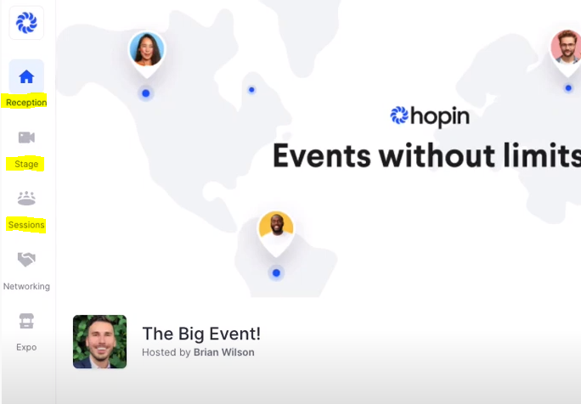
(Image description: Screenshot of Hopin site, with menu options ‘Reception’, ‘Stage’ and ‘Sessions’ highlighted on the left.)

These areas include:
Reception – which will show the schedule and links to upcoming Zoom sessions
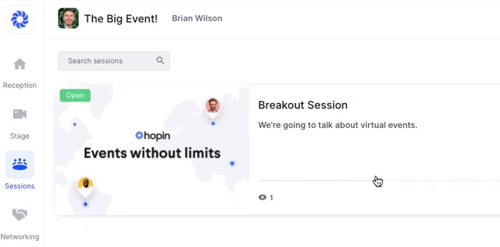
Sessions – Facilitated networking sessions can be found here. You will need to click on the session you want to attend.
(Image description: Screenshot of Sessions section, with mouse icon hovering over a Breakout Session option)
1-2-1 Networking – this is a feature in Hopin that allows you to be randomly matched with another attendee to network with them for 5 minutes.

(Image description: Screenshot of 1-2-1 Networking section)

Expo – the expo links are a way to find additional materials and videos from presenters and links from event sponsors.
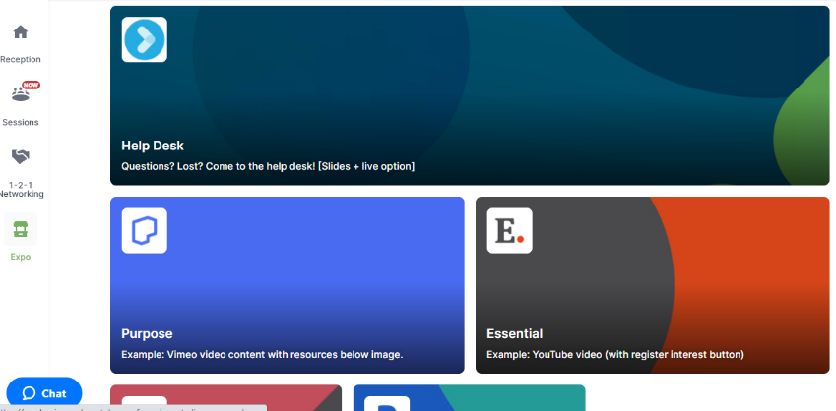
(Image description: Screenshot of expo section)
Joining sessions - Zoom
How do I join different sessions?
The online sessions will happen in Zoom. These sessions have speakers presenting through Zoom with audio and video. The links to the Zoom sessions will be in the Hopin Reception.
You only need to join the one Hopin event.
You need to click on the Zoom link in Hopin to join the different sessions.
In the Hopin Reception and chat, you will see what session/s are open to join and the links to join.
You can attend Zoom webinars and meetings via an internet browser or by downloading the app.
(Image description: Zoom logo)
You can click here to download the Zoom app for your computer or other device.
You can download the Zoom app from your device’s app store
(Image description: Zoom app icon)
Find out more about Zoom Webinar controls here
Using Zoom: Features in meetings is a great video about attending a meeting on Zoom.
What technology is needed to attend?
To attend online sessions you will need:
- A device with a screen and internet connection (such as a laptop, tablet, or smartphone)
- An internet connection strong enough to handle video streaming. This is a link to an internet speed tester. If your download speed is lower than 5Mbps you may find your video and audio is not smooth.
- Zoom downloaded on your computer or an internet browser (such as Chrome, Firefox, Safari, Edge, etc.). Hopin recommends using Chrome or Firefox and so you may wish to use one of these to jump between Hopin and Zoom throughout the conference.
- Earphones or headphones can be useful.
- You do not need a camera/webcam, unless you are a presenter or speaker.

How can I ask questions or make comments?
There is a text chat available throughout the conference in Hopin and in each session in Zoom
You can ask questions or make comments in the Hopin chat box.
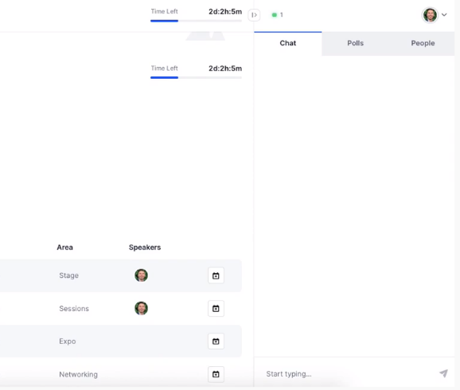
(Image description: screenshot showing Hopin chat function)
Sometimes the MC or host in a Hopin session may invite you to ask questions or be part of a discussion by sharing your audio and video.
(Image description: Screenshot with welcome message, and option to click on 'Share audio and video')
During Zoom Webinar Sessions you will be able to ask questions to the presenters using the Q&A function. You will also be able to ask more general questions in the chat box.
Both the Q&A and chat functions are explained in more detail on the Zoom Webinar controls link here

Information and help
If you are having technical issues or need support during the forum/conference please email support@yacvic.org.au.
For other information please email info@yacvic.org.au.

Access Supports
Auslan interpreters
Auslan interpreters will be provided.
During sessions, an interpreter will be in one of the video boxes on screen.
If you are an Auslan user who requires an interpreter, it’s important you please notify the organisers through your ticket registration or by contacting communications@yacvic.org.au

Breaks
You are welcome to participate as much or as little as you would like to.
We will have organized breaks throughout the day, but you are welcome to join and leave as you would like to.

Captioning
Live captions will be provided through AI Media.
To access the captions, you will need to click on the CC button in Zoom or use the link that will be provided in Zoom on the day.
If you click the link, a new window will open in your device’s web browser, and you will be able to read and scroll back through the captions.
Please note, due to the nature of live-captions, there is likely to be occasional errors with the transcription.
Epilepsy Trigger Warning
We will be using an online polling and presentation program called Menti.
In presentation mode, the screen may flicker with incoming information.
MCs and presenters will provide warnings prior to using presentation mode.

Noise
During interactive sessions, if you are eating or in a noisy environment, we ask you to please keep your microphones off unless talking.

Screen readers and Hopin
Screen readers work with Windows and iOS. We do not have information about testing with a Mac.
Testing has shown that using Hopin with iOS can be clunky. We recommend using a PC if you have the option.
If you can’t find a button, such as ‘join audio/video controls’, you may find it at the bottom of the page.
In areas where you can use video, there may be three unlabeled buttons in a row. These are
- Video on/off
- Microphone on/off
- Audio and video settings

Support Person
You are more than welcome to participate with a support worker, family member, or friend, to provide you with support.
A reminder that a support person’s role is to make it easier for you to attend and participate – they are not there to participate themselves.

