Reshape Our Future
Online/Virtual Access Key

How to attend
Tickets work for the whole day.
You can join and leave as you like.
You may like to check the Program, to make sure you don’t miss out on anything.
You do not need to have your video on, unless you are a presenter.

Online platform - Hopin
What online platform will be used?

For our online sessions, we will be using the online platform Hopin.
(Image description: Blue and white Hopin logo)

You can use Hopin with a computer, mobile phone or tablet.


You may like to download the Hopin app on your phone or tablet.
The App logo looks like this (Image description: Hopin app logo)

Some of the below information about Hopin may be a little different depending on whether you are using a computer, phone, or tablet.

You can learn more about Hopin here, or watch this video showing the features of Hopin for attendees.
Please note we may not be using all of the features mentioned.

How do I join different sessions?
You can access online sessions through Hopin in one of two ways
- YACVic will send all registered attendees a Magic Link. Clicking on the provided link will take you through to the event.
For more information about Magic Links click here.
- If you already have a Hopin account, you may like to join directly through Hopin’s Home page.
You will need to login.
You can then find the event in the list of your registered events.
For more information about how to go directly through Hopin click here.

You will not need to join different meetings/calls to attend different sessions.
You only need to join the one Hopin event.
As an online attendee, you will have a limited number of options to join.
Every hour or so, you will see what session/s are open to join.

Within the Hopin site, you can learn what sessions there are by using the menu on the left to navigate between different areas
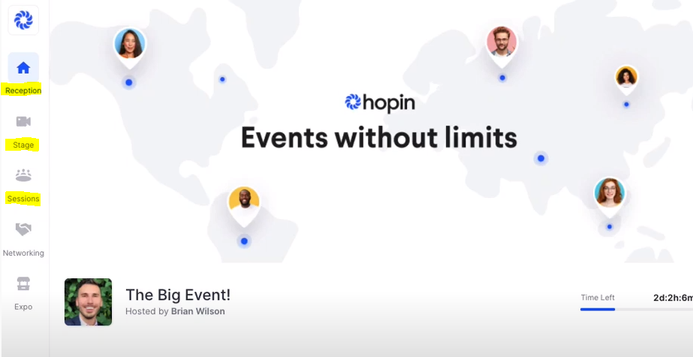
(Image description: Screenshot of Hopin site, with menu options ‘Reception’, ‘Stage’ and ‘Sessions’ highlighted.)

These areas include:
Reception – which will show the agenda and upcoming sessions
Stage – where you can find main events and sessions
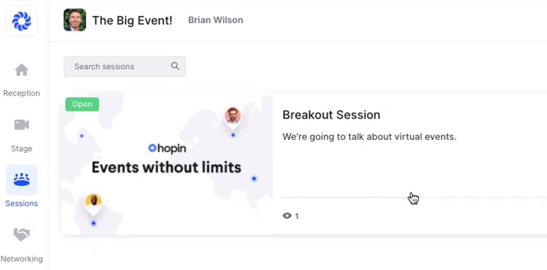
Sessions – Breakout sessions can be found here. You will need to click on the particular session you want to attend.
(Image description: Screenshot of Sessions section, with mouse icon hovering over a Breakout Session option)

What technology is needed to attend?
To attend online sessions you will need:
- A device with a screen and internet connection (such as a laptop, tablet, or smartphone)
- An internet connection strong enough to handle video streaming. This is a link to an internet speed tester.
- An internet browser (such as Chrome, Firefox, Safari, Edge, etc.)
- Earphones or headphones can be useful.
- You do not need a camera/webcam, unless you are a presenter or speaker.

How can I ask questions or make comments?
There is a text chat available throughout the conference.
You can ask questions or make comments in the text chat.
Please note there are different Chat channels, depending on what section you are in - Registration, Stage, or Sessions.
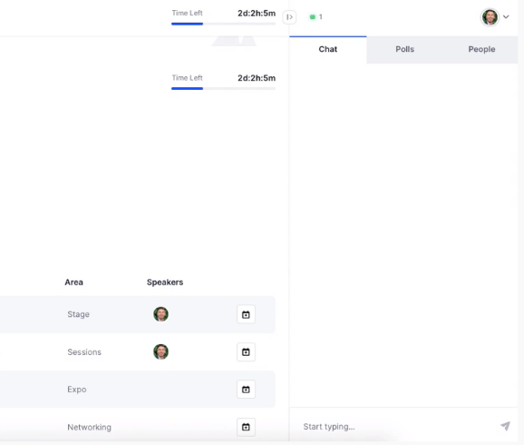
(Image description: screenshot showing chat function)

Sometimes the MC or host may invite people to ask questions or be part a discussion through the voice / video chat.
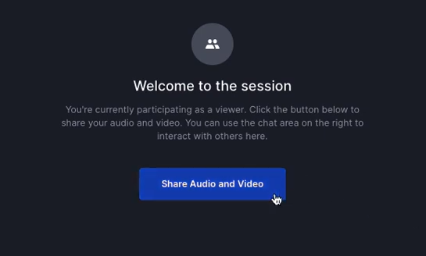
(Image description: Screenshot with welcome message, and option to click on 'Share audio and video')

Information and help
If you are having technical issues or need support during the forum/conference please email support@yacvic.org.au.
For other information please email info@yacvic.org.au.

Access Supports
Auslan interpreters
Auslan interpreters will be provided.
During sessions, an interpreter will be in one of the video boxes on screen.
If you are an Auslan user who requires an interpreter, it’s important you please notify the organisers through your ticket registration or by contacting communications@yacvic.org.au

Breaks
You are welcome to participate as much or as little as you would like to.
We will have organized breaks throughout the day, but you are welcome to join and leave as you would like to.

Captioning
Live captions will be provided through AI Media.
To access the captions, you will need to click on a link that will be provided in Hopin on the day.
A new window will open in your device’s web browser, and you will be able to read and scroll back through the captions.
Please note, due to the nature of live-captions, there is likely to be occasional errors with the transcription.
Epilepsy Trigger Warning
We will be using an online polling and presentation program called Mentimeter.
In presentation mode, the screen may flicker with incoming information.
MCs and presenters will provide warnings prior to using presentation mode.

Noise
During interactive sessions, if you are eating or in a noisy environment, we ask you to please keep your microphones off unless talking.

Screen readers and Hopin
Screen readers work with Windows and iOS. We do not have information about testing with a Mac.
Testing has shown that using Hopin with iOS can be clunky, and we recommend using a PC if you have the option.
If you can’t find particular buttons, such as ‘join audio/video controls’, you may find them at the bottom of the page.
In areas where you can use video, there may be three unlabeled buttons in a row. These are
- Video on/off
- Microphone on/off
- Audio and video settings

Support Person
You are more than welcome to participate with a support worker, family member, or friend, to provide you with support.
A reminder that a support person’s role is to enable you to attend and participate yourself – they are not there to participate themselves.

