Reshape Our Future
Melbourne
at Marvel Stadium

Getting there
Marvel Stadium has two entrances, the first is on Bourke Street via the Spencer Street/Bourke Street footbridge. You can also access Marvel Stadium from La Trobe Street.
The Bourke Street entrance is 550m from Southern Cross Station via Spencer Street and Bourke Street, towards the Harbour Esplanade. The La Trobe Street entrance is opposite Tram Stop D1, near the corner of La Trobe Street and Harbour Esplanade.
Most trainlines will go through Southern Cross Station, including VLine trains from rural and regional Victoria.
Trams 11, 48, 70 and 75 will take you to the Bourke Street/Spencer Street footbridge entrance to Marvel Stadium.
Tram 11 has level access stops at Stops 1, D14, D15, D16, D17 and D18, all of which are approximately 7-10 mins from the entrance.
Tram 48 is partly serviced by low-floor trams and stops at the same level access stops as Tram 11. Trams 70 and 75 are not currently serviced by low-floor trams.
Trams 30, 35 and 86 will take you to the La Trobe Street entrance to Marvel Stadium.
Tram 86 is partly serviced by low-floor trams and has level access stops at Stops 1 and D2. Trams 30 and 35 are not currently serviced by low-floor trams.
For more information on travel, visit the Public Transport Victoria (PTV) website or download the app.

Car parking
There is paid parking underneath Marvel Stadium at levels B3 and B2. Please park on level B3 and only park on level B2 if there is not parking available on B3.
There are multiple accessible parking spots on both levels which are closest to the building entrance. There is an accessible turnstile and lifts that go directly to the entrance gate.
Lifts should strictly be used by those who cannot take the stairs. The stairs are next to the lifts.
The cost of parking will be capped at $15 per day for anyone attending an event at Marvel Stadium, you will be supplied with a ‘follow-on’ ticket at your event to use when leaving the car park.

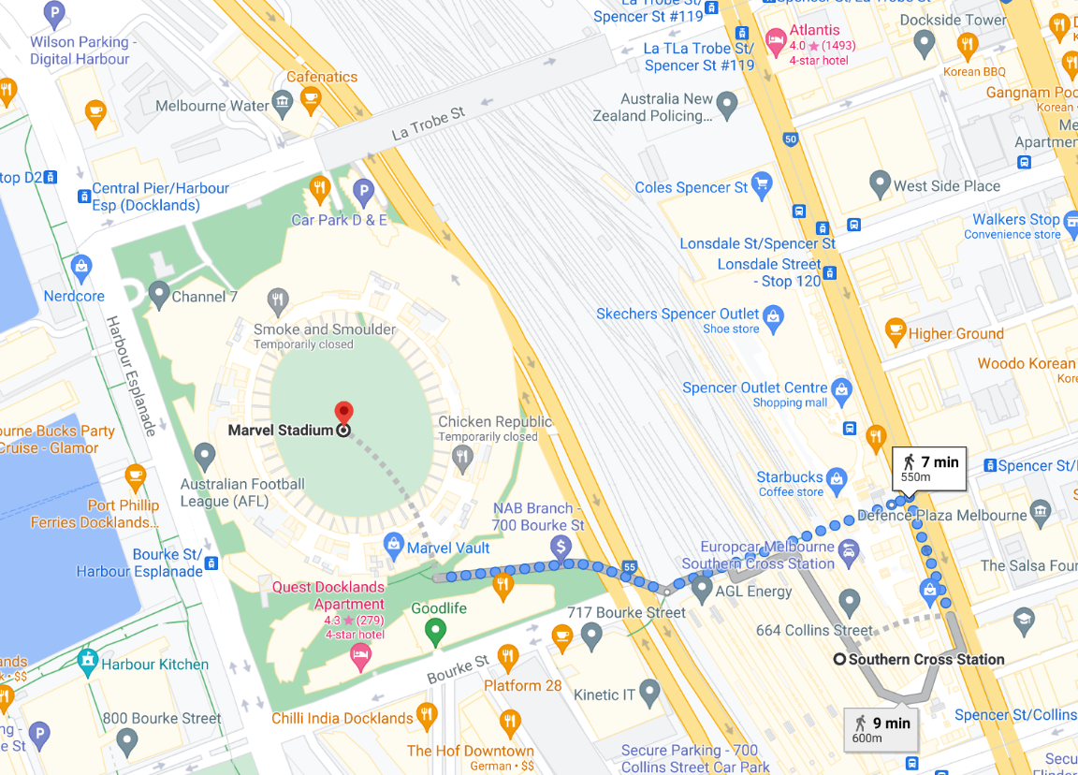
Figure 1: Bourke Street/Spencer Street footbridge entrance

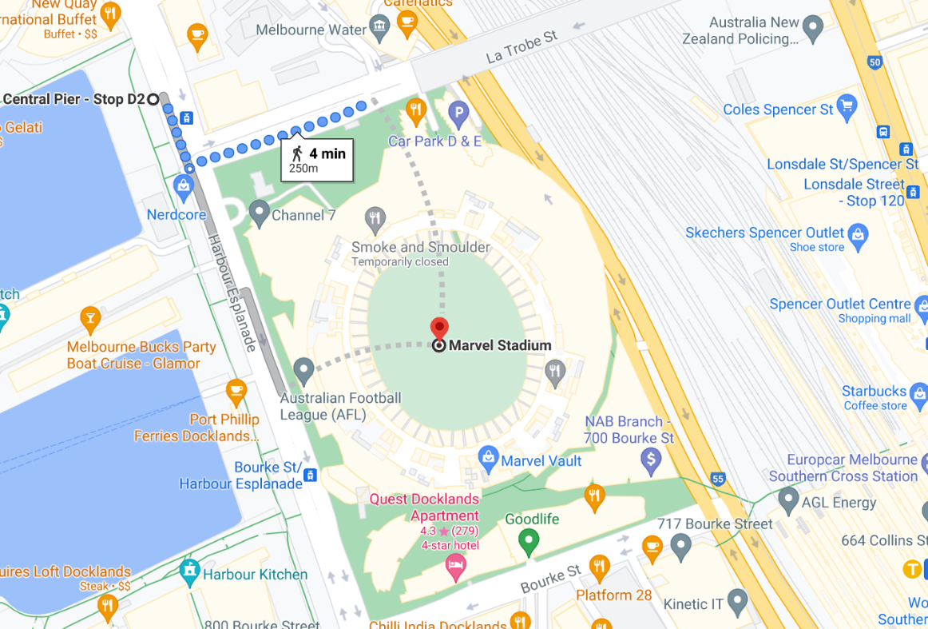
Figure 2: La Trobe Street entrance

Getting In
The entrance that leads to the event is ‘Gate 4’ (signage highlighted below). It is a small entrance to the right of the Main Entrance (Gate 5). There should be someone stationed outside and a YACVic banner to make it identifiable. Feel free to ask this person for further directions to the event.
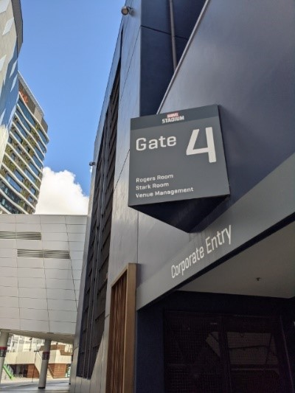
Image description: Gate 4 entry.
When you get through the door, there is a wide landing. To your left, there will be another door to a stairwell, and to your right is an automatic sliding door. The ground of the landing is concrete. Turn right and go through the automatic sliding doors.
You will go into a large foyer area. The carpet is a dark grey with a light grey pattern on it, and the lights above will be dimly lit. Directly ahead of you will be some small coffee tables with low chairs around them, and to your left you will see a registration table set up with two more banners either side, one that says ‘YACVic’ and one that says ‘Reshape Our Future’. There will also be people located at the registration table to help you sign in.

Directions:
- Once inside Gate 4, turn right immediately and go through the sliding doors.
- This is the entry into the main foyer area, from here you can turn left towards the registration desk and conference staff who will help you sign in.
- Elevators from the carpark will open up directly in the foyer, opposite the entrance door.
- Take the elevator or stairs to Level 1. The buttons outside and inside the lifts have raised symbols and Braille
- Exit the elevator and turn right. This is where the registration desk will be.

If you get lost, feel free to ask for directions. There will be signage leading from the carpark, up the stairwell and in the elevator to guide you to the venue. These will not have Braille.

Quiet Space
To access the quiet space you will need to turn left from the registration desk and go through the open door. This is the Roger Room, and will have tables, chairs, and some lounge chairs set up.
This space will be accessible for the duration of the youth forum and youth sector conference and is there if you need a chance to cool off or take a break from what is happening. Water will be provided as well as seating. The lighting will be dimmed. The floors in here are carpeted, but since it is quite close to the foyer there might be some noise that travels through. There are also bathrooms in this area, and whilst people will be directed towards other bathrooms in the venue, they may choose to use these ones.
You will also have the ability to go out into the stands if you would prefer some fresh air. There are doors located in every room (including from the Roger Room) which lead into the stadium. You are welcome to sit on any of the chairs and spend some time. Please note there is no smoking allowed in the stands.

Bathrooms
The facility has multiple bathrooms throughout the level. In the Roger Room there is one accessible bathroom and two gendered bathrooms. The gendered bathrooms have three hand basins, and a door that takes you through to the toilet cubicles. Please note in these gendered bathrooms there is another door that leads into a hallway (and an alternative exit), these doors will have signage on them. The accessible bathroom is spacious and has a handrail on the right-hand side of the toilet.

In the Parker Room (a room that will be used for afternoon breakout sessions) there is one accessible bathroom and two gender neutral bathrooms. The accessible bathroom is spacious and has a handrail on the left-hand side of the toilet. The gender-neutral bathrooms both have three hand basins, and a door that leads to the toilet cubicles.

The Stark Room and the Parker Room
To access the main room (where the event will take place), you will need to turn right from the registration desk and go through an automatic door. This will lead you into a foyer. You will need to walk about 15m to reach the Stark Room, which will be set up with round tables, eight chairs per table, and a stage with tv’s and projector screens either side of the stage.
The Stark Room is a long room with floor to ceiling windows all the way around and the same grey carpet that you saw in the foyer (this carpet is used throughout the whole venue). The room has air conditioning and lights that are able to be dimmed if necessary.
During the lunch break a white concertina wall will be put up in the Stark Room, splitting the room into the Stark Room and the Parker Room (the Parker Room will be the room furthest away from the registration desk where you entered). Both rooms will be set up identically, the gender-neutral bathrooms will be in the Parker Room.
The event isn’t likely to be very loud although there will be a use of a microphone. Other than the microphone at most, you can expect there to be a bit of loud chatter. You may hear some creaks as people walk on the floor, the sounds of doors sliding open and sometimes people talking in other rooms. During the session, you will hear people talking, chairs moving around and people shuffling paper.
The space has a slight smell of air freshener, similar to a vanilla scent, and the heating can be adjusted upon request.
The room has bright warm lights and lots of natural light. The lights can be dimmed if necessary, so if you would like this, please let one of the organisers know.
Many power points are provided along the walls close to the floor. If you choose to plug in a device, please be aware of where it is and make sure it isn’t in danger of being stepped on or tripped over.
Food, which will be mostly finger food, and drink are available during most of the day. You are welcome to also bring your own food if you like. Alcohol and smoking are prohibited in the building (including in the stands).
The event will be Auslan interpreted. You are welcome to bring any devices you use to communicate – these could be phones, tablets, communication boards or pen and paper.
The activities are mainly visual, and you are encouraged to talk to other people. There will be people to support you to do the activities if you would like support.

Activities:
In the session, you will be asked to record your thoughts and ideas. If you would like, you can get support to do this.

Epilepsy Trigger Warning
We will be using an online polling and presentation program called Mentimeter.
In presentation mode, the screen may flicker with incoming information.
MCs and presenters will provide warnings prior to using presentation mode.

Other people:
At the session, there will be Auslan interpreters, a facilitator, multiple presenters throughout the day, and other people who are attending or organising the session. YACVic staff will be identifiable via a large name badge, and you can ask any of them for support throughout the forum or conference.

