Reshape Our Future
Lakes Entrance
at Bellevue on the Lakes
Getting here
The address of Bellevue on the Lakes is 201 Esplanade, Lakes Entrance. It overlooks the Cunninghame Arm Harbour.
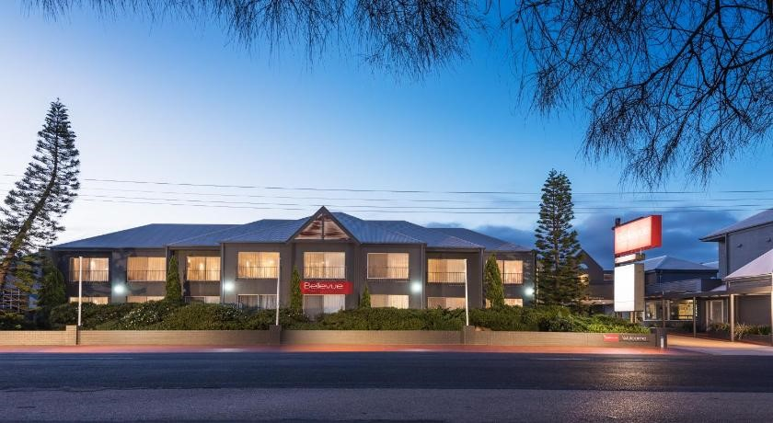
Image description: a photo of the outside of Bellevue on the Lakes.
If you’re driving from Melbourne, the Bellevue on the Lakes is one of the first places you will see on your left as you drive through. It looks like a hotel-motel from the outside. The Bellevue on the Lakes is 150 metres from the closest Lakes Entrance Bus stop.
If you are traveling using public transport, you can use this V/Line Timetable to plan your journey.

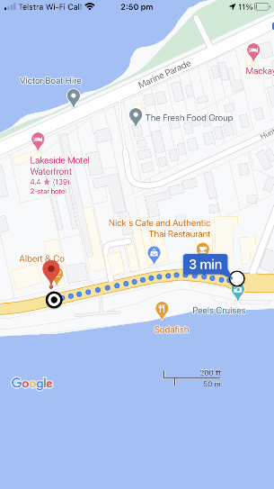
Image description: a map from the V/Line stop to the venue.
Footpaths and curb cuts
The footpath from the bus stop to the venue is three metres wide and is smooth concrete with 30 cms of accented pebbles.
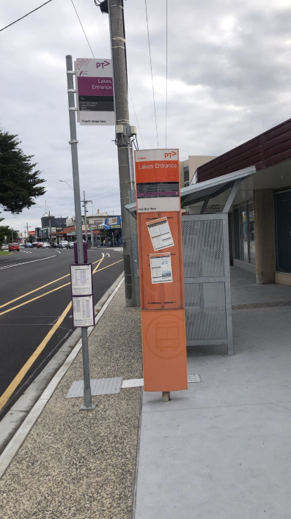
Image description: the bus stop, sidewalk, and accented pebbles.
Car parking
There is car parking available onsite (with access from the Princess Highway on the esplanade and in the street behind the venue marine parade. 2-hour parking is available roadside, and a large public carpark is also available directly opposite the venue, this public carpark as a clearly identified accessible parking space.
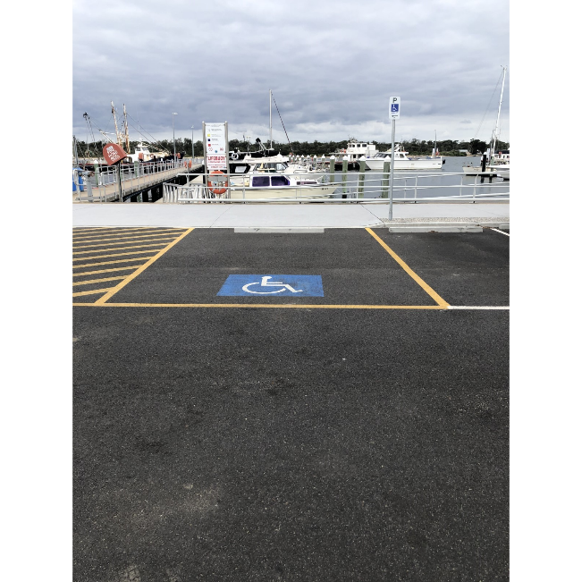
Image description: a photo of the accessible parking spaces at the venue.

Getting In

Directions:
Overlooking Cunninghame Arm harbour, the hotel is directly opposite the wooden sculptures that line its foreshore (pictured below).
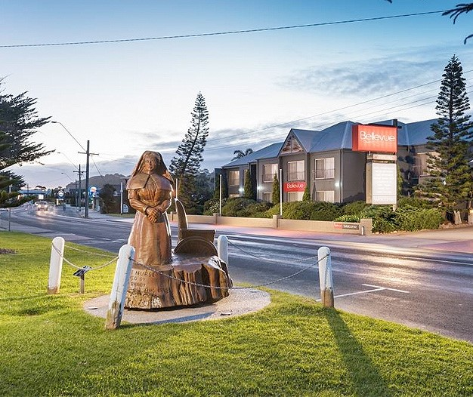
Image description: statue lining the foreshore.
Doors
The entrance to the conference is via a large double door which is pictured below.
There will be clear signange and conference staff available to help you find your way.
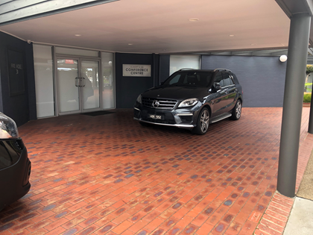
Image description: a photo of the entrance.
Steps
There are no steps to access this conference facility.
Lift
There are no lifts to access this conference facility.
Greeter
A greeter will meet you at the door of the conference venue. If you are in need of assistance, or have any questions, please ask.

Quiet Space

There is access from the main room to the chill out space. Our ‘chill out’ space will be labelled and is accessible via a door labelled ‘the Captains Boardroom’.

This space will be available for the duration of the day. You can visit the room if you need to take a break. There will be seating and water available. The lighting will be dimmed by using the dial on the wall. The floors are carpeted, but since it is quite close to the main room, it might still be a bit noisy.

The chill out space has a capacity of 15 people.

Bathrooms

There is one accessible bathroom with shower and two gendered bathrooms with toilet cubicles. The accessible bathroom is spacious and has a handrail on the left-hand side of the toilet and the wall to the left of the entrance.
Toilets can be accessed via a hallway to the right of the conference room, this hallway (150cm wide) leads to the gendered toilets on the left and the accessible toilet is accessed via a short hallway (120cm wide) on the right.
The door to the accessible toilet is heavy. There are two doors to access the gendered toilets that have 2 sinks, 3 toilet cubicles and baby change facilities. Handrails are located in the accessible toilet only.

The Venue:
The conference will be held in a conference centre with 200 seats. The Albert & Co Catering team will provide in-house catering in the Maranui Ballroom. This space will be directly accessed via the main conference doors.
Internal doors
Internal doorways are 80cm wide. The hallways are 120cm wide.
Power access
Many power points are provided along the walls close to the floor. If you choose to plug in a device, please be aware of where it is and make sure it isn’t in danger of being stepped on or tripped over.
Floors
The majority of floors throughout the venue are carpeted. Bathrooms are tiled, and entryways and alternative spaces are a floating linoleum wood. The floors are quiet to walk on.
Seating
There are padded chairs covered in black cloth fabric. Seating is cabaret style with 8 – 10 people per table. This is pictured below.
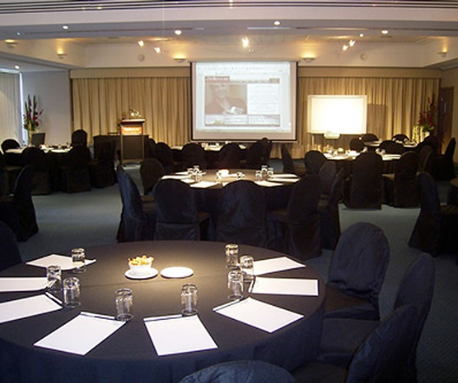
Image description: cabaret style seating at the venue.
Food/drinks
Additional food and drinks are available onsite via the Albert and Co Café at the front of the venue. The conference will be catered.If you haveany dietary requirements please notify us via your booking.
Noise
The event isn’t likely to be very loud. There will be use of a microphone. Other than the microphone, you can expect there to be loud chatter. You will also hear a quiet buzz of the air conditioning, some creaks as people walk on the floor, the sounds of doors swinging open and at times some background music. The doors on the right side of the room lead to kitchens, so when they open you might hear some kitchen sounds. During the session, you will hear people talking, chairs moving around on carpet, and people shuffling paper.
Lights
There is dim soft lighting throughout the venue and large open windows allowing natural light.
Temperature
The venues internal temperature is around 21-23 degrees in a climate-controlled environment.

Smells/scents
There is a low level of fragrance in the venue. There is a faint hint of cleaning products. As there will be a high number of people in the room, there may be strong people scents or perfumes.
As the catering is on site, there may at times be smells that come from the kitchen, particularly around meal preparation times.
Smoking
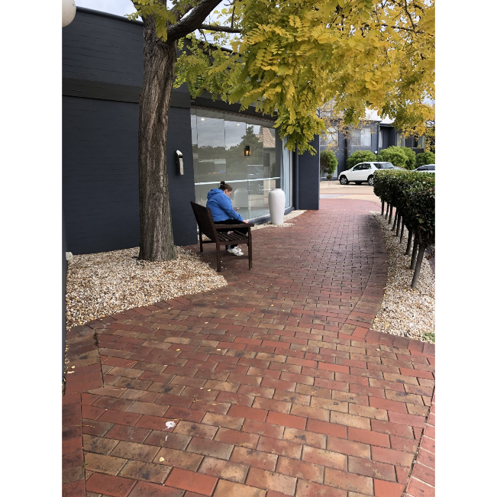
Image description: smoking area near the main entrance.
There is no smoking in the venue and no noticeable smells of smoking. A smoking area is accessible to the left of the main entrance around a corner with a bench seat under a tree.
Auslan
The event will not be Auslan interpreted, aside from streamed sessions. You are welcome to bring any devices you use to communicate. These could be phones, tablets, communication boards or pen and paper.

Epilepsy Trigger Warning
We will be using an online polling and presentation program called Mentimeter.
In presentation mode, the screen may flicker with incoming information.
MCs and presenters will provide warnings prior to using presentation mode.

