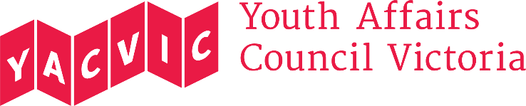

Title: | HR & Payroll Coordinator
Reporting to: | Office & HR Manager
Hours: | 0.8 FTE, 34.0 hours a week (4 days a week)
Remuneration: | $70,404 p.a. pro-rated, classified under the SCHADS Award at Employment Level 4.1.  (YACVic pays above award rates, with generous T&C.)
Status: | This is a fixed term, 8-month contract.
Location: | Based in Melbourne CBD, with working from home arrangements during COVID-19.

About the Youth Affairs Council Victoria (YACVic)
Youth Affairs Council Victoria (YACVic) is the peak body and leading policy advocate on young people’s issues in Victoria. YACVic’s vision is that the rights of young people in Victoria are respected, and they are active, visible and valued in their communities. YACVic is an independent, for-purpose, member-driven organisation that represents young people (aged 12–25 years) and the sector that works with them.
YACVic provides additional targeted advocacy and services through our key services, YACVic Rural and the Youth Disability Advocacy Service, and our auspiced partner, the Koorie Youth Council.
Working for Victoria Fund
The Working for Victoria (WfV) Fund is part of the Victorian Government's $1.7 billion Economic Survival Package to address the impact of the COVID-19 crisis. The Fund supports the creation of new short-term roles, and has partnered with Sidekicker to support job seekers to find work. Under this initiative, a coalition of eight youth-focused organisations, led by YACVic, has received funding to employ a variety of roles to strengthen youth outreach and the youth sector in Victoria in light of the COVID-19 crisis. This is one of those roles.
About the role
The HR & Payroll Coordinator will work as a member of YACVic’s small but dynamic Corporate Services Team. They will provide a range of support and services to help meet the organisation's needs, in particular, in relation to the WfV roles recruited by YACVic, and to identify and work on issues resulting from COVID-19.

Major Duties
- Assist with office and HR administrative processes, including Microsoft 365, payroll, HR registers, assets register and staff files.
- Support and coordinate recruitment, in particular for YACVic’s WfV roles – screening candidates and booking interviews through Sidekicker, filing applications and setting up Zoom interviews and meetings.
- Ensure on-boarding of new employees, including but not limited to Xero processing, new hire paperwork, and rostering and allocation.
- Assist with OHS questions from staff, and provide advice on working from home arrangements including well-being support.
- Assist with salary and payroll queries, and payroll-related reporting including staff turnover and leave.
- Support development and implementation of HR policies and procedures, in particular in relation to COVID-19 restrictions and safety.
- Assist with coordinating professional development and training sessions.
- Assist with HR special projects as required.

You will be required to perform these duties, and any other duties the Office & HR Manager or Corporate Services Manager may request, having regard to your skills, training and experience.

Reporting
This role reports to the Office & HR Manager. This role has no direct reports.

Employment conditions
YACVic is an Equal Opportunity Employer. People with disability, people from culturally and/or linguistically diverse backgrounds, and Aboriginal and Torres Strait Islander people are encouraged to apply for this position.

YACVic promotes the safety, wellbeing and inclusion of all children and young people, and takes child protection very seriously. All employees are subject to screening and assessment against child safety standards, including rigorous background, identity and reference checks. The successful applicant will require a current Working with Children Check and Police Check (costs reimbursed) and must agree to adhere to our child safe policy and code of conduct.

To be eligible to apply for this position you must be an Australian or New Zealand citizen, a permanent resident or hold a valid work permit or visa.

If you have any questions about the role, please contact Stephanie Brenkovich at recruitment@yacvic.org.au.

