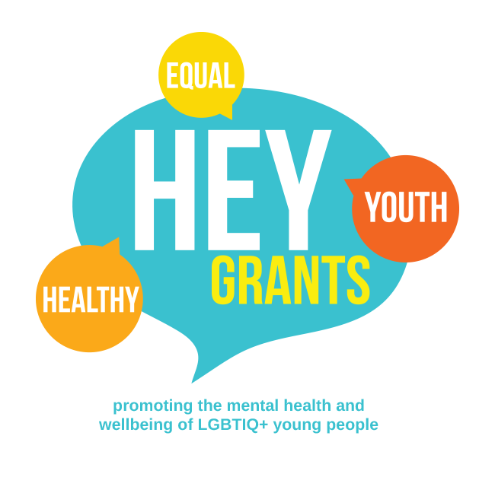
HEY Grants: Round 9 2020
Lesbian, gay, bisexual, transgender, intersex and
queer (LGBTIQ+) youth mental health small grants

Funding application form
Youth-led Initiatives ($10,000)

Submissions close 9am Wednesday 18 September 2019
ORGANISATION/GROUP
Organisation name:
Auspice name (if different from above):
ABN:
Postal address (incl. postcode):
Project location address (site address):
Phone:

MAIN PROJECT CONTACT PERSON
Title:
Last name:
First name:
Phone:
Email:

SECONDARY PROJECT CONTACT PERSON (if different from above)
Title:
Last name:
First name:
Phone:
Email:

YOUR PROJECT DETAILS
Project title:
Total project budget:
Amount requested from this grant round:
Anticipated start date:
Anticipated end date:
Have you applied before? If yes what year?

BRIEF DESCRIPTION OF YOUR ORGANISATION (2-3 sentences)

PLEASE IDENTIFY WHICH GROUPS OR ISSUES YOUR PROJECT TARGETS (you can tick more than one):
Same sex-attracted young people

Transgender or sex/gender diverse young people

Rural and regional SSAY or transgender or sex/gender diverse young people

Youth/community/health workers working with LGBTIQ+ young people

Other – please list:

BRIEF DESCRIPTION OF YOUR PROJECT – THIS SHOULD OUTLINE EXACTLY WHAT YOU ARE SEEKING FUNDING FOR (200 words max):

PLEASE LIST THE ACTIVITIES YOU ARE PROPOSING TO CONDUCT AS PART OF THE PROJECT (150 words max):

HOW MANY YOUNG PEOPLE OR WORKERS IS IT ANTICIPATED THE PROJECT WILL REACH?

GRANT CRITERIA: THE GRANTS COMMITTEE WILL ASSESS YOUR APPLICATION AGAINST THE CRITERIA LISTED IN THE SMALL GRANTS GUIDELINES:
- How will LGBTIQ+ young people be engaged with the project? (60%) (250-300 words max)
- How will the project support and promote the mental health and well being of LGBTIQ+ young people? (20%) (250-300 words max)
- How will the project meet demonstrated community need? (10%) (250-300 words max)
- What measures will be used to determine the project’s success? (10%) (250-300 words max)

YOUR BUDGET
Total income received for project |  |  | Expenditure of HEY Grant funding
Amount requested from HEY Grant round: | $ | Item  (eg. Venue hire): |  | Cost $
Other funding (i.e. grant funding or organisational input?) List here: | Cost $
Total income: | $ | Total expenditure: |  | $
Please note if you are listing a cost for salaries please show on costs separately. By on costs we mean superannuation, leave loading, work-cover and any other costs associated with employment.

BEFORE SUBMITTING THIS APPLICATION, PLEASE CHECK YOU HAVE:
- Completed all sections
- Included a maximum of two letters of support with contact details

Please DO NOT include any additIonal information in your application.

All applications must be received by 9.00am Wednesday 18 September 2019.
No late applications will be accepted.

Submitting your application:

In ONE email please send your application and two letters of support (formatted in Word or PDF) to info@yacvic.org.au with ‘HEY Grants Round 9 – Youth Led – [Organisation name]’ in the subject line.

Once an application has been received, you will receive a confirmation email. If you do not receive a confirmation email within two business days please follow up with us as there may be a problem with your submission.

If you have any questions that aren’t answered in the Grants Criteria or the Grants Guidelines on the YACVic website (www.yacvic.org.au), please call the YACVic office on 03 9267 3700.

