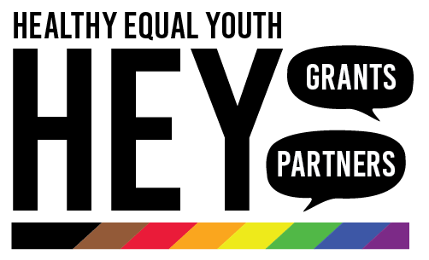
HEY Grants Round 11 Criteria
Lesbian, gay, bisexual, transgender, intersex, queer and asexual (LGBTIQA+) youth mental health and wellbeing small grants

Submissions close 11:59pm Sunday 15 August 2021

Two types of grants are available in Round 10 of the HEY Grants. Both categories are for up to $10,000.

- Youth led projects: for LGBTIQA+ young people with innovative projects they know will support their LGBTIQA+ peers. A youth led application must be proposed and led by people who are under 25! (They can get people older than that to proofread and assist them).
- Social Connectedness projects: for services to expand or improve their support for LGBTIQA+ young people, and for targeted projects for LGBTIQA+ young people that will improve their mental health and wellbeing.

Grants criteria
Social Connectedness (for grants of up to $10,000)
- How will the project support and promote the mental health and wellbeing of LGBTIQA+ young people? (25%)
- What problem or need in the community will the project address, and how will it be addressed? (25%)
- How will LGBTIQA+ young people be engaged and involved with the project? (40%)
- What measures will be used to determine the project’s success? (10%)

Youth-led Initiatives (for grants of up to $10,000)
- How will LGBTIQA+ young people be engaged and involved with the project? (60%)
- How will the project support and promote the mental health and wellbeing of LGBTIQA+ young people? (20%)
- What problem or need in the community will the project address, and how will it be addressed? (10%)
- What measures will be used to determine the project’s success? (10%)

HEY Day Participation
All successful grant recipients are expected to attend the annual HEY Day, where we formally announce the grants on 30 November, 2021. The day is designed to link all grant recipients with the HEY partners across the state. The format and date of HEY Day will be announced closer to the day, depending on COVID-19 restrictions in Melbourne and Victoria.

Grants Criteria

 | Social Connectedness | Youth-led Initiatives
Approach | Utilising existing models to improve or increase the support available to LGBTIQA+ young people (e.g. social support groups, gay/straight alliances, information and referral services, professional development activities). | Utilising existing models to improve or increase the support available to LGBTIQA+ young people (e.g. social support groups, gay/straight alliances, information and referral services, professional development activities).
Level of innovation | Preferred, but not essential. Projects in this category may draw from, or replicate, existing models to meet local need. | Youth-led initiatives are encouraged to be as creative and innovative as they like with their projects.  However, projects in this category may draw from, or replicate, existing models to meet local need.
Partnership | Can be delivered by an individual organisation. | Can be delivered by an individual youth leader in partnership with another organisation, as long as young people maintain control of the project.
Youth participation | Projects should be based on identified community need. This need may be demonstrated through existing data collected from young people and service providers and/or anecdotal evidence. Where appropriate, young people should be involved in decisions about the direction of the project. | Entire project must be youth-led in design, delivery and management.
Evaluation | Reporting will reflect consultation with participants about the impact of the project on their health and wellbeing. | Reporting will reflect consultation with participants about the impact of the project on their health and wellbeing.
Inclusion criteria  Note: Proposals that do not meet the inclusion criteria will not be considered. | The project is designed for LGBTIQA+ young people. The application demonstrates a need for the project, program, or service in the LGBTIQA+ community.  Does not duplicate an existing project, program, or service in the LGBTIQA+ community. | The project is designed for and by LGBTIQA+ young people.  The project does not duplicate an existing project, program, or service in the LGBTIQA+ community.

