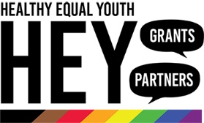
Grant Application
Social Connectedness
HEY Grants Round 13

Key Questions
Below are the key questions you will be asked to respond to as part of your grant application. Use this document to refine your application responses before copying and pasting it into SmartyGrants.

Describe your project in 50 words or less.
This is the description we will use when describing your project to government, to stakeholders, in media releases, and on social media.

For example, we would say, “Healthy Equal Youth (HEY) is a mental health and wellbeing program that supports a network of 16 partners who work with LGBTQIA+ young people across Victoria. The HEY Grants support innovative projects that improve the mental health and wellbeing of Victorian LGBTIQA+ young people.”

Please list the activities you are proposing to conduct as part of the project:
(150 words max)

Grant Criteria:
The grants committee will assess your application against the criteria listed in the HEY small grants guidelines.

If quoting a study, a report, or any statistics, provide a reference for where to find them. A study name with an author and year, or a web address is fine.
- How will the project support and promote the mental health and wellbeing of LGBTIQA+ young people? (25%) (250-300 words).
- What problem or need in the community will the project address, and how will it be addressed? (25%) (250-300 words).
- How will LGBTIQA+ young people be engaged and involved with the project? (40%) (250-300 words).
- What measures will be used to determine the project’s success? (10%) (250-300 words).

