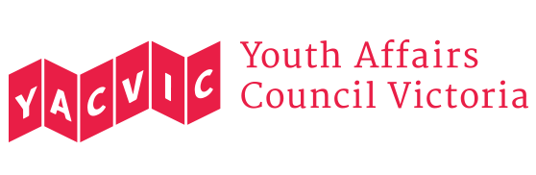
Permission and Talent Release Form
The Youth Affairs Council of Victoria (YACVic) is the peak body and leading policy advocate on young people's issues in Victoria. We support youth projects, services and organisations.
At times, YACVic takes photographs/video of young people (12-25 years old) to use in our publications and communications materials, including on our website and social media (including but not limited to Facebook, Twitter and Instagram).
In order to use your photograph, image, words, artwork or video/audio recording for ongoing use in the marketing and promotional materials of YACVic, we need your permission.
I (name) grant YACVic the permission to publish, reproduce or otherwise use my image, including in marketing and promotional material, in printed and online formats.
- I understand I will not receive any payment or royalties for the use of my image.
- I understand I can revoke this permission at any point in the future, although it will not be possible for documents already printed/posted online with my image to be withdrawn from use.
Signature Date
Phone Email
If under the age of 18:
I, (name of parent/guardian) give permission for my child to have their photograph(s) taken. I also give my permission to publish, reproduce or otherwise use their image, including in marketing and promotional material, in printed and online formats.
Signature Date
Phone Email

