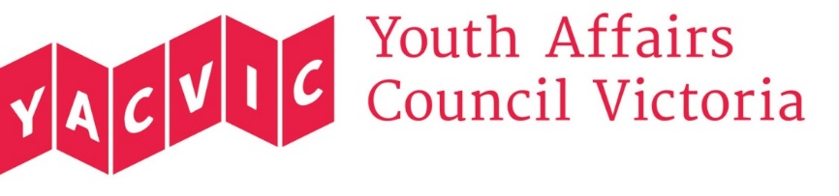

Board of Governance 2018

Nomination Form

*Please note that YACVic Board meetings are held from 4-6pm on the fourth Thursday of every second month, with the first meeting to be held within one month of the AGM. You need to be available to attend these meetings in order to nominate.
Please indicate which position you are nominating for:
Non-young person position
Young person position*
Rural position**
*Nominees for designated young person positions must be between the ages of 12 and 25 (inclusive) on the date of the AGM.
**Rural means a person (excluding a young person) who is a representative of the rural/regional sector of Victoria.
Full name
Organisation (if applicable)
Address
Phone
Email

YACVic’s Constitution states that nominations must be proposed by another member of YACVic.^

Proposer’s name and organisation (if applicable):

Signature:
IMPORTANT: Along with your nomination form, please email a short statement (no more than 150 words) to admin@yacvic.org.au. This statement about yourself, your skills and why you are interested in the role will be provided to members for voting purposes.

Return your nomination form with your short statement no later than 5.00pm 2 October 2018 to admin@yacvic.org.au. Copies of the YACVic Constitution are available on our website at www.yacvic.org.au. If you have any questions, please call the YACVic office on 0438 638 734.

^Procedure for nominating new board members: Clarification of Sections 24 and 25 of the Youth Affairs Council of Victoria’s Constitution (Election of Board members)
Section 24 of the YACVic Constitution requires that nominations of candidates for election as Board members be in writing and signed by a member other than the candidate. Section 24 also empowers the YACVic Board to determine policies to do with nomination requirements.
The following policy applies as to who the member signing a candidate’s nomination form may be. This person must be a current member of YACVic, either as an individual member or an organisational member. Any individual member may sign any member’s nomination form. However, if the candidate works for an organisation that is an organisational member, the organisation’s representative may not sign the nomination and either a representative of another organisation or an individual member needs to sign the nomination.
Section 25 of the YACVic Constitution sets out the requirements for the nomination of the rural person on the Board. This person will be a representative of the rural/regional sector of Victoria. The same interpretation with respect to who may sign the nomination form (as set out above) applies.
If you have any questions about these requirements for signing nominations, please contact the YACVic office on 0438 638 734 or admin@yacvic.org.au for clarification or assistance.
NB 1 “Individual members” include individual concession members, young members and life members; “organisational members” include youth led organisational members, Local Government members and associate members.
NB 2 The requirements for becoming a member of YACVic are set out in the YACVic Constitution which is available on the YACVic website.

