**Disability Pride Starts Here  
Work with us**

**Youth Disability Advocacy Service**

This is an Easy English book.  
It uses pictures to explain ideas.

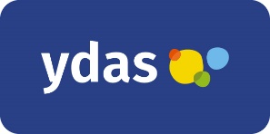**What is this book about?**

This book is from Youth Disability Advocacy Service or YDAS.

We support disabled young people in Victoria.

This book is about our Disability Pride project.

We will call it the project.

The project is from March to June 2023.

You can work with us on the project.

This book has some words in **bold**.

The **bold** words are hard words.

We will write what the hard words mean.

**What is the project?**

The project is about **disability pride**.

If you feel disability pride you might

* 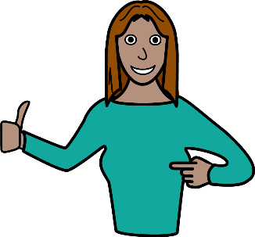Understand the good things about disability
* A picture containing text

  Description automatically generatedThink about how disability helps you
* Talk about how disability helps you.

For example, you might be good at speaking up for yourself because of your disability.

We will work with disabled young people to help the community understand disability pride.

We will make content about disability pride.

We might make

* Videos
* Icon

  Description automatically generatedBlog posts
* Art work.

Disabled young people will

* Tell us what disability pride means to them
* Help us choose what content to make.

**Is the project for me?**

We are looking for 5 young people for the project.

You can help us with the project if you

* + - * Diagram

        Description automatically generatedHave a disability  
          
        or
      * Shape

        Description automatically generated with medium confidenceHave a chronic illness  
          
        or
      * Are deaf or hard of hearing  
          
        or
      * Are blind or vision impaired  
          
        or
      * Are autistic.

You can also help us with the project if you have a **mental illness**.

Mental illness is a problem that changes how you

* Think
* Feel
* Act.

We want to hear from

* + - * LGBTQIA+ young people
      * First Nations young people.

We also want to hear from young people from different cultures.

You also must be

* 12 to 25 years old and
* Live in Victoria.

**What will I have to do?**

You will have to come to 4 online workshops.

The workshops will be on Zoom.

You will

* Work with 4 other disabled young people
* Help us choose what we will make.  
  For example, if we make art or a piece of writing.

**When are the workshops?**

Workshop 1  
Thursday 30 March 4pm to 6pm

Workshop 2

Thursday 13 April 4pm to 6pm

Workshop 3

Thursday 20 April 4pm to 6pm

Workshop 4

Thursday 4 May 4pm to 6pm

**Will you pay me?**

We will pay you $50 for every hour you work.

**How do I apply?**

If you want to help us with the project, answer some questions about you.

Website  
<https://www.surveymonkey.com/r/disabilitypridestartshere>

You can also tell us your answers on the phone.

You must apply by 9 AM Monday 20 March 2023.

**What if I want to know more?**

Contact Jun.

Jun works with YDAS.

You can email or phone Jun if you have any questions about the project.

Email address   
[**jlee@ydas.org.au**](mailto:jlee@ydas.org.au)

Phone number

**0457 453 784**