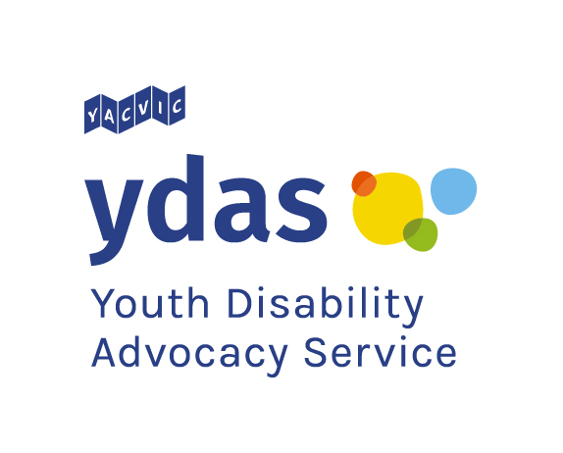
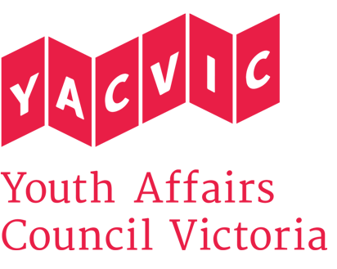

Title: | YDAS Emerging Young Leaders Program Assistant and Facilitator
Reporting to: | YDAS Program Coordinator
Remuneration: | $38.11 per hour. Classified as SCHADS Award Level 3.1 for casual employees. (YACVic pays above award rates, with generous T&C.)
Status: | Casual (approx. 16 to 20 hours a week)
Location: | Based in Melbourne CBD, with state-wide travel.

Youth Disability Advocacy Service (YDAS)
YDAS is a core YACVic agency, funded by the Victorian Government. YDAS has a service model which places the human rights and interests of young disabled people at the center of its work. YDAS undertakes individual and policy advocacy to support young disabled people to have a stronger voice, reduce the barriers that they experience and improve their quality of life.

About Youth Affairs Council Victoria (YACVic)
Youth Affairs Council Victoria (YACVic) is the peak body and leading policy advocate on young people’s issues in Victoria. YACVic’s vision is that the rights of young people in Victoria are respected, and they are active, visible and valued in their communities. YACVic is an independent, for-purpose, member-driven organisation that represents young people (aged 12–25 years) and the sector that works with them.

YACVic provides additional targeted advocacy and services through our key services, YACVic Rural and the Youth Disability Advocacy Service, and our auspice partners, the Koorie Youth Council and the Victorian Student Representative Council.

About the Emerging Young Leaders Program
The Emerging Young Leaders Program is a workshop series for young Victorians who identify as having a disability, being Deaf, being neurodiverse and/or having lived experience of mental health issues.

The series of four (4) half-day workshops allows young people to grow their skills, knowledge, confidence and motivation. The program also provides opportunities for jobs, volunteering, and other ways to continue a leadership journey.

The goal of the EYLP is that young people with disability are in influential leadership roles in a diverse range of organisations and communities. We want participants to use their leadership skills in work and their communities.

Each series of workshops has up to 15 disabled young people coming together in an accessible and inclusive space. There are four groups of participants each year. These workshop series take place in Melbourne and regional Victoria. Ages of participants range from 14 to 25. Our participants have a wide range of disabilities.

Participants build their knowledge of who they are, their confidence in teamwork and communication, and their advocacy and project skills.

Workshops are a mix of hands-on activities and discussions. Each workshop features a guest speaker who is an established disabled leader in their field. Each workshop is co-facilitated by two YDAS team members and supported by a trained mental health and physical aid support worker.

POSITION DESCRIPTION
About the role
The YDAS Emerging Young Leaders Program (EYLP) Assistant and Facilitator will support planning and preparation of the EYLP workshops, and delivery as one of two co-facilitators of the core component of the program to the emerging young leaders with disability.

Planning and preparation for each program group includes communicating with participants during the selection process; learning about and understanding their leadership goals and access needs; confirming their sign up, forms and surveys; and preparing the workshop materials in advance.

During the workshops, responsibilities will include rehearsing; keeping workshop content and materials organised; and setting up, jointly facilitating, and wrapping up each day’s workshop.

The Program Assistant and Facilitator will monitor the participants for child safety concerns (training will be provided). Additionally, the Program Assistant will track each participant's journey throughout the program and adjust for the following weeks’ workshops in response.

Other responsibilities include communicating with young people and organisations that support the program; providing short-term mentoring and advice to participants; and responding to any emergent tasks the workshops may have produced.

The Program Assistant will also support development of a EYLP Graduate Support Plan. This to ensure young leaders who finish the program secure opportunities to continue developing their skills, confidence and knowledge of leadership.

The Program Assistant will also provide advice to the EYLP team on how to work with and support young people with disability, based on their own lived experience.

The Program Assistant reports to the EYLP Program Coordinator and works closely with the EYLP Program Officer.

Key Responsibilities: What you’ll be doing
Facilitate Emerging Young Leaders workshops for disabled young people.
Review program materials to ensure they are effective for the audience.
Provide support to young disabled people to understand what leadership means and how they can lead.
Develop a Graduate Support plan for the graduates of the EYLP, supported by the team.
Maintain appropriate notes to document workshop outcomes.
Work with the Program Coordinator and Program Officer to evaluate the program.
Carry out any other duties senior managers may assign to you, having regard to your skills, training and experience.

KEY SELECTION CRITERIA: What you’ll need to show
- How you have upheld the rights and interests of disabled people.
- Proven ability to build rapport and work effectively with young people.
- Experience and skills in facilitating groups, classes, teams or workshops.
- Experience and skills communicating with young people on an individual basis.
- Demonstrated understanding of appropriate behaviours when engaging with children and young people, including those with diverse needs and/or backgrounds, and commitment to the Code of Ethical Practice for the Victorian Youth Sector.
- Highly developed organisational and technology skills, including use of videoconferencing (Zoom) and Microsoft Office software.
- Willingness and capacity to travel throughout Victoria and work occasional evenings.

DESIRABLE CRITERIA: What would be good to show

- Previous experience in a leadership role would be an advantage.
- An interest or desire to lead in a specific field or focus area.
- Experience of coaching or mentoring.
REPORTING
The Program Officer reports to the YDAS Emerging Young Leaders Program Coordinator.
EMPLOYMENT CONDITIONS
YACVic is an Equal Opportunity Employer. People with a disability are strongly encouraged to apply for this position.
YACVic promotes the safety, wellbeing and inclusion of all children and young people, including those with a disability, those who are Aboriginal or those from refugee or migrant backgrounds. We take child protection very seriously. All employees are subject to screening and assessment against child safety standards, including rigorous background, identity and reference checks. The successful applicant will require a current Working with Children Check and Police Check (costs reimbursed) and must agree to adhere to our child safe policy and code of conduct.
APPLICATION PROCESS
Applications should be emailed to Steph Brenkovich, HR & Office Manager at recruitment@yacvic.org.au with ‘EYL Program Assistant’ in the subject line and must include:
- A brief cover letter/email (no longer than 1 page), or video/audio recording (no longer than 5 minutes).
- Your resume
- Your response to the Key Selection Criteria, and if you can, the Desirable Criteria, explaining how and what you have done before.
- Contact details for a minimum of two referees, including your most recent line manager (we will not contact referees without your permission).
- Any access needs or requests you might have.
Only applications that follow the above process will be accepted and considered for interview.

Applications close at 5pm Wednesday 25 March. Interviews are likely to be the week starting 30 March 2020 in Melbourne CBD.

If you have any questions about the role, please contact Simon Green by emailing sgreen@ydas.org.au or by calling 03 9267 3700.

