YDAS Survey about the Disability Royal Commission

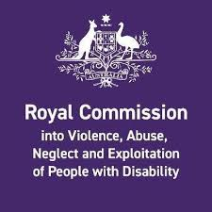

This form is easy to understand.
It has pictures to help explain ideas.

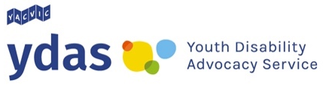
This form was made by YDAS.
When you see “we” or “our” it means YDAS.

Some words in this form are bold.
They are hard words.
We will tell you what they mean.
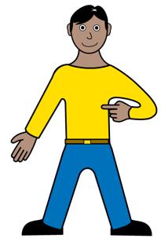
This form will ask you questions about:
- You
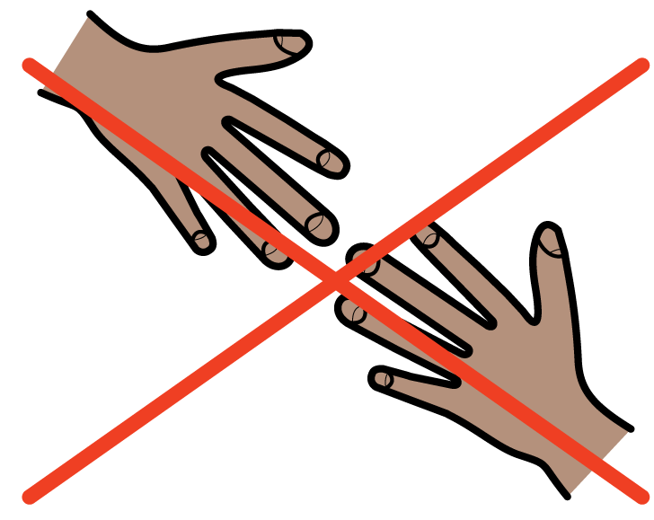
- How other people have made you feel
- If you have not been supported the way you should be
- Where you have worked
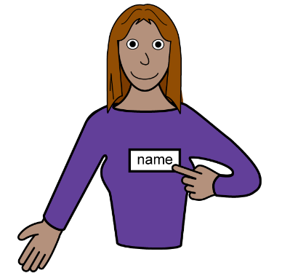
Questions about you

What is your name?

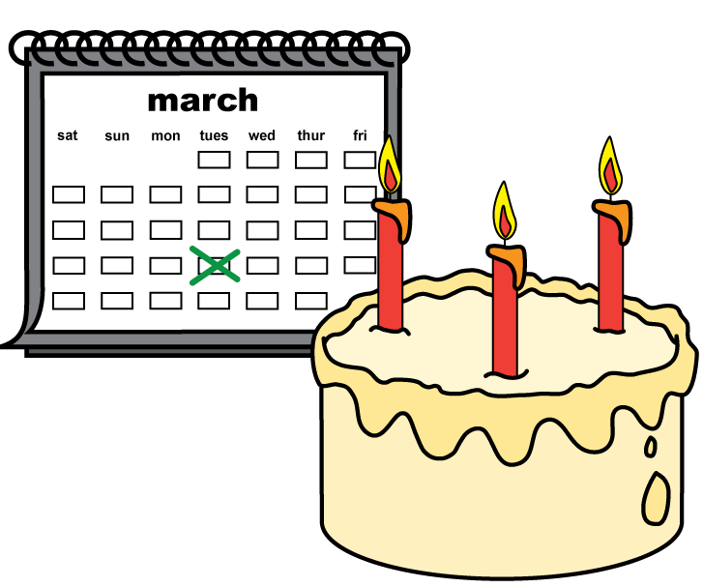

How old are you?

What is your gender?
- Female
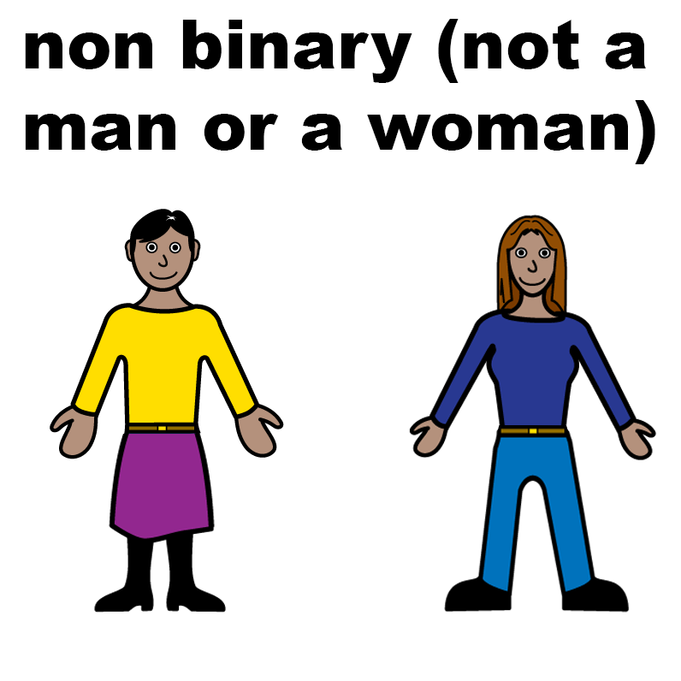
- Male
- Nonbinary

Questions about yourself

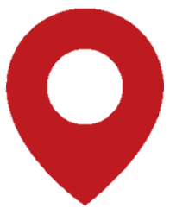
Victoria
Where do you live?
You can tell us:
- the name of the town
- or suburb
- or postcode.

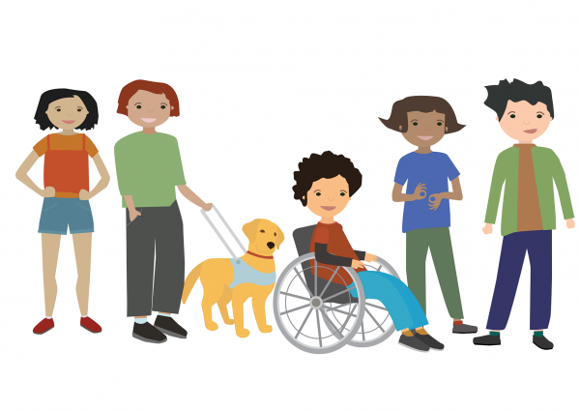

What kind of disability do you have?

How other people have made you feel
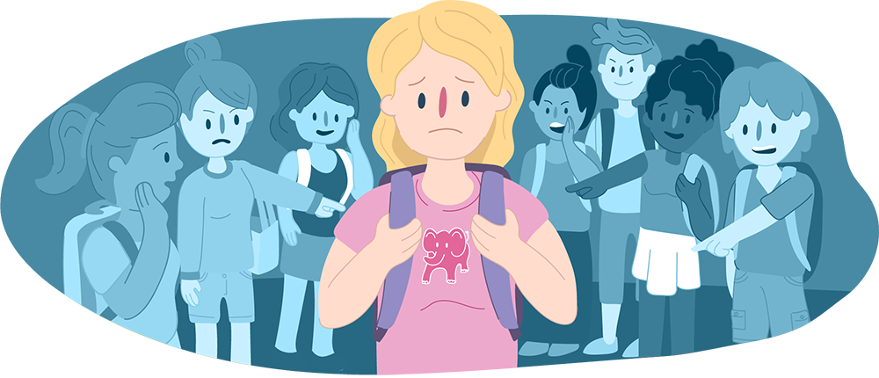
Put a ✓ in the ○ if anyone has ever:
- Bullied you?
Bullied means when someone makes fun of you or does not let you be part of a group or activity.
- Hurt you?
- Hurt your feelings?

How other people have made you feel

- Stopped you from eating?
- Did sexual things to do that you did not want?
Sexual things means when people touch your private parts.
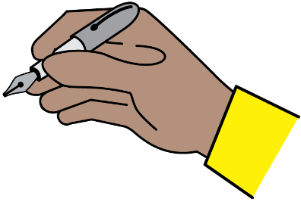
Can you tell us more about what happened?
You can write or draw what happened:
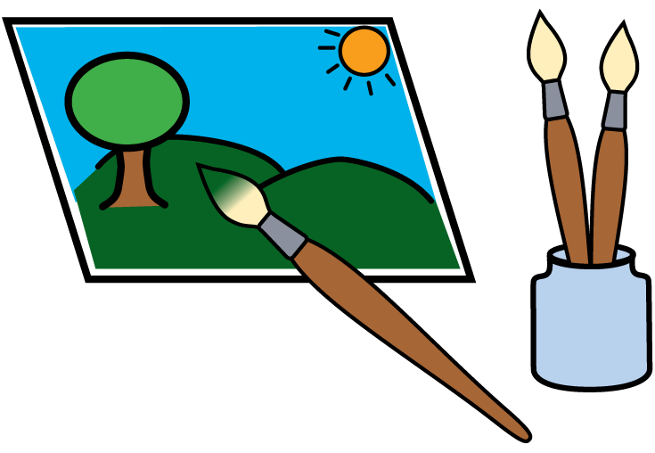
How other people have made you feel

Put a ✓ in the ○ if anyone has ever:
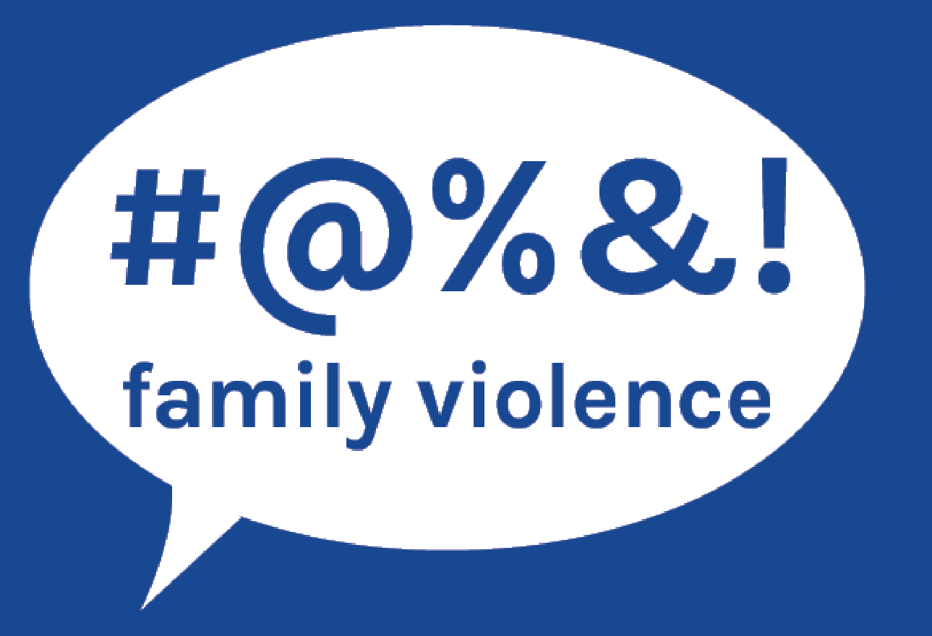
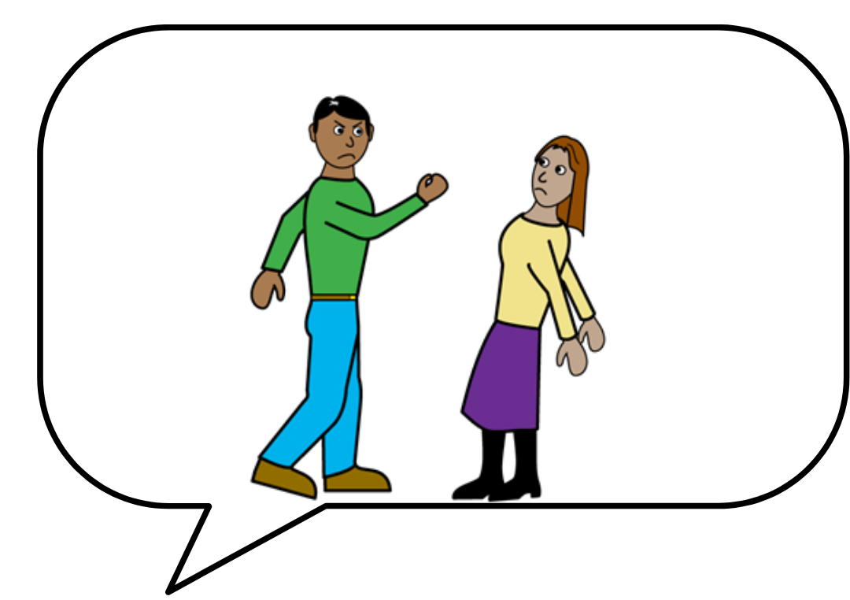
- Called you rude names?
- Said they would hurt you?
How people have made you feel

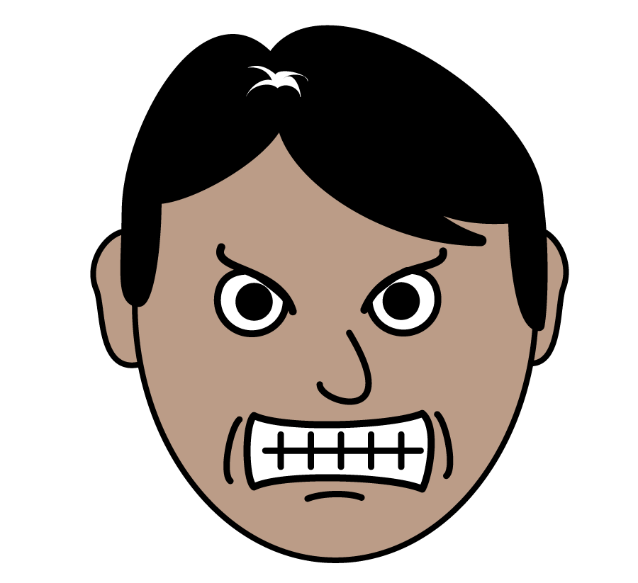
- Made you feel sad about yourself?
- Yelled at you?
Can you tell us more about what happened?
You can write or draw what happened:

Questions about if you have not been supported the way you should be

Put a ✓ in the ○ if you have ever had:
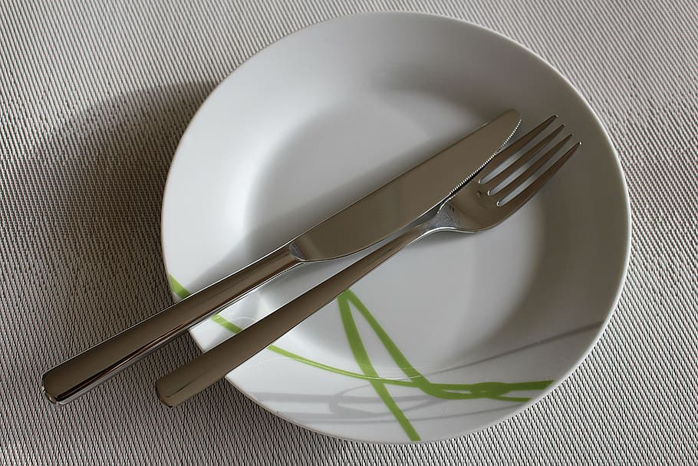

- Not enough food or drink?

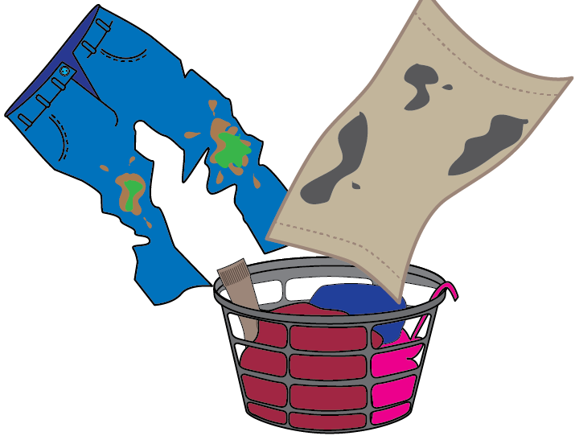
- Not enough clean clothes?
Questions about if you have not been supported the way you should be
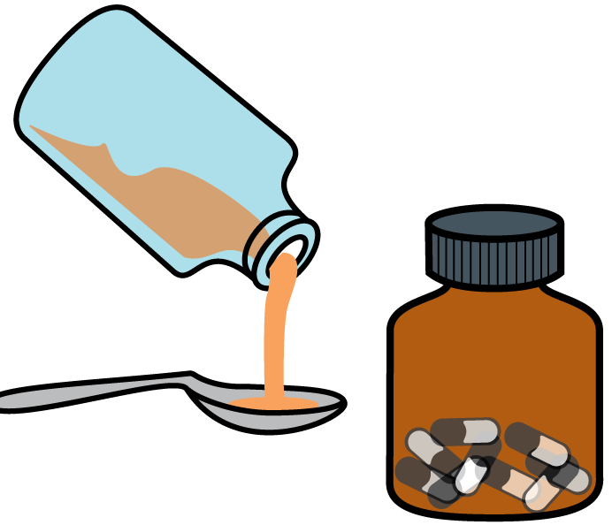
- No medicine?
- No help when you needed help?

Questions about if you have not been supported the way you should be
Can you tell us more about what happened?
You can write or draw what happened:

Questions about where you have worked
Put a ✓ in the ○ if you have ever:

- Done work without getting paid enough?
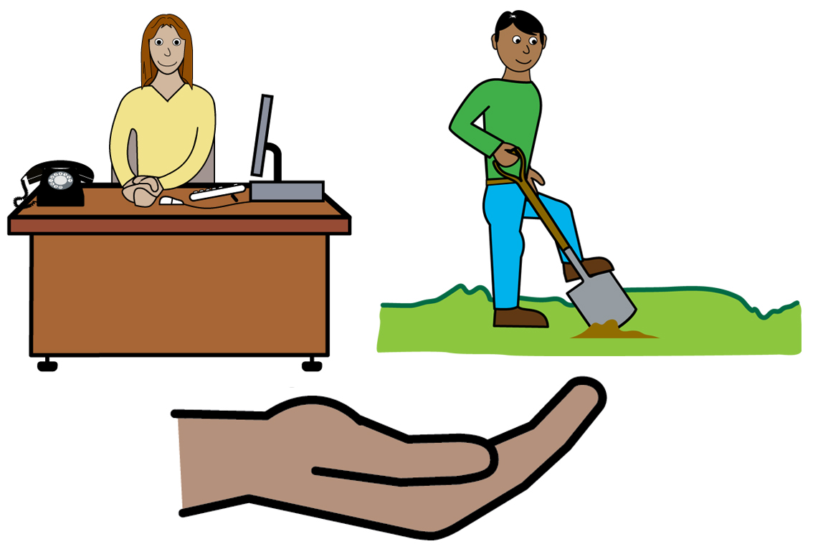
- Worked in supported employment?
Supported employment jobs are for disabled people who need help at work.

Can you tell us more about what happened?

You can write or draw what happened:

Thank you
This is the end of the questions.

Thank you for answering them.

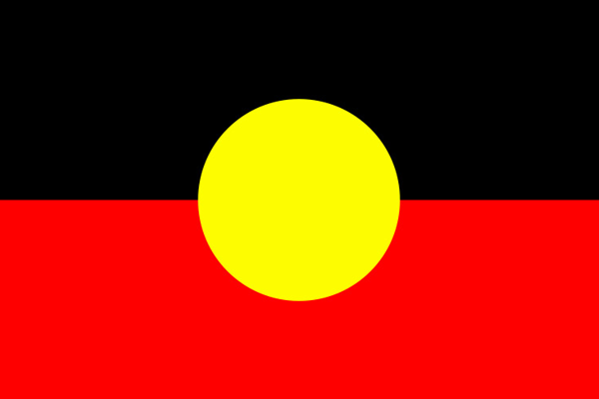
We work on Aboriginal land.

Aboriginal people have looked after the land for many years.

YDAS is on Wurundjeri land.

It is part of the Kulin nation.
The Disability Royal Commission logo is from the official website.
© Commonwealth of Australia 2020.

