Access Key

Beyond Borders: Breaking Down Silos – Great South Coast - Warrnambool

The Deakin Hydrogen Hub (Hycel Technology Hub) at Deakin University’s Warrnambool campus is located on the traditional lands of the Gunditjmara people. (insert room once decided)
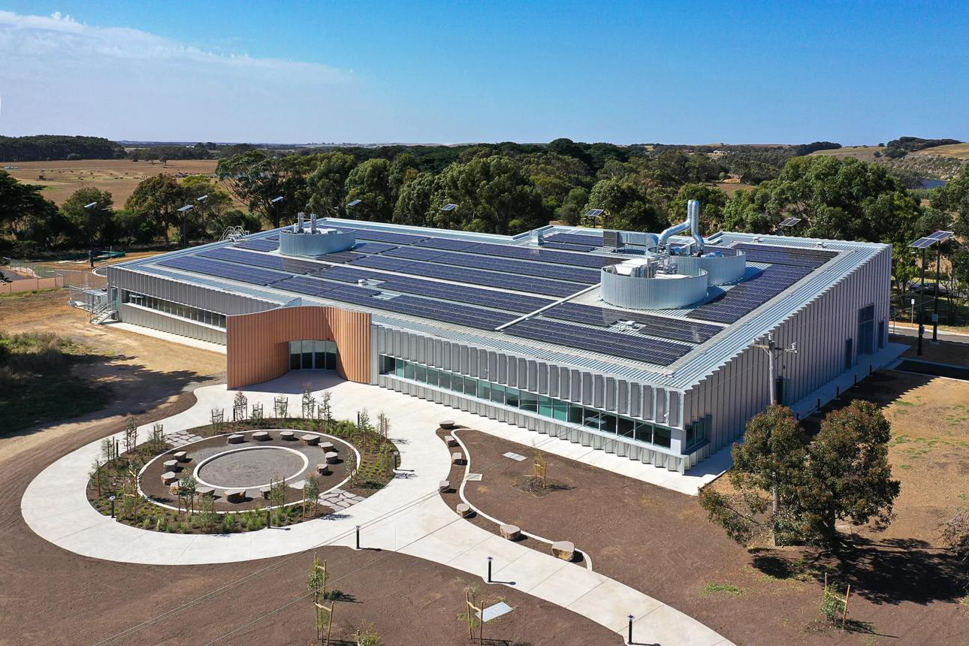
This Access Key provides important information about the Hydrogen Hub (or Hycel Technology Hub), the venue for the Beyond Borders: Breaking Down Silos – Great South Coast.
An Access Key outlines key details about the building, location, and the accessibility features available, to support all participants in planning their visit.
If you have any questions about access or specific requirements, please contact us using the details provided at the end of this document.

Table of Contents:

Beyond Borders: Breaking Down Silos – Great South Coast - Warrnambool 1
- From Warrnambool CBD 4
🚗 By Car (Easiest option) 4
Directions: 4
🚌 By Bus 4
🚶‍♀️ Walking / Cycling 4
Venue & Cultural Design Information 6
Deakin Hycel Technology Hub – Warrnambool 6
Sensory & Environmental Notes 7
Campus map: 8
Bathrooms & Accessibility Access 9
Kitchen & Shared Amenities 10
🚗 Very Close (2–5 km – 5–10 min drive) 11
🏡 NRMA Warrnambool Riverside Holiday Park 11
🏨 Comfort Inn on Raglan 11
🏨 Blue Whale Motor Inn & Apartments 11
🏙️ CBD Area (4–5 km – more food + walkable options) 11
🏨 Waves Motel and Apartments 11
🏨 Innova Motel Warrnambool 12
🏨 Eight Spence 12
🏕️ Discovery Parks Warrnambool 12
Places to Eat in Warrnambool 15

Gunditijmara Country
The Deakin Hydrogen Hub is located on the traditional lands of the Gunditjmara people, who have cared for this Country for tens of thousands of years. The Gunditjmara are known for their deep cultural knowledge, strong connection to land and waters, and sophisticated land and water management systems, including the World Heritage–listed Budj Bim Cultural Landscape, one of the oldest known aquaculture systems in the world.
This region forms part of a broader cultural landscape that includes significant sites such as Moyjil (Point Ritchie), where cultural practices, food systems, and knowledge have been sustained over generations. For Gunditjmara people, Country is a living system of relationships between land, waters, sky and community. Recognising their ongoing custodianship and leadership is essential to understanding both the deep history of this place and its future, including contemporary initiatives such as renewable energy and innovation.

About Warrnambool:

Warrnambool is a regional coastal city in south-west Victoria and a key centre within the Great South Coast region. Known for its strong community infrastructure, education facilities and creative industries, the city plays an important role in supporting surrounding rural communities.
The city features the Warrnambool Library and Learning Centre, a modern public facility offering study spaces, digital resources and community programs. Warrnambool is also home to One Day Studios, contributing to the region’s growing creative sector.
Deakin University Warrnambool campus further strengthens the city’s role as an education and innovation hub, supporting research, training and industry collaboration, including renewable energy initiatives.
Located along the Great Ocean Road and near significant natural coastal environments, Warrnambool continues to develop as a vibrant regional centre, combining education, creativity and community services within the broader Great South Coast region.

Getting there
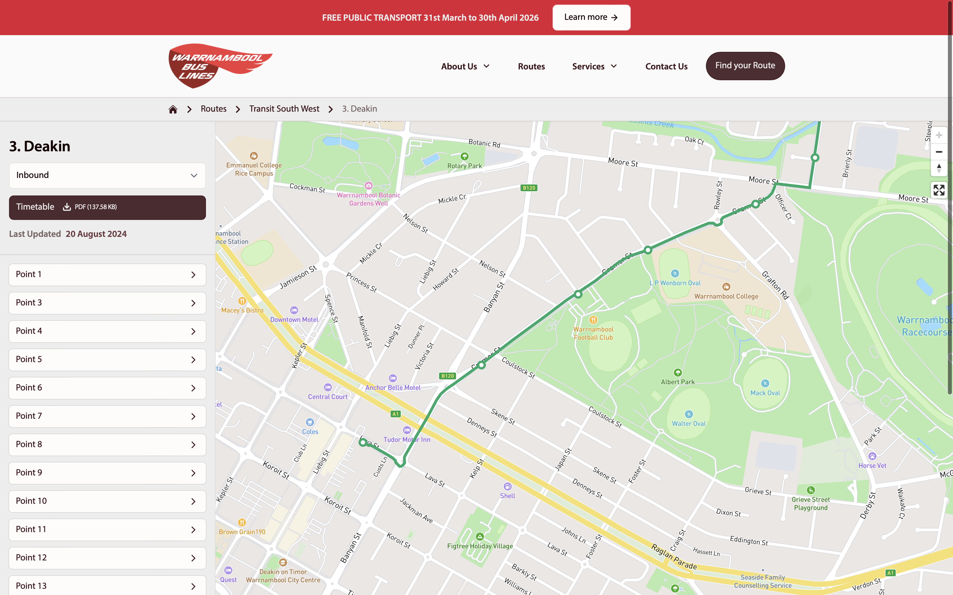
Hycel Hub is located: Deakin University, Princes Highway, Warrnambool, Victoria, 3280, Australia
Transport – Deakin Hycel Hub (Warrnambool Campus)
Deakin University Warrnambool Campus, approximately 3 hours south-west of Melbourne.
Public Transport (from Southern Cross Station):
- Take a V/Line train from Southern Cross Station to Warrnambool
- Travel time is approximately 3 hours 20–40 minutes
- Services run a limited number of times per day, so advance planning is recommended
Arrival Options:
- Warrnambool Station (recommended):
  - Main regional station with regular services
  - From here, the campus is approximately 5 km away
  - Accessible via local bus, taxi or rideshare (10–15 minutes)
- Sherwood Park Station (limited service):
  - Located adjacent to Deakin Warrnambool Campus
  - Not all trains stop at this station
- Here’s the exact Google Maps link you can use for directions to the Hydrogen Hub at Deakin Warrnambool 👇
- 👉 Open Deakin Hydrogen Hub in Google Maps

- From Warrnambool CBD
The campus is about 5 km from Warrnambool CBD

🚗 By Car (Easiest option)
⏱️ Travel time: ~8–10 minutes

Directions:
- Start in Warrnambool CBD
- Head north-east via Raglan Parade / Princes Highway
- Turn onto Proudfoot Road
- Follow signs to Deakin University
- Enter campus → follow signage to Hycel / Hydrogen Hub
👉 Parking is available on campus (usually free or permit-based depending on area)

🚌 By Bus
⏱️ Travel time: ~15–25 minutes
- Local buses run between CBD and Deakin campus
- Look for routes heading toward Deakin University / Warrnambool Campus
👉 You may need a short walk (5–10 mins) once on campus to reach the Hydrogen Hub

🚶‍♀️ Walking / Cycling
- 🚶 Walking: ~50–60 minutes
- 🚲 Cycling: ~15–20 minutes
👉 Route follows main roads (Princes Highway direction)

Final Access to the Hycel Hub:
- Once on campus, follow signage to the Hydrogen Hub (Hycel Technology Hub)
- The campus has step-free pathways and vehicle access
Important:
- Public transport services are limited in regional areas
- Please check current timetables via V/Line before travelling
- Allow additional time for connections
For further assistance with transport planning, please contact the event organisers.
Safe Travels
Safe Travel Advice – Deakin Hydrogen Hub (Warrnambool Campus)
Participants traveling to the Deakin Hydrogen Hub are encouraged to plan and allow extra time for regional travel.
Seasonal Conditions (May–June):
- Early winter in south-west Victoria can bring heavy rain, strong winds and cold conditions
- Localized flooding may occur on roads, particularly in low-lying or rural areas
- Bushfire risk is generally low at this time of year, but weather conditions can still change quickly
Travel Safety Tips:
- Check weather conditions before departure via the Bureau of Meteorology
- Monitor road conditions and closures via VicRoads - https://www.vicroads.vic.gov.au/
- Allow extra travel time, especially when driving from Melbourne or surrounding regions
- If using public transport, confirm V/Line timetables in advance
Emergency Contacts:
- Emergency Services (Police, Fire, Ambulance): 000
- State Emergency Service (SES): 132 500 (for flood and storm assistance)
- VicEmergency Hotline: 1800 226 226
- Non-urgent Police Assistance: 131 444
Participants are encouraged to prioritize their safety and delay of travel if conditions are unsafe.
If you find any other resources and info useful, please contact YACVic to share 😊
Venue:
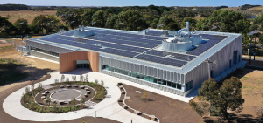

Venue & Cultural Design Information

Deakin Hycel Technology Hub – Warrnambool
The Deakin Hycel Technology Hub was designed using a “Codesigning with Country” approach in collaboration with First Nations consultants from the Gunditjmara/Maar Nation. The building was intentionally created to feel welcoming, connected to Country, and reflective of the local landscape and community.
Key design features include:
- The curved terracotta entrance was inspired by Gunditjmara eel baskets connected to the Budj Bim aquaculture systems, symbolizing gathering, invitation, and connection.
- Circular shapes throughout the building represent the six local mobs/tribes in the Warrnambool region and reflect ideas of equality, yarning circles, and collaboration.
- Interior colours and materials were chosen to reflect the surrounding environment, including eucalyptus, saltbush, and sandstone tones.
- The venue was designed to feel open, warm, and community-focused, rather than highly industrial or closed-off.
- Large windows and open spaces allow for significant natural light throughout many areas of the building.
- The space connects innovation, sustainability, education, and community through a culturally informed design process.

Sensory & Environmental Notes
- Many areas contain natural lighting which may become bright during sunny weather.
- The building is generally quiet outside of scheduled events and university activities.
- Open communal spaces may create some background noise during networking or catering periods.
- The venue has a modern university and research facility environment with minimal strong smells.
- Some areas may include polished flooring surfaces.
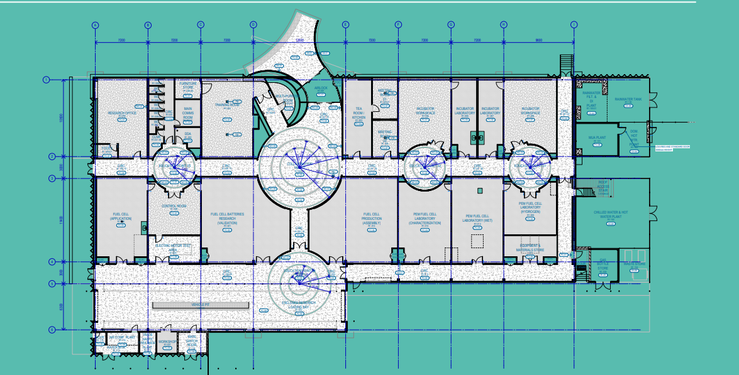

Campus map:
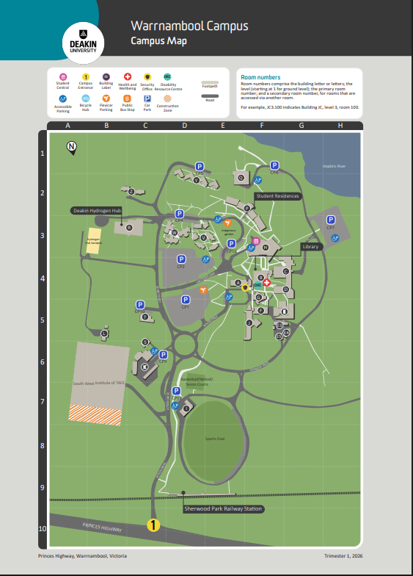
campus map

Function Room:
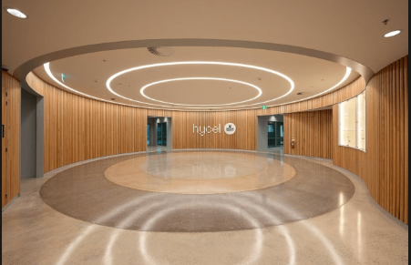

Meeting room: 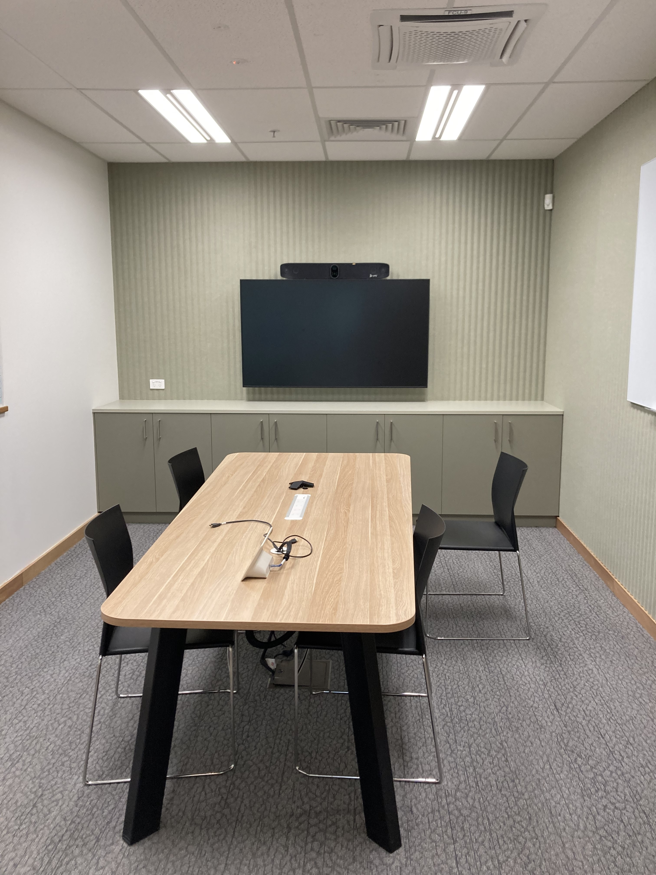

Bathrooms & Accessibility Access
- Accessible bathroom facilities are available within the Hycel Technology Hub building.
- Bathrooms are located within short walking distance from the main conference and meeting spaces.
- Female, Male and all-gender bathroom facilities are available onsite.
- Bathroom entrances are accessible via wide internal corridors.
- The venue is step-free throughout public areas and amenities.
- Lighting in bathroom areas is standard indoor lighting.
- Hand dryers and sinks are available within amenities of space.
- Bathroom doors may be heavier than standard.
- YACVic staff can assist attendees with wayfinding if required.

Kitchen & Shared Amenities
- There is a communal hub kitchen located within the building on the left-hand side of the main entrance.
- The kitchen space may be used by venue staff, university staff, and event organisers throughout the day.
- Tea, coffee items may be located within this area during the event.
- Background noise may increase during catering and break times.
- Food and coffee smells may be present around the kitchen area

Accommodation:

🚗 Very Close (2–5 km – 5–10 min drive)

🏡 NRMA Warrnambool Riverside Holiday Park
4.4•Holiday park
Directions•Website•(03) 5565 1327
- ~2.8 km from campus
- Cabins + park-style accommodation

🏨 Comfort Inn on Raglan
4.1•Motel
Directions•Website•(03) 5562 2755
- ~3 km from campus
- Good mid-range option

🏨 Blue Whale Motor Inn & Apartments
4.3•Motel
Directions•Website•(03) 5561 2833
- ~3.3 km from campus

🏙️ CBD Area (4–5 km – more food + walkable options)

🏨 Waves Motel and Apartments
4.3•Motel
Directions•Website•(03) 5562 8044
- ~4.5 km from campus
- Close to shops + beach
- 🏨 City Heart Motel Warrnambool
4.6•Motel
Directions•Website•0478 027 119
- ~4.7 km from campus
- Central location
- Good for walking to restaurants

🏨 Innova Motel Warrnambool
3.9•Motel
Directions•Website•(03) 5562 1277
- ~5 km from campus

🏨 Eight Spence
4.5•Motel
Directions•Website•(03) 5562 7144
- ~4.8 km from campus
- Close to train station

🏕️ Discovery Parks Warrnambool
4.2•RV park
Directions•Website•(03) 5561 1514
- ~5.5 km from campus
- Good for groups or budget

Where can I park
Car park 2 is the closest to Hycel Hub building it is in front the building, Walking distance about 200-300m. There is no crossing line, be aware of traffic when walkingo from car park to the venue
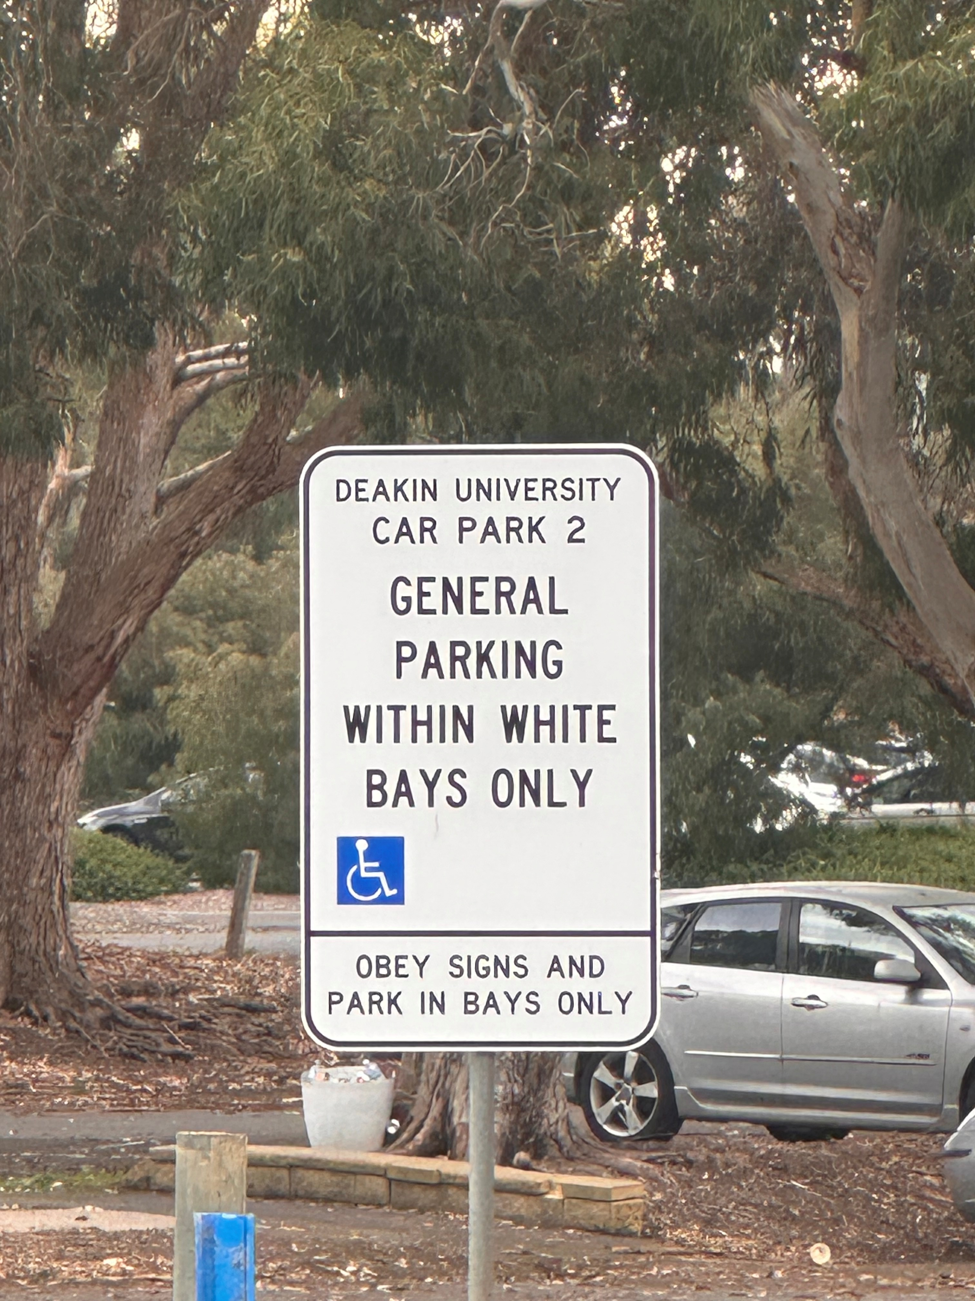
There is one disabled parking at the front of the building
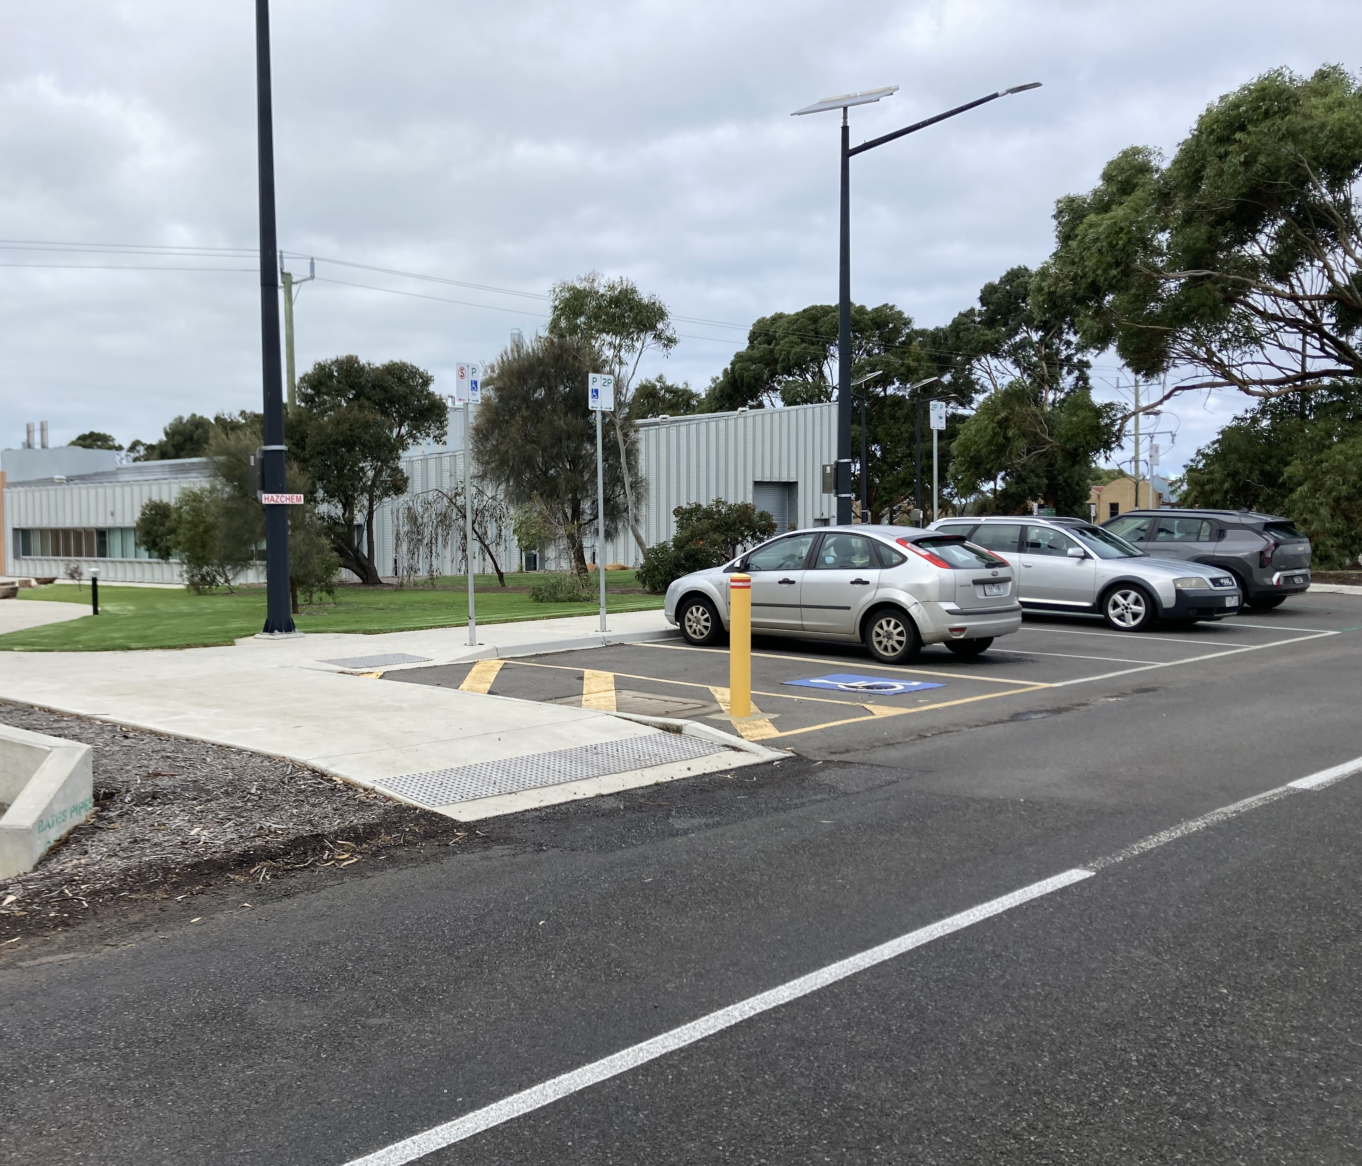

Activities:
In the session, you will be asked to record your thoughts and ideas. If you would like, you can get support to do this.
The activities are mainly visual, and you are encouraged to talk to other people. There will be people to assist you with the activities if you would like support.
We encourage all participants to actively engage in group discussions and breakouts, and to be respectful by giving everyone time to speak and contribute.
Again, we encourage you to be present in all activities and we are happy for you to excuse yourself to another room if you would like to complete non-CoP activities/work.
Other people:
At the session there will be facilitators and multiple presenters throughout the day, and other people who are attending or organising the session. If you need an interpreter, they can be booked and be available upon request and with notice. Please contact xxx or xxx directly for this request.
YACVic staff will be identifiable via a name badge, and you can ask any of them for support throughout the forum or conference.
- Epilepsy Trigger Warning
- We will be using an online polling and presentation program called Mentimeter. In presentation mode, the screen may flicker with incoming information. MCs and presenters will provide warnings prior to using presentation mode.
- Power access
- There will be some power points provided along the walls close to the floor. If you choose to plug in a device, please be aware of where it is and make sure it isn’t in danger of being stepped on or tripped over. YACVic will also provide a charging station with USB ports.
- Noise
  - The event isn’t likely to be very loud. However, you can expect there to be loud chatter. You will also hear a quiet buzz of the air conditioning, some footsteps as people walk on the floor, the sounds of doors swinging open and at times some background music. During the session, you will hear people talking, chairs moving around, and people shuffling paper.

- What to bring:
  - Comfy shoes, water bottle and preferred snacks
  - Notebook and pen (however you prefer to take notes)
  - Hats, sunscreen, sunglasses, and if you are so inclined, maybe even your bathers and a towel. The river is beautiful!
Statement of Principles
This event is designed to be inclusive, respectful, and accessible for all participants.
We are committed to:
- Creating a safe and respectful environment
Everyone is expected to engage respectfully and support a positive shared space.
- Supporting access and participation
We aim to reduce barriers to participation wherever possible and respond to individual access needs.
- Providing clear information
Information about the venue, program, and activities is shared in advance to support planning and comfort.
- Respecting different needs and preferences
Participants are welcome to engage in ways that feel comfortable, including taking breaks or stepping out as needed.
- Maintaining a low-pressure environment
Activities are optional, and there is no expectation to participate beyond your comfort level.
- Encouraging inclusive communication
We support clear, respectful, and inclusive ways of communicating across diverse groups.
- Promoting a calm and supportive setting
The event environment is designed to be low stimulation where possible, with consideration of noise, space, and sensory impacts.

Places to Eat & Coffee:
Warrnambool has a wide variety of cafés, restaurants and casual dining options close to the CBD and Deakin University campus. Options range from coffee shops and casual lunches through to waterfront dining and evening restaurants.
Tripadvisor recommendations can be found here:
Tripadvisor – Warrnambool Restaurants
Some popular local options include:
- Bohemia Cafe & Bar – Popular café option for breakfast, brunch and coffee in the Warrnambool CBD. Frequently recommended for casual daytime dining. (Tripadvisor)
- Clovelly Restaurant & Bar – Modern Australian restaurant located near Flagstaff Hill, suited for dinner and group dining. Known for local produce and contemporary meals. (Tripadvisor)
- Cattleya Thai Restaurant – Well-known local Thai restaurant offering dine-in and takeaway options in the town centre. (Tripadvisor)
- Bundy's Bar & Bites – Casual restaurant and bar option suitable for shared meals, drinks and evening catch-ups.
- Lost Cat – Contemporary restaurant focused on seasonal and locally sourced dining, created by a former Melbourne chef returning to Warrnambool.
- Salt Restaurant Warrnambool – Evening dining option with a more formal restaurant setting.
- Rough Diamond – Café known for coffee and lighter breakfast/lunch options.
- Allee Espresso – Small laneway-style café popular for coffee and quick breakfast options.
- Sizzling Manila – Filipino restaurant offering casual lunch and dinner meals.
- Lady Bay Resort Restaurant & Bar – Restaurant option near the coastline and beach precinct.
- Seaview Warrnambool – Casual takeaway and fish-and-chip style dining close to the foreshore.
- Piccolo Coffee Roasters - CAFE – Local coffee roastery and café option.
For quick meals and takeaway, Warrnambool also has supermarkets, bakeries, pubs, fast food outlets and late-night dining options throughout the CBD and foreshore areas.

Things to do in Warrnambool:

Visit Flagstaff Hill: Explore the maritime history and enjoy the sound and light show curiouscampers.com.au.
Whale Watching: Experience the annual migration of whales along the coast visitgreatoceanroad.org.au.
Warrnambool Botanic Gardens: Stroll through beautiful gardens and enjoy the scenery The Tourist Checklist.
Tower Hill Wildlife Reserve: Discover the wildlife and stunning landscapes in this volcanic crater curiouscampers.com.au.
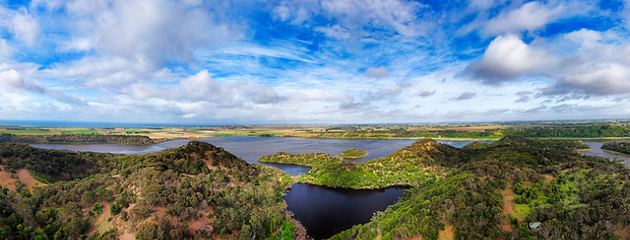

Bay of Islands Coastal Park: Enjoy breathtaking views and natural rock formations Tripadvisor.

Contact Us: the YACVic Team:
Please contact the YACVic Team if you have any
Name | Role | Email | Phone
Rhiannon | Rural Development Coordinator | rjennings@yacvic.org.au | 0474 506 000
Taline | Events Officer | tferreira@yacvic.org.au | 0401 237 911
Zoe | Rural Development Coordinator | zdamman@yacvic.org.au
Bec | Police and Projects Officer | bshaw@yacvic.org.au
Dern | Head of YACVic Rural | dryan@yacvic.org.au | 0408 674 738

