Reshape Our Future Youth Forum
Brother Fox at Deakin University, Warrnambool, Gunditjmara Country

Getting here
Bus route 3 runs between the Lava St interchange in the CBD and Deakin Campus in Warrnambool. The bus stop is located close to Brother Fox. There is a path with a slight downhill incline going from the bus stop to the H building where Brother Fox, the conference venue, is located. Buses within Warrnambool are fitted with wheelchair ramps.
The V/Line train from Southern Cross Station Melbourne stops at the Sherwood Park stop which is closest to the venue. The V/Line service is fitted with wheelchair access ramps but you will need to let a conductor know you require this and what stop you are getting off at. You can also check these websites for more information:
www.transitSW.com.au
www.vline.com.au/Plan-trip-buy-tickets
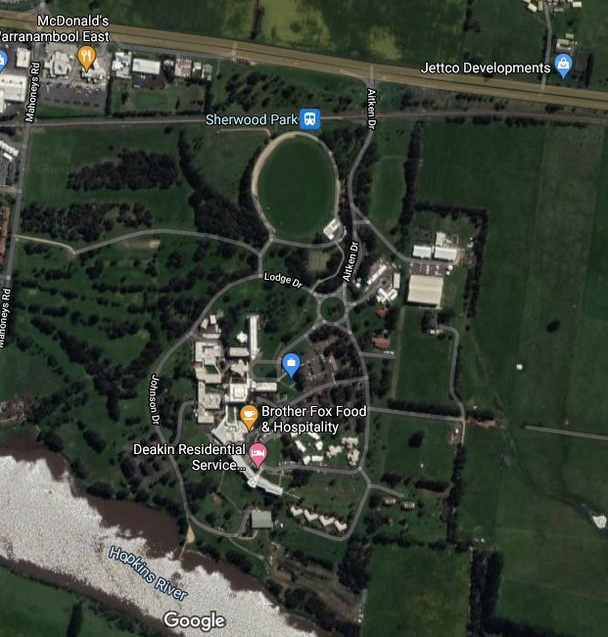
Above: a map of Brother Fox Food & Hospitality.
Campus Access is via the Princes Hwy approximately eight kilometres east of the centre of Warrnambool. Enter campus on Aitken Drive. Take the fourth exit, first right at the large roundabout onto Johnson Drive. Stay on Johnson Drive until you reach car park 7 (CP7), the assigned parking for the conference. Parking is free.
There is a paved path approximately 200 metres long going uphill to the venue at an approximately 25-degree slope. There will be an A-frame sandwich board style sign saying “Brother Fox” at the beginning of the path (see image below).
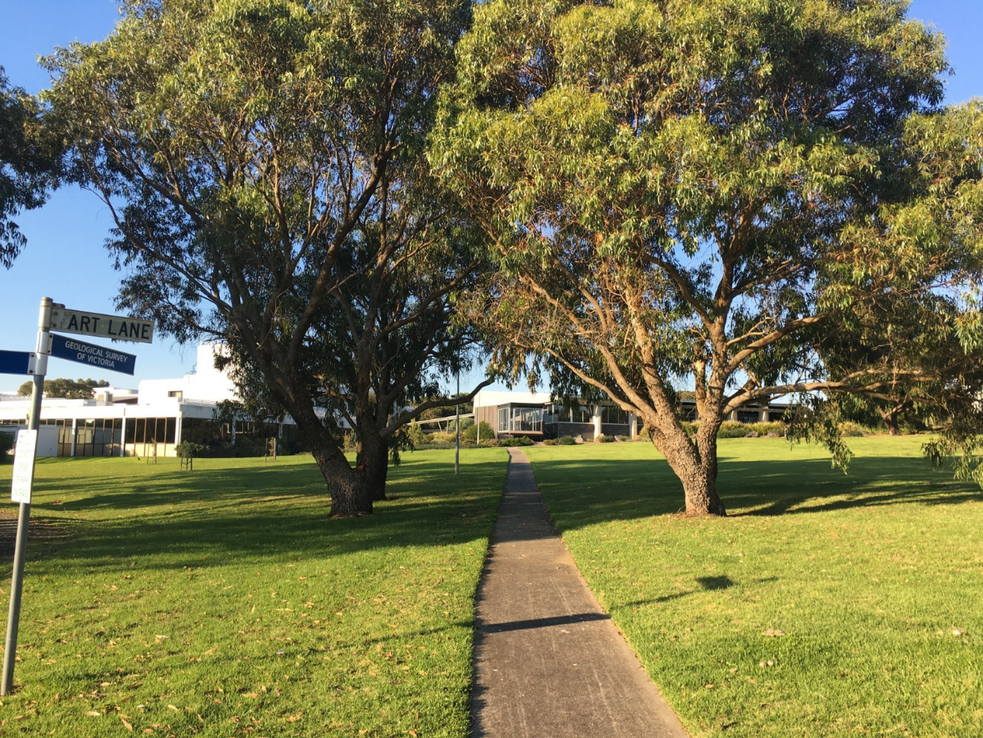
Above: a photo of a smooth concrete path to the venue from CP7.
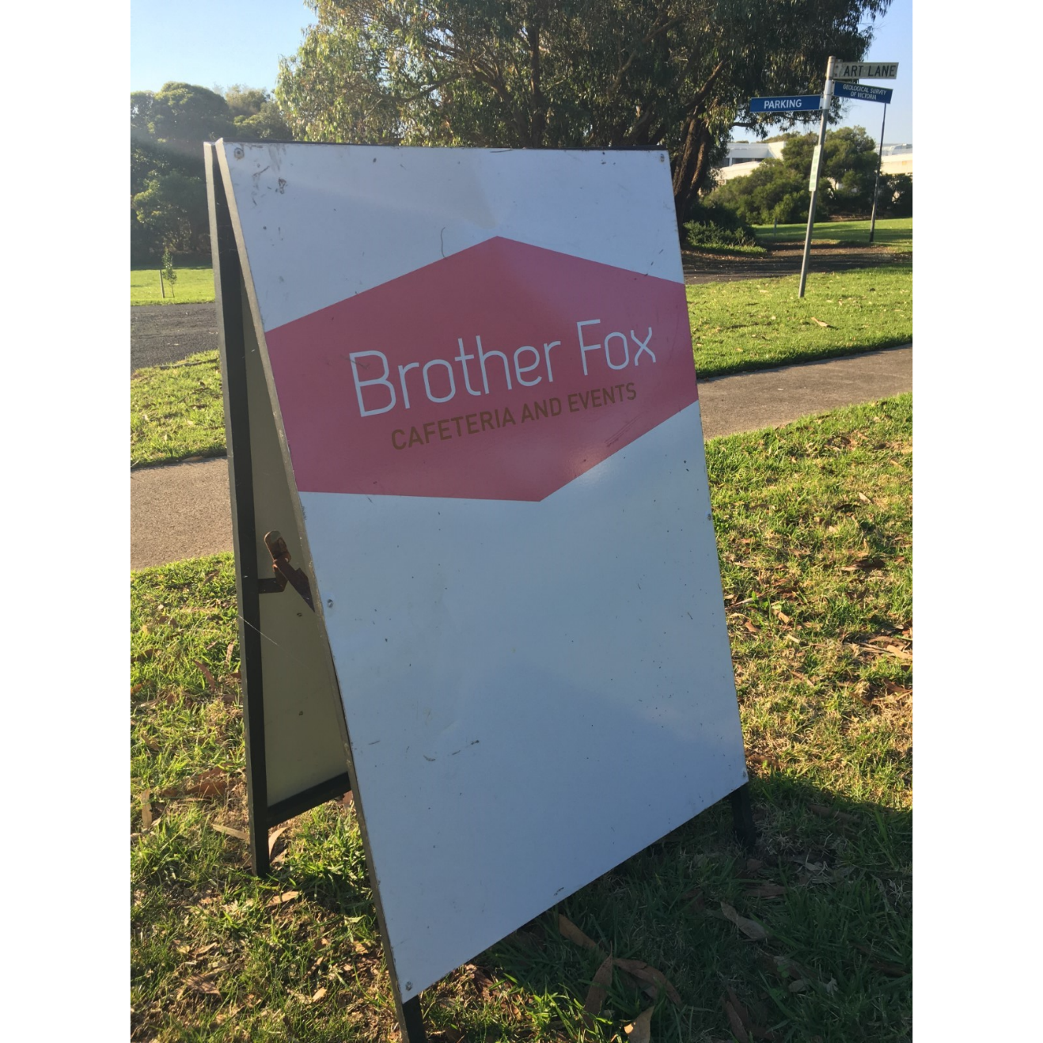
Above: an A-frame construction sandwich board that reads ‘Brother Fox Cafeteria and Events’.
If you require an accessible parking space, you will follow a different route. Refer to the following section on accessible parking spaces. Additionally, if you cannot walk up steps, we recommend you follow the route to the accessible parking spaces.

Accessible car parking
Enter campus on Aitken Drive from the Princes Highway. Take the second exit at the roundabout onto Lodge Drive and then turn right onto Cafeteria Lane. Stay on Cafeteria Lane past the small roundabout and the accessible car parks will be to your right. To enter the conference venue from these car parks, walk along the path to the automatic double doors to enter H building.

Getting in

Entering the venue from CP7
There are four steps leading up to the deck outside Brother Fox where there will be a registration table set up. If you cannot use steps to access the conference space we suggest you use the disabled parking spaces adjacent to H building (see above for how to access). To go inside to the conference space there are double automatic opening doors as well as heavy glass inward opening double doors, both with an entryway width of approximately 100cm.
Entering the venue from accessible parking
Enter H building through the automatic double doors. Immediately inside the building is smooth linoleum flooring leading into the cafeteria and food service area. The conference spaces themselves are carpeted with the exception of the bar, which also has linoleum flooring. There is a small lip between the carpeted areas and linoleum flooring areas that is not considered a trip hazard.

Inside the Venue
The venue is single story. Deakin University and Brother Fox do not have a scent policy in place and there will not be one enforced for this particular event. You can expect there to be some fragrance. Floors in the event space are carpeted with the exception of toilets and change spaces.
There is a mix of natural lighting from windows and glass doors as well as fluorescent overhead lighting. Smoking is prohibited on all Deakin campuses.
During the conference there will be a mix of auditory inputs including music, conversations, a PA system, and sounds from the café including food preparation and the coffee machine.
Inside the conference area round tables will be set up that seat approximately ten people. The tables will be spaced to allow plenty of room for people who use mobility aids. Presentations will be Auslan interpreted on screens if requested, and there will be a closed captioning option available on request as well as a hearing aid loop set up.

Quiet Space
There will be a designated quiet space in a separate room to the main conference proceedings to allow participants to take a break as needed.

Bathrooms
Inside H building there are:
- Women’s toilets with four separate stalls
- Men’s toilets with stalls and urinals
- An all-gender disabled toilet with handrails
- An accessible changing space with an automatic sliding door entry, hoist, hand rails, adult change table, toilet and shower.

Activities
During the event, you will be listening to speakers present on stage. You will be able to step out of the theatre at any time. Catering will be provided during the event - vegetarian, vegan, dairy free and gluten free options will all be available. Alcohol and smoking are prohibited in the building.
The event will be Auslan interpreted if requested. You are welcome to bring any devices you use to communicate – these could be phones, tablets, communication boards or pen and paper.

Epilepsy trigger warning
We many be using an online polling and presentation program called Mentimeter. In presentation mode, the screen may flicker with incoming information. MCs and presenters will provide warnings prior to using presentation mode.

Other people
At the event there will be: Auslan interpreters, an MC, multiple speakers and other people who are attending or organising the session. YACVic staff will be identifiable via a large name badge, and you can ask any of them for support throughout the event. Deakin staff will also be present if you have any general questions. Deakin will also be open to the public during the event, so you may see other people who are not attending the event.

Please feel free to contact us at if you have any further questions. We’re looking forward to seeing everyone!
YACVic’s contact details are:
Email: support@yacvic.org.au
Phone: 9267 3700

