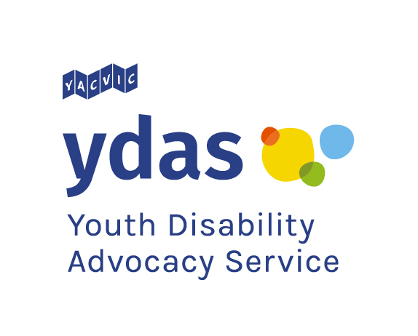
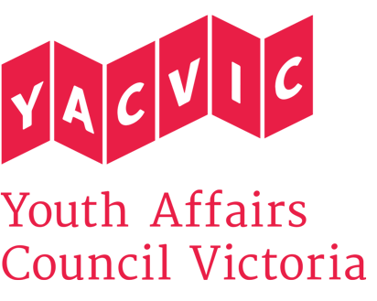

Title: | YDAS Map Your Future Workshop Facilitator
Reporting to: | YDAS Manager
Remuneration: | $37 per hour. Classified as SCHCADS Award Level 3.1 for casual employees. (YACVic pays above award rates, with generous T&C.)
Status: | Casual
Location: | Based in Melbourne CBD, with state-wide travel.

Youth Disability Advocacy Service (YDAS)
YDAS is a core YACVic agency, funded by the Victorian Government. YDAS has a service model which places the human rights and interests of young disabled people at the centre of its work. YDAS undertakes individual and policy advocacy to support young disabled people to have a stronger voice, reduce the barriers that they experience and improve their quality of life.

About Youth Affairs Council Victoria (YACVic)
YACVic is the peak body and leading policy advocate on young people’s issues in Victoria. YACVic’s vision is that young Victorians have their rights upheld and are valued as active participants in their communities. YACVic is an independent, not-for-profit, member-driven organisation that represents young people (aged 12-25 years) and the sector that works with them.

About Map Your Future
Map Your Future is a program that builds the capacity of young people with disability to exercise choice and control in their lives and access the full potential of the National Disability Insurance Scheme (NDIS). The program targets young people aged between 13 – 25 years.

Map Your Future runs as a structured course with workshops being delivered to groups of young people. Innovative and flexible activities empower young people to identify and plan life goals and create a personal ‘roadmap’. This helps young people to navigate the process of their NDIS planning meetings and plan implementation.

Map Your Future is unlike other NDIS support programs currently available for young people with disability, which are more structured around the interests of service providers or young people’s families/carers. It is also not generic casework or ongoing support coordination.

About the role
The YDAS Map Your Future Workshop Facilitator will facilitate and deliver workshops and review program materials. The Workshop Facilitator will document the outcomes of these workshops and support the YDAS Manager and Workshop Liaison Officer with the planning for the Map Your Future program. This includes obtaining feedback from young people and participating in the evaluation of the overall program.

POSITION DESCRIPTION

Key Responsibilities

- Facilitate Map Your Future workshops for disabled young people.
- Review program materials to ensure they are effective for the audience.
- Provide support to young people with disability to understand how to be ready for NDIS and to understand their rights and responsibilities.
- Maintain appropriate case notes to document workshop outcomes.
- Work with the YDAS Manager and Workshop Liaison Officer to evaluate the program.
- Carry out any other duties senior managers may assign to you, having regard to your skills, training and experience.

KEY SELECTION CRITERIA:

- Demonstrated commitment to the rights and interests of disabled people.
- Proven ability to build rapport and work effectively with young people.
- Demonstrated skills in facilitating groups or workshops with young people.
- Demonstrated communication skills with young people on an individual basis.
- Demonstrated understanding of appropriate behaviours when engaging with children and young people, including those with diverse needs and/or backgrounds, and commitment to the Code of Ethical Practice for the Victorian Youth Sector.
- Highly developed organisational and technology skills, including use of Videoconferencing (Skype) and Microsoft Office software.
- Willingness and capacity to travel throughout Victoria and work occasional evenings.

DESIRABLE CRITERIA:

- Experience of coaching or mentoring.
REPORTING
The YDAS Map Your Future Workshop Facilitator reports to the YDAS Manager.

EMPLOYMENT CONDITIONS
YACVic is an Equal Opportunity Employer. People with a disability are strongly encouraged to apply for this position.
YACVic promotes the safety, wellbeing and inclusion of all children and young people, including those with a disability, those who are Aboriginal or those from refugee or migrant backgrounds. We take child protection very seriously. All employees are subject to screening and assessment against child safety standards, including rigorous background, identity and reference checks. The successful applicant will require a current Working with Children Check and Police Check (costs reimbursed) and must agree to adhere to our child safe policy and code of conduct.

APPLICATION PROCESS
Applications should be emailed to recruitment@yacvic.org.au with ‘MYF Workshop Facilitator’ in the subject line and must include:
- A brief cover letter
- Your resume
- Your answers to the key selection criteria, as listed in the position description
- Contact details for a minimum of two referees, including your most recent line manager (we will not contact referees without your permission).

Only applications that follow the above process will be accepted and considered for interview.

Applications close at 5pm 11 December. Interviews are likely to be the week starting 16 December 2019 in Melbourne CBD.

If you have any questions about the role, please contact Mija Gwyn by emailing mgwyn@ydas.org.au or by calling Stephanie Brenkovich at 03 9267 3700.

