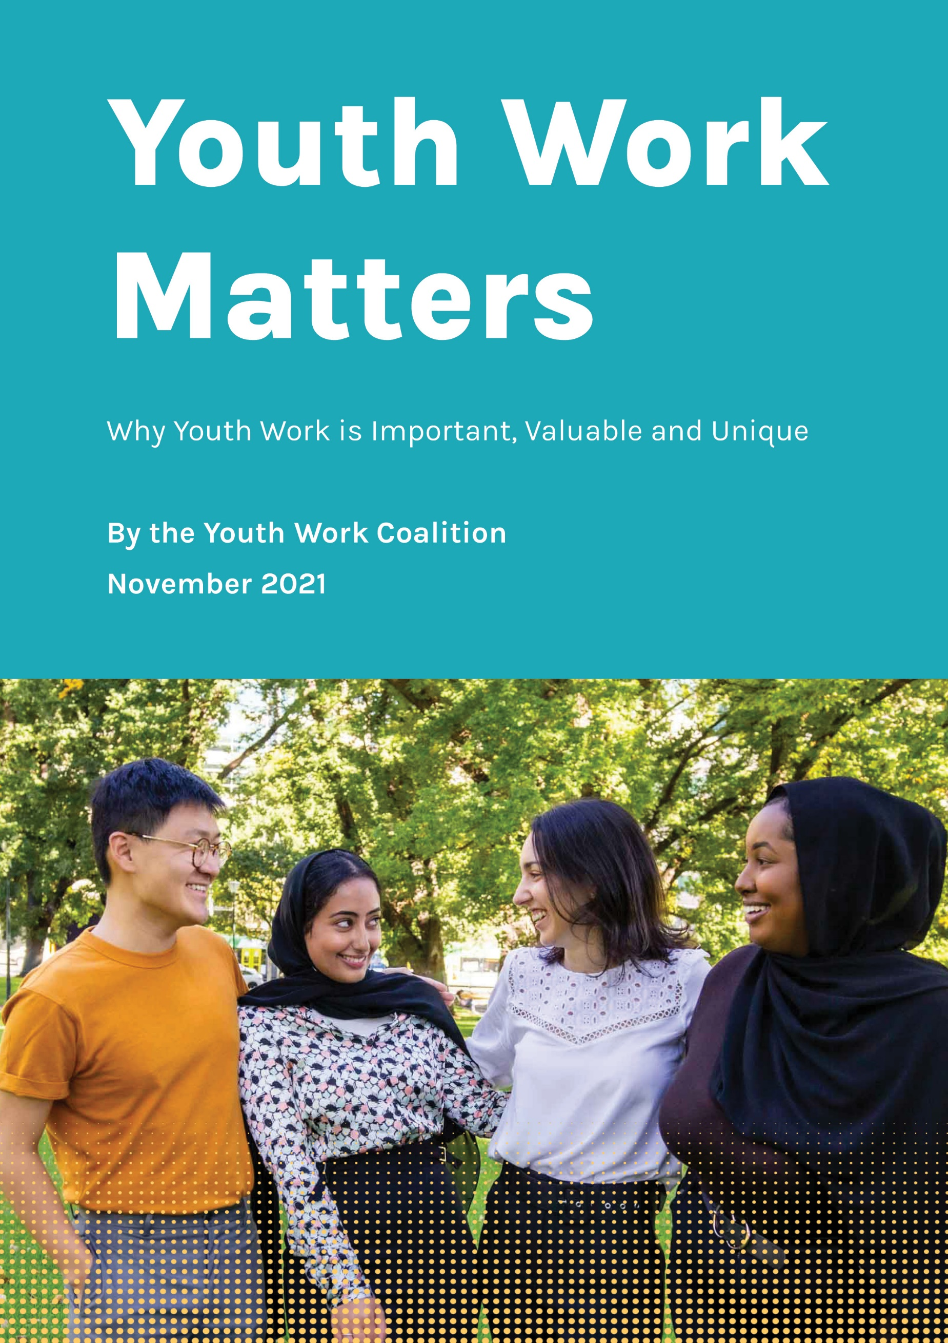

Youth Affairs Council Victoria (YACVic) is the peak body and leading advocate for young people aged 12–25 and the youth sector in Victoria.

Our vision is that the rights of young people in Victoria are respected, and they are active, visible and valued in their communities.

YACVic respectfully acknowledges the Aboriginal and Torres Strait Islander people of this continent. We pay our respects to the ancestors and Elders past and present of all Aboriginal nations in Victoria.
Table of Contents
Youth Work is an Invaluable Profession 4
What is youth work? 4
Why do we need youth work? 4
How is youth work different? 5
In what environments do youth workers operate? 6
What barriers do youth workers face? 6
Youth Work in Practice 8
Case Study 1 One-on-one support for 14-year-old Paulo* 8
Case Study 2: Youth Crime Prevention Program (PIVOT), delivered by YSAS-led Consortium with Mission Australia, Taskforce Community Agency, Jesuit Social Services and the Salvation Army 9
Case Study 3: Live4Life - Rural Youth Mental Health Promotion and Suicide Prevention Program 11
Case Study 4: Emerge - A social support program for LGBTIQA+ young people, delivered by Knox Youth Services. 13
Case Study 5: Keys to Unlocking Our Future - An employment pathway pilot program delivered by North-East Local Learning and Employment Network (NELLEN) 14
Case Study 6: Jobs Victoria Community Traineeship Pilot Program, delivered
by the Victorian Council of Social Services (VCOSS) 15

Youth Work is an Important Profession
Youth work is a profession that supports young people aged 12-25 years to engage with their community, and develop skills and capabilities to achieve their goals.

What is youth work?

In Victoria youth work is underpinned by the Code of Ethical Practice for the Victorian Youth Sector, which is informed by the United Nations Convention on the Rights of the Child, positioning the young person at the centre of a youth worker’s practice as the primary consideration.

Youth workers operate alongside the young person, placing the young person’s interests first. It is an empowering practice, that advocates for and facilitates a young person's independence, participation in society, connectedness, and realisation of their rights.

Youth work encompasses a range of generalist and specialist areas, including active citizenship, engagement in education, social cohesion, crime prevention, housing support, drugs and alcohol support, family violence prevention and recovery, labour market participation, and positive mental health and wellbeing.

Youth Workers have various qualifications, including a Bachelor of Youth Work or Certificate III/IV or Diploma in Youth Work or Community Services. Many have moved into youth work with qualifications such as social work, teaching or community development, and others have no formal qualifications but many years of field experience.

There are four universities offering degree-level courses specifically in youth work in Australia, three of which are based in Victoria and accredited by the Youth Workers Association. There are also numerous TAFEs offering vocational qualifications in Youth Work across Victoria. As a result, there are more tertiary qualified youth workers in Victoria than in any other state.

Why do we need youth work?
There are over a million young Victorians aged 12-25; young people make up 18% of our community. As Victoria’s population continues to grow – it is projected to rise by 58% by 2046 – services and supports for young people will need to keep pace.

Many young people do not have access to assistance, support and connections from their family or networks. Many also face discrimination and marginalisation, and/or experience trauma or disaster in their lives. Without skilled support such as that provided by youth workers, they are more likely than their peers to disengage from education, experience unemployment, experience mental ill-health, and become involved in the justice system.

The COVID-19 pandemic has disproportionally impacted young people in Victoria and further exacerbated the issues young people face. More young Victorians are trying to access support to navigate
through the challenges they face, and youth workers are fundamental to providing that dedicated, targeted support that they need.

How is youth work different?
Youth work is a distinct discipline and body of knowledge. It is unique from other professions that work with young people (e.g. social workers, teachers, counsellors), in that the focus is not on academic achievement or addressing a young person’s issues, but instead on the skills and capabilities they possess, and how to build on these so the young person can achieve their goals.

Youth workers provide strengths-based, holistic care to young people to reach their full potential and thrive as active members of their community. They recognise young people as experts of their own lives and work in a way that promotes and encourages this.

Youth work practice therefore contributes to safe, strong, supportive communities for young people, and can often be the glue that:
- Melds systems together – education and justice, mental health and AOD, school to work transitions, and more;
- Helps families, schools, and other institutions stick by young people; and
- Supports young people to stick with positive pathways.

Youth workers are key enablers for big ticket government reforms as well as the ‘business as usual’ of policy and program implementation focused on young people.

They are also extremely effective in prevention and early intervention, with non-stigmatised approaches that engage young people and build trust, facilitate diversion before issues become crises, and smooth pathways to more complex care if needed. So, investing in youth work represents an investment in the future of our state.

Every young person deserves someone they can count on and having trusted adults around is a strong protective factor for young people. At a time when the Victorian Government has a razor-sharp focus on mitigating crisis costs, investing in youth work represents a smart investment in prevention, early intervention and recovery.

In what environments do youth workers operate?
The environments within which youth workers engage and work with young people vary enormously. A significant proportion of youth workers work for local government, while many also work in NGOs. There are also youth workers based in education settings, as well as other community groups such as health, or sport and recreation.

The support that youth workers provide will also vary depending on the program they are delivering and the context within which they work.

Some programs are focused on providing generalist prevention or early intervention support to young people in their community or geographic area, while others provide specialist programs designed to support broad engagement of young people via a particular theme (e.g. FReeZA, sports clubs).

Other youth workers and youth programs are focused on providing an immediate crisis response for an individual young person (e.g. AOD, homelessness), and some are targeted to specific cohorts of young people (e.g. multicultural young people, disabled young people).

All these environments and contexts are crucial in supporting young people to thrive as active members of their community. They also highlight the need for flexibility to be able to respond to the unique needs of young people at any key point in their lives.

What barriers do youth workers face?
Youth Workers face both professional and structural challenges which impact their ability to support young people effectively.

Day-to-day challenges include a lack of appropriate resources to meet demand or allow innovation; program eligibility restrictions imposed by funders; lack of flexibility to work holistically with young people to address all their needs; and significant vicarious trauma and burnout.

Lack of adequate and multi-year funding for youth workers / youth programs often results in limited service provision, and issues with continuity of service and staff. This is a major issue considering the importance of building and sustaining trusted relationships with young people, especially those with little stability in their lives.

As well as being short-term, funding is often service- or issue-specific and sometimes does not cover the full cost of a program or staff member. As a result, many organisations are required to use a significant amount of time and resources in a perpetual hunt for new funding and are continually juggling funds. Often funding is not renewed or secured until the very end of a funding cycle which makes employment precarious and creates a lack of value for the profession. Challenges also include limited resources for evaluation, to scale evidence-based programs, or to innovate new programs. Many youth workers have sufficient practice wisdom and theoretical knowledge to know ‘what works’, but such an approach does not usually receive funding.

Youth work as a profession lacks recognition and is not adequately understood as a unique approach and set of skills. The relationship-based work of youth workers can be taken for granted as innate personality traits, rather than the result of advanced knowledge and skills attained through education, training and experience. This can result in youth work not being included in professions and programs eligible for government funding opportunities and advisory groups.

There is another common misconception that youth work is ‘social work for young people’, which minimises the role of the professional youth worker, can give them less gravitas as a support person in legal and medical systems, and reduces status on multi-disciplinary teams.

These challenges affect the care that young people receive, which impacts on their engagement in the community and individual wellbeing. They also ultimately contribute to high turnover of staff, loss of skills and expertise, as well damage to trust and relationships that have been built with young people over time.

Youth Work in Practice
The following case studies help demonstrate the many distinct and varied ways that youth work provides positive outcomes for young people aged 12-25.

Case Study 1: One-on-one support for 14-year-old Paulo* who had attendance and engagement concerns at secondary school. This service was delivered in a school setting by a youth worker from Grampians Community Health.

Youth workers can provide independent early intervention support for young people at school. The workers (re)engage students and increase school connection by identifying their interests and developing trust.
In this case, the Youth Worker works 0.2 FTE in the school as part of the school’s Wellbeing Support Program. The Worker’s case load is between 8-10 students. The Youth Worker provided support to Paulo one day a week at the secondary school. Paulo’s challenges prior to engagement with the Youth Worker:
- Low attendance rate.
- Lack of engagement at school.
- Disengagement from family and peers.
- Anxiety at school.
Interventions delivered by the Youth Worker:
- Implementation of an Individual Learning Plan with a focus on mental health and wellbeing.
- Development of a graffiti art project within the school.
- Basketball as an informal, non-threatening engagement strategy.
- In-class support for anxiety.
- Connection with family (at Paulo’s request) to navigate challenges at home.

Outcomes
Paulo* was able to achieve greater connection to school, increased wellbeing and confidence, and a better school/work experience balance. He also experienced personal growth, based on positive community connections, and his relationships at home improved.

‘It has been wonderful to see the growth in Paulo. Taking a holistic approach has helped him navigate his concerns and barriers and find real positives on the other side. The capacity to engage in things other than talk has helped form a real connection with him.’ - Youth Worker

‘It has been really cool to have a worker who believes in me, and that has helped me at camp and at school, and it would be great if the youth worker could be at school more often’. - Paulo

Case Study 2: Youth Crime Prevention Program (PIVOT), delivered by YSAS-led Consortium with Mission Australia, Taskforce Community Agency, Jesuit Social Services and the Salvation Army

The PIVOT program aims to increase protective factors, community connectedness and sustained engagement in school, training and/or employment for young people aged 14-22 years who are serious or recidivist offenders. This is done through developing pathways into education and employment, referrals into alcohol and other drug support and mental health services, and utilising a Youth Worker to provide ongoing case management support and coordination for young people in the program.

James* is an 18-year-old male of multicultural background who resides with his mother and two siblings. James has a history of trauma, which includes being the victim of physical discipline perpetrated by his father. He has also witnessed physical abuse towards his mother. The family have isolated themselves from their community because of the shame associated with James’s criminal history.
James was completing a 7-month sentence at a youth justice Centre. James’s charges included armed robbery, aggravated burglary and theft of a motor vehicle. James was re-referred to the Youth Crime Prevention (PIVOT) Program due to his high risk of re offending. James’ challenges prior to engagement in the program:
- Substance use
- Disengagement from peers
- Family conflict
- Risk of breaching parole and re-offending

Interventions delivered by the Youth Worker:
- Developing pathways into education and employment
- Referral into alcohol and other drug support and mental health services
- Monthly family counselling sessions
- Engagement with Youth Learning Pathways Program
- Support and advocacy to help keep James on track
Outcomes
James has successfully engaged in education and training. He completed a Bricklaying taster course, followed by enrolment at Chisholm TAFE for a Certificate II in Building and Construction (Pre-apprenticeship), which he now regularly attends via public transport.

Monthly family therapy sessions improved the relationship amongst James’ family members, by creating better ways of communicating and a stable home environment.

James has also seen significant Improvements with his mental health. He has increased his connection to culture through attending a local community group with his mother and siblings, and is engaged and connected in ongoing support.

After engaging with PIVOT, James is stable, displays good decision-making skills, has ceased offending, has access to ongoing support, and successfully completed his parole.

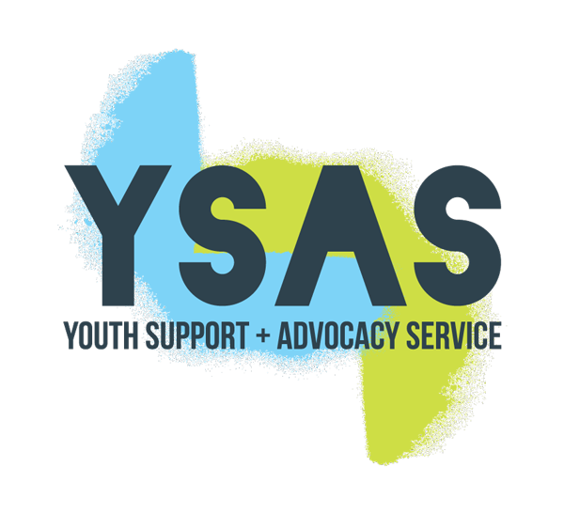

Case Study 3: Live4Life - Rural Youth Mental Health Promotion and Suicide Prevention Program, delivered by Live4Life Communities across rural Victoria.

Live4Life is an evidence-based collective impact model for improving youth mental health and reducing suicide across rural communities. Live4Life builds young people’s capacity to recognise and seek help, and offer help, for mental health concerns, and builds the capacity of the whole community to look after and support their young people. It engages young people, teachers, parents, carers and the broader community in evidence-based mental health education and health promotion activities.

Youth Workers play a critical role in the delivery of the Live4Life model, delivering a range of activities including training and collaborating with the Live4Life Crew (young peer volunteers) to deliver mental health-focused school/community events, and training of program contributors in Youth Mental Health First Aid.

The Live4Life Crew are engaged, active and invested in the mental health education and literacy of their peers and their wider community.

Becoming a Live4Life Crew member provides young people with the opportunity to be leaders in their local area, and to advocate for mental health support and education in an ongoing and empowering way.

Challenges prior to engagement:
- Lack of community resilience
- High number of youth suicides
- Lack of community knowledge regarding mental health, including available services/resources
- Lack of awareness and barriers regarding help-seeking behaviour
- Stigma and lack of proactive support to peers / community members
Interventions delivered by the Youth Worker:
- Recruitment of year 9 and 10 students annually into the Live4Life Crew.
- Induction and training of the Crew members, with a focus on developing their knowledge of mental health, personal and team skills, and event planning and communication skills.
- Collaboration with the Crew to host a series of mental health promotion events and activities throughout the year, targeting year 8 students from all schools within their community.
- Regular support for the Crew’s ongoing development and delivery of activities.

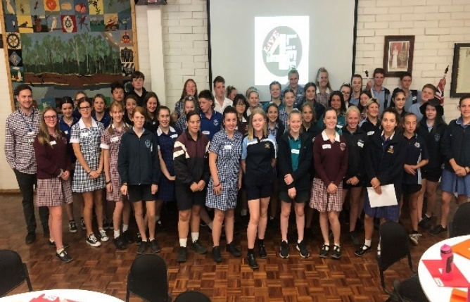

Crew members and their parents have reported that involvement in the Live4Life Crew has been a profound experience, and for some it has been transformational. Crew members have
reported having increased leadership skills, more confidence to undertake public speaking and advocate on issues they care about, and a deeper understanding of mental health issues and competence to support others. Some Crew have expressed a desire to go on to a career in the mental health field.

Evaluation shows that more than 90% of students who had been involved in Live4Life were having conversations with others about mental health. An analysis of return on investment indicated that every $1 invested in Live4Life generated $1.65 to $3.65 of social and economic value.

‘Yeah, there’d be less kids at school if we didn’t have Live4Life.’ - Year 9 Student

‘The amount of times that people have stopped me in the street, the hallways at university or at social events and told me they remember me from the Live4Life program and the way it has helped them is staggering.’ - Live4Life Crew Member

Case Study 4: Emerge - A social support program for LGBTIQA+ young people, delivered by Knox Youth Services.

Emerge is a 12-month social/support program for LGBTIQ+ young people aged 18-25. Two Youth Workers from Knox Youth Services coordinate and facilitate fortnightly gatherings of approximately 12 young people. The program aims to build the confidence, connectedness, social skills, self-care, self-esteem, and therefore overall wellbeing, of LGBTIQ+ young people.

Challenges faced by the young people, prior to engagement in the program:
- Lack of support in coming out and/or transitioning
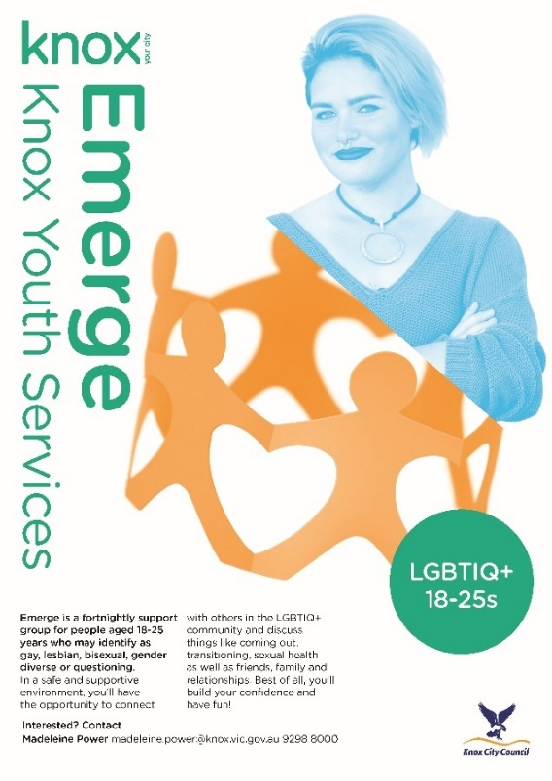
- Low confidence and self-esteem
- Mental health challenges
- Lack of belonging/peer support.
Interventions delivered by the Youth Worker:
- Safe and open discussions in large and smaller groups, related games and art/craft activities.
- Guest speakers/presenters.
- Visits to LGBTIQ+ organisations and a sexual health clinic.
- Regular social sessions planned by the young people (e.g. board games days).
- Quarterly activations with the Knox Youth Services’ LGBTIQ+ groups (up to 60 young people) and bi-annual family BBQs (when COVID-19 permits).
Outcomes
The Youth Workers have provided a safe space for young people to connect and grow together. The young people are supported, encouraged, and empowered to step out of their comfort zone and challenge themselves. The program has helped develop the young people’s mental health including their confidence and self-worth, as well as a sense of belonging. This is evidenced by:
- Acts of self-care (e.g. making their bed, showering daily, sleep hygiene, etc)
- Connection to the group (e.g. talking and catching up with other group members outside the group, a group messenger chat)
- Increased connectedness to society (e.g finding and holding down work, moving into their own rental, starting a course at university or TAFE, joining other social/sport/art groups)
- Increased confidence (e.g speaking in front of the group, sharing experiences and perspectives, dressing in a way that affirms their gender)
- Their general demeanour (e.g eye contact, posture, etc)
- Their expression of appreciation.

‘I’ve loved being a part of Emerge, connecting with everyone in the group and feeling supported while sharing my experiences. [Youth Worker] Maddy has been absolutely amazing at supporting me in the space, helping me find the support I need, putting things into perspective and telling me what I need to hear’. - Participant of the program
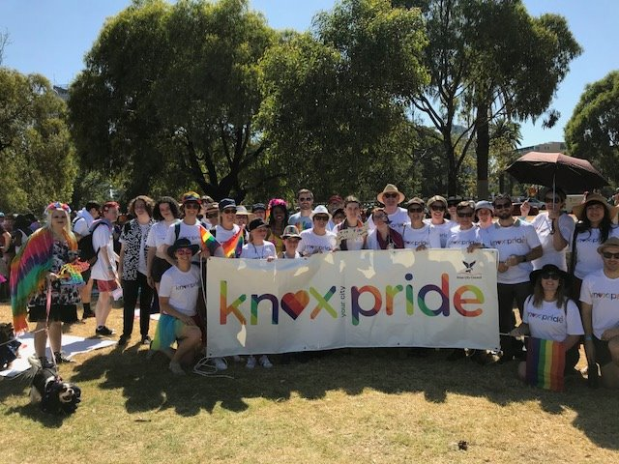

Case Study 5: Keys to Unlocking Our Future - An employment pathway pilot program delivered by the North-East Local Learning and Employment Network (NELLEN)

The Employment Pathway Program, delivered by a Youth Worker based at NELLEN in Wodonga, aims to build a collaborative response to the needs of newly arrived migrant and refugee young people, as they complete Year 12 and commence job-seeking or job-creating activities.

NELLEN received funding from the Department of Premier and Cabinet to pilot this as a six-month program, which has been successful, even despite model changes due to COVID-19 restrictions. The participants of NELLEN’s program had mostly resettled in Australia from Congo and Rwanda.

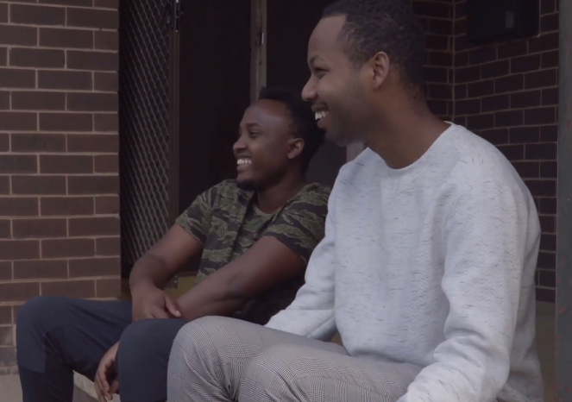
Challenges faced by the young people, prior to engagement in the program:
- Barriers to employment
- Lack of culturally specific support

Interventions delivered by the Youth Worker:
- Collaborative, culturally appropriate group workshops and one-on-one mentoring and support
- Preparation for transition into employment
- Support to engage with employers who offered jobs
- Linking young people up with supports (e.g. Centrelink, Skills and Job Centre).
- Monitoring the job application process and outcomes
- Conducted a series of consultations with young people to co-design a ‘best practice’ model that supports young people to obtain a vocational pathway

Outcomes
From the 22 participants who were engaged in the project six young people found employment and four young people completed their Certificate II studies.
‘The whole model is for the young people to come in, learn as much as they can and build their confidence and their independence to go and successfully look for work’ - Youth Worker

‘We learnt a lot; how to find a job, how to write a cover letter, how to approach [businesses]’ - Program participant

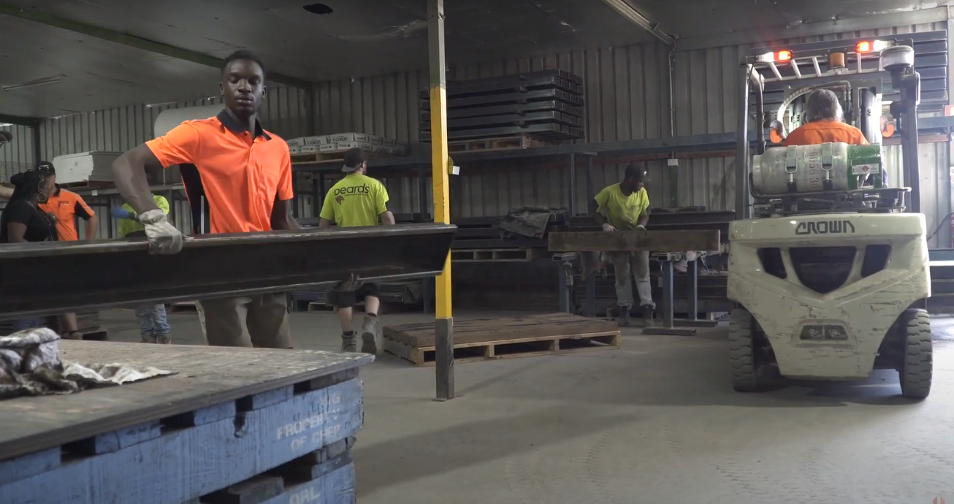

Case Study 6: Jobs Victoria Community Traineeship Pilot Program, delivered by the Victorian Council of Social Services

The Jobs Victoria Community Traineeship Pilot Program (CTPP) provides traineeships in the community services industry for young people (15-24) from the Cities of Hume and Greater Dandenong, who are experiencing barriers to secure and meaningful employment. Trainees graduate with a Certificate IV in Community Services as well as 12-month paid traineeship in the community services industry. As part of the program, a Youth Worker provides holistic interventions to support completion of the program for each young person.

Challenges faced by the young people, prior to engagement in the program:
- Barriers to employment (e.g. homelessness and mental health issues).
- Disengagement from education.

Interventions delivered by the Youth Worker:
- Matching trainees and host employers and supporting them throughout the traineeship.
- Liaison and advocacy with employers and TAFE teachers, to support the young people to address any issues.
- Individual support and catch-ups, including financial wraparound supports.
- Additional educational support for TAFE course work and assessments.
- Connecting and referring trainees to support services such as housing, alcohol and other drug support and mental health services, as needed.

Outcomes
Since the program commenced in May 2019, Youth Workers have supported 120 young people facing disadvantage to secure a traineeship in a community service organisation, and to date 84 of the young people have commenced their traineeship.

Traineeship completion rates in the program are currently at 70%, compared with the national average of approximately 57%.

Over half of the young people who have completed their traineeship have secured ongoing employment with their employer.

‘I have successfully completed my Cert IV Community Services course, graduated with a traineeship, and have now been offered full-time permanent employment with my employer. I have gained an incredible amount of skills and experience since commencing in the Community Traineeship Pilot Program and I am keen to use these skills to give back to my local community’. - Program participant

