19 May 2021

An Open Letter to Victoria’s Businesses & Community Organisations

Re: Participation in the Global Climate Strike on 21 May 2021

Youth Affairs Council Victoria (YACVic) is once again calling on organisations across Victoria to support and encourage their employees and other stakeholders to join young people in the Global Climate Strike on Friday 21 May. Events will be held in Melbourne and regional cities across Victoria.
The climate crisis is a dangerous reality for young people. Without urgent action to reduce emissions, temperatures in Australia are expected to rise to dangerous levels as early as 2030, and we face a collapse in coral reef systems, more frequent droughts and an increase in the severity and occurrence of catastrophic bush fires. These devastating changes will occur well within the lifetime of today’s young people and will severely harm their wellbeing and prosperity.

Young people therefore have an essential right and unique voice in efforts to prevent the climate crisis. YACVic supports and shares the vision of the Australian Youth Climate Coalition and the School Strike 4 Climate for a just and sustainable world with a safe climate for young people and future generations.

We encourage all schools, universities and community organisations, as well as police and other services, to support young people to join the Global Climate Strike and ensure safe and inclusive spaces for young people to demand action.

We also encourage all organisations and businesses to support and encourage their employees to join young people in solidarity at the Global Climate Strike.

Information on the upcoming Global Climate Strike, including locations, can be found on the School Strike 4 Climate website at https://www.schoolstrike4climate.com/may21

We hope you will encourage your employees and other stakeholders to join the Global Climate Strike and support young people to demand a safe climate for their and future generations. For support or further information from YACVic please contact Policy Manager Julia Baron by email at: jbaron@yacvic.org.au.
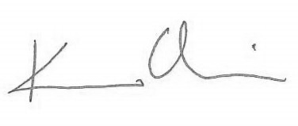

Katherine Ellis
CEO

