Royal Commission into Mental Health:
Terms of Reference consultation

Submission by Youth Affairs Council Victoria

January 2019

About Youth Affairs Council Victoria

YACVic is the leading advocate for young people aged 12–25 in Victoria. As a peak body, we work closely with young Victorians and the sector that supports them to deliver effective advocacy, events, training, resources and support – so that young people can live their best lives.
Our vision is that young Victorians have their rights upheld and are valued as active participants in their communities. As Victoria’s youth peak body, we work across the state in the best interests of young people and the youth sector to:
- lead policy responses to issues affecting young people
- represent the youth sector to government
- resource high quality youth work practice
- research and advocate on youth issues.
We value our members and prioritise their needs.
Youth Affairs Council Victoria
Level 2, 235 Queen St
Melbourne, VIC 3000

T: (03) 0418 413 518
E: policy@yacvic.org.au

Author: Dr Jessie Mitchell, Policy Manager, Youth Affairs Council Victoria

January 2019

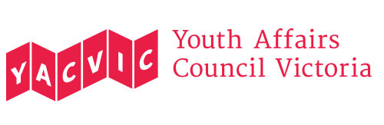

Contents

Executive summary | 4
Recommendations | 5
Background | 8
Engage with young people | 10
Address access and equity for rural, regional and interface areas | 17
- Case study: rural disadvantage and distance from services | 22
Involve schools | 24
Prioritise prevention | 27
Examine how services respond to young people with mental health concerns | 31

Executive summary

As the peak body for young Victorians and the workers and services that support them, Youth Affairs Council Victoria (YACVic) urges the Royal Commission into Mental Health to pay particular attention to young people aged 12-25.

We hope to see the Royal Commission’s Terms of Reference shaped by the following core messages:

- Meaningfully engage with young people

- Address access and equity for rural, regional, and interface areas

- Involve schools

- Prioritise prevention

- Examine current service system responses and identified best practice for young people with mental health concerns.

Young people’s meaningful participation in the Royal Commission is important for several reasons. For one thing, adolescence and young adulthood are high-risk times for the development of a mental illness, and some groups of young people are at elevated risk due to factors like disadvantage, marginalisation and violence. Moreover, young people have a right to be involved in the work of the Royal Commission, and their contributions will help ensure better outcomes.

We urge that the Commissioners get ‘out on the road’ and engage with young people and their communities in rural, regional and interface areas. Engagement with young people would best be led by young people themselves – ideally by Youth Commissioners. Alongside direct engagement, the Commission should resource peak bodies, specialist agencies and local services to engage on its behalf with priority groups, i.e. young people identified as being at disproportionate risk of poor mental health. These include Aboriginal and Torres Strait Islander young people, young women, young people with disability, young people who are LGBTQI+, young people from refugee and migrant backgrounds, young people who are carers, young people with an experience of homelessness, family violence, the out-of-home care, youth justice or child protection systems.

Access to mental health services and related services depends critically on where a person lives. Rural communities experience massive inequalities of service access, and there are also significant shortages in the regional centres and the interface suburbs of Melbourne.

While the Royal Commission will doubtless scrutinise Victoria’s mental health service system, it is less clear which other service settings will come within the Commission’s scope. We urge that the Commissioners engage with schools and consider the huge responsibility that is falling onto schools to protect and support young people’s mental health. This is especially apparent in communities where local mental health services are scarce or non-existent.

Young people and youth support workers are eager to speak with the Commissioners about the design, funding and operation of clinical services. We encourage this, but we also urge the Commissioners to address two additional key issues: the role played by other services where a young person with a mental health problem might ‘land’ (e.g. homelessness, youth justice, family violence), and the critical matter of prevention. All this work should be informed by understanding of the wider context of a young person’s life – including the social and structural factors which endanger a young people’s mental health, and the strengths that can be built upon.

Recommendations

Engage with young people

- Pay strong attention to the mental health of young people aged 12 – 25, either as a defined key topic or as a theme assessed across all key topics

- Set up a range of mechanisms for the Royal Commission to engage with young people. Key principles should include:

- Engage young people early on to co-design a youth engagement strategy, then in the design and delivery of consultations.
- Engage with young people all around Victoria.
- Offer young people a range of meaningful opportunities to get involved, including as Youth Commissioners.
- Offer expert wellbeing support to young people through the consultation process and beyond.
- Work with and resource local services, networks schools, parents and carers to support young people’s participation, especially priority groups.
- Make consultations accessible and affordable to all young people.
- Ensure consultations are comfortable, welcoming, respectful, and genuine.
- Have realistic goals and timeframes, which young people understand.
- Use honest and clear communication.
- Engage with a diverse range of young people, of all ages from 12 to 25.
- Consider paying or rewarding young people for taking part.
- Talk to young people about mental health, as well as illness.
- Consistently evaluate the youth engagement strategy to ensure young people (especially from priority groups) have access to the Royal Commission and can participate.

- Engage in targeted ways with young people identified as being at disproportionate risk of poor mental health. According to existing research, this should include:

- Aboriginal and Torres Strait Islander young people
- Young women
- Young people who have been in out-of-home care and/or the youth justice system, and –
- Young people who have experienced homelessness.

Our stakeholders also recommend that the Commissioners engage with:

- Young people with disability (including intellectual, physical, and psychosocial disability)
- Young people from refugee and migrant backgrounds
- LGBTIQ+ young people, and –
- Young victim-survivors of family violence.

- Learn from existing mental health research conducted with young people, including recent work by CSIRO and VicHealth, Mission Australia and Black Dog Institute, Youth Affairs Council Victoria, and the Victorian Government’s Youth Congress.

- Learn from research conducted with young people on topics impacting strongly on young people’s mental health, including racism, sexism, involvement in the justice system, and abuse in institutional settings and workplaces. In particular, we note recent research by the Koorie Youth Council, Plan International Australia, the Young Workers Centre, and the Royal Commission into Institutional Responses to Child Sexual Abuse.

Address access and equity for rural, regional, and interface areas

- Name geographical inequality and access to services in rural, regional and interface areas as specific key topics to be addressed by the Royal Commission.

- Hold consultations for young people in diverse rural, regional, and interface communities, as well as metropolitan Melbourne. Work with local government youth services and other youth services to make these opportunities meaningful, safe, youth-friendly, and accessible.

Involve schools

- Engage with school students, school wellbeing staff, and teachers, especially in communities with limited access to external mental health services.

- Recognise schools as key places where young people present with mental health issues and are supported – but also places which are under strain in relation to youth mental health.

Prioritise prevention

- Explore approaches to prevention, and to youth suicide prevention, to identify which approaches have demonstrated success and why, and the resourcing needed to make these approaches ongoing and address the extent of the need.

- Work with young people and their communities to identify strengths which could be built upon to enhance young people’s mental health, and to identify the factors which endanger young people’s mental health, including social and structural pressures.

Examine how services currently respond to young people with mental health concerns alongside identified best practice, to inform system improvements

- Consult with young people and youth support workers about the interventions which are intended to address youth mental health, from early intervention models through to psychiatric wards. But also consult about the other service settings where young people present with mental health issues, and which have an impact on youth mental health.

- Set up targeted consultations with young people in spaces including:

- Youth justice settings
- Disability support services
- Youth homelessness services
- Family violence services
- Out-of-home care, and/or leaving care support settings
- Flexible learning providers
- Youth alcohol and other drug services

- Ensure young people can access supported entry points to the Royal Commission without having to go through a dedicated mental health service, if they do not wish to.

Background

YACVic is the state peak body for young people aged 12-25 and the sector that supports them. We are a vibrant, member-based organisation, with close to 400 members. More than half our members are young people; the others include local governments, community and health services, and research bodies.

Alongside our work as Victoria’s leading youth policy advocate, we build the capacity of the youth sector and the wider Victorian community to engage with young people and support those facing disadvantage or marginalisation.

Young people and the workers who support them tell us regularly that youth mental health is one of the greatest issues of concern to them.

In this submission, we are drawing on our recent projects, including:

- #vicyouth2020, our platform for building the best Victoria for young people.

- The work of our core agency, YACVic Rural, which has had thousands of conversations with young people and workers across rural and regional Victoria. They held youth sector consultations about mental health in five rural communities in 2017, speaking to 37 rural youth sector professionals, and ran the When Life Sucks youth mental health consultations across six communities in the Loddon Campaspe region in 2018, engaging 160 young people.

- Our consultation with 70 youth sector representatives from across Melbourne’s interface council areas in 2018. Mental health was identified as a major concern in these large, diverse and fast-growing communities.

To inform this submission, we also hosted the following:

- A consultation, attended by over 50 people. About two-thirds of participants were aged under 25, and half the participants were working in youth support services. 60% of participants were from rural or regional Victoria; the others were from Melbourne.

- Instagram and Twitter polls, where we posed quantitative and qualitative questions about what people wanted from the Royal Commission. These received 99 quantitative responses, and 15 qualitative ones.

- An online survey, which received 34 responses. Over a third of respondents were young people, almost half of the respondents were working in youth support services, and the others included teachers, school wellbeing workers, and local government workers. 58% were from rural or regional Victoria, and 42% were from Melbourne. Respondents came from 24 different postcodes.

Given the tight timelines, this submission is not comprehensive, but it articulates some priority topics and approaches for the Royal Commission. As the Commissioners commence their work, we anticipate that other priorities for young people will also emerge. YACVic will continue to advocate to the Royal Commission on behalf of young people.

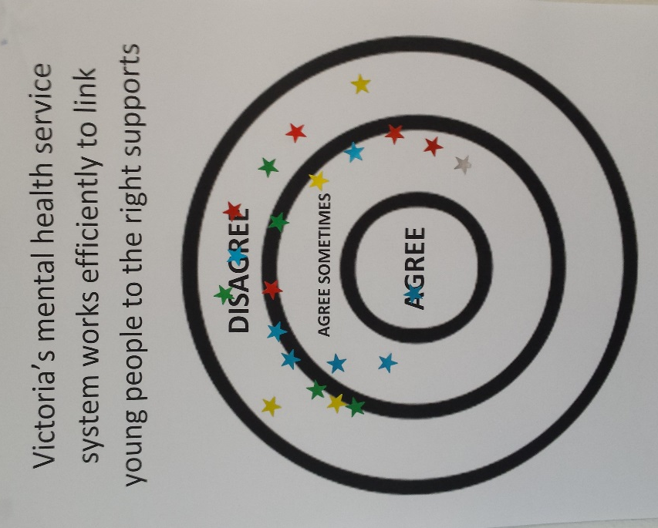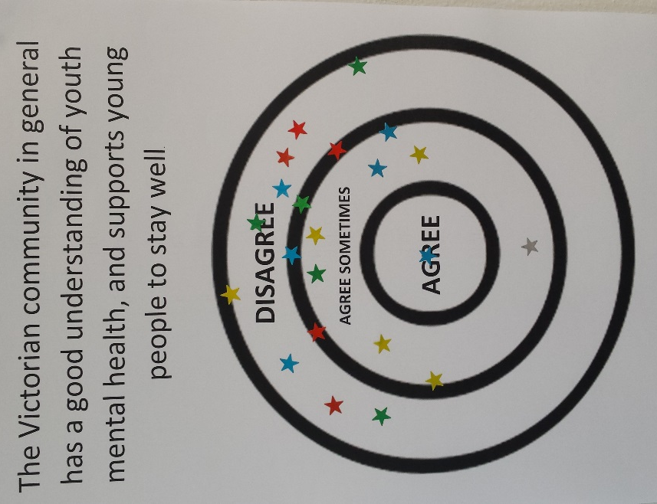
Consultation exercise where participants were invited to mark with stickers where they stood on key questions about youth mental health.

Social media polls asking young people and youth workers their priorities for the Royal Commission.
Engage with young people

Key messages:

- Young people have unique strengths, ideas, needs, and vulnerabilities in relation to mental health.

- Change works better when young people are meaningfully involved. Young people also have a right to be involved.

- Adolescence and young adulthood are vulnerable times for all young people. However, some groups of young people are at higher risk of poor mental health than others.

- It’s vital to engage with young people in ways which are meaningful, safe, respectful, and accessible.

- Young people have already been generous and articulate in sharing their experiences and ideas about mental health, via past consultations and research.

Recommendations:

- Pay strong attention to the mental health of young people aged 12 – 25, either as a defined key topic or as a theme assessed across all key topics.

- Set up a range of mechanisms for the Royal Commission to engage with young people. Key principles should include:

- Engage young people early on to co-design a youth engagement strategy, then in the design and delivery of consultations.
- Engage with young people all around Victoria.
- Offer young people a range of meaningful opportunities to get involved, including as Youth Commissioners.
- Offer expert wellbeing support to young people through the consultation process and beyond.
- Work with and resource local services, networks schools, parents and carers to support young people’s participation, especially priority groups.
- Make consultations accessible and affordable to all young people.
- Ensure consultations are comfortable, welcoming, respectful, and genuine.
- Have realistic goals and timeframes, which young people understand.
- Use honest and clear communication.
- Engage with a diverse range of young people, of all ages from 12 to 25.
- Consider paying or rewarding young people for taking part.
- Talk to young people about mental health, as well as illness.
- Consistently evaluate the youth engagement strategy to ensure young people (especially from priority groups) have access to the Royal Commission and can participate.

- Engage in targeted ways with young people identified as being at disproportionate risk of poor mental health. According to existing research, this should include:

- Aboriginal and Torres Strait Islander young people
- Young women
- Young people who have been in out-of-home care and/or the youth justice system, and –
- Young people who have experienced homelessness.

Our stakeholders also recommend that the Commissioners engage with:

- Young people with disability (including intellectual, physical, and psychosocial disability)
- Young people from refugee and migrant backgrounds
- LGBTIQ+ young people, and –
- Young victim-survivors of family violence.

- Learn from existing mental health research conducted with young people, including recent work by CSIRO and VicHealth, Mission Australia and Black Dog Institute, Youth Affairs Council Victoria, and the Victorian Government’s Youth Congress.

- Learn from research conducted with young people on topics impacting strongly on young people’s mental health, including racism, sexism, involvement in the justice system, and abuse in institutional settings and workplaces. In particular, we note recent research by the Koorie Youth Council, Plan International Australia, the Young Workers Centre, and the Royal Commission into Institutional Responses to Child Sexual Abuse.

Background:

Many young people show great strengths and awareness in relation to mental health. Nearly three quarters of young Victorians agree that they place a strong value on their mental health, and youth services tell us that in recent years young people’s mental health literacy and help-seeking have increased noticeably. Mission Australia’s Youth Survey shows that young Victorians are more likely now than they were four years ago to seek help for an important issue from a telephone hotline, community agency, or school counsellor, and almost 12% of young Victorians have engaged in online counselling with a professional.

Young people are also very conscious of mental health as a broader social issue. When Mission Australia surveyed 28,286 young Australians in 2018, asking them about the biggest issues facing Australia today, mental health was the most popular topic chosen, nominated by 43% of young people.

At YACVic, we find that young people are eager to have their say about mental health. At our recent consultation to inform this submission, we asked the group to nominate their biggest priorities for the Royal Commission – ‘Giving young people a real voice in how the mental health service system works’ was the equal third most popular topic out of 18 options. Similarly, in 2016, YACVic Rural ran consultations in twelve communities around the state to ask young people about the biggest issues where they lived; 472 young people took part, and they nominated mental health as their number one concern.

Young people are original and innovative thinkers, good at coming up with fresh solutions to long-standing problems. For example, at YACVic Rural’s recent youth forums in the Loddon Campaspe area, the young participants’ ideas for action on mental health included school counselling sessions offered before and after school, local youth support ‘hubs’, youth services directory apps for young people to explore on their phones, youth services caravans to bring services to the young people, mental health first aid training for students, regular mental health forums for parents, support animal programs (‘dog doctors’) in schools, self-care evenings, and a ‘gym in the park’ program with free sport and yoga, to encourage conversations about mental health.

Such creative young thinkers would be a huge asset to the Royal Commission.

At the same time, young people are highly vulnerable in relation to mental health. For example:

- Half of all lifetime mental health disorders emerge by age 14. Three-quarters emerge by age 24.

- Nearly 1 in 5 young Victorians show high levels of psychological distress. Rates of distress in teenage girls are almost twice those reported by boys, and rates of distress for young people get worse during adolescence, rising sharply between Grade 5 and Year 11.

- In recent years, there has been an increase in young people showing signs of probable serious mental illness. Aboriginal and Torres Strait Islander young people are at significantly higher risk of probable serious mental illness than non-indigenous young people, and young women are twice as likely as young men to show signs of probable serious mental illness.

- One in 10 young Australians have self-harmed. Rates of hospitalization for self-harm amongst Aboriginal and Torres Strait Islander young people are almost five times those of their non-indigenous peers, and rates of hospitalization for self-harm in young women are more than twice as high as the rates for young men. Historically, self-harm has also been disproportionately common amongst young people in out-of-home care and youth justice facilities.

- 45% of young Victorians aged 15-19 describe being concerned about coping with stress. A third report feeling concerned about mental health, and a third describe being concerned about body image. Along with school or study problems, these are the most common personal concerns reported by young Victorians. Adolescent girls report significantly higher rates of concern about these issues than their male peers.

- Almost 9% of young Victorians describe their general mood as sad or very sad, and 9% describe feeling negative or very negative about the future.
We asked young people and youth support professionals for their key messages to the Royal Commission before the Commissioners get to work. Here are just a few responses:

‘Be open to a completely new & innovative approach to youth mental health.’

‘Have a broad aspect of looking into mental illness and not just mental health issues. i.e. bipolar and autism and how that effects mental health.’

‘Supports for Aboriginal & Torres Strait Islander youth, as supports are hard to get to.’

‘How mental health affects LGBTIQ young people, young people with disabilities, young Indigenous people and young people of colour.’

‘Targeting most complex YP (homelessness / disengaged).’

‘Youth with disabilities look down on themselves [and] have some have mental health issues. This needs to be fixed.’

‘Cultural diversity – being inclusive when not all cultures share understanding / acknowledge “mental health”. YP caught between cultural & mainstream expectations.’

‘How to support youth who have experienced trauma, family break-ups and family violence.’

As members of our community, and consumers of mental health services and related services, young people have a right to be involved in the work of the Royal Commission. If the process is managed well, there will be other benefits too, including building young people’s skills, confidence and connections, and encouraging young people to take up advocacy and leadership roles in the future.

Through our consultation processes and prior engagement with young people and youth support services, we identified the following approaches as especially important, for the Royal Commission to engage well with young people:

- Engage young people to co-design a youth engagement strategy, then in the design and delivery of consultations. Participants at our consultation workshop suggested engaging young people to facilitate face-to-face consultations for the Royal Commission. (Note: local governments and many youth services host youth advisory groups or action groups, many of whom would be keen to be involved in something like this.) They also urged that any consultations undertaken through schools be done in collaboration with Student Representative Councils (SRCs), not just school staff or the board.

- Engage with young people all around Victoria. Commissioners should travel to a wide range of rural and regional communities, and to different parts of Melbourne, including Melbourne’s interface local government areas. This is best led by young people themselves – ideally Youth Commissioners.

- Offer young people a real range of opportunities to get involved. These should include face-to-face interviews, focus groups, social media, and school-based engagement. There could also be options for online chat and text messaging. Key messages from our stakeholders were:

- Effective use of social media and online engagement is important. Respondents suggested social media polls and campaigns (Instagram especially), accessible and appealing videos, and enabling young people to send in their ideas via text and Facebook messenger.
- Schools provide universal spaces for engagement. Options could include large-scale student surveys or in-person consultations.
- However, many respondents stressed that online engagement and school engagement should be just two options for consulting with young people, not the only options.

- Support young people through the consultation process and beyond. Young people should be connected with appropriate supports before, during, and after the consultation process. Support figures might include youth workers, mentors, school wellbeing staff, or trusted community members, as well as mental health professionals.

- Work with local services, schools, parents and carers to support young people’s participation. Key messages from our stakeholders included:

- Engage with services where young people regularly gather and feel comfortable, including TAFEs, libraries, sporting clubs, Scouts, youth services, universities, and Aboriginal community spaces. These services can help promote consultations, support young people to take part, and/or provide a familiar physical environment for consultations.
- Engage appropriately with parents and elders in refugee and migrant communities to support young people to take part. Keep in mind that multi-lingual resources may be needed, and that understandings of health can be very different across diverse cultures. Not every cultural community shares the Western concepts surrounding ‘mental health’.

- Make consultations accessible and affordable to all young people. Offer engagement opportunities after school and on evenings and weekends. Provide catering, and cover young people’s travel costs or provide dedicated transport. Engage with disability advocacy bodies such as the Youth Disability Advocacy Service to create suitable environments.

- Ensure consultations are comfortable, welcoming, respectful, and genuine. Key messages from our stakeholders were:

- Create a relaxed and welcoming environment.
- Take time to build trust and rapport with young people.
- Listen to young people, believe them, and take them seriously.
- Give young people space to formulate and express their own ideas, without feeling discredited, judged, or rushed.
- Listen to every young person, not just the most confident ones.
- Provide spaces, activities, and/or objects which help young people to ‘de-stress’ during consultations.
- If hearings are used, ensure they are small and safe.
- Use appropriate and non-stigmatizing language.
- Acknowledge young people’s skills, talents, knowledge and contributions.
- Consider using enjoyable, non-verbal approaches like art and music therapy.

- Have realistic goals and timeframes, which young people understand. Young people should feel confident that their contributions can make a real difference.

- Use honest and clear communication. Do not assume young people have detailed knowledge of the service system, and do not use jargon. Provide timely feedback to young people about what has been done with their contributions. Build young people’s knowledge about mental health, advocacy, and how a Royal Commission works.

- Engage with a diverse range of young people, of all ages from 12 to 25 (not just the middle teens, who may be ‘easier’ to reach). Key messages from our consultations were:

- Recognise that people with intellectual disability or cognitive variance may experience mental health differently and express themselves differently to their peers. Commissioners should have a good understanding of this, and take seriously the insights of these young people.
- Mental health can play out differently in the lives of Aboriginal and Torres Strait Islander young people, young people with disability, young people with serious or chronic health issues, young people from refugee and migrant backgrounds, and LGBTIQ+ young people. Tailored approaches may be needed for engagement.

- Consider paying or rewarding young people for taking part. Work with local youth services to develop an approach, keeping in mind different communities may have a different philosophy around things like money, vouchers, or some other form of recognition. (One young person suggested prizes such as such as one month of premium Spotify.)

- Talk to young people about mental health, as well as illness.

We asked young people and youth workers how the Royal Commission should go about engaging with them. Here are just a few quotes from participants:
We also asked young people and youth workers what the Royal Commission should NOT do. Here are just a few quotes from participants:
Address access and equity for rural, regional, and interface areas

Key messages:

- Access to mental health services and related services depends critically on where you live.

- Rural communities experience massive inequalities of service access.

- Regional centres and interface suburbs also have poorer access to services than the inner and middle suburbs of Melbourne, although their access is better than that of rural towns.

- Needs, strengths, and stresses in relation to youth mental health also vary between rural, regional, interface, and inner metropolitan areas.

Recommendations:

- Name geographical inequality and access to services in rural, regional and interface areas as key topics to be addressed by the Royal Commission.

- Hold consultations for young people in diverse rural, regional, and interface communities, as well as metropolitan Melbourne. Work with local government youth services and other youth services to make these opportunities meaningful, safe, youth-friendly, and accessible.

Background:

Rural and regional Victoria is home to over 234,000 young people, and in the past couple of years, our YACVic Rural team has met with more than 2,000 of them from all corners of the state. YACVic Rural have also had over 2,000 conversations with youth sector professionals from across rural and regional Victoria.

Meanwhile, in 2018 YACVic consulted with 70 youth sector representatives from across Melbourne’s interface council areas – the large, diverse communities around the edges of Melbourne. We also scoped research into interface service needs, and youth surveys and plans released by interface local governments.

Through these consultations, and our 2019 mental health consultations, we learned that youth mental health is a major concern in rural, regional and interface areas.

At our consultation workshop about the Royal Commission, we asked young people and youth support workers what they saw as the priority topics for the Commissioners. Out of 18 topics we suggested, the topic that received the most votes was ‘Making sure young people can access high quality mental health support in rural, regional, and outer suburban communities’.

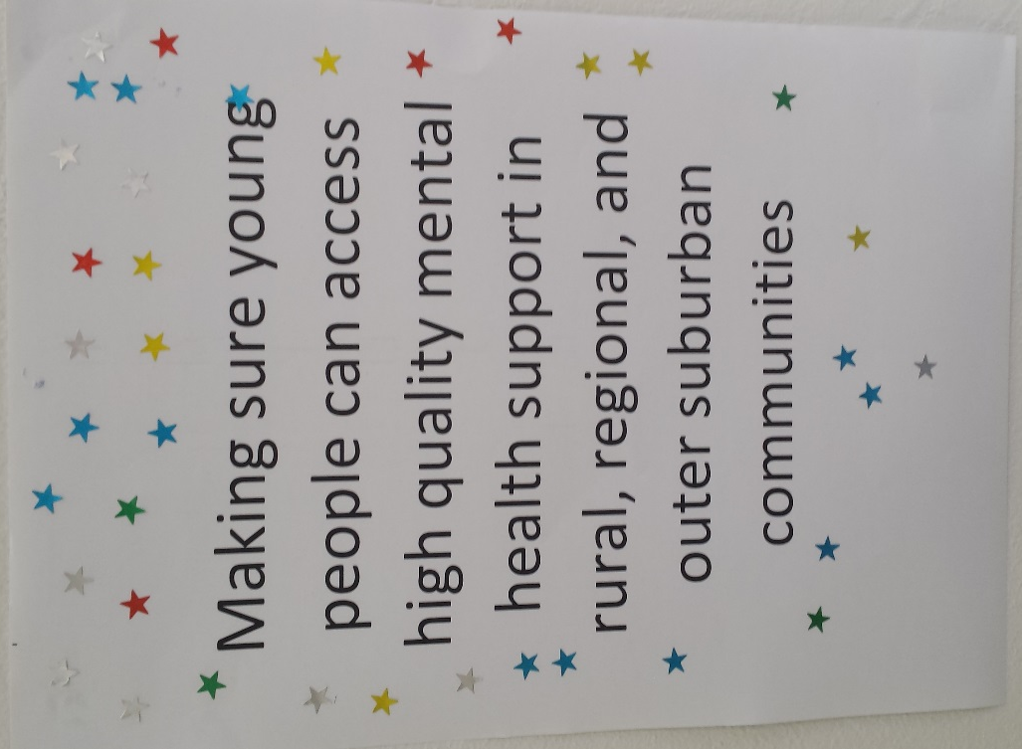
We asked workshop participants to indicate with stickers the topics they saw as key for the Royal Commission. Rural, regional, and interface access was the ‘winner’. It was also prioritised by respondents to our online survey.

Rural and regional communities often show extraordinary dedication, strength and innovation in caring for young people, but they face huge challenges.

Key issues highlighted by young people and youth support workers in rural and regional areas include:

- Serious shortages of mental health services. Some rural communities are supported by a psychiatrist who flies in one day a week; some are supported by psychiatric nurses based in regional centres several hours away – and some have less support. In an isolated rural area, a young person might wait many months to see a mental health professional, even after a traumatic experience. For example, we heard of one community with six-month waiting lists for specialist sexual assault counsellors.

- Other, related services – e.g. youth alcohol and other drug (AOD) services, and Koorie Education Support Officers – also have to cover huge distances and may struggle to properly support young people. For example, we heard of one rural service which had a youth AOD worker for four hours a week. This worker was highly valued, but could not meet the need.

- Getting help for a mental health problem often means long, costly travel to Melbourne or a regional centre. This places pressure on families – especially single parents with limited transport – and takes young people away from their local supports. It’s a particular risk for young people with more serious or complex mental health issues, who may be referred all the way to the Banksia Unit in Melbourne.

- Many young people have good awareness of headspace, and the headspace model is valued for its youth-friendly early intervention. Unfortunately, many headspace centres don’t offer rural outreach, or offer only very limited outreach. Rural service delivery has specific costs in relation to distance, travel and shortage of other local services, which the traditional headspace model was, arguably, not developed to address.

- Even when a local health service exists, it may not be appropriate for every young person. Local rural hospitals, for example, are not always trusted by young people and their families to deliver mental health support.

- The CAMHS and triage systems tend to be based in regional centres and can struggle to respond promptly and appropriately to a young person in crisis in an isolated rural area.

- Public transport is often seriously inadequate – e.g. two buses per day – which makes it hard for young people to get to the services they need.

- With few mental health services, responsibility for supporting young people falls heavily onto other places, like schools and sporting clubs.

- Some rural and regional schools have shortages of appropriately qualified wellbeing staff. Some students spoke of waiting many weeks just to see a school counsellor.

- Higher than average youth suicide rates in some rural and regional areas, and the need for community-driven interventions to address this.

- Impacts of family violence on young people’s mental health, and the shortages of appropriate counselling services in rural and regional areas.

- Vulnerability of young adults aged 18-25, who no longer have school-based supports, and who may be stigmatized for staying on in a rural or regional area, where people often assume the ‘successful’ young adults will leave.

- Recruiting specialist mental health staff to work in rural and regional communities is a big challenge. The shortage of specialist staff means that even when a new mental health project or centre is funded, it can cause tensions, as services feel under pressure to compete for funding and staff. In communities which rely heavily on collaboration, this can be very harmful.

- Many rural towns have little or no access to generalist youth workers.

- There has been a rise in online and telehealth facilities, but these models are not always appropriate or accessible for a rurally isolated young person with a mental health problem.

It’s important to note that many rural and regional communities have already compiled a strong knowledge base around youth mental health. For example, several of our stakeholders highlighted the datasets of the Greater Shepparton Lighthouse Project, the Middle Years Development Index, and Communities That Care. Their expertise should inform the work of the Royal Commission.

We asked young people and youth support professionals for their key messages to the Royal Commission before the Commissioners get to work. Here are just a few responses:

‘Please make sure you visit rural areas – I’m not talking about Bendigo and Geelong which are well resourced and serviced. Please include towns such as Benalla, Wangaratta, Echuca, Swan Hill, Charlton etc.’

'Engage regional, remote and rural areas – where isolation and stigma may increase poorer mental health AND coupled with overall inaccessible services to support youth.'

'Lack of services in Regional areas that have high rates of suicide. Hospital responses that are inadequate i.e.: no effective follow up, judgmental staff, no or lack of knowledge of dual diagnosis, and childhood trauma, time limited services, no outreach, models of service delivery that are effective'.

'Rural mental illness and the options available. It there enough available if people don’t get along with the primary support?'

'funding rural models for youth early intervention mental health services. There are examples of rural towns screaming out for services with high youth suicide rates but headspace funding model is devised with larger populations in mind. Benalla is an example of one such town- young people are not going to travel to Albury or Shepparton (45mins-1hr drive away) to access headspace.'

‘Rural isolation is a big impact on mental health to a lot of young Victorians.'

Meanwhile, over the past twelve years, the population of Melbourne’s interface council areas has grown by 43%. Nine out of ten of Victoria’s fastest growing suburbs are in interface areas.

Interface communities are very diverse – culturally, economically, and geographically – and while they have many strengths, they also have high rates of disadvantage and relatively poor access to transport, services, and opportunities, compared to Melbourne’s inner suburbs. It’s estimated that by 2031, 1.7 million people will live in our interface suburbs – mostly families with children.

Youth services in interface areas have told us clearly that mental health is a major concern. Mental health services often struggle to meet the need, especially for geographically isolated young people. There are ‘black spots’ of particularly poor service access and poor public transport in the local government areas of Mitchell Shire and Yarra Ranges especially.

As in rural and regional areas, a disproportionate pressure falls onto schools to support students’ mental health, in the absence of other supports.

Some workers also told us that they were concerned that headspace centres which service interface areas may be under pressure to deliver interventions in spaces not originally part of their remit, such as school disengagement and serious mental illness.

Services in interface council areas also raised other concerns about youth mental health which warrant further exploration. These include:

- Impacts of family violence and sexual violence on young people’s mental health. Long waiting lists for sexual assault support services were identified as an especially grave concern in interface areas.

- Mental health impacts of social media, including ‘social contagion’ and ‘panics’ over certain issues, such as local suicides and other deaths.

- Mental health impacts of gaming and gambling, including school disengagement and social isolation.

Case study: Rural disadvantage and distance from services

Approach

We looked at the 10% of Victorian communities which have the highest proportion of people living with disadvantage, according to the Australian Bureau of Statistics (ABS) Index of Relative Socio-Economic Disadvantage.

These communities have many strengths, and young people there may enjoy excellent mental health. However, for young people in these communities who do become concerned about their mental health, accessing professional support that meets their needs is likely to be harder than it would be for their peers elsewhere, due to limitations of income, transport, information, and social capital.

We calculated basic geographical distance between these locations and the nearest mental health professionals, using the public databases provided by the Royal Australian & New Zealand College of Psychiatrists, the Australian Psychological Society, and headspace.

Findings

Rural towns with high levels of disadvantage tend to have very poor access to mental health specialists. For example:

- None of Victoria’s most disadvantaged rural suburbs have a psychiatrist within 10 km.

- Only 5% of Victoria’s most disadvantaged rural suburbs have a headspace centre within 10 km.

- In more than a quarter of Victoria’s most disadvantaged rural suburbs (28%), you would have to travel over 100 km to see a psychiatrist.

- In 15% of Victoria’s most disadvantaged rural suburbs, you would have to travel over 100 km to the nearest headspace centre.

- In 70% of Victoria’s most disadvantaged rural postcodes, you would have to travel over 50 km to see the nearest psychologist.

Some rural communities have very high levels of disadvantage, and are also:

- at least 100 km from the nearest psychiatrist, and

- at least 50 km from the nearest psychologist, and

- at least 100 km from the nearest headspace centre.

These communities are found in the local government areas of East Gippsland, Gannawarra, Northern Grampians, and West Wimmera.

Other communities facing a strong combination of disadvantage and long distances to mental health services are found in local government areas including Buloke, Glenelg, Hindmarsh, Loddon, Pyrenees, Swan Hill, Towong, Wellington, and Yarriambiack. (This does not capture the full extent of rural need, only some of the worst gaps.)

Victoria’s regional centres and interface council areas generally have better access to mental health professionals than smaller rural towns. But their access tends to be worse than in the inner and middle suburbs of Melbourne.

For example, 86% of the most disadvantaged postcodes in interface areas have a psychologist within 10 km. Almost two-thirds of the most disadvantaged interface suburbs (63%) have a psychiatrist within 10 km, and 54% of highly disadvantaged interface suburbs are 10 km or less from a headspace centre.

In contrast, almost 100% of the most disadvantaged communities in inner/middle Melbourne have a psychiatrist and a psychologist within 10 km, and 71% of these communities also have a headspace centre within 10 km.

There are many limitations to the approach we have taken here. It is intended merely as an ‘opening’ discussion about access, distance, and disadvantage. More research is needed, and we trust the Royal Commission will encourage this.

Involve schools

Key messages:

- Schools are not mental health services, but they play a vital role in protecting and supporting young people’s mental health.

- Very significant responsibility for young people’s mental health is falling onto schools, especially in rural, regional and interface communities where other services are scarce.

- Schools have experienced many mental health ‘programs’ and similar in the past. But too many programs were short-term or one-off, not school-wide and sustainable.

- Recent announcements of increased mental health investment in schools were very welcome. However, in rural and regional areas, especially, getting appropriately qualified staff on the ground is likely to remain a challenge.

- Schools have great potential to build young people’s connections and wellbeing, and encourage good mental health. But school experiences can also put a young person’s mental health under particular strain.

Recommendations:

- Engage with school students, school wellbeing staff, and teachers, especially in communities with limited access to external mental health services.

- Recognise schools as key places where young people present with mental health issues and are supported – but also places which are under strain in relation to youth mental health.
Background:

Schools are one of the few places where most young people aged 12-18 are engaged, and which have a strong duty of care to young people. As such, it’s common for young people’s mental health issues to become apparent in school, and for young people to seek mental health support from their schools.

When Mission Australia surveyed 5,132 young Victorians aged 15-19, they found that almost 4 in 10 young people said they would go to a school counsellor or a teacher for help with an important issue in their lives. This was a much higher proportion of young people than those who would go to a community agency or a telephone hotline for help.

Many secondary schools do great work, investing in student wellbeing, partnering with community services and headspace centres, and building staff understanding of trauma-informed practice. In some schools, students’ mental health is further enhanced by a culture of strong student voice, respectful behaviour, and meaningful opportunities for students to contribute to their school communities.

We have also heard positive feedback from students and workers in communities which have introduced comprehensive, locally-led Mental Health First Aid programs in schools, engaging students, teachers and parents in protecting young people’s mental health.

However, schools can also be places where a young person’s mental health is under strain. For example:

- When Mission Australia surveyed young Victorians about their greatest personal concerns, ‘school or study problems’ was the second most common concern nominated, after ‘coping with stress’.

- As of 2015, only about two-thirds of Years 7 to 9 students in Victoria reported feeling connected to school, and only around 55% reported feeling socially connected and getting on well with their peers.

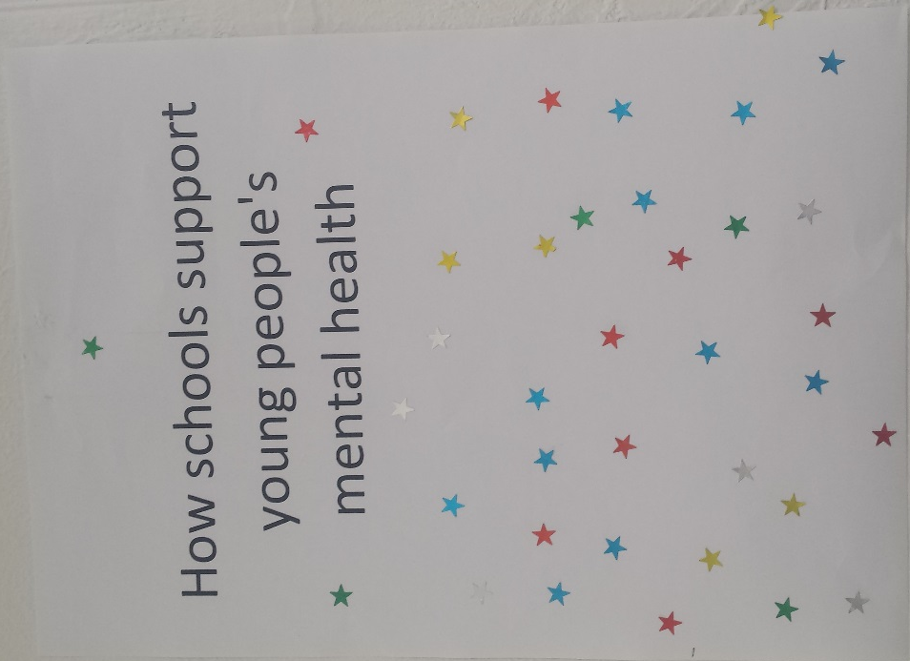
At our consultation workshop, we asked young people and workers to indicate with stickers the topics they saw as key for the Royal Commission.

Out of 18 possible topics, the role of schools was the second most popular.

Through our consultation process, we found that young people and youth support workers were keen for the Royal Commission to look at the role of schools in relation to youth mental health. Key issues raised included the following:

- Schools are under pressure to deal with a huge array of issues, including supporting some students who are seriously mentally ill. Demands on schools are especially pressing in rural, regional and interface communities, where there are relatively few external services. One respondent to our survey called for the Royal Commission to hold ‘A special hearing for every single counsellor/mental health expert/psychologist that works in a Victorian High School’.

- Many rural and regional schools struggle with limited access to qualified wellbeing staff and mental health practitioners. Wellbeing staff play a vital role, but many also have teaching loads, and may not come from a specialist mental health background. The youth services sector welcomed the recent announcement by the Victorian Government of a new Mental Health in Schools program to employ over 190 mental health professionals and ensure that every state secondary school will receive between one and five days a week of support. However, concerns remain in rural areas, especially, about how to get the right, qualified staff on the ground locally. It will be important for the program to work from a strong evidence base and be well evaluated to deliver the best results for students.

- In communities with scarce access to mental health services, schools can be the only source of support. This puts great pressure on staff – some of whom are untrained in mental health – and means that students are missing class in order to access support during school hours. This can weaken a student’s connection to education – and what happens when a student has a crisis after hours? Several young people at our consultation agreed ‘Holidays can be a tough time for young people’.

- School communities are grappling with issues like bullying, social media and Year 12 pressure, and how these impact on a young person’s mental health.

- Many school communities are wary of the idea of mental health ‘programs’. In the past, many school-based programs have been short-term or one-off, led by individual staff members and not adopted across the whole school. The quality of programs has also varied.

- Some schools are reputedly reluctant to engage with external youth services in relation to mental health. Some schools may feel they don’t have capacity to work in partnership, while others may fear that encouraging discussion of mental health will ‘open a can of worms’, spurring students to ask for mental health support which the school cannot provide.

- Some teachers need a stronger understanding of youth mental health.

- Mental health problems are beginning to present in primary schools.

Prioritise prevention

Key messages:

- Preventing young people from becoming unwell, and preventing youth suicide, are critical areas where action is needed.

- It is vital to understand the wider context of a young person’s life – to build on existing strengths, and address all the factors (including social and structural forces) which endanger a young person’s mental health.

Recommendations:

- Explore approaches to prevention, and to youth suicide prevention, to identify which approaches have demonstrated success and why, and the resourcing needed to make these approaches ongoing and address the extent of the need.

- Work with young people and their communities to identify strengths which could be built upon to enhance young people’s mental health, and to identify the factors which endanger young people’s mental health, including social and structural pressures.

Background:

The youth services sector has long emphasised the need for more high-quality prevention work to support young people’s wellbeing. Prevention work is needed at universal, targeted, and high-risk levels.

A similar message emerged from our consultations this time:

- We asked respondents to our online survey to choose from nine broad topic areas, to tell us what they thought the Royal Commission should prioritise. The two most popular topics selected were ‘How to prevent young people from becoming ill in the first place’ and ‘Preventing youth suicide’.

- Through an Instagram poll, we asked what focus the Royal Commission should take. Respondents voted 52% in favour of ‘Building strong communities so fewer people develop mental health issues’ (as opposed to ‘Fix our mental health services so they work for everyone’ – 48%).

- At our consultation workshop, we asked young people and youth workers to identify the topics they wanted the Royal Commission to prioritise. The equal third most popular topic (out of 18) was ‘Preventing youth suicide’, and the 10th most popular was ‘As a community, how do we prevent young people from becoming ill, and support them to enjoy good mental health?’ When we asked the group whether they agreed that the Victorian community had a good understanding of youth mental health and supported young people to stay well, 58% of the group disagreed, 39% agreed somewhat, and only 3% agreed definitely.

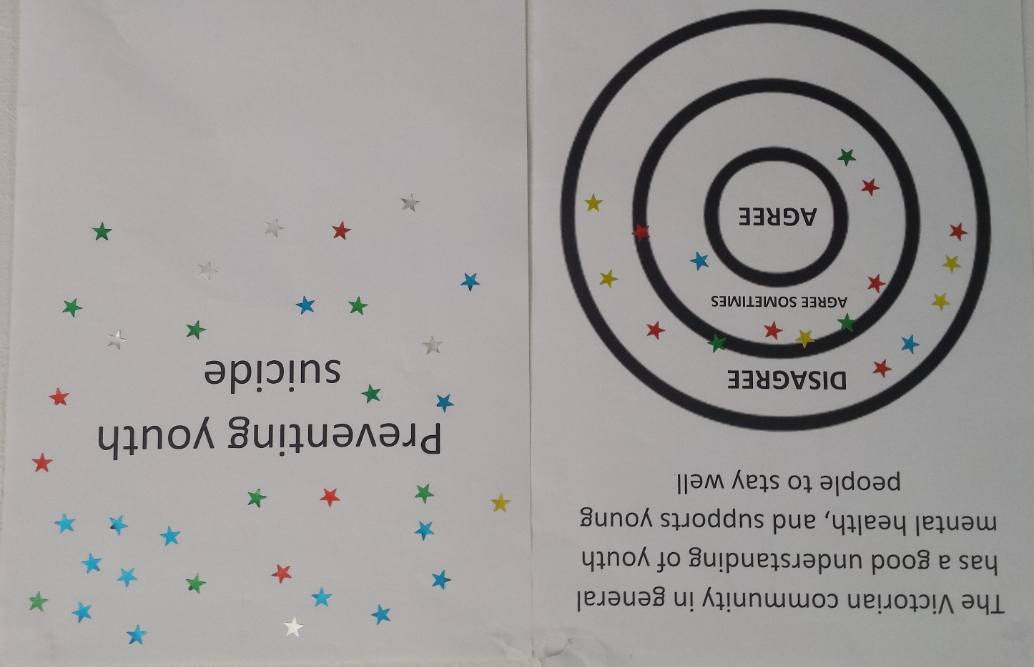

We asked young people and youth support professionals for their key messages to the Royal Commission before the Commissioners get to work. Here are just a few responses:

‘Preventing young people from becoming unwell in the first place.’

‘I can't stress how important it is to focus on the models of prevention prior to an individual becoming unwell. How much funding and what policy emphasis is cast on prevention in Australia?’

‘Protective factors’.

‘What causes the stress and anxiety leading to mental health issues such as the stresses placed on individuals from school, family and financial burden. Stop mental health issues at the causes, we need to prevent not treat.’

‘How to engage POSITIVE mental health! PREVENTION!’

Our stakeholders stressed that in order to do prevention work effectively, it is important to understand the wider context of a young person’s life, including the stressors and strengths. Key points that emerged from our consultations included:

- The importance of building children’s social skills early, supporting them to develop good friendships, discourage cliques and bullying, and develop resilience.

- Much stronger knowledge and strategies are needed to address the complex and serious impacts of social media on young people’s mental health, including bullying, competition, anxiety and distancing from other people, as well as the neurological impacts of screen time and ‘scrolling’ and the effects on sleep patterns.

- Address the social exclusion of young people with disabilities, whose mental health can be harmed by being left out of typical ‘youth’ activities and friendship groups.

- Address the impacts of disadvantage on youth mental health. (One young person asked if we really needed a Royal Commission into Poverty.)

- Consider how local catastrophes and pressures on parents impact in turn on young people’s mental health. For example, the dairy crisis has put many rural families under grave financial and emotional strain.

We asked young people and youth support professionals for their key messages to the Royal Commission before the Commissioners get to work. Here are just a few responses:

‘Link between class and mental health (class divide) (poverty + M.H.)’

‘educating youth about the real effects of social media on self-esteem’

‘Putting all social media under the microscope and supporting new platforms that aren't addictive and don't fuel young people’s insecurities through competition and superficial rubbish. We need to support platforms that promote creativity, positivity and nurture young people’s strengths and self esteem.’

‘Improving mental health outcomes in the workplace or employment.’

‘Preventing the demonisation of youth behaviour that is often a result of mental health issues (e.g. alcohol and drug use or minor criminal offences). These behaviours need to be treated as part of the mental health issues, with more of a focus of treatment not punishment.’

We asked youth workers and young people to identify the strengths in their communities which help to nurture young people’s mental health. Their answers included (but were not limited to) the following:

- Communities (especially in rural areas) where people look out for each other. Local figures such as teachers, youth workers, and police can take on significant responsibility for caring for young people.

- Local government youth services and other services which give young people a real voice and opportunities to make change in their community. For example, young people from Mitchell Shire spoke strongly about the positive impacts of taking part in their Youth Council.

- Comprehensive and locally-owned mental health education, provided to students, teachers and parents across a school community. For example, the Live 4 Life and Read The Play programs work in several rural communities to engage schools, sports clubs and local services in mental health education, prevention, and supporting young people.

- High quality youth mentoring programs. For example, some stakeholders praised the Standing Tall program (Warrnambool) and the MATES program (West Wimmera).

- Local projects to promote community connection. For example, we were told about the Meals for Change program (UnitingCare Ballarat), which provides subsidized meals at cafes for young people at risk of homelessness, with an emphasis on promoting nutrition and inclusion.

- Local sporting clubs, especially those which engage a diversity of players and offer a range of sports and options to take part.

- Adventure playground programs run by local government youth services, e.g. City of Port Phillip.

- Secondary school nurses, who engage students and staff proactively about mental health.

- Interventions which support young people’s engagement in education, such as the Local Learning and Employment Networks, Navigator, Beyond the Bell (Warrnambool), and Hands On Learning.

- High quality respectful relationships education in schools.

- Adventure therapy and other outdoor / nature-based interventions.

- Meaningful and well supported opportunities for young people to volunteer.

- Cultural strengthening for Aboriginal young people.

Examine how services respond to young people with mental health concerns

Key messages:

- Young people and youth support workers are eager to engage with the Royal Commission about the design, funding and functioning of interventions designed to support youth mental health – from headspace to hospitals.

- Some young people have high or complex mental health needs which have not been successfully addressed by the mental health service system, or which mental health services cannot address alone. Many of these young people present in other service settings.

Recommendations:

- Consult with young people and youth support workers about the interventions which are specifically intended to address youth mental health, from early intervention models through to psychiatric wards. But also consult about the other service settings where young people present with mental health issues, and which have an impact on youth mental health.

- Set up targeted consultations with young people in spaces including:

- Youth justice settings
- Disability support services
- Youth homelessness services
- Family violence services
- Out-of-home care, and/or leaving care support settings
- Flexible learning providers
- Youth alcohol and other drug services

- Ensure young people can access supported entry points to the Royal Commission without having to go through a dedicated mental health service, if they do not wish to.

Background:

Young people and the workers supporting them have a lot to say about the various services which are meant to support youth mental health.

For example, at our consultation workshop, when we asked participants for their reaction to the statement ‘Victoria’s mental health service system works efficiently to link young people to the right supports’, 58% disagreed, 39% agreed somewhat, and only 3% agreed strongly.

Similarly, 86% of respondents to our Instagram survey did not think Victoria’s mental health system was easy for young people to access.

At our consultation workshop, we asked young people and youth support workers to nominate the topics they most wanted the Royal Commission to focus on. Out of 18 possible topics, the 4th to the 9th most popular topics were (in order):

- ‘Are the typical supports offered by mental health services actually working well for young people?’ AND (equal score) –

- ‘The “missing middle”? Support for young people who have high or complex needs, but are living in the community and not hospitalized.’

- ‘Waiting lists for support services’.

- ‘Making mental health supports accessible and effective for diverse young people’.

- ‘After-hours and outreach support for young people’.

- ‘How hospitals and emergency services respond to a young person in crisis’.

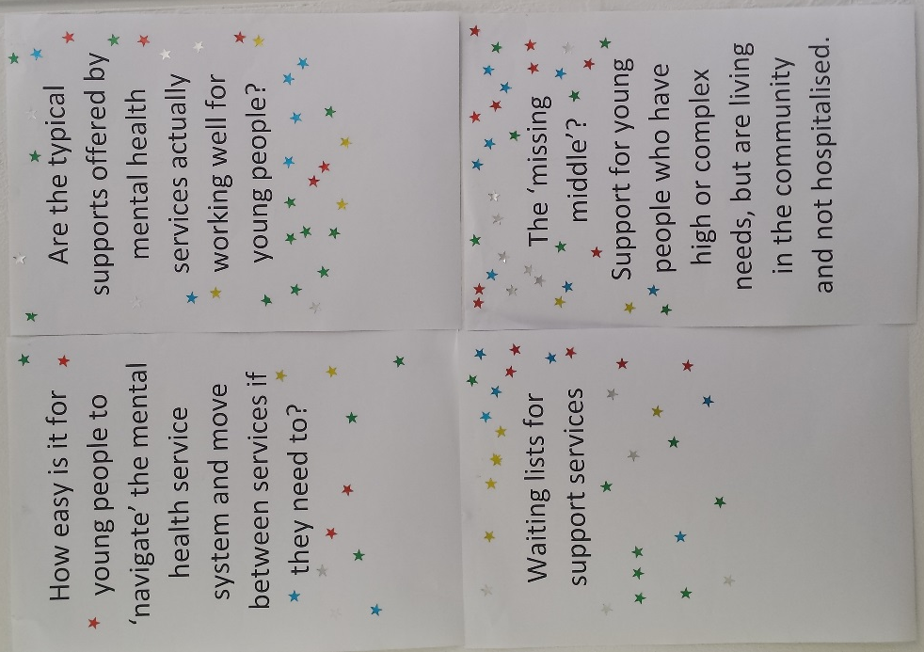 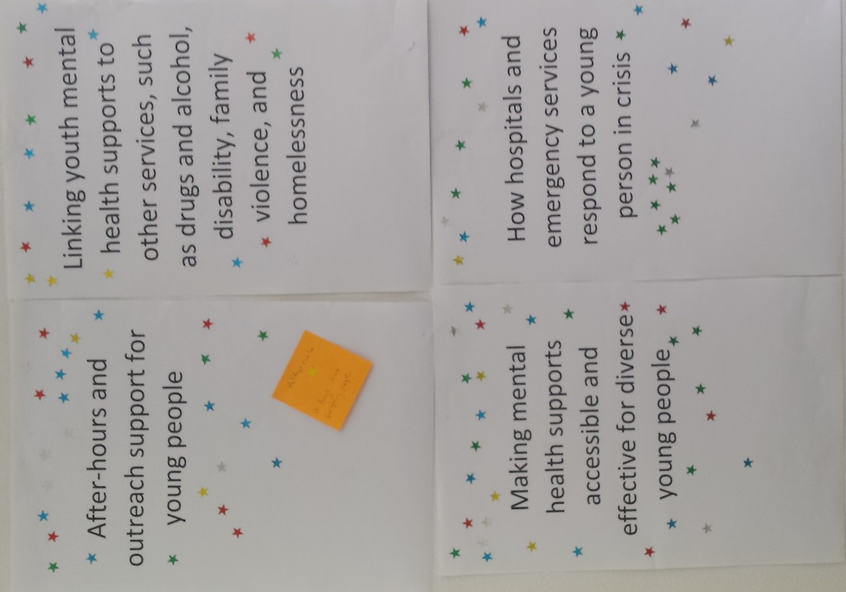We ask
We asked workshop participants to prioritise topics for the Royal Commission to look at.

When asked to elaborate, young people and youth support workers used our workshop and survey to outline the following points:

- There is deep concern for young people who have high or complex mental health needs, but are not unwell enough to be hospitalized. While schools and families have become relatively confident in referring young people to headspace or online supports, many of these models were designed as early interventions, not for young people with more urgent, complex or long-term problems. There seems to be a significant ‘missing middle’ in youth mental health support, especially in rural areas.

- Young people want to speak about practices in psychiatric wards, hospitals, and emergency services. For example:

- Emergency services do vital, life-saving work, but their model of intervention is focused on immediate, physical care. It may not be appropriate for a young person in a mental health crisis.

- Being admitted to hospital can be traumatic, especially if a young person is transferred far from home, or placed in a ward with adults in mental health crisis. One young person commented ‘You might see people in there [hospital] who have been mentally ill for longer than you’ve been alive.’

- A hospital stay for a serious physical illness or injury can also have harmful impacts on a young person’s mental health – e.g. witnessing other people’s pain and death, and feeling obligated to cheer up others.

- The mental health ‘follow-up’ after a young person is released from hospital is not always appropriate.

- Some young people are virtually housebound due to mental illness; more outreach models are needed to support them.

- Financial barriers and waiting lists hinder young people from getting the right help. Some young people know they can receive a Medicare rebate for ten psychologist sessions a year, but they fear this will not be enough, or that they won’t be able to access support in time. Similarly, when the 2014 Mental Health Survey of Children and Adolescents surveyed the parents of adolescents with mental illness, parents were asked about the barriers to getting the right help for their children. A third of parents said a barrier was ‘Couldn’t afford it’, and 29% said ‘Couldn’t get an appointment’.

- While many young people access online support and/or phone support, there are limits to these models. In some rural areas, internet access remains relatively poor, and some telephone helplines can have long waiting periods. This is distressing for a young person in crisis.

- To deliver high quality mental health support to young people, the local service system needs a strong culture of partnership between services, schools, local governments and other stakeholders (e.g. businesses, volunteer organisations, sporting clubs), working flexibly and creatively together. This approach is especially apparent in rural and interface areas. However, competitive tendering models often weaken services’ capacity to work in this way.

- Questions remain about the most effective funding models for services to deliver youth mental health interventions. In particular, state and federal government needs to collaborate better, and we need appropriate, dedicated resourcing to cover the true costs of rural service delivery and outreach.

- Concerns were voiced about potential impacts of NDIS on young people with mental illness and psychosocial disability. In particular, it’s unclear what supports will be in place for young people who are deemed ineligible, and young people who live in small and isolated rural towns, where the local ‘market’ is very limited.

We asked youth workers and young people for their key messages to the Royal Commission before the Commissioners get to work. Here are just a few responses:

‘Explore / investigate the deficiencies of the Better Health initiative. In some rural communities THIS IS ALL THERE IS.’

‘Look into / explore the deficiencies in the community mental health services. Case management response NOT complimented by therapeutic responses = poor response.’

‘Assess applicability of NDIS criteria of mental health’.

‘Mental Health services in our region focus on schools and young people who are engaged with community. There needs to be discussion of young people from out of home care and AOD services that are complex and hard to engage.’

‘Financial burden on young people to get the ongoing support they need’.

‘Resourcing & practice of Adolescent psychiatric wards. Support to inpatients & families’.

‘ARE HOSPITALS THE RIGHT PLACE / ENVIRONMENT FOR A Y.P. (or anyone) EXPERIENCING M.H. CRISIS?’

'getting invites [to participate in the Royal Commission] to all workers involved in youth work and not just management’.

At the same time, there are many other service settings where a vulnerable young person with a mental health problem might present. Some of these young people will not be receiving support from an dedicated mental health service. For example:

- Of the 226 young people detained on sentence or remand in Victoria’s youth justice system in 2017-18, 70% had experienced trauma, abuse or neglect, 53% presented with mental health issues, and 30% had a history of self-harm or suicidal ideation.

- In The Cost of Youth Homelessness in Australia (2016), 53% of the homeless young people surveyed reported that they had been diagnosed with at least one mental health condition. Youth mental illness increases a young person’s risk of homelessness, and vice versa. According to Mission Australia, young people with a probable serious mental illness are 3.5 times more likely to have spent time away from home than those without a mental illness.

- Victoria’s Royal Commission into Family Violence (2016) found that ‘victims of family violence can also experience a range of mental health difficulties, among them post-traumatic stress symptoms, depression, anxiety, eating disorders, sleep problems and self-harming behaviour. For many victims, these have long-term consequences.’ Family violence has serious impacts on the wellbeing of young people, including their mental health.

- A comprehensive survey of 857 young people in 35 different Victorian youth alcohol and other drug services in 2016, found that 35% of the young people had a current mental health diagnosis, 39% self-injured, and 20% had attempted suicide in the past. 51% had experienced emotional abuse, 39% had experienced physical abuse, 17% had experienced sexual abuse, and 22% had been the victims of violent crime.

- Young people in the out-of-home care system often have complex mental health needs, due to factors such as trauma, abuse and neglect, exposure to perinatal risk, and difficult and disrupted relationships. Historically, many young people in care have struggled to have their health issues addressed effectively.

- Anecdotally, we have heard from providers of flexible learning centres that mental health issues, notably anxiety, are a significant reason why young people transfer there out of mainstream schools.

We asked youth workers and young people for their key messages to the Royal Commission before the Commissioners get to work. Here are just a few responses:

‘Don’t just ask CEO’s and higher management – we need input from people on the ground’.

‘Don’t consult with services that do not cover areas [where we live]. (For example, headspace for Mitchell Shire)’.

‘Don’t rely on KPI’s to demonstrate service outcomes’.

‘Don’t ignore conflicts of interest of key stakeholders involved in the Royal Commission $$’.

‘Don’t miss this opportunity to really innovate. Nothing much has changed in the M.H. sector in 20 years. THE ONLY TIME IS NOW.’

‘Don’t expect to fix everything’.

Youth Affairs Council Victoria will continue to engage with young people and youth support services to inform the work of the Royal Commission into Mental Health.

For more information, contact Jessie Mitchell on policy@yacvic.org.au or 0418 413 518.

Those which fall within the following local government shires and rural cities: Alpine, Ararat, Bass Coast, Baw Baw, Benalla, Buloke, Campaspe, Central Goldfields, Colac Otway, Corangamite, East Gippsland, Gannawarra, Glenelg, Golden Plains, Hepburn, Hindmarsh, Indigo, Loddon, Macedon Ranges, Mansfield, Moira, Moorabool, Mount Alexander, Moyne, Murrindindi, Northern Grampians, Pyrenees, Queenscliffe, South Gippsland, Southern Grampians, Strathbogie, Swan Hill, Towong, Wellington, West Wimmera, and Yarriambiack. We based this on membership of Rural Councils Victoria.
Ballarat, Bendigo, Geelong, Horsham, Latrobe, Mildura, Shepparton, Wangaratta, Warrnambool and Wodonga. We based this on membership of Regional Cities Victoria.
Cardinia, Casey, Hume, Melton, Mitchell, Mornington Peninsula, Nillumbik, Whittlesea, Wyndham and Yarra Ranges. Based on membership of Interface Councils Group.
Disadvantage is calculated by factors such as household income, children with unemployed parents, households without internet connection, high levels of separation and divorce, people working in sectors which are traditionally poorly paid, adults without educational qualifications, households without cars, and people who don't speak English well. These communities do not necessarily have huge numbers of people in disadvantage (many are in small rural towns), but they have the highest rates of disadvantage, relative to the whole population.
Limitations include: - The databases are ‘opt-in’, and may not capture every practitioner. - We do not know how many hours each practitioner works per location. - Young people’s access is further affected by public transport, affordability, and appropriateness of practitioners. - We are only measuring whether communities have mental health professionals nearby; we have not (yet) attempted to assess the numbers of professionals relative to the size of the population and its estimated levels of need. - Due to database design, we could search for psychiatrists and headspace centres by suburb, whereas psychologists could only be reliably located by postcode. - The Australian Psychological Society’s database only calculates location up to 50km away; access beyond that is unclear. - Headspace centres provide some rural outreach, which is not captured here. - Young people receive mental health support from other sources, such as counsellors, youth workers and school wellbeing staff.
E. Carlisle, J. Fildes, S. Hall, V. Hicking, B. Perrens, J. Plummer, Youth Survey Report 2018, Mission Australia, 2018; CSIRO and VicHealth, (2015) Bright Futures: Megatrends impacting the mental wellbeing of young Victorians over the coming 20 years; Loddon Campaspe Regional Partnership, Victorian Government, and Youth Affairs Council Victoria, When Life Sucks: youth mental health forums across the Loddon Campaspe region, 2018, https://www.whenlifesucks.com/; Mission Australia in association with Black Dog Institute, Young Mental Health Report: Youth Survey 2012-16, https://blackdoginstitute.org.au/docs/default-source/research/evidence-and-policy-section/2017-youth-mental-health-report_mission-australia-and-black-dog-institute.pdf?sfvrsn=6; Mission Australia, From City To Country: Comparing Major Cities and Regional Areas, 2018, https://www.missionaustralia.com.au/publications/research/young-people; Mission Australia, Youth Mental Health and Homelessness Report, 2017, https://www.missionaustralia.com.au/publications/research/young-people; VicHealth, CSIRO Data61, YACVic and NCFH, Bright Futures: Spotlight on the wellbeing of young people living in rural and regional Victoria, Victorian Health Promotion Foundation, Melbourne, 2018. In addition, Victorian Government Youth Congress (2018) undertook a 12-month, youth-led research project into youth mental health, with a focus on mental health in the workplace and the ‘missing middle’ (the shortage of services for young people with high or complex issues who are not hospitalized). We understand this work has not been released yet, but we anticipate it will be very useful.
Koorie Youth Council, Ngaga-dji (hear me) – young voices creating change for justice, 2018, https://www.ngaga-djiproject.org.au/; Plan International Australia research, including The Dream Gap: Australian girls’ views on inequality, 2017, https://www.plan.org.au/media/media-releases/australian-girls-say-they-are-not-treated-equally, Unsafe in the City, 2018, https://www.plan.org.au/freetobe, and She can lead: Young people in Australia share their views on women in politics and leadership, 2017; Royal Commission into Institutional Responses to Child Sexual Abuse (2015-16), including: Taking us seriously: children and young people talk about safety and institutional responses to their safety concerns, Our safety counts: Children and young people’s perceptions of safety and institutional responses to their safety concerns, Safe and sound: Exploring the safety of young people in residential care, and Feeling safe, being safe: What is important to children and young people with disability and high support needs about safety in institutional settings?, https://www.childabuseroyalcommission.gov.au/research; https://www.plan.org.au/~/media/Plan/Documents/Reports/IDG%202017/She%20Can%20Lead ; Young Workers Centre, Young Workers Health & Safety Snapshot, 2016, https://d3n8a8pro7vhmx.cloudfront.net/victorianunions/pages/1411/attachments/original/1475818335/Young_Workers_Health___Safety_Snapshot.pdf?1475818335
YACVic Rural, 'What Matters to Young People' and 'What Matters to Youth Workers', September 2018, https://www.yacvic.org.au/advocacy/what-matters-to-rural-and-regional-young-people-and-youth-workers/
Youth Affairs Council Victoria, 'Interface council areas and youth service delivery', July 2018, https://www.yacvic.org.au/advocacy/interface-council-areas-and-youth-service-delivery/
Carlisle et al, Youth Survey Report 2018; CSIRO and VicHealth, Bright Futures; Loddon Campaspe Regional Partnership et al, When Life Sucks; Mission Australia with Black Dog Institute, Young Mental Health Report; Mission Australia, From City To Country; Mission Australia, Youth Mental Health and Homelessness Report; VicHealth et al, Bright Futures. Also, work of Victorian Government Youth Congress (2018).
Koorie Youth Council, Ngaga-dji (hear me); Plan International Australia, research including The Dream Gap, Unsafe in the City, and She can lead; Royal Commission into Institutional Responses to Child Sexual Abuse (2015-16), including: Taking us seriously, Our safety counts, Safe and sound, and Feeling safe, being safe; Young Workers Centre, Young Workers Health & Safety Snapshot
Carlisle et al, Youth Survey Report 2018, p.158; VCAMS, 'Indicator 10.10: Proportion of young people who have a high level of emotional wellbeing,' 2016, https://public.tableau.com/views/10_10_1/VICInd10_10?:embed=y&:display_count=no&:linktarget=_self&:tabs=no&:showVizHome=no
Carlisle et al, Youth Survey Report 2018, pp.163-64; J. Fildes, A. Robbins, L. Cave, B. Perrens, A. Wearring, Mission Australia’s 2014 Youth Survey Report, Mission Australia, 2014, p.154
Carlisle et al, Youth Survey Report 2018,
YACVic Rural, ‘Turning Ideas into Action: Youth Forums 2016 - Summary Report’, pp.37-38 https://www.yacvic.org.au/assets/Documents/YACVic-Rural-Youth-Forums-2016-Report-Feb17-2.pdf
YACVic Rural, ‘When Life Sucks – Youth Mental Health’, Consultation Report, November 2018, https://www.whenlifesucks.com/reports ; YACVic Rural, ‘Turning Ideas into Action: Youth Forums 2016 - Summary Report’, pp.37-38
Mission Australia in association with Black Dog Institute, Young Mental Health Report: Youth Survey 2012-16
VCAMS, 'Indicator 10.8: Proportion of young people with the highest level of psychological distress', 2016, https://public.tableau.com/views/10_8_1/VICInd10_8?:embed=y&:display_count=no&:linktarget=_self&:tabs=no&:showVizHome=no
Mission Australia with Black Dog Institute, Young Mental Health Report
Mission Australia with Black Dog Institute, Young Mental Health Report
J. Robinson, L. McCutcheon V. Browne, K. Witt. Looking the other way: Young people and self-harm, Orygen, The National Centre of Excellence in Youth Mental Health, Melbourne, 2016, p.4, 14-16
Carlisle et al, Youth Survey Report 2018, pp.159-60
Carlisle et al, Youth Survey Report 2018, p.168
YACVic Rural, 'What Matters to Young People' and 'What Matters to Youth Workers', September 2018
Youth Affairs Council Victoria, 'Interface council areas and youth service delivery', July 2018
Interface Councils, Interface Councils Liveability Snapshot, September 2017, https://docs.wixstatic.com/ugd/e90bcb_a55714c1a77149c4a1ff5df5865dc339.pdf
Australian Bureau of Statistics (ABS), 3218.0 - Regional Population Growth, Australia, 2016-17, http://www.abs.gov.au/ausstats/abs@.nsf/mf/3218.0
Interface Councils, Fairer Funding Report, August 2014, https://docs.wixstatic.com/ugd/e90bcb_b600baa8014540408ae8915b7ae84b63.pdf
See ABS, 2033.0.55.001 Socio-Economic Indexes for Australia (SEIFA), 2016, Table 2: State Suburb Index of Relative Socio-economic Disadvantage, 2016. The suburbs were: Adelaide Lead, Albanvale, Albion, Allestree, Alma, Amherst, Amphitheatre, Anderson, Apsley, Ararat, Archdale, Ardeer, Argyle, Arnold, Arnold West, Avoca, Bahgallah, Bairnsdale, Bangholme, Barkly, Barmah, Bass, Bealiba, Bearii, Beaufort, Bell Park, Bemm River, Benalla, Berringa, Bet Bet, Betley, Big Pats Creek, Braeside, Braybrook, Breakwater, Bridgewater on Loddon, Broadmeadows, Bromley, Bullumwaal, Bung Bong, Burnbank, California Gully, Campbellfield, Cann River, Cape Clear, Carlton, Carwarp, Casterton, Charlton, Churchill, Club Terrace, Clunes, Cobram, Colac, Colac East, Coleraine, Colignan, Collingwood, Combienbah, Coolaroo, Corio, Coronet Bay, Corryong, Cotswold, Cranbourne, Cullulleraine, Dallas, Dalyston, Dandenong, Dandenong North, Dandenong South, Dargo, Dartmoor, Deer Park, Delahey, Derrinal, Derrinallum, Dimboola, Doveton, Dunach, Dunluce, Dunolly, Dutton Way, Eaglehawk, East Bairnsdale, Eddington, Eildon, Elmore, Eumemmerring, Eureka, Euroa, Evansford, Fawkner, Flemington, Flowerdale, Frankston North, Frenchmans, Girgarre, Glenbrae, Golden Beach, Golden Gully, Goldborough, Goroke, Grantville, Hampton Park, Hastings, Hattah, Havelock, Heathcote, Heidelberg West, Heyfield, Heywood, Hotham Heights, Hunterston, Illabarook, Inglewood, Jamieson, Jeparit, Jung, Kangaroo Flat, Katamatite, Kerang, Kevington, Kingower, Kings Park, Kingsbury, Koondrook, Korong Vale, Korumburra, Kurting, Lake Tyers, Lakes Entrance, Lalor, Landsborough, Langsborough, Laverton, Laverton North, Leitchville, Lillicur, Linton, Lismore, Llanelly, Loch Sport, Long Gully, Majorca, Manns Beach, Maryborough, McMahons Creek, Meadow Heights, Melton, Melton South, Merbein, Merrigum, Merrinee, Mia Mia, Mildura, Millgrove, Minyip, Moe, Moliagul, Moonlight Flat, Mooroopna, Mortlake, Morwell, Mount Beauty, Mount Doran, Mount Glasgow, Mount Hooghly, Mount Pleasant, Murphy’s Creek, Murtoa, Myrtleford, Nangiloc, Newborough, Newcomb, Noble Park, Noorinbee, Noorinbee North, Norlane, North Bendigo, North Shore, Nowa Nowa, Nug Nug, Numurka, Nyah, Nyah West, Orbost, Paradise, Piggoreet, Pioneer Bay, Port Albert, Port Welshpool, Portland, Powelltown, Powlett Plains, Pyramid Hill, Quambatook, Ravenhall, Rawson, Red Cliffs, Red Lion, Redan, Reefton, Robertsons Beach, Robinvale, Rochester, Rockbank, Rosebud, Roxburgh Park, Rushworth, Salisbury West, Sandford West, Sea Lake, Seaspray, Sebastopol, Seymour, Shepparton, Simson, Skinners Flat, Skipton, South Dudley, Springdallah, Springvale, Springvale South, St Albans, St Arnaud, Staffordshire Reef, Stanhope, Stawell, Sunshine, Sunshine North, Sunshine West, Talbot, Tamboon, Tarnagulla, Tarraville, Tongala, Tonghi Creek, Toora, Thomastown, Tungamah, Venus Bay, Violet Town, Waanyarra, Wargan, Warracknabeal, Waterholes, Waubra, Wedderburn, Wendouree, Werrimull, West Bendigo, Whittington, Willaura, Wimbledon Heights, Wonthaggi, Woods Point, Woomelang, Woosang, Wunghnu, Wycheproof, Wychitella, Yallourn North, Yarram. The postcodes were: 3019, 3020, 3021, 3022, 3026, 3047, 3048, 3053, 3060, 3061, 3074, 3075, 3081, 3171, 3174, 3175, 3177, 3200, 3214, 3219, 3311, 3324, 3355, 3356, 3370, 3371, 3377, 3380, 3393, 3412, 3414, 3423, 3465, 3467, 3468, 3472, 3475, 3478, 3494, 3496, 3500, 3517, 3518, 3520, 3523, 3540, 3549, 3556, 3580, 3594, 3595, 3612, 3629, 3630, 3639, 3660, 3672, 3728, 3825, 3840, 3842, 3887, 3888, 3889, 3890, 3915, 3940, 3976, 3995.
Royal Australian & New Zealand College of Psychiatrists, ‘Find a psychiatrist,’ accessed December 2018, https://www.yourhealthinmind.org/find-a-psychiatrist)
Australian Psychological Society, ‘Find a psychologist’, accessed December 2018, https://www.psychology.org.au/
headspace, 'Find a Centre', https://headspace.org.au/headspace-centres/?gclid=EAIaIQobChMIvayIvZqm3wIVRAwrCh05mQCHEAAYASADEgJdMPD_BwE
Carlisle et al, Youth Survey Report 2018
Carlisle et al, Youth Survey Report 2018
VCAMS, 'Indicator 10.6: Proportion of students who report feeling connected with their school', https://public.tableau.com/views/10_6_0/VICInd10_6?:embed=y&:display_count=no&:linktarget=_self&:tabs=no&:showVizHome=no and VCAMS, 'Indicator 33.2: Student perception of connectedness with peers', https://public.tableau.com/views/33_2_0/VICInd33_2?:embed=y&:display_count=no&:linktarget=_self&:tabs=no&:showVizHome=no
David Lawrence, Sarah Johnson, Jennifer Hafekost, Katrina Boterhoven de Haan, Michael Sawyer, John Ainley , Stephen R. Zubrick, The Mental Health of Children and Adolescents: Report on the second Australian Child and Adolescent Survey of Mental Health and Wellbeing, Department of Health, Canberra, 2014, p.86
Youth Parole Board, Annual Report 2017–18, Victorian Government Department of Justice and Regulation, Melbourne, 2018, p.15
David MacKenzie, Paul Flatau, Adam Steen, Monica Thielking, The Cost of Youth Homelessness in Australia, Swinburne University of Technology, Centre for Social Impact, University of Western Australia, Charles Sturt University, Salvation Army, Mission Australia, Anglicare, 2016
Mission Australia, Youth Mental Health and Homelessness Report, 2016
Royal Commission into Family Violence, Melbourne, March 2016, Summary and Recommendations p.22 and vol.1 p.32
K. T. Hallam, O. Landmann, K. Hall, J. Kutin, A. Bruun, D. Ennis, The Victorian Youth Needs Census: Report on the Needs and Characteristics of Young People in the Youth Alcohol and Other Drug System in 2016-2017. Melbourne, 2018, p.4
Royal Australian & New Zealand College of Psychiatrists, ‘Position statement 59: The mental health care needs of children in out-of-home care’, March 2015

