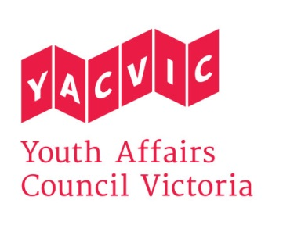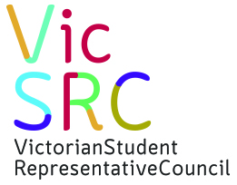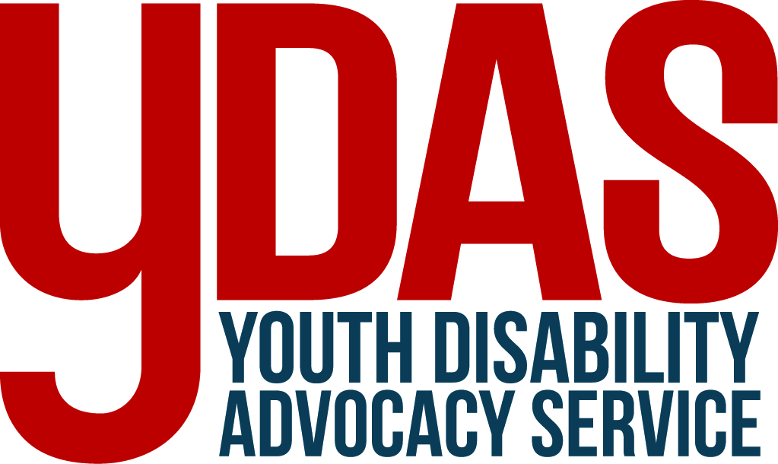

Victorian Ombudsman
Level 2, 570 Bourke Street
Melbourne Vic. 3000
6 / 10 / 2016

Investigation into expulsions at Victorian Government schools

Youth Affairs Council Victoria and our partner organisations the Koorie Youth Council, the Victorian Student Representative Council, and the Youth Disability Advocacy Service, welcome the announcement of an ‘own motion’ investigation by the Victorian Ombudsman into school expulsions in Victoria.

In particular, we welcome the Ombudsman’s decision to examine:

- Whether the data collected by the department regarding expulsions is sufficient to inform departmental policy-making and programs.
- Whether ‘vulnerable or at-risk students’ are over-represented in expulsion numbers and whether the department is effectively addressing any such issues.
- Whether students facing expulsion are provided with other educational and development opportunities, and with a fair and effective appeals process.
- Whether the department is monitoring and preventing instances of informal expulsions, which occur outside a formal expulsion process.

YACVic and our partner organisations welcome the Victorian Government’s strong commitment to strengthening student engagement and overcoming educational disadvantage. This is evidenced by substantial new investments in student Equity funding, the Navigator, LOOKOUT and Reconnect programs, and the refunding of the School Focused Youth Service and Local Learning and Employment Networks.
The Victorian Government has recognised student exclusion as a serious concern, and the Department of Education and Training (DET) is reviewing their Student Engagement and Inclusion Guidance in relation to this issue, to ensure they align with the philosophy and aims of the Education State. This is very welcome news.

However, further actions are needed to prevent and address student expulsion and other forms of exclusion. In this submission, we call for:

- Comprehensive, accessible data, including breakdown of numbers and rates of expulsion according to geography, student cohort, and mainstream/specialist schools.
- Adequate support for school communities to engage all students meaningfully in their own education, work appropriately with students experiencing trauma and mental illness, provide an equitable, human-rights-based education for students with disabilities, and work in line with the Out-of-Home Care Commitment, Equal Opportunity Act 2010, and Marrung: Aboriginal Education Plan.
- Expert support and advocacy for all students facing exclusion to help them re-engage with education, training or employment in line with the student’s aspirations, needs and circumstances. This support should be provided by a body which is connected to schools but independent from them, and which can work closely with students and their families, schools, flexible learning and VET providers, community services and departmental staff.

We would be delighted to discuss any of these issues further with you.

Yours sincerely,
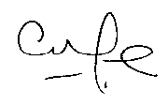  Georgie Ferrari, CEO  Youth Affairs Council Victoria | Krista Seddon  VicSRC Manager
Greg Kennedy, Manager  Koorie Youth Council | George Taleporos  YDAS Manager
Preventing and addressing expulsion of students from Victorian schools

- Data collection, analysis and sharing

In order for schools and their community partners to develop more targeted and effective solutions to student disengagement, more information should be made publically available about the expulsion of students from Victorian secondary and primary schools each year. In particular, we recommend:

- A regional (and where appropriate, area-level) breakdown of expulsion figures, plus a proportional measure of expulsions per 1,000 students in each region, taking care to appropriately de-identify students and communities. This information should be used to identify ‘hot-spots’ (if any) for innovative, targeted interventions.
- A breakdown of the numbers (and proportion per 1,000 students) of expelled students who are living in out-of-home care, who have a disability, and who are Aboriginal or Torres Strait Islander. Breakdown of numbers according to CALD and young carer status would also be ideal, although we appreciate there is less accurate data available on those topics.
- A comparison of the numbers of expulsions (and the proportion per 1,000 students) between the mainstream and specialist school sectors.
- How many Expulsion Appeals are lodged each year, how many of these appeals result in an Expulsion Review Panel being convened, and how many expulsions are subsequently upheld or rejected.
- How many expelled students are attending education, training or employment six months after an expulsion.

This data could be reported upon under the following ambitions of the Education State:

- ‘Over the next 10 years, Victoria will reduce the impact of disadvantage on achievement.’
- ‘Over the next 10 years, the proportion of students leaving education during Years 9 to 12 will halve’.

We believe these actions around expulsion should be part of a broader process of data collection, sharing and analysis about student exclusion, which should also address:
- Students suspended from school, including length and number of suspensions per student.
- Students placed on reduced attendance, and for how long.
- Students who are informally excluded – for example students who have ceased to attend school following a suspension or a threat of expulsion. This should include students who are still formally enrolled in a school, but who have ceased to attend following an exclusion.

We appreciate the latter topic is very challenging to document. However, the Disengaged Students Register and annual On Track survey provide opportunities to better capture such data. Furthermore, a number of local school-community partnership groups have already undertaken excellent data collection and analysis on school exclusion and disengagement at a local level, thanks to the leadership of stakeholders including Local Learning and Employment Networks, the School Focused Youth Service, and Child and Youth Area Partnerships. Their achievements provide models for the Victorian Government to draw upon.

At present, however, we do not have access to comprehensive, state-wide data on student exclusion. Formal expulsions are reported by principals, but the data is not released publically. In our advocacy, we have relied on the findings of research projects and the qualitative insights of our stakeholders in the youth and education sectors.

Consequently, we are unable to comment in detail on the strength of DET’s current internal approaches to data collection and analysis. It is possible that some further steps may be needed to ensure all relevant issues are being addressed.

For example, in April 2013, the Hon. Jenny Mikakos, the then-Shadow Minister for Youth, tabled a question in parliament: Of all the students suspended or expelled in 2012, how many had a recognised disability, and how many were receiving funding through the Program for Students with a Disability? The answer provided was that the education department did not keep separate data on suspensions or expulsions of students with disabilities. In their 2013 Held Back report, the Victorian Equal Opportunity and Human Rights Commission raised the same concern, commenting that the available data did not allow them to assess how common it was for students with disabilities to be excluded from school.

Meanwhile, the On Track survey provides valuable, accessible data about student pathways in general, but the researchers face challenges in charting expulsions and exclusions. On Track does not survey the majority of early school-leavers (in 2015 they surveyed around a fifth of this cohort), and their reliance on six-month-old contact details presumably makes it hard to reach the most transient young people. Nor does On Track survey young people who disengaged from school before Year 10. The survey’s reliance on young people’s voluntary self-reporting also raises the possibility of under-reporting of stigmatised issues like expulsion.

- Breaking the link between disadvantage and exclusion

In light of the limited public data on expulsions, our analysis of the relationship between formal expulsion and disadvantage is necessarily limited.

However, on the broader topic of student ‘exclusion’, the existing knowledge indicates that exclusion from school is often part of a bigger picture of disadvantage and marginalisation. Our members and stakeholders tell us that young people from disadvantaged backgrounds, young people with disabilities, and Aboriginal young people appear to be at higher risk than their peers of being excluded from school. Furthermore:

- Victoria’s Commissioner for Aboriginal Children and Young People has raised serious concerns about expulsions and suspensions of Aboriginal young people, notably those in out-of-home care.
- In their 2013 report Held Back, the Victorian Equal Opportunity and Human Rights Commission (VEOHRC) raised deep concerns about the exclusion of students from disabilities from schools, although without official data they would not estimate how common this was. Approximately 4% of the 617 parents they surveyed reported that their child had been expelled – although many more reported informal exclusions, ranging from schools refusing to enrol a student with a disability, to students with disabilities being sent home repeatedly without a suspension being recorded. We urge that more work also be done to assess the extent to which exclusions of students with disability are investigated, to ascertain whether the students’ behaviour may be the result of a lack of access to appropriate support in the school environment
- Young people in out-of-home care show higher than average rates of school disengagement, and studies from other parts of Australia have identified exclusion as one element in this. For example, a recent report by the Guardian of Children and Young People in South Australia found that school exclusion rates of children in care were four to five times higher than the general student population. This can be a result of trauma-related behaviours which schools struggle to deal with, or disengagement resulting from severely interrupted schooling, unsupportive or chaotic home lives, caring responsibilities and/or poor self-esteem.
- The On Track data (while it should be treated cautiously on this topic) suggests that rates of student exclusion tend to be highest in interface suburbs and some regional cities. This implies a higher risk of school exclusion in communities with very large numbers of young people, where the population is growing and changing rapidly, and where levels of disadvantage are high. A link between high rates of school exclusion and socio-economic disadvantage has also been traced in several other Australian studies. It is our understanding that exclusion tends to be less common in small rural communities, where schools have few alternative places to exit a student to, and where there can be a stronger sense of collective responsibility for young people. However, students who are excluded from a rural school may struggle to find any other education, training or employment options locally.

Male gender, when overlaid with other risk factors, is also relevant. For instance, the recent ‘Under 16’ research projects led by LLENs in Melbourne’s north found that the vast majority of expelled students were boys, and the examples given suggested it was common for these students to come from backgrounds of disadvantage and/or family breakdown. Their greater risk of expulsion may reflect higher rates of some cognitive disabilities amongst boys, which some schools struggle to support adequately. It may also result from a shortage of learning environments which are welcoming and responsive to the needs and interests of boys from low-income, culturally diverse and Aboriginal communities. Where boys are expelled for violent or threatening behaviours, this can also be symptomatic of a wider social failure to prevent and address male violence early in life.

In response to these issues, we have recommended that the Victorian Government ensure all students can access adequate support as needed from properly qualified wellbeing staff. We have also called for ongoing, state-wide support for schools to develop trauma-informed practice and build literacy and first aid skills in relation to youth mental health. Reputable models include the Berry Street Education Model, Calmer Classrooms (Berry Street Victoria for the Child Safety Commissioner), MindMatters, Youth Mental Health First Aid, and Teen Mental Health First Aid. It is also important to work with teacher training universities to ensure that new teachers are adequately supported to work with students experiencing trauma and mental health problems.

Moreover, to prevent and address student disengagement and disruptive behaviours (which can end in expulsion), there must be ongoing work to ensure all students are actively and meaningfully engaged in their own education. This should include:

- Supporting students and teachers to work together to foster active student decision-making and school cultures based on mutual respect, communication and understanding, as outlined in the policy platform and ‘Teach the Teacher’ work of VicSRC.
- Adequately resourcing and encouraging schools to provide students with a range of high quality VET in Schools and VCAL options, without passing costs onto families experiencing disadvantage.
- Supporting secondary students, especially those facing isolation or disadvantage, to develop career aspirations and work-ready skills, and to access high quality mentoring and work ‘tasters’ relevant to their aspirations.
- Funding best-practice flexible learning models, including within mainstream schools, in line with the Framework of Quality Flexible Learning Programs (FQLP) developed by Associate Professor Kitty te Riele.

More work is also needed to fully implement the recommendations of VEOHRC’s Held Back report, and ensure school communities are fully aware of their obligations under the Out-of-Home Care Commitment and the Equal Opportunity Act 2010, and the actions and outcomes set down in Marrung: Aboriginal Education Plan.

- Other opportunities for students facing expulsion

If an expelled student is of compulsory school age, the principal and regional DET office are required to ensure they enrol at another school or registered training organisation as soon as ‘practicable’. If there is a delay, the school must provide the student with meaningful work until they move into a new educational setting.

Our advice is that, in reality, young people’s access to this kind of support can vary. However, a common observation from our stakeholders is that the most poorly supported students can be those who have not been formally expelled but rather ‘asked to leave’ or excluded from school in other, informal ways.

One case study was provided by researchers working on behalf of the Child and Youth Area Partnership in Central Highlands (2015). In a series of interviews with 16 young people who had experienced severe school disengagement, the researchers found there was a common perception by students that they had been ‘kicked out of school’ – but that none of them recalled any formal investigation process or behaviour review conference. Correctly or incorrectly, the young people believed they had been told to leave. Most of these young people were already experiencing multiple forms of disadvantage, and the majority had already moved houses and schools several times.

Similarly, in 2014-15 when Victoria’s Education Justice Initiative worked with 103 young people who appeared in the criminal division of the Melbourne Children’s Court, they found that 84% of them had not attended a single day of school in the past month, and that 46% were not enrolled anywhere. Some had been formally expelled, some believed they had been ‘kicked out’ although there was no record of this, and some had been urged to leave their schools so they would not ‘have an expulsion on their record’. It was EJI’s observation that students who had been excluded but not formally expelled could be especially vulnerable, as their schools were not obligated to transition them anywhere. Another problem identified was when a young person had been transitioned into a short-term training course, but had nowhere to go after that and was not welcomed back into the school system. Expert assistance to re-engage was important. As one Senior Case Manager (Youth Justice) commented

‘For a lot of parents, once a child has been suspended or expelled from school, the parents just don’t know what to do and schools are not very helpful, I’ve found. Some schools will pass on a name or a number of another school and say, “here, ring them”, and then that’ll be it. And sometimes, getting past the reception at a school to talk to the right person is really difficult.’

In response to this, we have called for specialist support and advocacy for students facing expulsion and other forms of exclusion to re-engage with education, wherever they live. This should be provided by a body which is connected to schools but independent from them, and which can clarify a student’s enrolment status, work with them and their families to identify their aspirations and future options, and collaborate closely with schools, flexible learning providers, VET providers, community services and departmental staff. Such a body should be able to engage young people via active outreach and referral. This work should be guided by the evaluation findings of comparable programs such as the Education Justice Initiative, the Education Engagement Partnership, and Youth Connections.

In some communities this role is played by the Navigator pilots – a very welcome announcement by the Victorian Government. However, Navigator only operates in eight communities at present; equivalent support is needed state-wide.

- Preventing and addressing informal expulsions

As noted above, official expulsion figures do not encompass all students who believe they have been ‘kicked out’ or ‘can’t go back’ to their original school. Any initiatives to reduce school expulsion must also consider those students who have been suspended and not supported to return, or urged to leave the school ‘to avoid having an expulsion on your record’, or told by school staff that they must transfer elsewhere as soon as possible. Some of these students and their families believe they have been expelled when they have not been, or feel uncertain about whether an expulsion took place.

Many of our stakeholders tell us that informal exclusions are more prevalent and challenging than formal expulsions. However, without data, it is hard to demonstrate this, or track whether the problem is getting better or worse. Greater research and targeted, evaluated interventions are needed.

- Ensuring natural justice for young people facing expulsion

It is important that young people at risk of exclusion from school have appropriate access to natural justice, receive a fair process and are fully aware of their rights and options. A natural justice approach ensures that people facing a ‘charge’ are fully informed about the case against them, given the right to a meaningful hearing, and are guaranteed that decisions will be made only on a sound evidence base and by people who do not have a personal interest in the outcome.

DET regulations provide certain guarantees about students’ access to Behaviour Review Conferences and DET reviews in cases of expulsion. However, the fact that DET is not obliged to review an expulsion and the fact that a student can be expelled without much further discussion if they do not attend the Behavioural Review Conference or mount an appeal within ten days, suggests that these models may not provide sufficient protection for every student. Moreover, there are very few formal protections in place in relation to suspensions and informal exclusions, and the research and anecdotal evidence indicates that many excluded students do not fully understand why they’ve been removed from school. Further work and clearer, accessible data are needed.

- Addressing exclusion of primary school students

While our organisations advocate for young people aged 12-25, we wish to reflect here that our sector is reporting growing concerns about the formal and informal exclusion of children from primary schools. Exclusion at such a young age sets a very worrying precedent for the child’s future educational engagement, social connections and wellbeing.

To prevent and reduce the developmental vulnerability of young children, we support calls by the Victorian Council of Social Service for:

- Improved access for vulnerable families to high quality, affordable early learning services, from birth through to school. To achieve this, these services may need to develop outreach initiatives, transport support for disadvantaged families, and approaches which are accessible, integrated and culturally safe.
- Comprehensive transition planning for all children moving from primary to secondary school – a time of high risk of disengagement. This planning should span the year before and after transition, and identify and respond to ‘early warning signs’. Schools will need adequate support to understand their obligations, including around appropriate disclosures of information.
- Investment to ensure that early childhood education providers and schools are resourced to be fully inclusive of children with disabilities and additional needs. This includes providing relevant undergraduate and postgraduate course content; ongoing professional development and mentoring; and widespread implementation of evidence-based and human rights based approaches.
- Integrated service models for vulnerable children and families, combining universal education and health services such as kindergartens, primary schools and maternal and child health services, with specialist health supports where needed, in settings which are welcoming, accessible and culturally safe.

We would be delighted to discuss any of these issues further with you. Please contact Jessie Mitchell, YACVic Policy Manager, on policy@yacvic.org.au or 9267 3722.

Victorian Government, Education State: Schools, Melbourne, 2015, p.11
Victorian Equal Opportunity and Human Rights Commission (VEOHRC), Held Back: The Experiences of Students with Disabilities in Victorian Schools, Melbourne, 2012, p.93; Victorian Government Hansard, ‘Education: schools - student expulsion’, 17 April 2013, Legislative Council
Victorian Government, On Track Survey 2015: The destinations of school leavers in Victoria, Statewide Report, Melbourne, DET, 2015, p.37
Commission for Children and Young People, Commission for Children and Young People Annual Report 2013–2014, Melbourne, 2014, pp.5, 23;
VEOHRC, Held Back, p.46, 98-104
Office of the Guardian for Children and Young People, 'Children and Young People in State Care in South Australian Government Schools, 2008-2015,' Adelaide, May 2016, pp.6-8. Also Toni Beauchamp (Social Policy and Advocacy Team, Social Justice Unit, UnitingCare Children, Young People and Families), ‘Addressing high rates of school suspension’, UnitingCare, Parramatta, October 2012, pp.3-7; Sheryl Hemphill and John Hargreaves, ‘Suspension: Quick Fix or Lasting Harm?’, Teacher: The National Education Magazine, December 2009, p.53; Daniel Quin and Sheryl Hemphill, ‘Students' experiences of school suspension,’ Health Promotion Journal of Australia: Official Journal of Australian Association of Health Promotion Professionals, Vol. 25, No. 1, April 2014, p.53; Youth Action NSW, ‘School Suspension,’ 2012 http://www.youthaction.org.au/school_suspension_2012
Sheryl A. Hemphill, John W. Toumbourou, Rachel Smith, Garth E. Kendall, Bosco Rowland, Kate Freiberg, Joanne Williams, ‘Are rates of school suspension higher in socially disadvantaged neighbourhoods? An Australian study’, Health Promotion Journal of Australia. 21 (1), 2010, pp.14-16. See also Samia Michail, UnitingCare Children, People and Families Parramatta NSW, ‘Understanding School Responses to Students’ Challenging Behaviour,’ 2011, p.7 http://www.education.vic.gov.au/Documents/about/programs/pathways/youthpartnerships/Understanding%20School%20Responses%20to%20Students.pdf
Michail, , 'Understanding School Responses to Students’ Challenging Behaviour,’ p.7
Hume Whittlesea LLEN, ‘The Hume Under 16 Project: Out of School - Out of Sight, Final Report’, June 2012, http://www.hwllen.com.au/images/final%20hume%20u16%20report%2012%20june.pdf; Hume Whittlesea Youth Connections Consortium, Hume Whittlesea Local Learning and Employment Network Inc and Whittlesea Youth Commitment / HWLLEN, ‘The Whittlesea Under 16 Project’, March 2013, http://www.hwllen.com.au/images/whittlesea%20u16%20final%20report%2014%20march.pdf; Inner Northern Youth Connections Consortium (NMIT) and Inner Northern Local Learning and Employment Network Inc, 'Darebin Under 16 Project - Improving Education Engagement,' December 2012, http://inllen.org.au/wp-content/uploads/2014/08/Darebin-U-16-Final-Report-December-2012.pdf; Inner Northern Youth Connections Consortium (NMIT), Moreland City Council, Crossroads, Salvation Army, Inner Northern Local Learning and Employment Network, 'U16: Invisible & Ineligible...The Moreland Under 16 Project', November 2011, http://inllen.org.au/wp-content/uploads/2014/08/Moreland-Under-16-Report-Final-1.pdf; Cox, 2012, ‘Banyule Nillumbik Under 16 Project’, Banyule Nillumbik Local Learning and Employment Network
Associate Professor Kitty te Riele, Putting The Jigsaw Together: Flexible Learning Programs In Australia: Final Report, Melbourne, The Victoria Institute, July 2014
Central Highlands Children & Youth Area Partnership, ' "Straight Up": The Lived Experience of Central Highlands Youth,' August 2015, http://www.highlandsllen.org/site_images/DS-images/documents/CHCYAP%20Report%20FINAL%20MERGED.pdf
Assoc. Professor Kitty te Riele and Karen Rosauer, ‘Education at the Heart of the Children’s Court: Evaluation of the Education Justice Initiative - Final Report,’ Victoria University, the Victoria Institute, December 2015, pp.14, 41, 43, 48; Associate Professor Kitty te Riele and Karen Rosauer, ‘Education at the Heart of the Children’s Court: Evaluation of the Education Justice Initiative – Summary Report,’ Victoria University, the Victoria Institute, December 2015
Victorian Council of Social Service, State Budget Submission 2016-17, Melbourne, 2016

