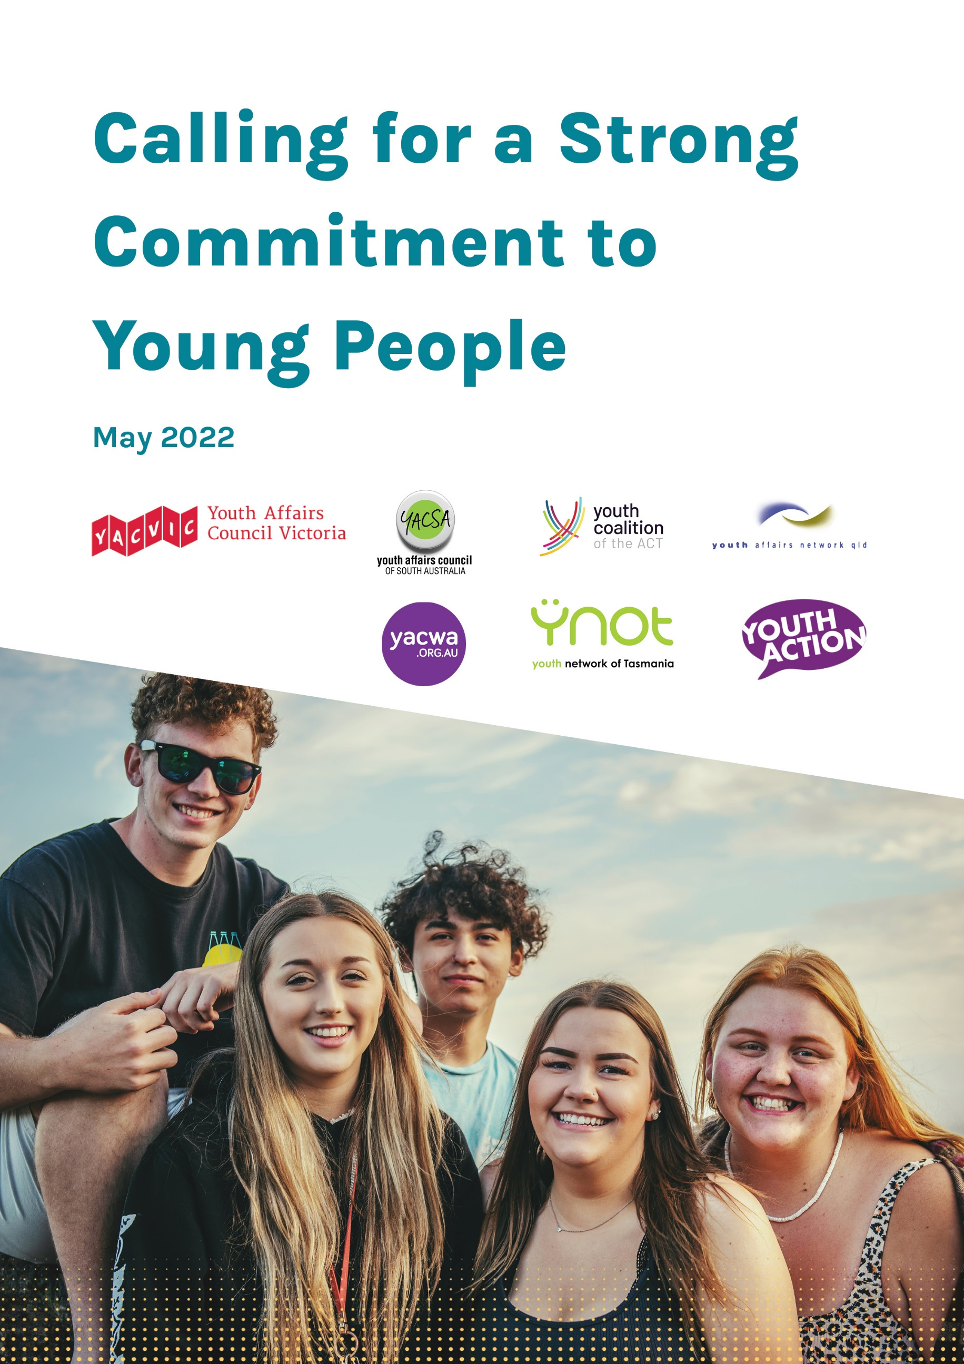

National Youth Plan
The State/Territory Youth Peaks call on all political parties and independents to make a strong commitment to young people, in particular by creating a National Youth Plan that:
- Embeds young people's voices and lived experience in government decision-making;
- Recognises and celebrates young people’s resilience and strengths;
- Recognises the many and often intersecting ways that young people experience marginalisation;
- Addresses rising inequality and increased cost of living pressures;
- Implements effective climate action policies;
- Provides equitable access to safe and secure housing, employment opportunities, education, and mental health services; and
- Embeds partnership with trusted community organisations which work closely with young people and understand the diversity of their experiences.

The Federal Government should partner with Australia’s young people and the Australian Youth Affairs Coalition (AYAC) to establish the National Youth Plan, so that it is relevant to, and addresses the needs and priorities of, all young people, especially those who face marginalisation.

The National Youth Plan should include the following key priority areas, as identified by young people:
- Climate Action
- Disaster Resilience and Recovery
- Employment
- Education
- Housing Security
- Mental Health
- Access and Inclusion

Climate Action
Young Australians want to see more decisive and meaningful action to address the driving forces of climate change and mitigate the associated impacts. The Federal Government should commit to a co-design process with young people, as the ones who will be most impacted by the effects of climate change, to develop effective policies that respond to their concerns.

Disaster Resilience and Recovery
Young people are uniquely impacted by disasters, which affect their work, study, and other critical resources like phone reception, internet and roads which keep young people connected to their communities. Young people have unique perspectives that can help to build strong and resilient communities, but are often left out of decision-making processes. The Federal Government needs to ensure young people are included in future disaster preparedness, response, recovery and rebuilding efforts.

Employment
Young people are still overrepresented in unemployment and under-employment figures nationally. Young people were the first to lose their jobs and the last to regain them during the COVID-19 pandemic, and are often vulnerable to unsafe and corrupt employment practices. More needs to be done to ensure job security and safety for young people, tackle youth unemployment which is more than double the national rate at 8.3 per cent , and increase opportunities for the 300,000+ young people who were underemployed as of March 2022.

Education
All young people deserve equal access to educational settings that are affordable, fit-for-purpose, supportive, and recognise individualised pathways. More flexible and remote learning options should be funded to support young people who face barriers to participating in education, and further investment is required to make higher education and VET courses more affordable for all young people.

Housing Security
Across Australia, many young people cannot afford to rent in the private rental market or access social housing, and are ending up homeless or dependent on family or friends. More investment is required to support young people to access stable and affordable housing, which is also a major factor in mental health, education attainment and employment success.

Mental Health
Young Australians continue to face increasing mental health challenges, which have been exacerbated by the COVID-19 pandemic and the increasing prevalence and severity of natural disasters such as the 2019/20 bushfires and 2021/22 floods. With the added threats of climate change and intergenerational inequity, many young people are concerned about their futures, and the increasing demand on mental health services means many young people are not getting the support they need. They need urgent investment in local and accessible youth mental health services and programs, including generalist youth workers who provide early intervention and prevention support to so many, especially in rural and regional areas.

Access and Inclusion
Disabled young people, and other young Australians who experience intersecting forms of marginalisation, face unique barriers when accessing education, employment and support services. Much of this is not addressed in the National Disability Insurance Scheme (NDIS). Additional investment is essential to ensure that all disabled young people can access services on an equitable basis. This includes ensuring that solutions are co-designed with disabled young people and trusted community organisations who represent disabled young people, and ensuring that community sector workforces are trained, skilled and equipped to support disabled young people.

Support for Other Campaigns

Australian Youth Affairs Coalition (AYAC)
The State/Territory Youth Peaks call on the Government to commit to ongoing core funding for the Australian Youth Affairs Coalition (AYAC), as the national youth peak body, to facilitate connection between the Federal Government, young people and youth experts. AYAC will provide essential connections and support for the Federal Government with young people and youth experts across the country, including for co-design of the National Youth Plan, ensuring diversity of backgrounds, and lived and professional experience.

Raise the Rate
The State/Territory Youth Peaks also support the Australian Council of Social Services (ACOSS) campaign to ‘Raise the Rate’ of the JobSeeker payment up to $70 a day. The current rates of JobSeeker and Youth Allowance do not cover the costs of basic essentials, further entrenching people in a cycle of poverty.

Inquiry into Intergenerational Fairness
Young people will bear the costs of the debt created by the COVID-19 pandemic stimulus / response, and also have to find ways to sustain the economy generally with an ageing population. It is crucial, now more than ever, for the Federal Government to respond to the economic fallout. Young people want to live a quality life that is fair across all generations. Think Forward are advocating for an Inquiry into Intergenerational Fairness, and the State/Territory Youth Peaks support this campaign to secure the prosperity and wellbeing of future generations of Australians.

