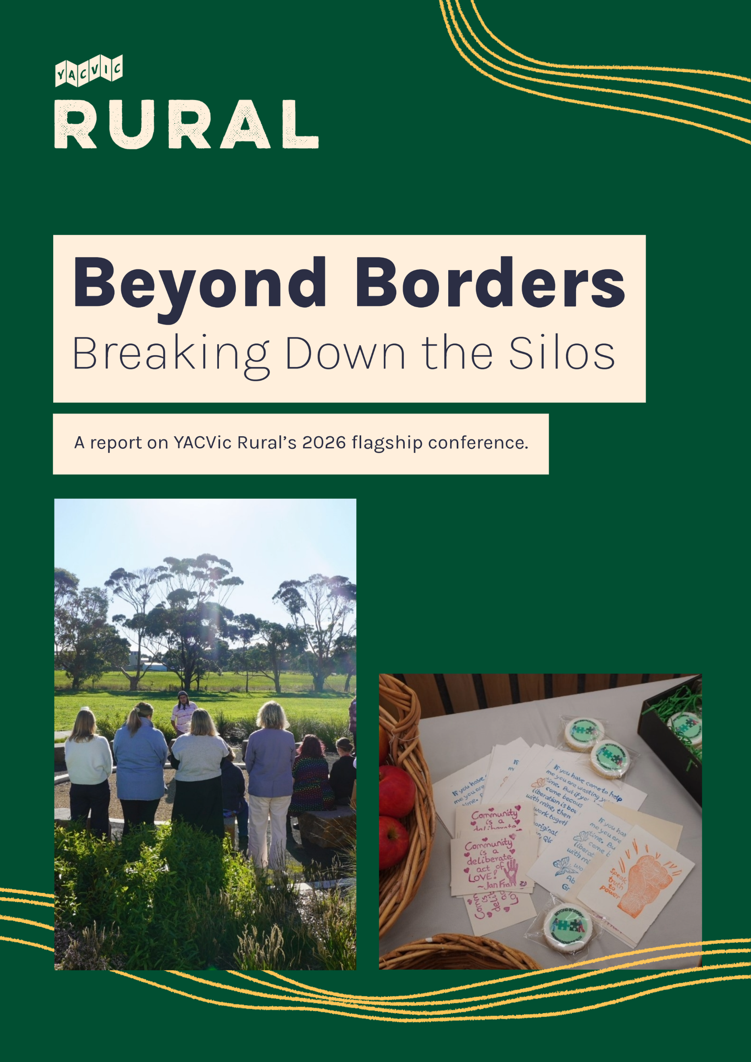

Acknowledgement of Country
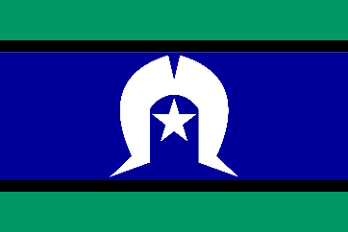
Our work takes place across Victoria. YACVic’s head office is on the lands of the Wurundjeri people of the Kulin Nation in Naarm (Melbourne). We also have offices on the lands of the Gunditjmara Nation in Warrnambool, and on the lands of the Wemba Wamba and Wadi Wadi Nations in Swan Hill.
YACVic pays our respects to Elders past and present for their wisdom, strength, support and leadership. Bunjil’s lore states that those who walk on this land must care for Country and the waterways as well as care for the children and young people.
We stand in solidarity to pay respect to the ongoing culture and continued history of all Aboriginal and Torres Strait Islander nations. Sovereignty was never ceded.

This always was, and always will be, Aboriginal land.

About YACVic
Youth Affairs Council Victoria (YACVic) is the peak body and leading advocate for young people aged 12–25, and the youth sector that supports them. Our vision is that the rights of young people in Victoria are respected, and they are active, visible and valued in their communities.
We promote youth participation and make policy recommendations on issues that affect young people’s lives, build the capacity of the youth sector and nurture connections for collaboration and support, and identify and advance thinking on emerging issues for young people. As changemakers we have a particular focus on young people who face marginalisation and disadvantage.

About YACVic Rural
YACVic Rural provides additional targeted advocacy for young people and services in rural and regional Victoria.
We connect with young people, youth practitioners and the youth work sector to identify the unique needs and priorities of rural and regional young people. We respond through purpose-driven and place-based projects, programs and trainings, collective impact, sector support and policy input to accelerate positive change for young people.
Contents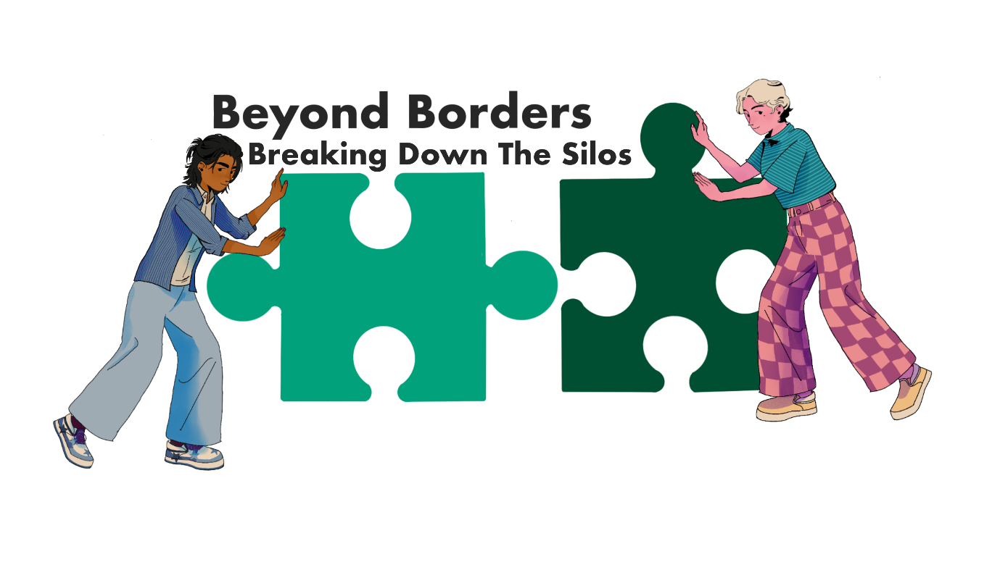
Beyond Borders – Breaking Down the Silos 1
Acknowledgement of Country 2
About YACVic 2
About YACVic Rural 2
Centring rural youth voice in professional development for the rural youth sector 4
Young people’s panels 5
Southern Mallee Forum 5
Great South Coast Conference 5
Keynote and workshop sessions 6
60-Day Challenge 7
What participants hope to see in 60 days 7
What participants committed to doing 7
Participant feedback 8
Overall reflection 8
What YACVic Rural will do next 8
Conclusion 9

Centring rural youth voice in professional development for the rural youth sector
Beyond Borders: Breaking Down the Silos was the overarching theme for the 2026 YACVic Rural conference. It comprised two events: the Southern Mallee Forum and the Great South Coast Conference. Both events were designed for the rural Victorian youth sector, bringing together youth workers, educators, local government representatives, health professionals, community organisations and other stakeholders to explore how stronger partnerships can improve outcomes for rural young people.
Aligned with YACVic's commitment to youth participation, advocacy and systems change, both events were intentionally youth centred. The primary audience was professionals working alongside young people, and the programs were structured to begin, and continually return to, the voices, experiences and aspirations of young people living in each region. This ensured discussions remained grounded in lived experience and focused on the priorities that matter most to rural young people.
A central theme across both events was the importance of breaking down silos between organisations, sectors and communities. Participants recognised that many of the challenges facing rural young people cannot be addressed by working alone. Instead, meaningful change requires collaboration, shared leadership and collective action.
Each event was tailored to reflect the unique strengths, challenges and opportunities within its region. Both events highlighted the value of youth participation, regional leadership and cross-sector partnerships. The events reinforced the vision of a Victoria where young people are heard, valued and empowered to shape the decisions, communities and systems that affect their lives.
The Southern Mallee event was developed in partnership with the North Central Local Learning & Employment Network (NCLLEN) and KD Solutions, with valuable support from the VET Hospitality students at Charlton College. These partnerships were instrumental in delivering a locally relevant event that reflected the priorities and strengths of the Southern Mallee region, while also showcasing the important role of collaboration in supporting young people and the broader community.
“Young people are not the problem to solve – they are partners in creating the solution.” – Katie Acheson

Young people’s panels
Across both events, participants consistently identified the youth voice sessions as one of the most valuable aspects of the program.

Southern Mallee Forum
Attendees: 35
The Southern Mallee Forum featured a panel of four young people from across the region: Tess Lee, Darby Fitzpatrick, Ducky Polglase and Mason Heonan. Each brought different lived experiences, backgrounds and perspectives. Panel members shared insights into the challenges and opportunities facing rural young people in their communities, helping participants better understand local needs, barriers and aspirations.
The panel reinforced the importance of listening to diverse youth voices and ensuring young people are involved in shaping the services, programs and opportunities designed to support them.

Great South Coast Conference
Attendees: 73 across both days
The Great South Coast Conference featured two youth voice panels across the two-day program.

Day One – Young Youth Workers Panel
The first panel featured young people who work in the youth sector: Katy Jarvie, Nashi Oakley-Sexton and Matilda Ryan.
Panel members reflected on their experiences as emerging professionals, the barriers they observe from a young person's perspective, and what they need from the broader sector to feel supported, valued and heard.

Day Two – Young People's Voices Panel
The second panel featured young people involved in volunteer groups, community initiatives and youth-led programs.
The panellists were: Amelia Dumesnym of Green Futures Now; Milla Colliton of Hamilton Yumcha Group; Stella Kennedy-Bamblett and Yakirah of VAEAI; Jesse Huf of Portland Music Scene; Edward Higgins of Friends of Tower Hill and Green Futures Now.
These young people shared their experiences of leadership, volunteering, advocacy and community participation, highlighting the importance of meaningful engagement, accessible opportunities and genuine partnerships between organisations and young people.
Hearing directly from rural young people grounded discussions in lived experience and challenged participants to consider how their organisations, services and communities can better support, engage and empower young people moving forward.

Keynote and workshop sessions
YACVic Rural built the conference program to reflect the needs of the local regions. Continuous youth sector and community consultation led to the decision to invite Katie Acheson, Kane Sparks and the YACVic team to deliver targeted and meaningful sessions that would challenge and empower attendees.
Katie Acheson's keynote presentations at both the Southern Mallee Forum and Great South Coast Conference established the foundation for the events, encouraging participants to think beyond individual organisations and consider how to best create lasting change for young people. Drawing on principles of systems thinking, Katie challenged participants to reflect on how collaboration, shared accountability and genuine partnerships with young people can strengthen communities and improve outcomes.
A key message throughout the keynotes was that young people are experts in their own lives and should not simply be consulted but recognised as partners in designing solutions and shaping the services and systems that affect them. Katie reinforced throughout the sessions that "Young people are not the problem to solve — they are partners in creating the solution." Participants were encouraged to move beyond organisational boundaries, identify shared priorities and focus on practical actions that could strengthen regional collaboration.
In Southern Mallee, Kane Sparks of KD Solutions facilitated a valuable regional perspective, prompting participants to consider local strengths, challenges, and opportunities for community-led action.
Participants were encouraged to think beyond organisational boundaries and explore how communities, services, funders, and young people could work together to address shared challenges.
Three priority discussion topics emerged:
- Improving accountability in outreach service models.
- Developing shared youth centres and community youth spaces.
- Trialling pooled or shared funding models for collective impact.
While each discussion focused on a different issue, participants consistently returned to common themes of collaboration, communication, accountability, youth participation, sustainable funding, and place-based approaches.
At the Great South Coast, YACVic’s Lauren Frost delivered a workshop on advocacy systems strategy. The session introduced power mapping, critical systems pathways and gave attendees practical tools and tips. The workshop was designed to provide strategic support to local changemakers. Feedback on the workshop was unanimously positive, leaving the sector feeling empowered and equipped to work on advocacy goals.
Rather than ending with discussion alone, participants were encouraged to identify concrete actions they could take within their own organisations and communities, reinforcing the conference's commitment to turning ideas into meaningful change.

60-Day Challenge
At the Great South Coast conference, participants reflected on two questions:
- When you think back to this conference in 60 days, what do you want to have happened?
- What are you going to do as a result of this conference?
Responses showed a strong desire for action, collaboration and momentum beyond the event.
“Let young people have more input and be heard.”

What participants hope to see in 60 days
Participants wanted the ideas, relationships and conversations from the conference to lead to meaningful action.
Many hoped forum discussions would gain traction and lead to practical change and tangible outcomes.

What participants committed to doing
Participants also identified actions they would take after the conference. The key themes of these actions were:
1. Youth engagement and leadership
Participants committed to ensuring young people are heard, represented and involved in decisions that affect them.
2. Collaboration and partnerships
There was strong interest in strengthening relationships across organisations, sectors and communities.
3. Turning ideas into action
Participants wanted discussions to lead to practical outcomes, including projects, working groups and collaborations.
4. Community connection
Many responses focused on creating more opportunities for young people to connect, volunteer and engage in their communities.
5. Long-term change
Participants recognised the importance of sustainable funding, ongoing collaboration and long-term commitment to improving outcomes for young people.

Participant feedback
Consistent feedback, collected through a post-event evaluation survey, showed the impact of hearing directly from young people.
Quotes from the evaluation include:
"Bring the young person into the room."
"Let young people have more input and be heard.”
"Network and collaborate with local organisations to create opportunities for young people."
"More young people volunteering and feeling connected to their community."

Overall reflection
The 60-Day Challenge showed that participants left the forums with optimism, responsibility and commitment. Responses suggest Beyond Borders fostered new connections, strengthened regional networks and inspired action. Most importantly, participants expressed a shared commitment to keeping young people at the centre of future conversations, decisions and actions.

What YACVic Rural will do next
Over the next 6–12 months, YACVic Rural will build on the momentum created from Beyond Borders by:
- sharing the findings and outcomes from both regional events with participants and key stakeholders
- continuing to strengthen connections across the rural youth sector through networking, collaboration and knowledge-sharing opportunities
- supporting youth-centred approaches that amplify the voices, experiences and leadership of rural young people
- encouraging cross-sector collaboration to address shared challenges and improve outcomes for young people
- promoting examples of sharing power with young people through effective youth participation, engagement and leadership across regional Victoria
- exploring opportunities for future regional gatherings, communities of practice and collaborative initiatives informed by the priorities identified through Beyond Borders.
By continuing to invest in local relationships, championing youth participation and collective action, YACVic Rural aims to support stronger, more connected rural communities where young people are respected, valued and active in the local communities.

Conclusion
Beyond Borders highlighted a strong commitment from participants to strengthen collaboration, strengthen youth participation and create better outcomes for rural young people. The events provided a valuable opportunity for the rural youth sector to learn from one another, hear directly from young people and identify practical actions that can support more connected, responsive and youth-centred communities.
The Beyond Borders events highlight the strength of YACVic’s presence in local areas to gather stakeholders for professional development opportunities. The presence of YACVic Rural in both the Southern Mallee and Great South Coast ensures the rural youth sector has access to place-based support, and resources to respond to local needs while staying connected to statewide advocacy. YACvic Rural fosters collaboration, strengthens relationships and demonstrate the power of working collectively to create meaningful change for and with Victoria’s young people.

