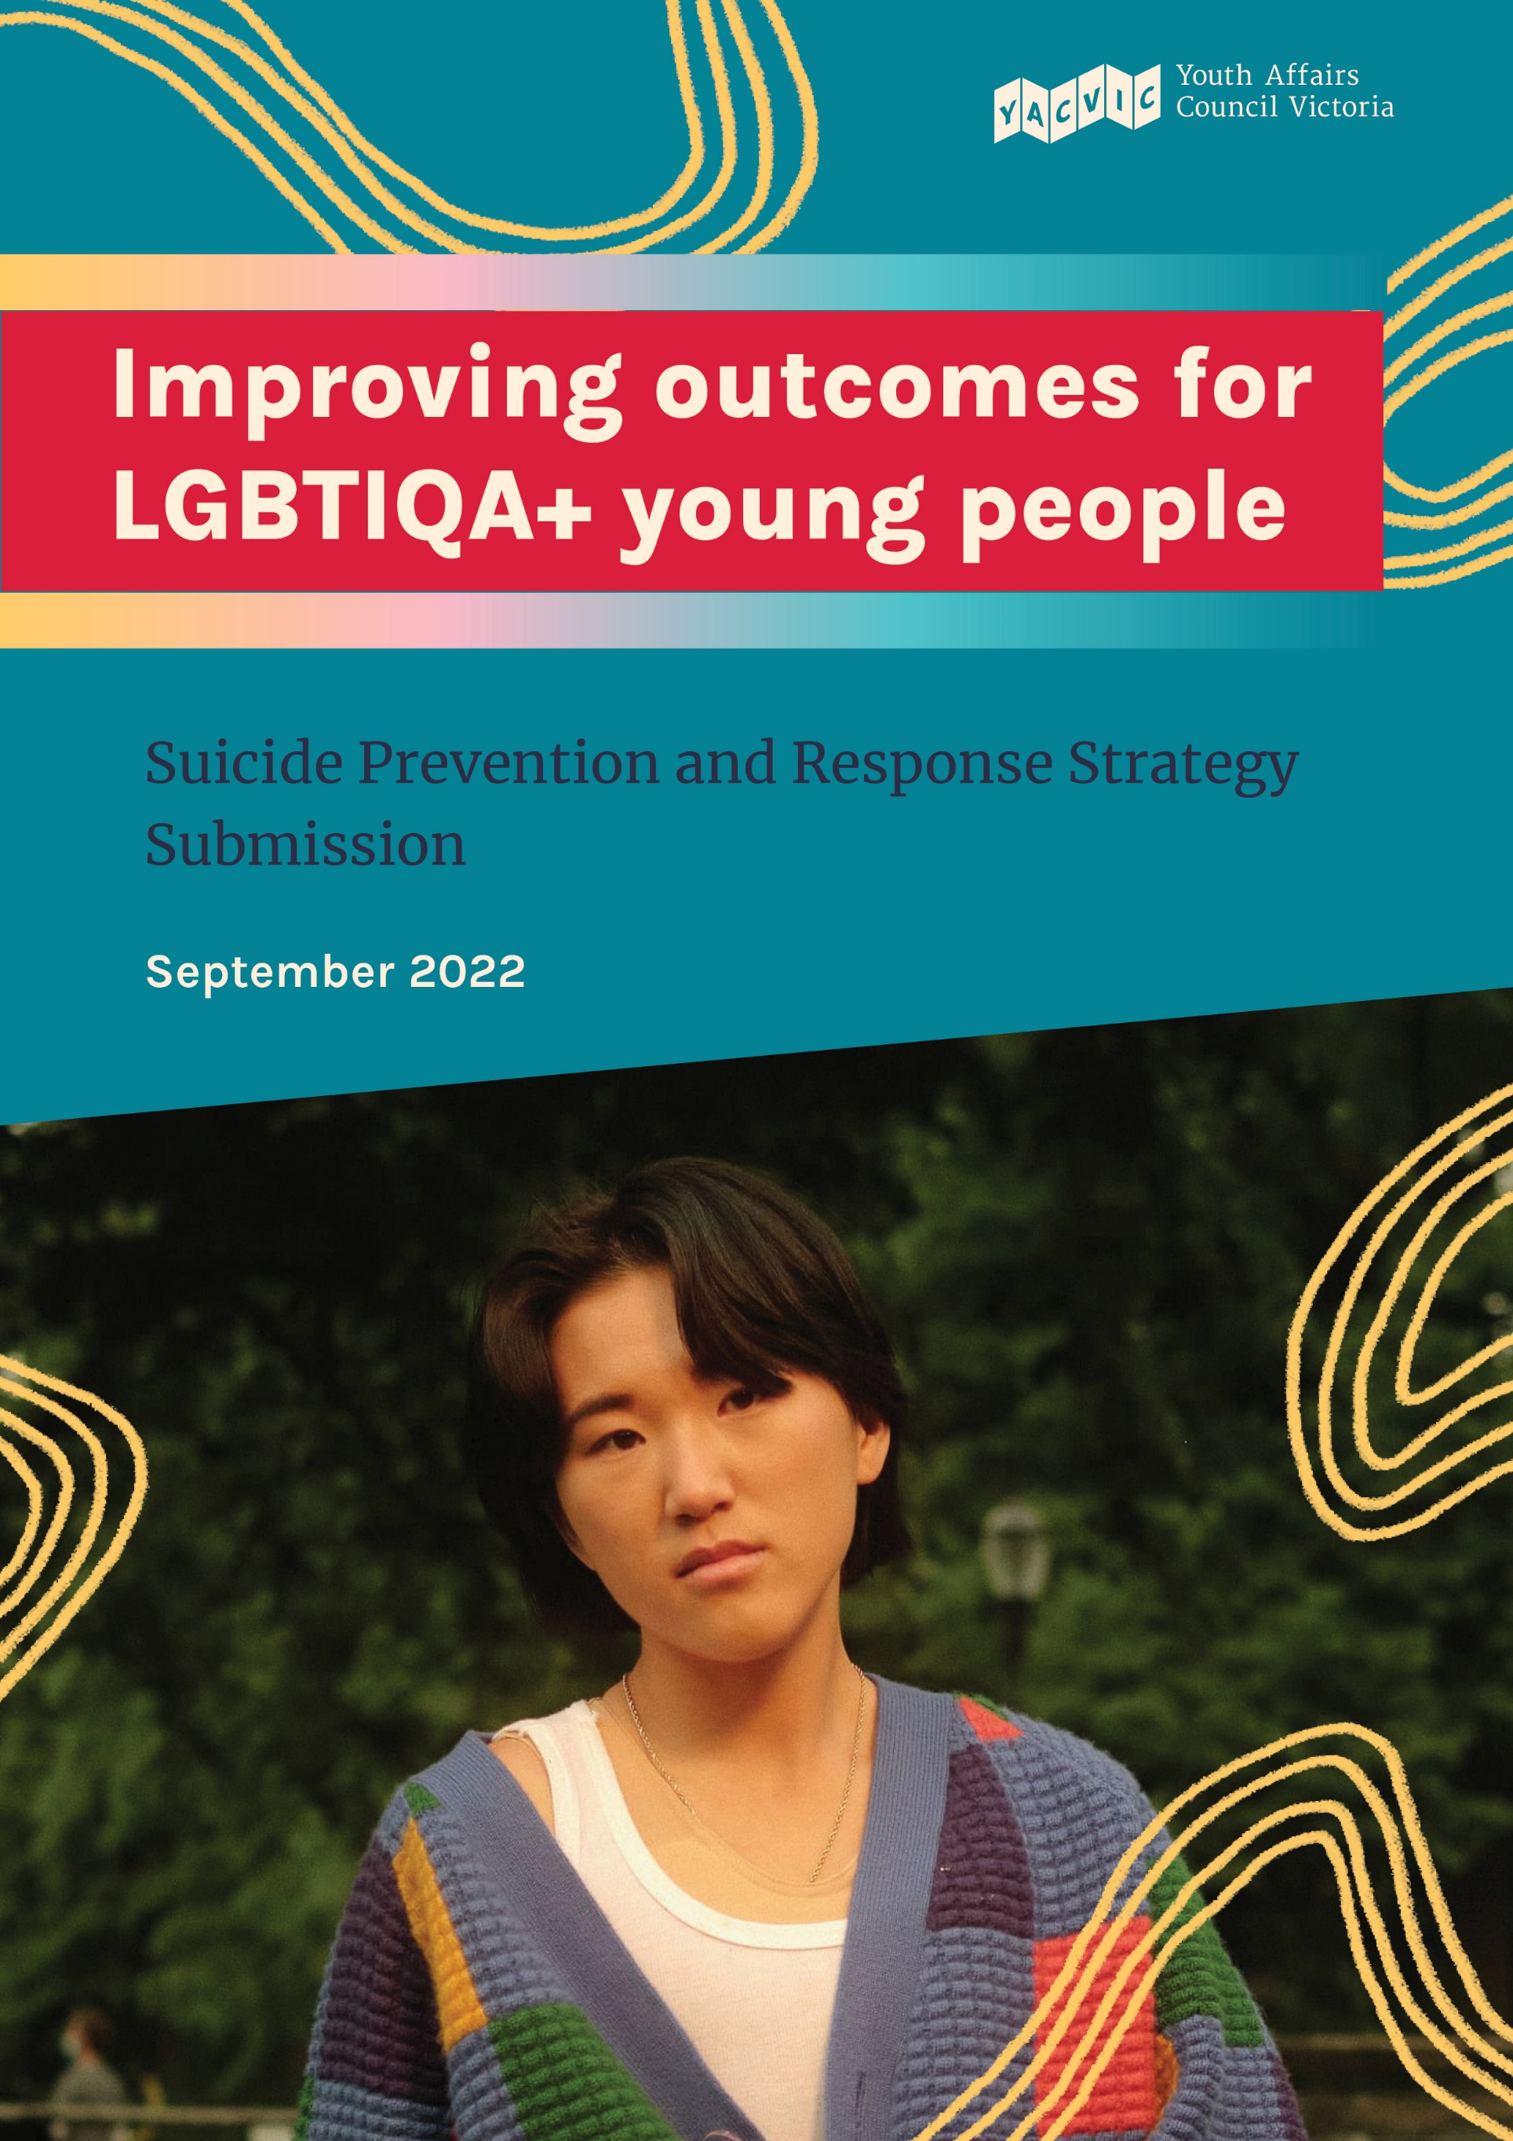

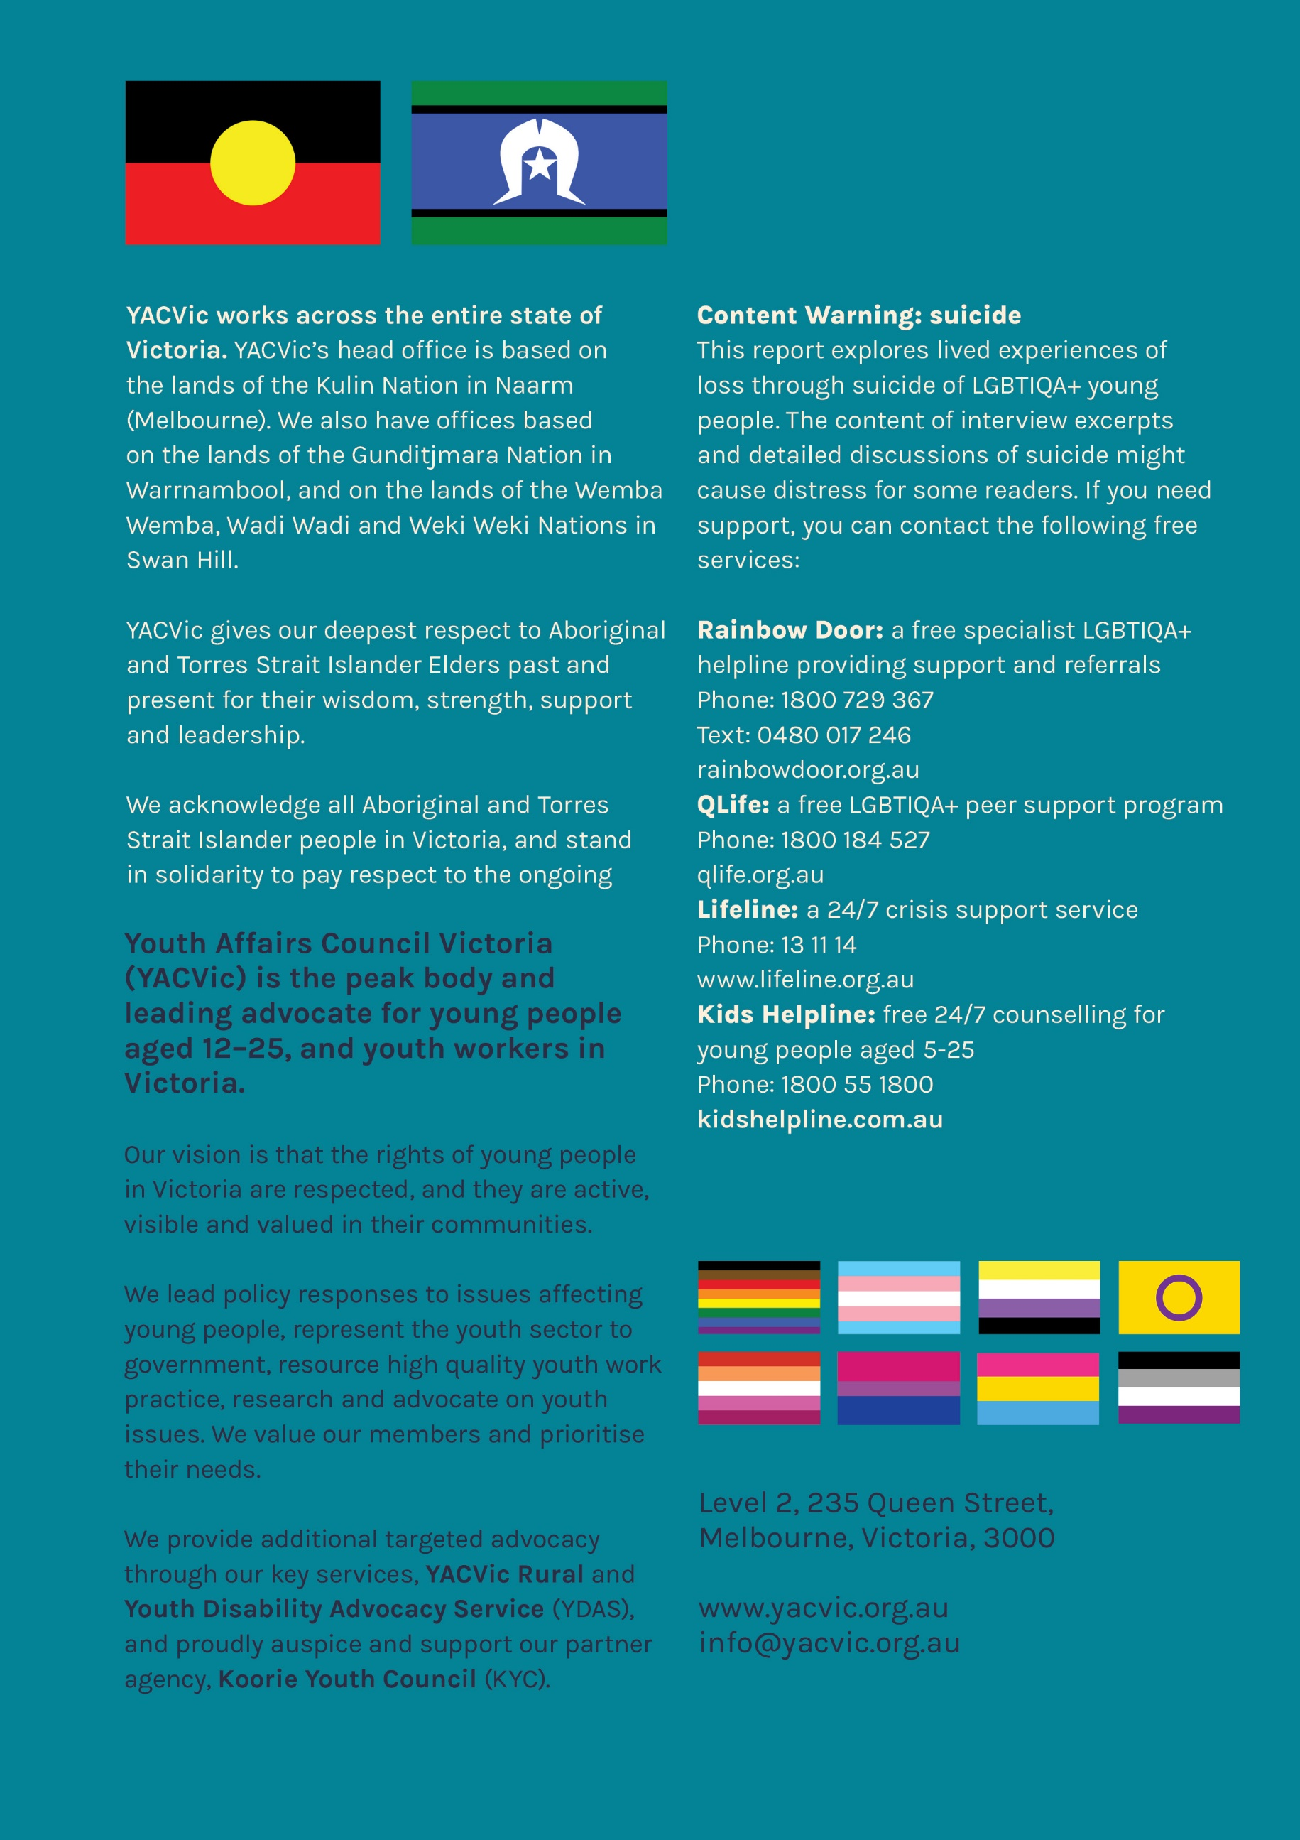

Table of Contents
Introduction 1
Background 1
Methodology 1
Statistics 2
Summary of Recommendations 4
Key Findings 5
Vision 5
Priority Populations 5
Priority Areas 5
Accessible and Inclusive Services 5
Recognising the Value of Youth Work in Mental Health Services 6
Principles 7
Youth Participation 7
Person-Centred Care 8
Suicide Prevention and Response Initiatives and Actions 8
Place-based response 9
Citations 11

Introduction

Background
Youth Affairs Council Victoria (YACVic) is the peak body and leading policy advocate for young people and the youth sector in Victoria. Our vision is that the rights of young people in Victoria are respected, and they are active, visible and valued in their communities. Our mission is to propel action that inspires positive change for young people and the youth sector.
YACVic co-ordinates the Healthy Equal Youth (HEY) Partners and administers the HEY Grants. HEY is funded by the Victorian Government Department of Health. HEY Partners brings together a network of 16 partner organisations specialising in support and services for LGBTIQA+ young people. HEY Partners provide peer support, referral, community visibility, celebration and education. The vision of the HEY partners is that LGBTIQA+ young people in Victoria have their rights upheld, and are safe, empowered and celebrated. HEY grants, offered annually, support youth organisations to undertake mental health promotion and community engagement activities which support LGBTIQA+ young people. The HEY grants recognise that communities are critical in creating LGBTIQA+ acceptance and supporting better mental health outcomes for LGBTIQA+ young people. Now in its twelfth year, HEY grants have supported over 110 organisations across the entire state, with over $1.2 million for projects selected by a panel of LGBTIQA+ young people and workers, awarding grant funding based on community need and the involvement and empowerment of young people.
This submission has been informed by consultations with young people and HEY partners and previous grant recipients. This submission focuses on the unique needs of LGBTIQA+ young people in Victoria, with input from LGBTIQA+ young people and HEY partners and grant recipients. This submission further builds on our 2019 submission to the Royal Commission, Beyond Access which recommended a number of targeted reforms, including greater investment in suicide prevention and postvention programs to address the unique risk factors that exist for LGBTIQA+ young people in particular in rural and regional areas; greater support and resourcing for peer-based responses and programs that work to reduce stigma and discrimination.

Methodology
YACVic conducted two consultations, one with HEY partners and the other with LGBTIQA+ young people.
Ten young people with lived experience of mental ill-health attended the consultation, identifying as LGBTIQA+ or as having friends or family who are LGBTIQA+. All participants identified some lived experience or an understanding of the impacts of suicide on LGBTIQA+ young people and their communities. There was a mix of participants from metropolitan, regional and rural areas, as well as disabled young people and young people from refugee and migrant backgrounds present at the consultation.
The HEY partners consulted operate their services in various locations across Victoria including Swan Hill, Geelong, Shepparton, Warrnambool, and the Surf Coast. The responses were recorded and have been used to create the foundation of this response.
Lived experience is a key component of the recommendations outlined in the Royal Commission and YACVic prioritises youth participation in all work, which is why we focused on the insights and experiences of these groups for the consultations.

Statistics
The Writing Themselves In 4 report, released in February 2021, consulted 1,859 LGBTIQA+ young people aged 14-21 in Victoria, and found the following:
- Over half (58.2%) of all participants had seriously considered attempting suicide in the previous 12 months, and almost three-fifths (58.7%) of those aged 16-17 had done so. This is more than five times the rate observed within studies of the general population aged 16–17 (11.2%).
- Over four-fifths (81.9%) of all participants had experienced high or very high levels of psychological distress during the past four weeks.
- Almost half (48.8%) of all participants reported having ever being diagnosed with generalised anxiety disorder and 47.4% with depression.
- Approximately one-quarter (24.0%) of participants had experienced one or more forms of homelessness in their lifetime, and 11.8% in the last 12 months.
  - Approximately one in four (24.8%) participants reported that their experience/s of homelessness were related to being LGBTIQA+.
- More than three-fifths (62.1%) of participants at secondary school felt unsafe or uncomfortable due to their sexuality or gender identity in the past 12 months.
- Only 30.6% of participants at secondary school felt that they could safely use bathrooms and only 20.5% felt that they could safely use the changing rooms that match their gender identity.
- Only 56.7% of participants at university felt that they could safely use bathrooms and only 34.0% felt that they could safely use the changing rooms that match their gender identity.
- Approximately two-fifths (38.3%) of secondary school students reported missing day/s at their educational setting in the past 12 months because they felt unsafe or uncomfortable.
- Approximately one-fifth (18.9%) of university students reported missing day/s at their educational setting in the past 12 months because they felt unsafe or uncomfortable.
- Approximately three-fifths (59.7%) of participants at secondary school reported that they frequently heard negative remarks regarding sexuality at their educational setting during the past 12 months.
The Trans Pathways study, published by the Telethon Kids Institute in 2017 was (at the time of publishing) the largest study ever conducted into the mental health and care pathways of trans and gender diverse young people in Australia. It is also the first Australian study to incorporate the views of parents and guardians of trans young people (194 participants). It found:
- 4 out of 5 trans young people have ever self-harmed (79.7%) This is compared to 10.9% of adolescents (12-17 years) in the Australian general population.
- 1 in 2 trans young people have ever attempted suicide (48.1%) This is 20 times higher than adolescents (12-17 years) in the Australian general population This is 14.6 times higher than adults (aged 16- 85 years) in the Australian general population

Summary of Recommendations
Recommendation 1: Youth participation should be embedded in all mental health services across Victoria.
Recommendation 2: Encourage all mental health services to undertake the Rainbow Tick accreditation and promote those with the Rainbow Tick accreditation via an easy-to-access online resource.
Recommendation 3: Expand specialist LGBTIQA+ and youth mental health services in rural and regional communities to address the growing demand and ensure everyone who needs support has access to it in a timely manner.
Recommendation 4: Mandate training for the mental health workforce on The Code of Ethical Practice for the Victorian Youth Sector and Youth Participation, and mental health providers to embed and resource ethical practice and youth participation practice.
Recommendation 5: Embed and resource youth participation models and principles throughout the design, delivery, governance, monitoring and evaluation of all mental health services, but especially suicide prevention and postvention services.
Recommendation 6: Incorporate feedback mechanisms to inform people who have contributed to this Strategy about how their input has been actioned.
Recommendation 7: Adopt person-centred approaches in all mental health services, with an emphasis on using trauma-informed care
Recommendation 8: Co-design resources and training with LGBTIQA+ young people for teachers and other educators to improve the school environment and reduce instances of bullying and harassment.
Recommendation 9: Invest in a specialist LGBTIQA+ suicide postvention program for young people who have attempted suicide. This program should be co-designed with LGBTQIA+ young people and their friends and family.
Recommendation 10: Support local communities through grant opportunities and training to deliver community memorials and other events when experiencing a loss by suicide.
Recommendation 11: Improve access to supports such as counselling and other programs for students bereaved by suicide.
Recommendation 12: Provide ongoing professional development to teachers and other school staff on how to have conversations about suicide without causing further harm or trauma to other students.

Key Findings

Vision
  - The Royal Commission suggested ‘towards zero suicides’ as a vision for the strategy. Is this appropriate?
YACVic is supportive of this high-level vision of ‘towards zero suicides’ overall, acknowledging that there is a significant amount of work and research needed to ensure this vision is achieved. The Suicide Prevention and Response Strategy is an important tool in achieving this goal, but must meet the needs of Victorians and address systemic issues in the current mental health system in order to do so. This Strategy must involve a variety of people with lived and living experience in its creation and implementation, utilising genuine co-design to ensure the Strategy meets the needs of those who will be using it.

Priority Populations

2.1 In the discussion paper we have listed a series of groups that may need greater focus in the strategy. Is this appropriate?

There are a variety of different groups which need targeted support from the strategy, and YACVic understands that the groups listed are appropriate. Throughout this response we focus on LGBTIQA+ young people, which are two of the outlined groups in the discussion paper. There is a need to recognise the intersectionality of people’s identities and how this relates to their interactions with services within the system. Acknowledging this and ensuring that systems are meeting the diverse needs people have based on their intersecting identities will be key in having favourable outcomes for the strategy.

Priority Areas

3.1 What priority areas should be included in the strategy to create the greatest impact and help us achieve our vision?

Accessible and Inclusive Services
All mental health services need to be accessible and inclusive of all young people, including LGBTIQA+ young people. To achieve this, it is important staff are provided with adequate training to engage with young people effectively, understanding their specific needs and how best to support them.
Recommendation 1: Youth participation should be embedded in all mental health services across Victoria.
Participants highlighted the importance of mental health services being inclusive of LGBTIQA+ people. Young people described past experiences of discrimination based on their identity, and how that impacted their willingness to engage with services in times of crisis. To address this, participants suggested more services gain the Rainbow Tick accreditation which would improve the accessibility of mental health services and promote safe environments where LGBTIQA+ young people are welcome.
Recommendation 2: Encourage all mental health services to undertake the Rainbow Tick accreditation and promote those with the Rainbow Tick accreditation via an easy-to-access online resource.
For those living in rural and regional Victoria, the lack of accessible or online services is of major concern, particularly for young people who do not have access to a car or reliable internet. For many young people living in rural and regional areas, public transport is infrequent, unreliable, and often expensive, which can lead to many young people not seeking the support they need. Whilst the increase in telehealth services has gone some way to addressing this issue, many young people are unable to utilise this option, preferring to meet with service providers in person.
A study conducted by QLife found that LGBTIQA+ young people living in rural and regional areas identified the follow barriers to existing services:
- A lack of access to specialist services made it difficult to receive support in a timely manner.
- A limited number of services impacted privacy, with young peoples’ friends, family, colleagues etc. all accessing the same services.
Recommendation 3: Expand specialist LGBTIQA+ and youth mental health services in rural and regional communities to address the growing demand and ensure everyone who needs support has access to it in a timely manner.

Recognising the Value of Youth Work in Mental Health Services
Youth work is a practice and profession that places young people and their interests first. It is a relational practice, where the youth worker operates alongside the young person in their context. Youth work is also an empowering practice that advocates for and facilitates a young person's independence, participation in society, connectedness and realisation of their rights. Youth workers support young people to engage with their community and develop their skills and capabilities to achieve their goals.
Workers in the mental health sector who interact with young people are doing youth work. Ensuring the mental health workforce is guided and supported by youth work practice and principles, with the relevant and specific skills and knowledge, enables more positive outcomes for young people.
In Victoria the youth work profession is underpinned by a Code of Ethical Practice, which is informed by the UN Convention on the Rights of the Child and places the young person at the centre of a youth worker’s practice as the primary consideration.
Youth work is not specific to one area of expertise, and instead encompasses a range of generalist and specialist areas, including active citizenship, education attainment, social cohesion, community connection, crime prevention, housing support, drugs and alcohol support, family violence prevention and recovery, labour market participation, positive mental health, and wellbeing.
Recommendation 4: Mandate training for the mental health workforce on The Code of Ethical Practice for the Victorian Youth Sector and Youth Participation, and mental health providers to embed and resource ethical practice and youth participation practice.

Principles

4.1 What principles should guide the development and implementation of the strategy?

Youth Participation
The design of a suicide prevention and response strategy must include the genuine participation of young people. A suicide prevention and response strategy developed using co-design processes that meaningfully value diverse lived experiences will be more successful.
Successful co-design with young people requires a commitment to sharing responsibility and decision-making roles. This process empowers young people and all other stakeholders to learn from each other and collectively create the best outcome.
Young people should be engaged on an ongoing basis to determine priorities and take part in decision-making processes, and continue providing a lens of lived experience and connecting priorities to the experiences of communities. Best practice for youth participation also includes involving young people in governance and evaluation. This ongoing engagement of young people in the process will ensure that the Strategy effectively responds to the unique needs and preferences of young people accessing mental health services.
In 2020, Switchboard Victoria, released an LGBTIQA+ specific suicide postvention response plan which outlines a comprehensive response to suicide deaths using a community co-design process. Co-design responses with LGBTIQA+ young people recognise their connection to their peers, community, culture and history. Co-design brings these connections, experiences, specialist knowledge and understanding into the centre of the process and by doing so creates opportunities for inclusion and acts to de-pathologise responses.
More opportunities for LGBTIQA+ young people to contribute to policy interventions relating to suicide prevention and response is needed to ensure this Strategy achieves its goals. Importantly, consultation participants noted how rare it is to be kept informed of projects they have contributed feedback to. We encourage the inclusion of feedback mechanisms in all co-design process so that young people feel valued for their contribution and expertise.
Recommendation 5: Embed and resource youth participation models and principles throughout the design, delivery, governance, monitoring and evaluation of all mental health services, but especially suicide prevention and postvention services.
Recommendation 6: Incorporate feedback mechanisms to inform people who have contributed to this Strategy about how their input has been actioned.

Person Centred Care
Participants identified the need to build safe and holistic services that are tailored to each person’s needs. A person-centred approach to mental health and wellbeing would ensure young people are able to access services in the way that best suits them, with local services working collaboratively to support young people.
Participants identified the important role services can play in helping to reduce stigma faced by LGBTIQA+ young people by collaborating more effectively and advocating for young peoples’ needs.
Recommendation 7: Adopt person-centred approaches in all mental health services, with an emphasis on using trauma-informed care

Suicide Prevention and Response Initiatives and Actions

5.1 In addition to the Royal Commission’s recommended initiatives, what other initiatives should be included in the strategy?
Having access to a wide range of resources is essential to address the stigma faced by LGBTIQA+ young people. The Safe Schools Guide research project found that in addition to poorer educational outcomes, LGBTIQA+ young people are at greater risk of self-harm, suicide and excessive drug use compared to non-LGBTIQA+ young people due to bullying experienced at school.
Teachers and educators need access to training and resources so they are able to address bullying experienced by LGBTIQA+ young people, build safe and inclusive school environments, and recognise the signs of mental ill-health in their students so that they can intervene earlier.
Recommendation 8: Co-design resources and training with LGBTIQA+ young people for teachers and other educators to improve the school environment and reduce instances of bullying and harassment.

5.3 In addition to training, what else is needed to support frontline workforces and other social and health services workforces to respond compassionately to: people experiencing suicidal thoughts and behaviour; suicide attempt survivors; and families and carers?
Frontline workers were named in our consultation as a key group who required additional training to support LGBTIQA+ young people when managing crisis incidents in mental health and suicide to ensure that their responses did not do further harm. The adoption of youth participation practices, trauma-informed care and ongoing training to ensure services are safe and inclusive for LGBTIQA+ young people will ensure frontline workers have a better understanding of best practice models for working with LGBTIQA+ young people.
In addition, there is a need for specialist LGBTIQA+ suicide postvention programs for young people who have attempted suicide, which provides ongoing and holistic care to young people, their friends, families and carers.
Recommendation 9: Invest in a specialist LGBTIQA+ suicide postvention program for young people who have attempted suicide. This program should be co-designed with LGBTQIA+ young people and their friends and family.
5.6 For people who have been bereaved by suicide, what are the most compassionate and practical responses we can implement? How might this differ across various communities/groups?

Place Based Response

A place-based response is key to help those who have been impacted by suicide and loss. For rural and regional communities this approach is critical to supporting and advocating for LGBTIQA+ young people. Community memorials and other events play an important role for the broader community to acknowledge the loss, but also within the LGBTIQA+ community.
Participants of the consultation highlighted the important role schools could play in supporting students, especially LGBTIQA+ students, who are bereaved by suicide. More access to counselling in schools and an emphasis on upskilling students to learn coping mechanisms for themselves and to be supportive of their friends were noted as some ideas that could be of benefit. It was also mentioned that many teachers do not have the skills or training to manage a conversation in the classroom regarding the loss of a student to suicide, and further professional development to understand the importance of having these conversations in a way that is not triggering for students would help to address this concern.
Recommendation 10: Support local communities through grant opportunities and training to deliver community memorials and other events when experiencing a loss by suicide.
Recommendation 11: Improve access to supports such as counselling and other programs for students bereaved by suicide.
Recommendation 12: Provide ongoing professional development to teachers and other school staff on how to have conversations about suicide without causing further harm or trauma to other students.

Citations

Hills O, A., Lyons, A., Jones, J., McGowan, I., Carman, M., Parsons, M., Power, J., & Bourne, A (2021). Writing Themselves In 4 The health and Wellbeing of LGBTIQA+ young people in Australia. La Trobe University. https://www.latrobe.edu.au/__data/assets/pdf_file/0005/1198967/Writing-Themselves-In-4-Victoria-report.pdf.
Ibid.
Ibid.
Ibid.
Ibid.
Ibid.
Ibid.
Ibid.
Ibid.
Ibid.
Ibid.
Telethon Kids Institute. (2017). Trans Pathways Summary. https://www.telethonkids.org.au/globalassets/media/documents/brain--behaviour/trans-pathways-summary.pdf
Ibid.
Ibid.
Ibid.
QLife (2016). Rural and Regional: A Qlife Guide for Health Professionals. https://qlife.org.au/uploads/14-Rural-and-Regional.pdf.
Ibid.
Australian Youth Affairs Coalition. (2013). The AYAC Definition of Youth Work in Australia: revised. https://ayac.org.au/uploads/131219%20Youth%20Work%20Definition%20FINAL.pdf
Youth Affairs Council Victoria. (2007). Code of Ethical Practice – A First Step for the Victorian Youth Sector. https://www.yacvic.org.au/training-and-resources/code-of-ethical-practice/
Youth Affairs Council Victoria (2021). Yerp. Retrieved from https://yerp.yacvic.org.au
Bernasochi, A. (2020). LGBTIQA+ Suicide Postvention Response Plan: Preliminary Findings. Switchboard Victoria. https://www.svhm.org.au/ArticleDocuments/3985/210202SwitchboardPostvention.pdf.aspx?embed=y
Victorian Government (2022) Safe Schools. https://www.education.vic.gov.au/Documents/about/programs/health/safeschoolsguide.pdf

