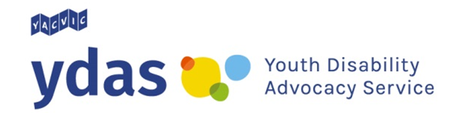

NDIS 101: Self-management

There are some skills you need to have to self-manage your NDIS plan. Think about whether you have the skills to do the tasks below or whether you need to learn them.

Research

Can I do this now?

Do I need to learn?

Contact

Can I do this now?

Do I need to learn?

Decide

Can I do this now?

Do I need to learn?

Make agreements

Can I do this now?

Do I need to learn?

Problem solve

Can I do this now?

Do I need to learn?

Check and pay your bills

Can I do this now?

Do I need to learn?

Access the NDIS portal

Can I do this now?

Do I need to learn?

Talk to people about how things are going

Can I do this now?

Do I need to learn?

What next?

If you feel like you need to learn some new skills before you can self-manage your NDIS plan you can tell your planner or Local Area Coordinator (LAC). You may be able to get extra help to learn new skills so that you can have more control over your NDIS plan.

YDAS acknowledges the support of the Victorian Government.

