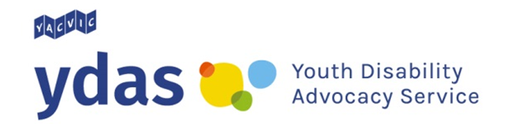

NDIS 101: True or false?

Facts about self-management

True: You can hire your own support workers.
Self-managing your own NDIS plan gives you more choice about who you can get disability supports from. You can even hire your own support workers.

False: You have to pay for your disability supports with your own money.
This is not true. Some people think that if you self-manage your NDIS plan you have to pay for your disability supports with your own money.
When you get a bill for disability supports you have used you can go to the NDIS portal online to record details of the bill. The NDIS will then put the money owing into your bank account so you can pay for the bill.

True: You can save money by self-managing your plan.
Hiring your own support workers and getting services from companies that are not registered (signed up) with the NDIS gives you more choice.
You can shop around and save money on your supports. This means the money in you NDIS plan will last longer.

False: You have to know a lot about finance to hire your own support workers.
This is not true. There are some companies that can help you self-manage your plan. You can choose your own support workers while these companies can do more tricky tasks for you, such as:
- hiring support workers
- making bookings
- invoicing
- paying tax and superannuation
- insurance

True: You can learn how to self-manage your plan.
If you feel like you need to learn some new skills before you can self-manage your NDIS plan you can tell your planner or Local Area Coordinator (LAC).
You may be able to get extra help to learn new skills so that you can have more control over your NDIS plan.
YDAS acknowledges the support of the Victorian Government.

