Access Key
YACVic Rural Conference 2023
Potholes to Possibilities
Dja Dja Wurrung Country
at All Seasons Resort, 171-183 McIvor Highway Bendigo
Local Venue free WIFI – ASB Public

Jarra Country

The Dja Dja Wurrung people are the traditional owners of Jaara country and the land on which Bendigo is located.

In a time when the landscape was bare and featureless, the ancestral spirits shaped the earth with Bunjil, creating song lines, raising trees out of the soil and making places of power where an object was left behind, where a spirit had entered the earth or where a journey was completed and a spirit sat down on the land. The ancestral spirits of the Jaara (people), that have shaped our Country and remain in the landscape today are Waa the Raven, Gamadgi the White Cockatoo and Mindi the Giant Serpent (punisher of lore-breakers) who travels through the treetops.

Bunjil and his brother Waa created the people and bestowed the moiety/kinship system for the people to have Eagle children and Crow (raven) children that would be unrelated. Once the Jaara, animals and plants were created, Bunjil taught the people how to behave on earth and the lore to follow. A part of these lessons was how to conduct the ceremonies that would ensure the continuation of life.

When Bunjil was satisfied with his work, he changed form into the Wedge-tailed Eagle and flew up into the sky to watch down on the earth. Today he is still looking down through the eyes of the Eagle and at night sits by his campfire in the sky known today as Jupiter.

– Rebecca Phillips (Descendant of Caroline Malcolm), Dja Dja Wurrung Clans Aboriginal Corporation

About Bendigo:
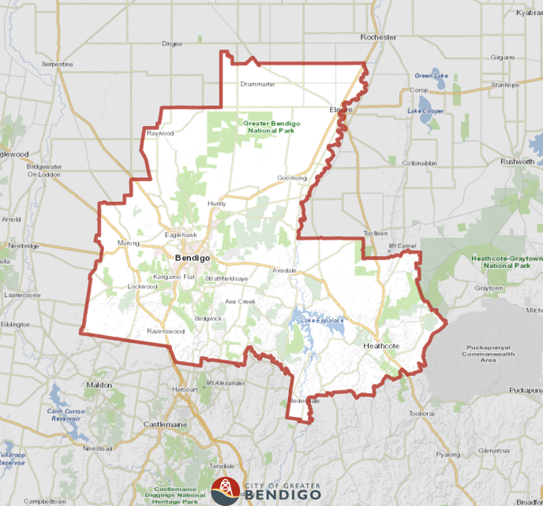
Bendigo is located approximately 150 km North-West of Melbourne with a population of 100,991 according to the 2020 ABS. In 1851, the discovery of gold in Bendigo Creek led Bendigo (then known as Sandhurst until 1891) to becoming one of colonial Australia’s biggest boomtowns. Bendigo became eastern Australia’s biggest 19th-century gold-mining economy. The wealth generated in this time can still be seen today as reflected in the Victorian architecture seen around the regional city.

As mining petered out in the 1940s, manufacturing became a significant contributor to the Bendigo economy with over 10% of the workforce still working in the manufacturing industry today. Tourism is another huge contributor to the local economy, with Bendigo’s rich history of the gold rush providing lots to do and see including different cultural attractions such as Joss House – a historic Chinese Temple built by Chinese miners in the 1860s and the only of its kind in regional Victoria.
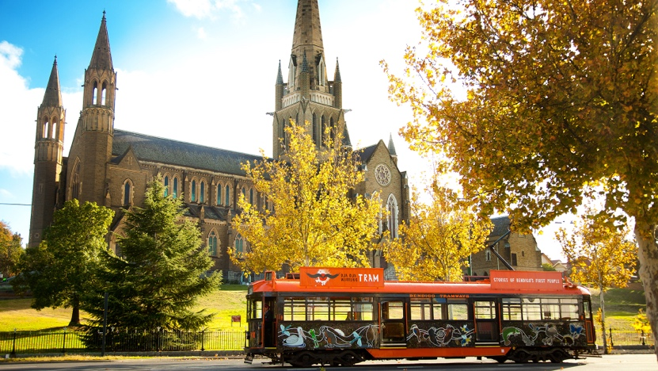

Getting there
If you will be catching public transport to Bendigo, details are outlined below on the services available to you.
Bendigo Line Train Timetable
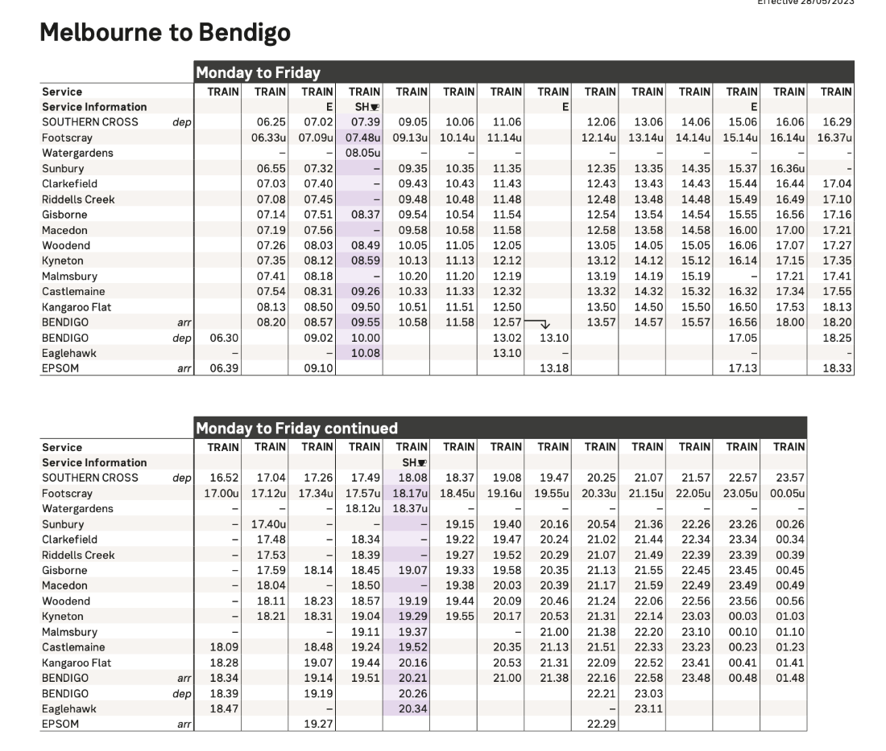
Any of the above trains can be taken to get to Bendigo. Please depart the train at Bendigo Railway Station – please be aware this is NOT the last stop on every service.
Bendigo Bus Service
To get from Bendigo Railway Station to All Seasons Resort Hotel, you can catch the Route 60 bus that departs from the front of Bendigo Railway Station roughly every hour. Route 60 buses depart from Bus Bay 8 which is located to your right when you exist Bendigo Railway Station’s customer service building. After 14 stops, you will want to depart the bus at Putnam Avenue & McIvor Highway. It is then less than a 1-minute walk to the All Seasons Hotel.

Taxi Service
If you would like to order a taxi from Bendigo Railway Station, there are different service provider numbers for your convenience below.
Taxis Associated Bendigo – 13 10 08
13cabs – 13 2227

All Seasons Resort Hotel
The All Seasons Resort Hotel is an iconic entertainment destination that has accommodation and a bistro open 7 days a week for breakfast, lunch and dinner. It is located at 171-183 McIvor Highway, Bendigo. It is adjacent to the Golden Reef Hotel. If you drive in the McIvor Highway entrance, you will see an undercover drop off/pick up bay. (pictured below) Proceed past this area to the car park and the Conservatory Room which is a separate building.
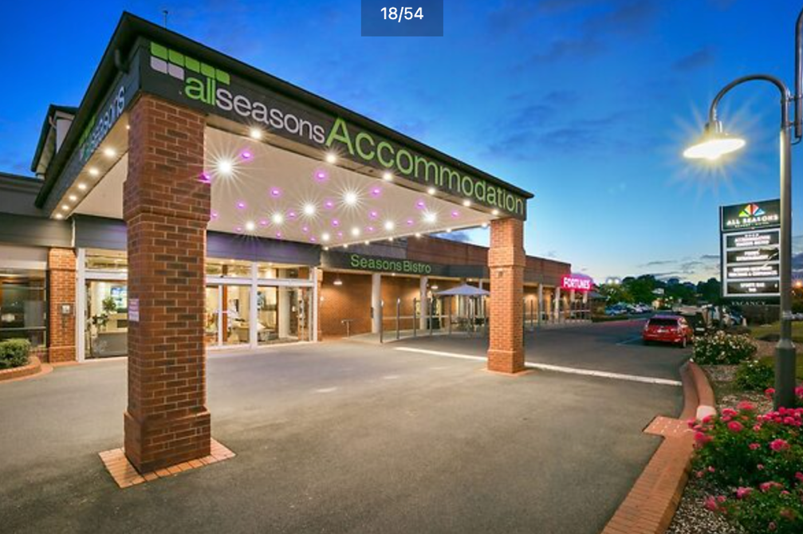
Reception
The reception desk is located in the front entrance of the main building for those who wish to book in for their accommodation. The reception desk is staffed by full time administration. Reception staff are wonderfully helpful and available to provide directions and support during the day.
Day 1 and Day 2 sessions for the Potholes to Possibilities Conference are in the Conservatory Room building on the other side of the main car park. Some Day 3 sessions will be on the ground floor of the main building in the Bassford Room. Lifts and stairs are available for anyone staying in the accommodation on premises.
The reception of the building has high ceilings with bright downlights and a non-slip tile floor. Other flooring throughout the building includes low pile carpet. There are no lips are ledges for trip hazards.
There can be a slight echoing of sound through the room.
Throughout the building, there is a light floral scent that is reminiscent of a cleaning product.
The building is temperature controlled at a comfortable 22 degrees.
Bathrooms
Gendered bathrooms are located to the right as you enter reception.
Gendered bathrooms in The Conservatory are located at the back left of the room down a hallway. An accessible bathroom is the first door on your right upon entering the hallway.
Each of the gendered bathroom has cubicles with sanitary dispensary options available in the ladies' bathrooms. There is a slight incline in the flooring when you enter the bathroom. Upon entering you will see a 3m x 3m space for handwashing. There are multiple sinks that sit at a height of 78cms. There is liquid handwash available that is low odour. Low lights are located above mirror with Dyson auto hand driers at the rear of the room along with paper towel drying option.
Flooring & Walkways
Sessions at the conference will all be in the Conservatory & Atrium Room except the Friday morning Consent sessions which will be in the Bassford Room in the main building. The footpaths between the main hotel building and the Conservatory Room building are textured, non-slip footpaths and paved walkways complete with ramps of slight incline. The distance between the two buildings is 40 metres.
Lighting
The Conservatory & Atrium Room is a large open space with lots of natural light. Adjustable LED downlights are available to be used however we will utilise the natural light wherever possible. There will be tables set up towards the front of the space where a projector will be set up behind a lectern. There will be plenty of space to navigate around the room with the back of the room being free from tables and chairs.
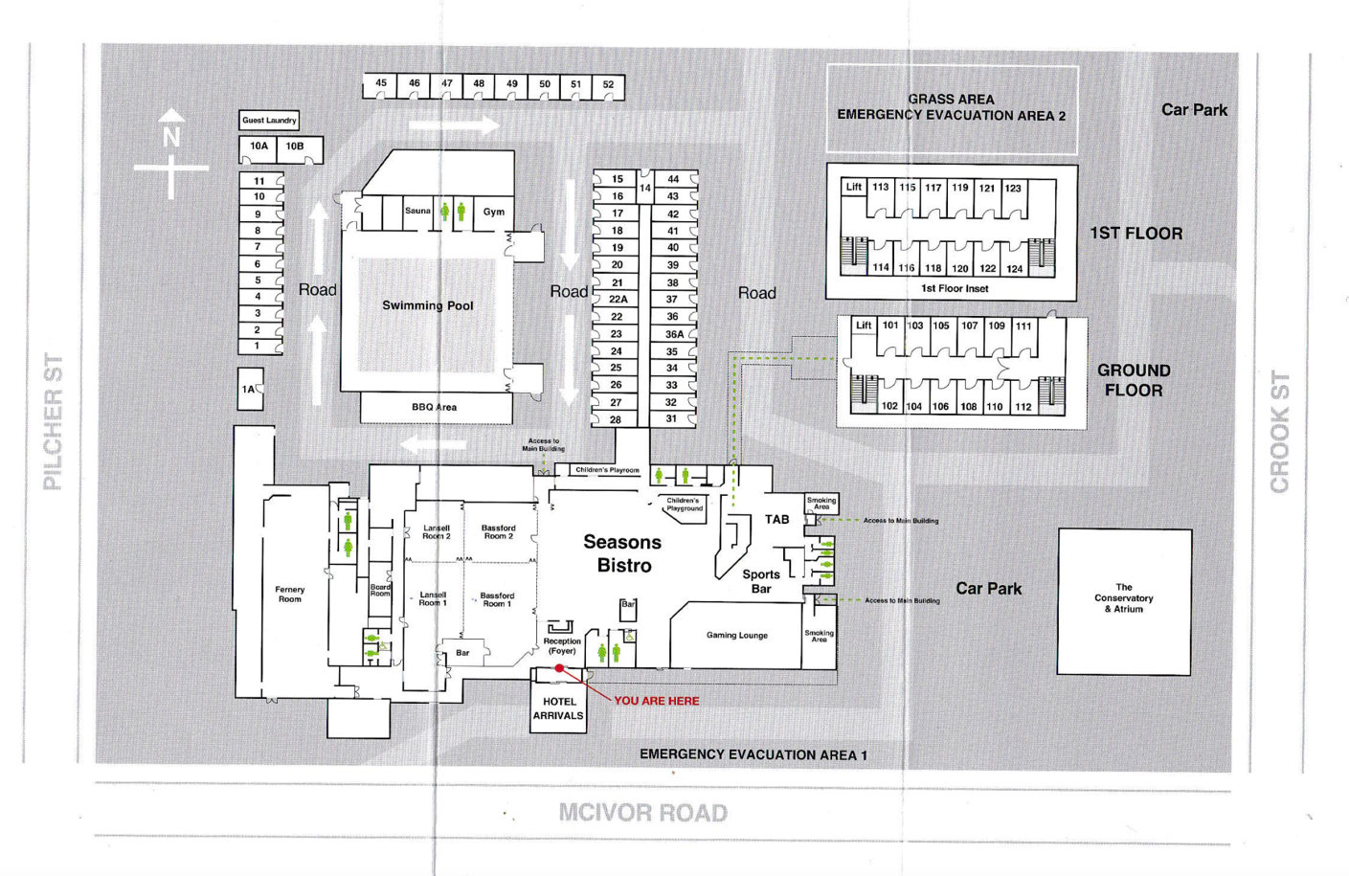

The Bassford Room will host some of the Day 3 breakout rooms and plenary sessions. These rooms are located by the kitchen facilities which may contribute to light wafting smells of food during service times of the day. These rooms are also located next to the bistro so some background noise may be heard but not to a distracting volume. A light whirring sound can be heard in the Bassford room as the result of a refrigerator at the back of the room.
The lighting in these rooms is adjustable so please get in touch with a staff member on the day if the lighting is affecting you.
In both these rooms we will be using large round tables to seat 8 people at each. We will ensure that people using mobility aids are seated at tables accessible to the exits and bathrooms as well as the audio and power point displays.
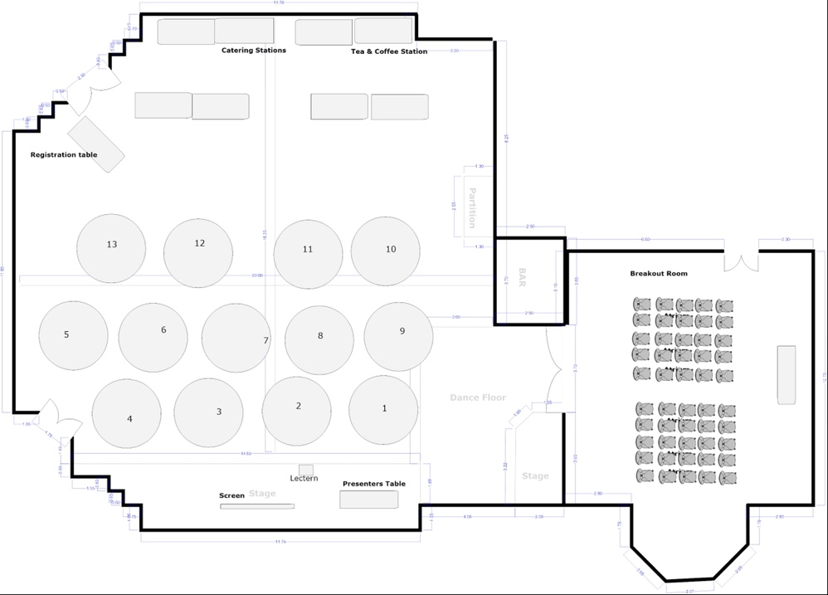The Conservatory Building

Where can I park?
For those bringing their own vehicle, plenty of parking is available to the right of the main building at the venue and also on the opposite (Crook Street) side of the Conservatory Room building.
There is Accessible Parking spaces out the front (at the reception entrance) and to the side (at the Bistro entrance) of the main building. There is also Accessible parking spaces out the front of the Conservatory & Atrium Building.
All parking spaces in All Seasons Resort Hotel carparks outlined are free and are not time restricted.

Extra Info:
Staff
We know that going to a big event with lots of people you don’t know can sometimes be overwhelming. To make it easier for you to spot staff who can support you with any queries throughout the conference, YACVic staff will be wearing either green or red shirts with “Staff” written on them. For any concerns or questions, please have a chat with one of our friendly staff members.
Health & Safety
YACVic is committed to making sure all precautions are taken to ensure people’s health and wellbeing. We will have Rapid Antigen Tests (RATs) and masks available at no charge for anyone wanting them. We encourage you to please test if you have ANY symptoms or any doubt that you may have COVID-19.
Hand sanitiser will also be readily available for conference attendees which we encourage you to use regularly.
If you require a First Aid kit for any reason, please find a staff member who will be able to direct you to the appropriate person for the day.

Accommodation:
All Seasons Resort Hotel:
Accommodation is available at the All Seasons Resort Hotel. As the venue hosting the conference, they have kindly offered our participants at the Potholes to Possibilities Conference 2023 a 20% discount. If you’d like to utilise this discount when booking, use the code: YOU221123
W: All Seasons Resort Hotel
E: enquiries@allseasonsbendigo.com.au
P: 03 5443 8166

There are multiple other accommodation options in the nearby vicinity, including short stay house and apartment options which may be more cost effective for groups.

Best Western Crystal Inn Bendigo:
Located at 233-235 McIvor Highway, Bendigo, the Best Western is just a 1-minute drive from the conference venue with very reasonably priced rooms.
W: Best Western Crystal Inn
E: N/A
P: 1800 026 370

Golden Reef Motor Inn:
Conveniently located directly across the road from the conference venue.
W: Golden Reef Motor Inn
E: bookings@goldenreefmotorinn.com
P: 03 5441 1000
Places to Eat & Coffee:
For anyone looking for a delicious meal or the perfect coffee, we have compiled a list of places in Bendigo to find what you’re looking for!
Cafes:
- Sim R Café - breakfast/lunch/brunch - vego friendly, vegan options, gluten free options
- Percy and Percy – breakfast/lunch/brunch - vego friendly, vegan options, gluten free options
- The Boardwalk Bendigo – breakfast/lunch/brunch - vego friendly, vegan options, gluten free options
- Bendigo Corner Store Café
Restaurants:
- Food O’Clock & Indian – dinner – vego friendly, vegan options, gluten free options
- The Woodhouse – lunch/dinner - vego friendly, vegan options, gluten free options
- The Old Boundary Hotel – lunch/dinner - vego friendly, vegan options, gluten free options
- Bridge Hotel Bendigo – lunch/dinner - vego friendly, vegan options, gluten free options

Things to do in Bendigo
While you’re in Bendigo, if you’d like to do some exploring, there are some activities and sights to see listed below!
- Take a ride on the Bendigo HOHO Tram and learn about the city’s history
- Visit the Bendigo Art Gallery and see a great range of high-quality art and textiles
- Journey to the Central Deborah Gold Mines and tour the underground tunnels of a real gold mine that operated during the gold rush boom!
- Check out the Golden Dragon Museum and see historical Chinese artifacts from the gold rush. A ticket here also includes entry to the Chinese gardens and Kuan Yin Temple.
- Walk around Rosalind Park to view a range of historic trees, structures, buildings and landscapes.
Contact Us the YACVic Team:
Please contact the YACVic Team if you have any questions, and copy your email to rural@yacvic.org.au Staff are full time and will endeavor to respond to your query within 24hrs.
Derm Ryan  Manager, YACVic Rural (Mon-Fri) | dryan@yacvic.org.au  0408 674 738
Karen Walsh  Rural Development Coordinator, Great South Coast (Mon-Thur) | kwalsh@yacvic.org.au  0472 514 870
Rhi Jennings  Rural Development Coordinator, Southern Mallee (Mon-Thur) | rjennings@yacvic.org.au  0474 506 000

